### Spellbook section

### Area description

The spellbook section is a rectangular room, containing a maze of bookcases. In the section there are many candles that are supposed to lit the room.

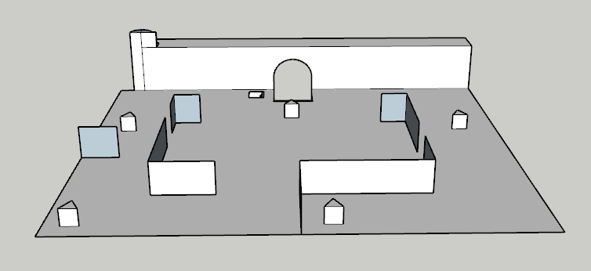

### Lore

The spellbook section contains everything concerning any sort of enchantment: from the simple *Wingardium Leviosa* to the arduous *Animagus*. Books in it are soaked with magic. It is not uncommon to witness some of them make themselves invisible, just to proudly prove the knowledge they carry. This makes the spellbook section one of the hardest to search for a specific book. By night, this section is protected by the Pallium Umbra, a shadowy creature particularly annoyed by light, that keeps the room in complete darkness, blowing of the candles hung on the walls.

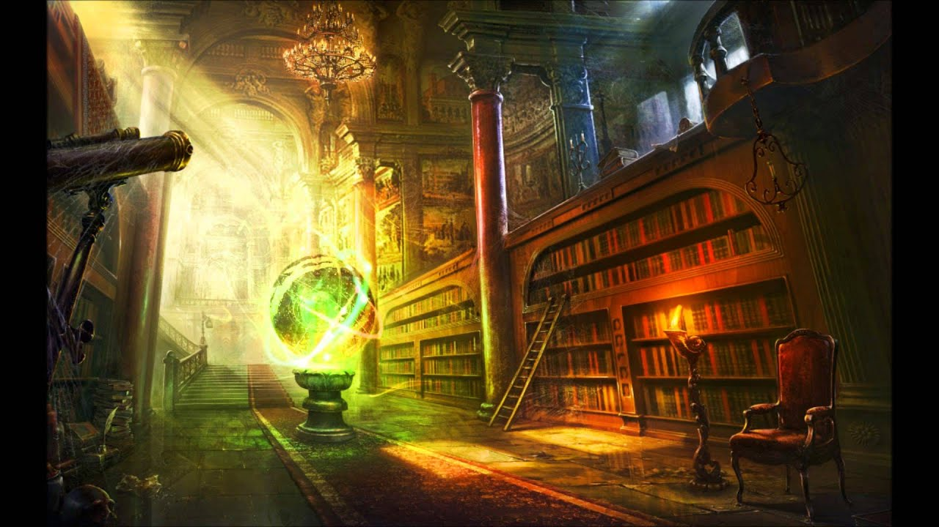

### Map

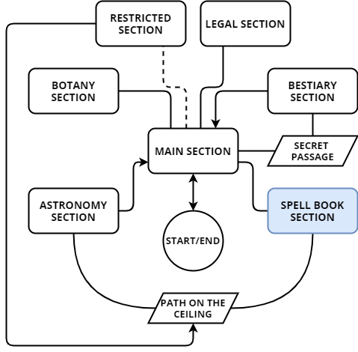The spellbook section is protected by the enemy Pallium Umbra who is able to mutate the section. In the section there is a passage through a small trap door that leads to the path on the ceiling. Candles and the passage are the only objects that hold their initial position.

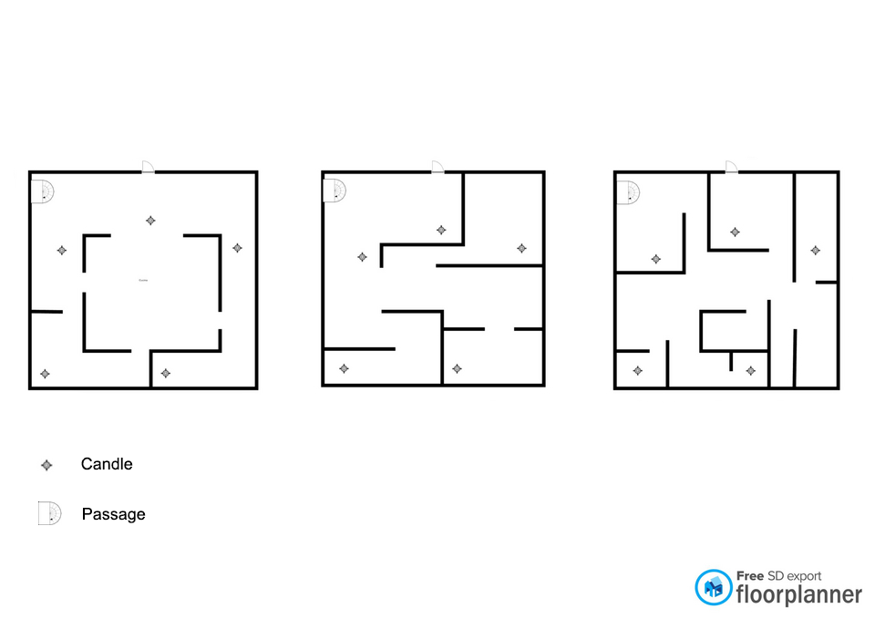The section can have three shapes, one for each phase of Pallium Umbra:

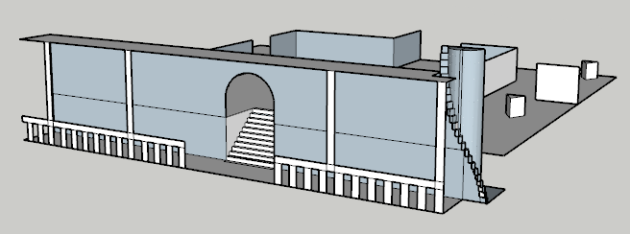**Structure of the spellbook section:**

**The passage:**

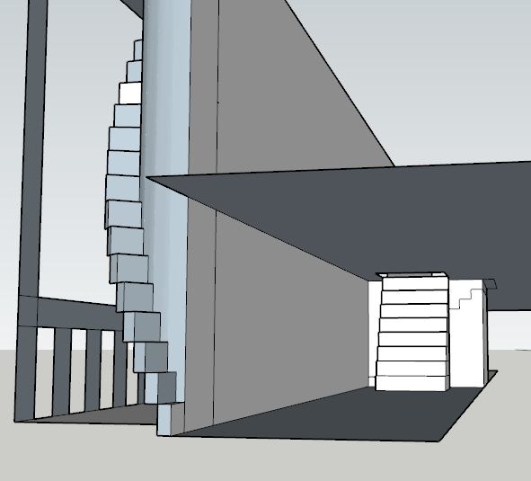

### Goals

The main goal of this section consists in defeating the enemy Pallium Umbra to take the signet of the spellbook section.

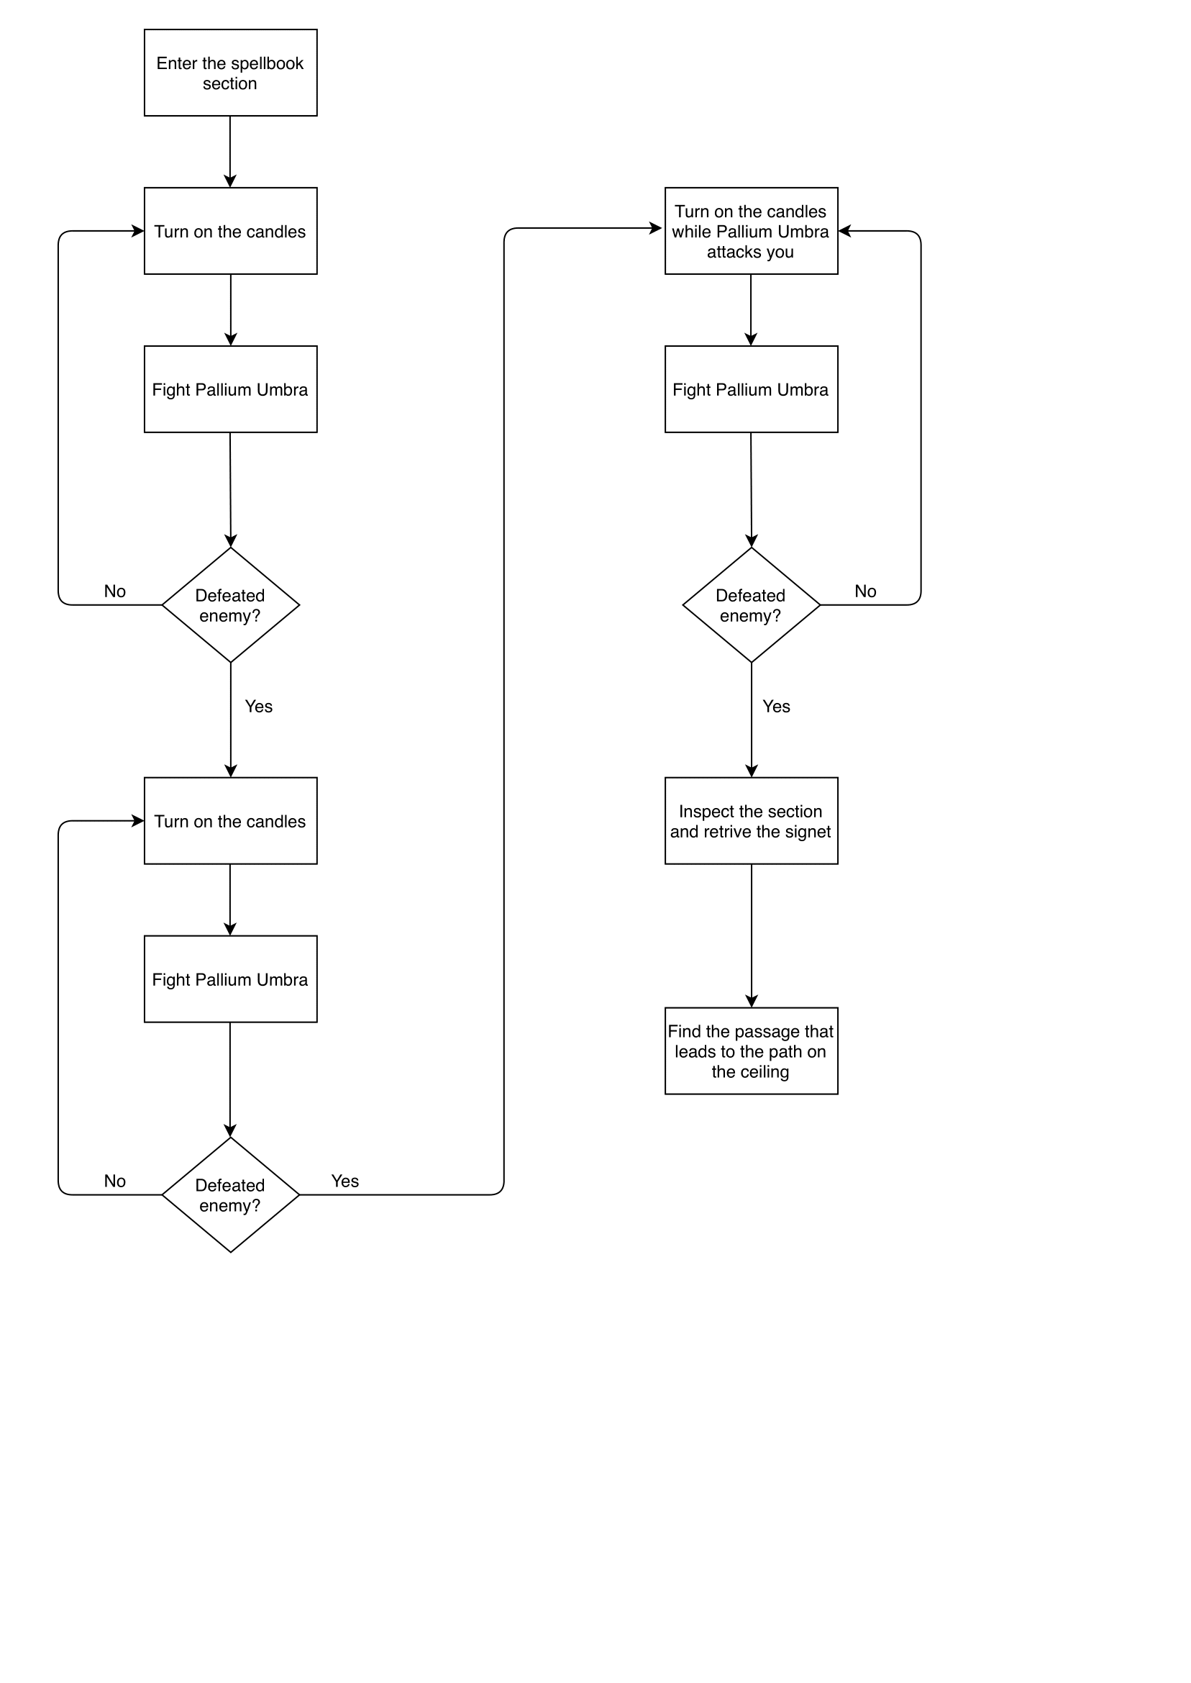

### Main quest

#### Turn on the candles:

Minerva must solve the candle puzzle and defeat the enemy Pallium Umbra to get the signet from the spellbook section.

#### Find the passage:

Minerva must find the passage in the room that leads to the path on the ceiling in order to reach the astronomy section.

### Room contents

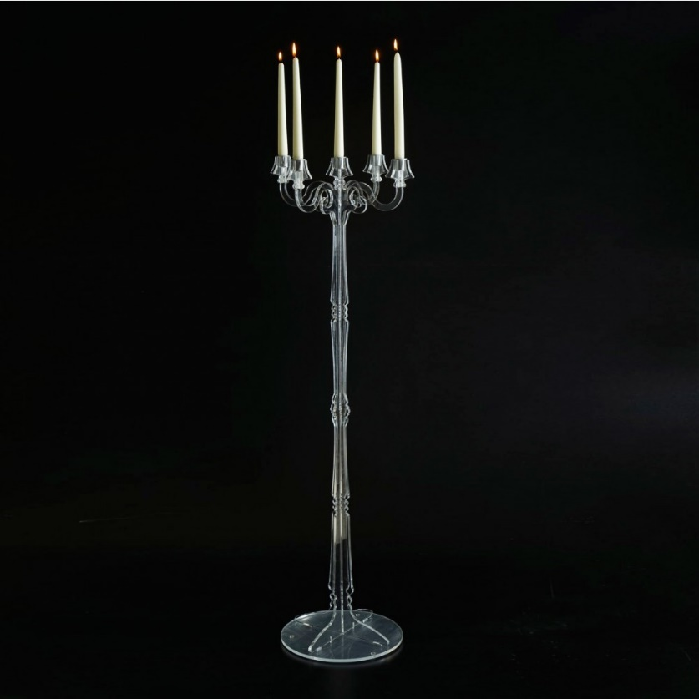The spellbook section contains everything concerning any sort of enchantment. The main elements of the section are **candles** scattered around the room and a **small trap door** leading to the path on the ceiling.

**Candles:** The candles are supported by a long candlestick. These candles are enchanted in fact they do not suffer any effect when Pallium Umbra changes the shape of the room.

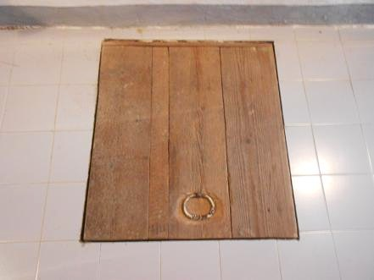

**Small trap door:** This passage leads to the path on the ceiling in order to allow Minerva to reach the astronomy section, this is in fact the only way to reach it.

### Cutscenes and Dialogues

1. When Minerva enters the spellbook section for the first time, there is a **cutscene** in which the young student enters the section where there is a single lit candle, the one immediately in front of the entrance. After a few steps, Minerva sees the candle go out and the sound of a breath. At this point Minerva is in the dark.

**Minerva's thoughts:** *"I don't see anything ..."*

Minerva uses the "Lumos" spell to shed some light, thereby illuminating the tip of her wand.

1. Whenever Minerva manages to light the candles in the room, a **cutscene** starts in which the room changes its structure to its initial shape and Minerva is faced with the enemy Pallium Umbra in the center of the section.
2. When Minerva finally manages to defeat Pallium Umbra in all three phases, there is a **cutscene** in which the enemy dissolves and the signet falls to the ground.
3. When Minerva finds the passage to the path on the ceiling there is a short **cutscene** in which the young woman opens the small trap door.

**Minerva's thoughts:** *"There is a passage here ... but in this way I will certainly not be able to pass it."*

### Gameplay

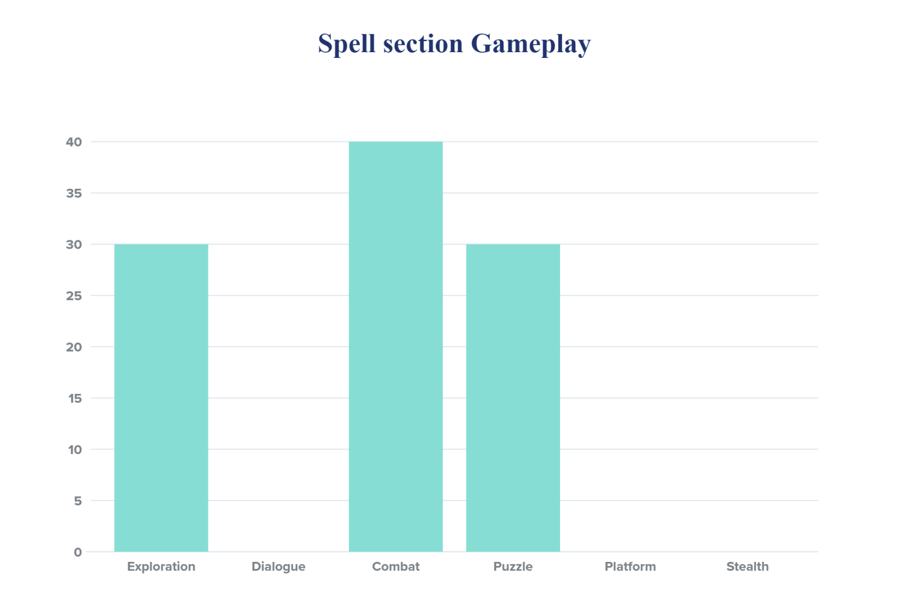This area of ​​the map is mostly puzzle, exploration and combat oriented. The main goal of the section is to be able to turn on all the lights to face Pallium Umbra, defeat him and take the signet from the spellbook section.

#### Exploration:

1. 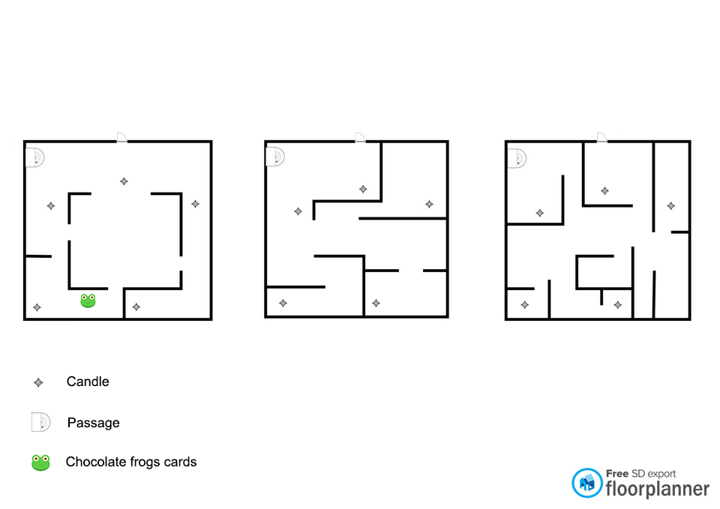Minerva must be able to reach all the candles to light at each stage and must explore to find the passage.
2. In the section there is one hidden collectible which can only be taken by Minerva in the first phase or once Pallium Umbra is definitively defeated.

#### Dialogue:

In this section there are not dialogues.

#### Combat:

The fight with the enemy Pallium Umbra begins once Minerva has managed to light all the candles for the first time and thus the 3 phases of the enemy begin:

1. At the beginning of the first phase (1), when the fight begins, Pallium Umbra teleports Minerva to the center of the room to face her.
2. At the beginning of the second phase (2), when the fight begins, Pallium Umbra changes the shape of the room back to its initial shape of the first phase and teleports Minerva to the center of the room to face her.
3. At the beginning of the third phase (3), when Pallium Umbra meets Minerva while she is lighting the candles, he launches an attack on her instead of running away and once all the candles are lit, when the fight begins, the enemy changes the shape of the room again making it return to its initial shape of the first phase and teleports Minerva to the center of the room to face her.

Shape of the room in each phase, whenever a fight starts the room reverts to form 1:

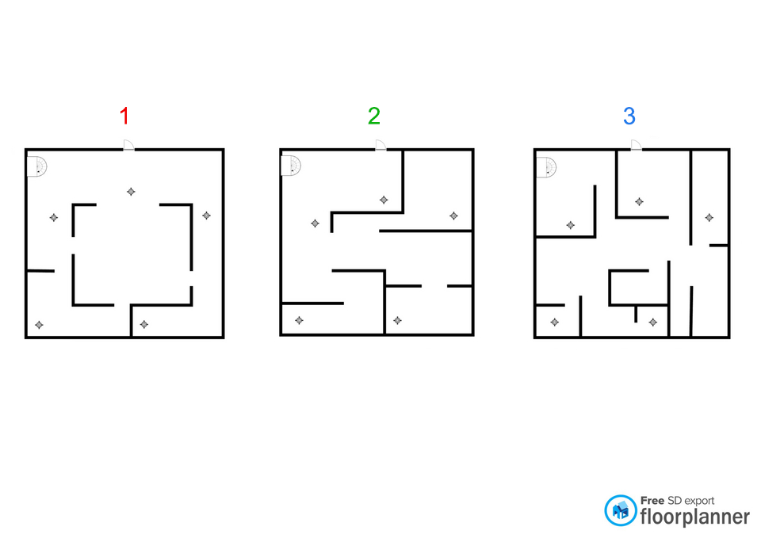

Position of Minerva and Pallium Umbra at each start of the fight: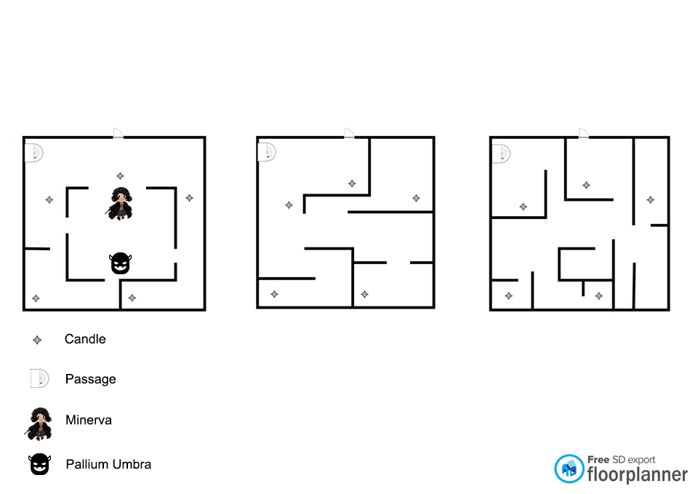

Pallium Umbra mechanics: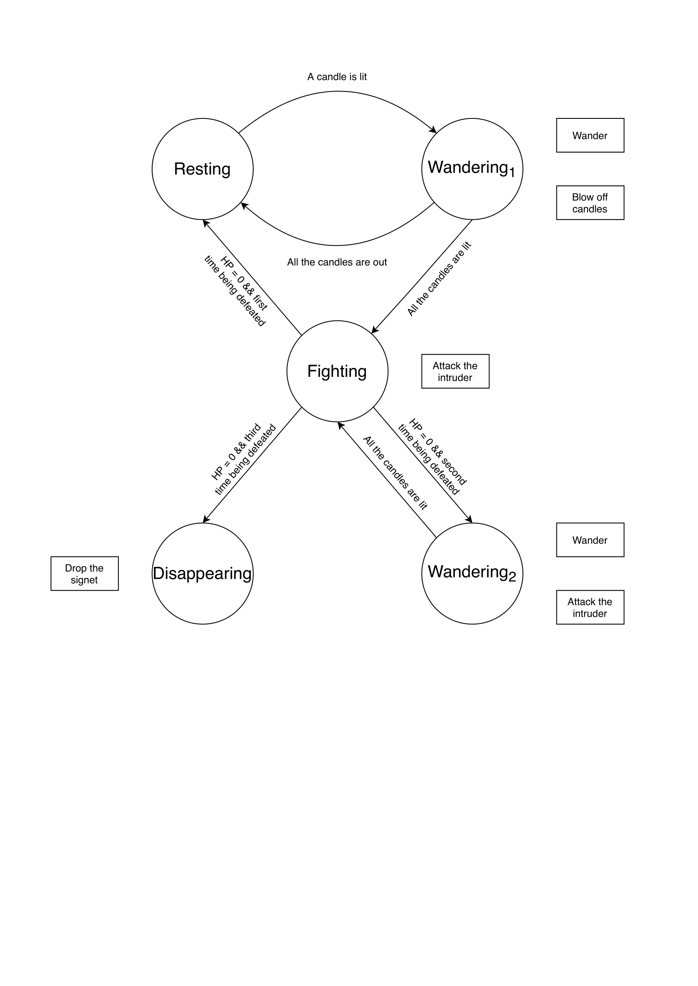

#### Stealth:

In this section there is not a stealth mode.

#### Puzzle:

1. The main puzzle of this section consists of **three stages** in which Minerva must be able to light all the candles before they are blown out by Pallium Umbra.

Pallium Umbra is able to pass through walls and objects. When Minerva lights the candles, the enemy goes to the candles to blow them out in the order they were lit. After blowing out a candle, Pallium Umbra returns to the center of the room.

In the first two stages, if Pallium Umbra meets Minerva he runs away from her light. In the third phase instead, if Pallium Umbra meets Minerva he launches an attack on her and then runs away.

Between one phase and another the room changes its shape. At the end of each phase the fight begins against Pallium Umbra who teleports Minerva to the center of the room and returns the room to its initial form, that of phase one. At each end of the fight, Pallium Umbra restores his hit points.

If Minerva is defeated, she returns to the beginning of the phase she is in and must therefore re-light the candles.

Minerva's wand and candles generate light with a radius equal to 1.50 meters.

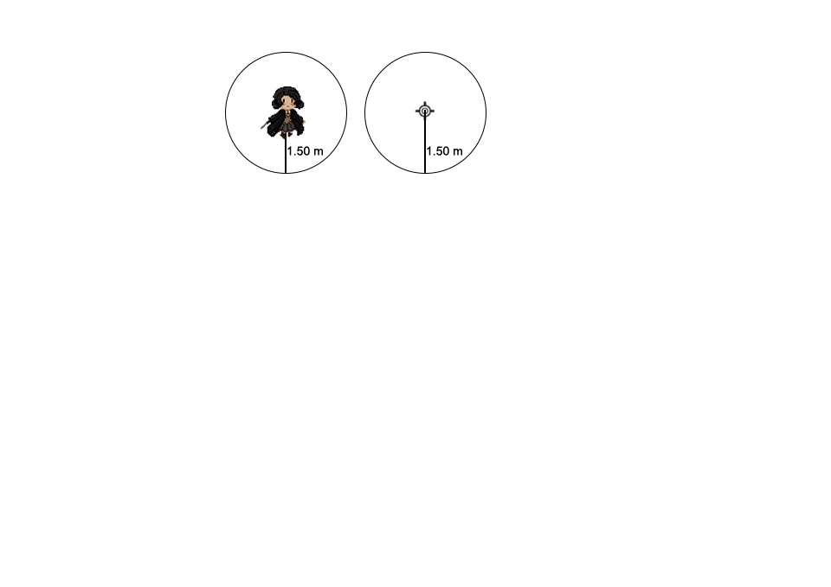

#### Platform:

In this section there are not platform path.

### Enemies:

#### Pallium Umbra

**Description:** Pallium Umbra is a shadow generated by an enchanted book that defends the Spell Section from intruders by trying to keep the room dark. This enemy is made up of three combat phases between which he will follow the path of Minerva to blow out the candles that have been lit. Between each stage the enemy recovers his hit points and in the last stage he can attack Minerva as she tries to light the candles by throwing a blow.

**Armor Class:** 12

**Hit Points:** 16

**Speed:** 12 meters

|  |  |  |  |  |  |
| --- | --- | --- | --- | --- | --- |
| **STR** | **DEX** | **CON** | **INT** | **WIS** | **CHA** |
| 6(-2) | 14(+2) | 13(+1) | 6(+1) | 10(+0) | 8(-1) |

**Melee Weapon Attack:** d20 +4 to hit, reach 1 meter and a half, one target. Hit: 1d6 +2 necrotic damage. When attacking the enemy to approach the target to deliver a blow and then return to its initial position.

**Attack and Escape:** In the last stage he can attack Minerva as she tries to light the candles by throwing a blow. Hit: 2 necrotic damage.

**Incorporeal Movement:** The enemy can move through other creatures and objects.

**Exp:** 300

### Lights

In this room the lights are key. They are part of the puzzle so the lighting in the room is very important. The room is completely dark. Once the light is switched on, only the area adjacent to it will be visible. A lit light is visible in the distance and serves as a reference point. When Pallium Umbra is defeated, the room will be illuminated. All the lanterns are lit and the contents of the room are visible, even the secret passage will be illuminated.

### Sounds:

|  |  |
| --- | --- |
| **Sound Effect** | **Track** |
| When Pallium Umbra blows to blow out the candles | BlowingCandle.wav |
| When the candles are lit | IgnitionCandle.wav |
| Pallium Umbra noises | PalliumUmbra.wav |