## Level Analysis

Throughout the level, Minerva has access to different resources. Here follows an analysis on how many of each of these resources she is expected to gain.

### Experience

Minerva gains experience for different types of accomplishment during the level:

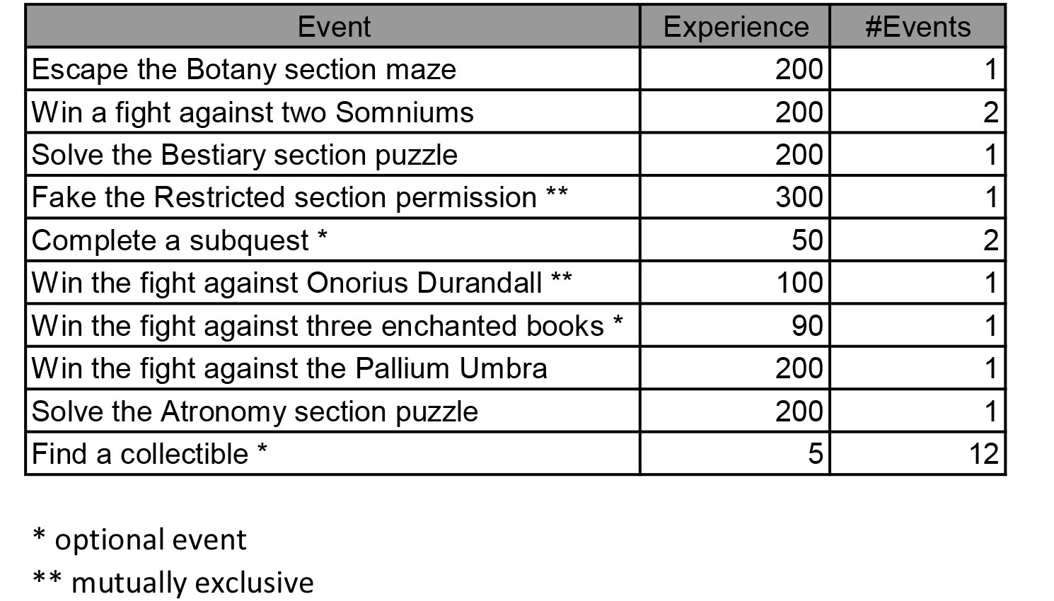

Considering all the events that provide experience in the level, Minerva can gain a minimum of 1450 experience points and a maximum of 1750.

### Coins

Minerva gains coins for different types of accomplishment during the level:

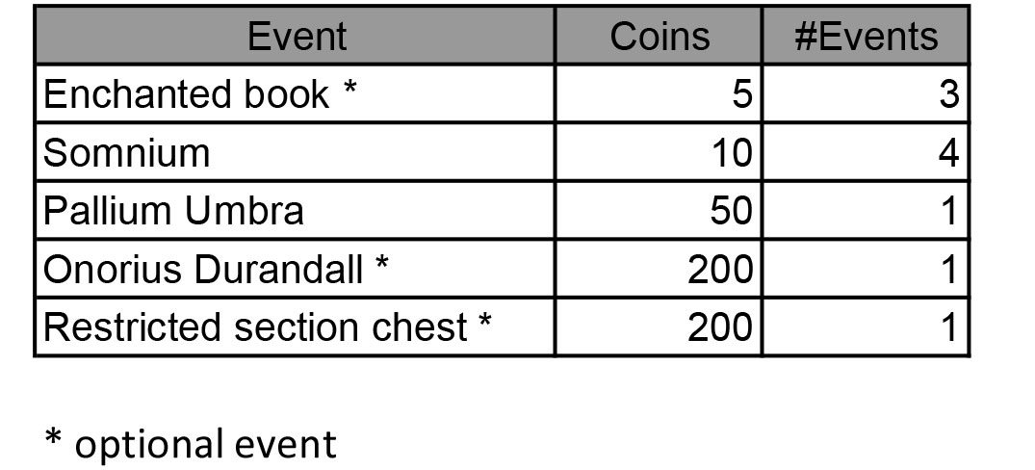

Considering all the events that provide coins in the level, Minerva can gain a minimum of 90 coins and a maximum of 505.

### Collectibles

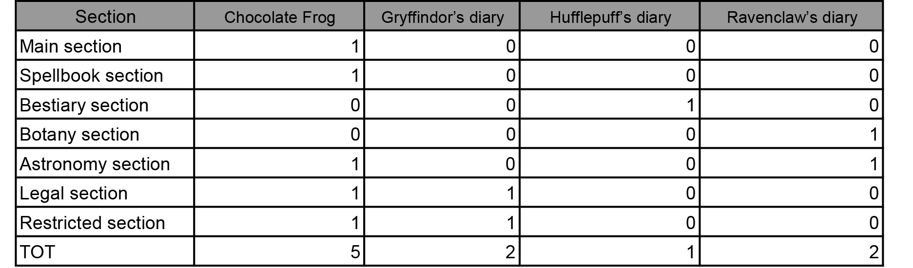

Minerva can find a lot of collectibles throughout the level. They are distributed as follows:

Minerva can find a total of 12 collectibles in the level. All the collectibles are optional.

### Health potions

Minerva has access to a total of 9 Health potions.

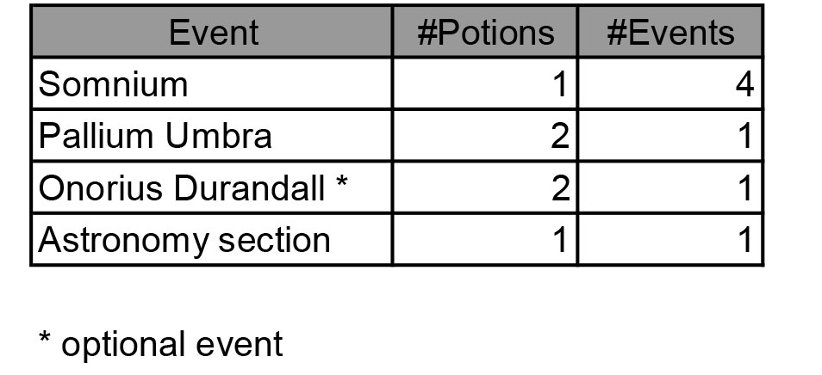

### Mana potions

* + 1. Minerva has access to a total of 7 Mana potions.

