**VISUALS**

The level "Something old, something borrowed and something new" is set at night in Hogwarts library in which there is a gloomy atmosphere given by the dim light of the candles positioned around the various sections and the dark colors present in them.

The library structure consists of a ground floor where there is the Main Section, a lower floor where there is only the Restricted Section and an upper floor where there is a balcony overlooking the Main Section and four other sections: Spell Section, Botany Section, Bestiary Section, Astronomy Section and Legal Section.

The library is filled with bookcases, tables and chairs. At the center of the Main Section there is a huge globe and next to it are the stairs leading to the various floors.

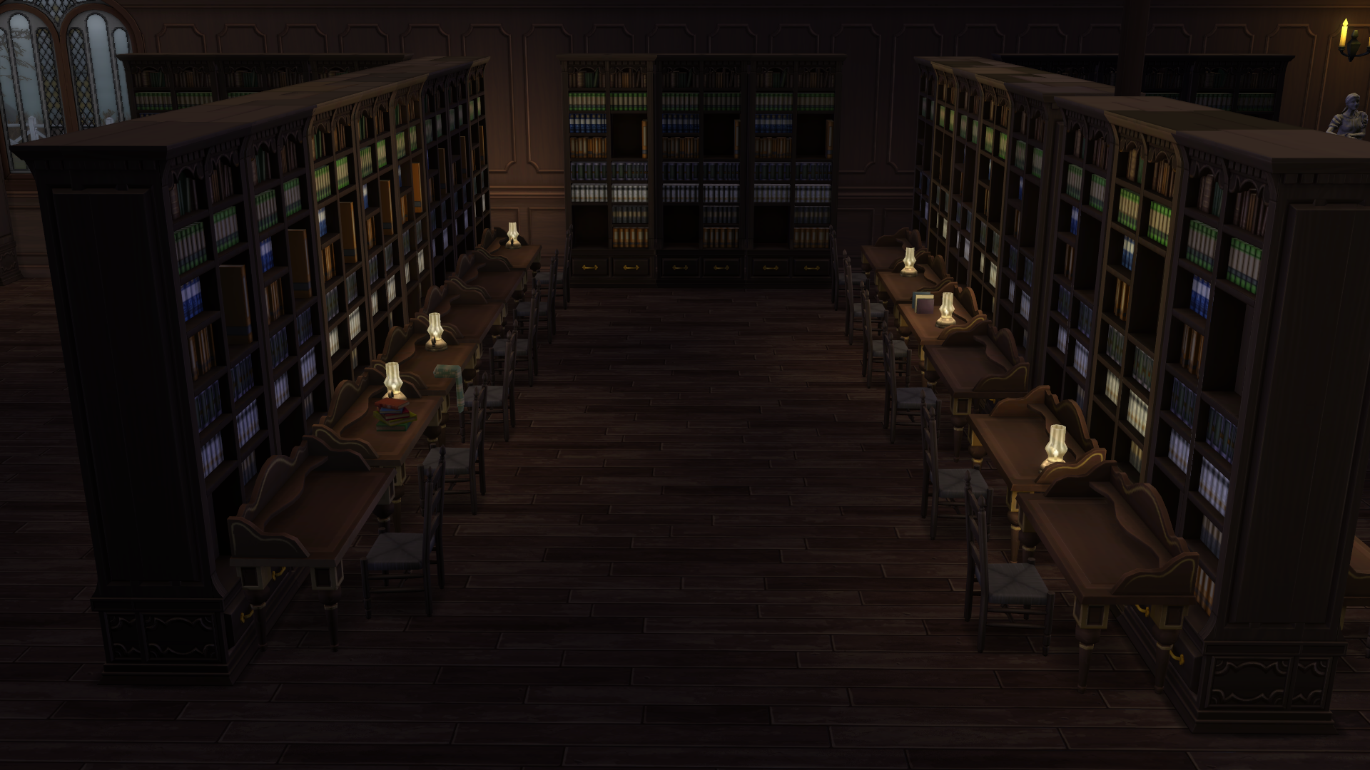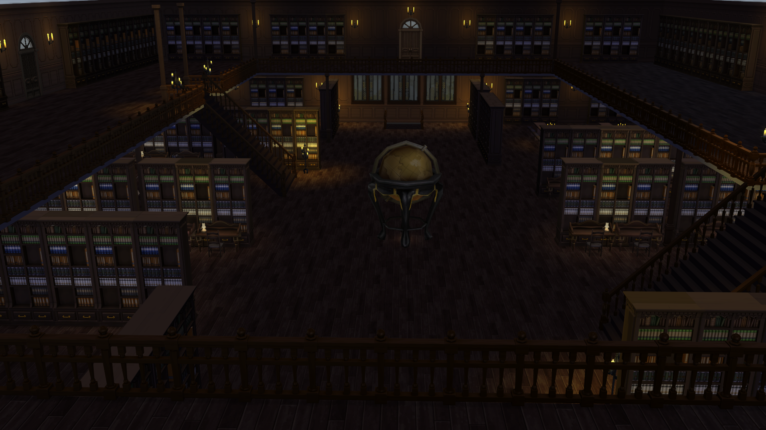

The colors that prevail in the library are the following:

