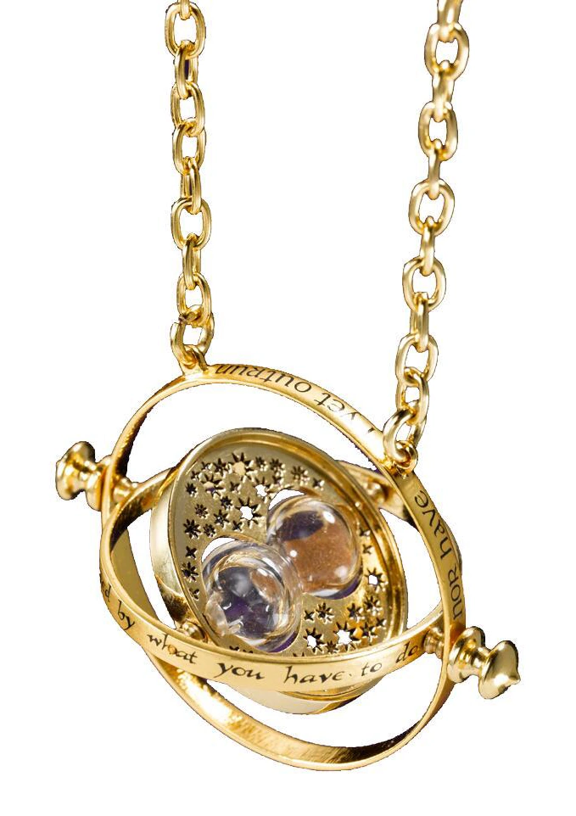
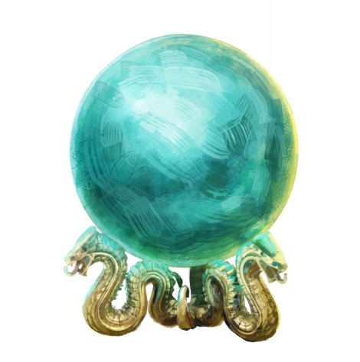
Story Elements

The time-turner
A magical device used to time travel. Old Helena steals one from Albus Dumbledore’s office, after his death, during the death-eaters' control on Hogwarts. She uses it to go back in time, giving birth to the events of the story. At the end of the story, old Helena dies, making so that Dumbledore gains possession of the time-turner in the first place.

Unforgivable curses
Three of the most powerful and dark spells known to wizards: Crucio, the curse of torture; Imperio, the spell that controls the mind; and Avada Kedavra, that causes instant death. The use of any of them is illegal. Avada Kedavra, the worst of them, leaves a mark even on the soul of the caster, tearing it apart and never letting it become a whole again.

The prophecy
A prediction of the future, made by a seer. They can take different forms, but they are often stored in crystal balls. Robert’s death prophecy was made by old Helena, to lead Minerva in search of the resurrection stone.

The creature in the forest
The creature that Minerva and Helena meet in the forest is different depending on players’ choices. It can be either Amos, the centaur or Kricket, the elf. It is an incredibly old creature. Very knowledgeable of the history of the school and of the wizarding world.

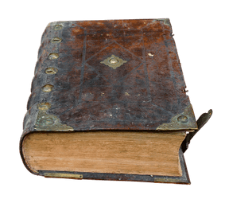
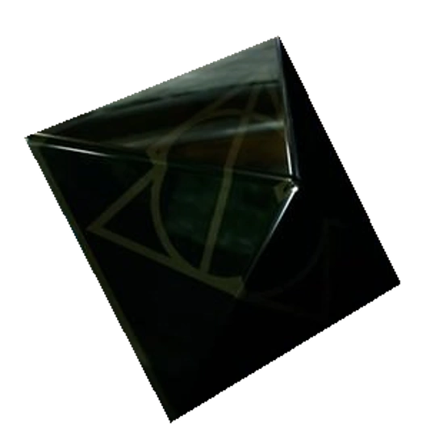
The book of no more
Wrote decades ago by a group of powerful wizards. It's the product of their foolish research on ways to defeat death and give immortality to the wizards kind. It is full of dark spells and, therefore, Hogwarts copy is safely stored in the restricted section of the library.

Disvidere
One of the spells contained in “the book of no more”. It’s supposed to break a death prophecy, but no one has ever heard of someone casting it with success. Along its incantation and wand movement, the spell requires three materials: an old soul; something stolen, once belonging to a powerful being; and the resurrection stone.

The soul
The soul that Minerva captures is different, depending on players’ choices. It can be either the ghost haunting the Shrieking Shack or a ghost inhabiting one of Hogwarts paintings.

The pearl
The pearl that Minerva steals is different, depending on players’ choices. It can be either the pearl lying in the lost ruins in the depth of Hogwarts lake, or the one that is set in Magnus Black’s watch.

The resurrection stone
One of the fabled Deathly Hallows, as presented in “The tale of the three brothers”. It is said that the holder can bring back the spirits of his deceased loved ones.

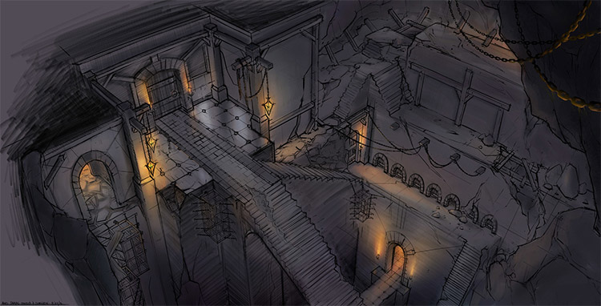
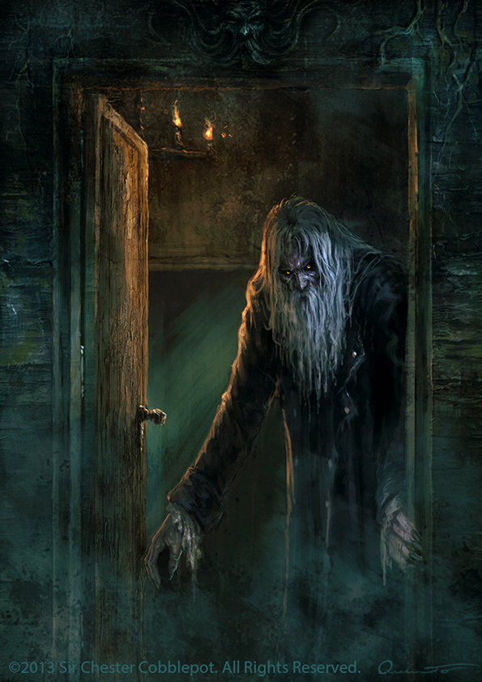
Korvald, the banished wizard
He was one of Hogwarts professors. Banished and barred from practicing the use of magic, he took refuge in the deepest part of the forbidden forest. He lives alone in his ruined cabin, in sorrow.

The room of requirement
One of the many secret rooms in Hogwarts castle. It appears only when a person is in great need of it and transforms itself into whatever the wizard needs it to be. In the case of this story: a way to the dungeon where the resurrection stone lies.

