- HTML is the standard markup language for creating Web pages.

- HTML stands for Hyper Text Markup language.

- It describes basic structure for web page.

- It tells the browser how to display the contact.

- current version: HTML5

- HTML Structure:

<!DOCTYPE html> --> defines that this document is an HTML5 document

<html> --> root element of HTML page

<head> --> contains metadata information about HTML page

<title>Page Title</title> specifies a title of HTML page

</head>

<body> --> defines document's body

<h1>My First Heading</h1> --> for heading

<p>My first paragraph. </p> --> for paragraph

</body>

</html>

Q. What id Metadata or which type content include into <head> tag part?

=> Metadata in HTML provides essential information about the document for:

Search engines: Improve search rankings, display better snippets, or control how the page is indexed.

Browsers: Helps manage layout, character encoding, and compatibility settings.

Social media: Control how content appears when shared on platforms like Facebook or Twitter.

Developers: Provide information like authorship and set rules for the handling of the page.

**Form:**

<form>: this tag use to create form in HTML

<form> attribute:

1) action: It defines the action should be performed after the form will be submitted

- Note: if the action attribute is omitted, the action is set to the current page.

<form action="/work/home.html">

2) target: It specifies where to display the respone after submitting form.

Target attribute values:

1. _blank: response display on new window.

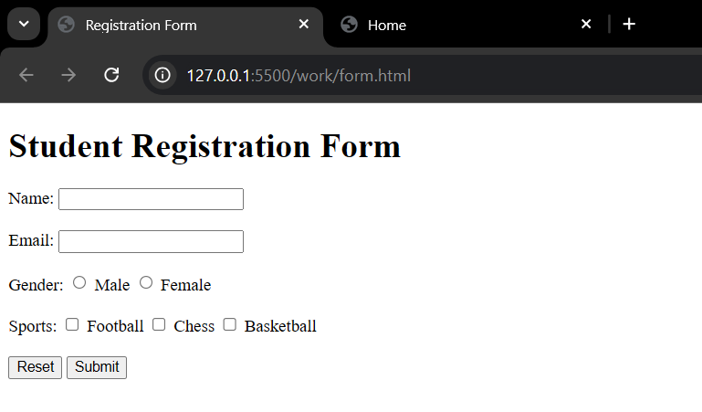

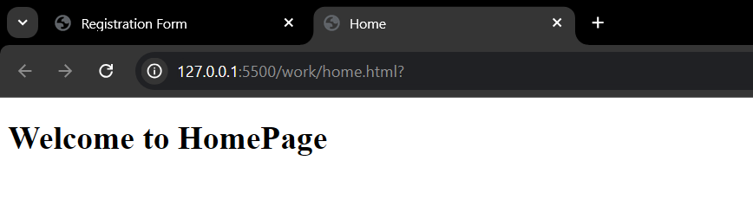

1. _self: response display on the current window. (**default value**)

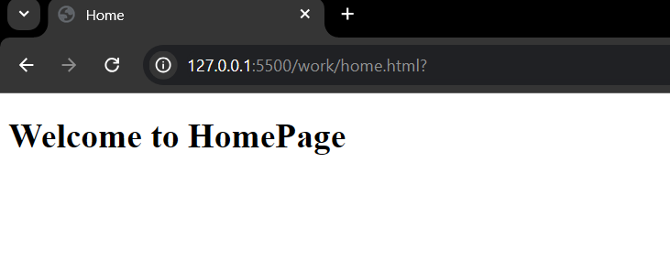

1. _parent: response display on parent frame.

Ex: If we are at Home page (Parent page) and another small window open which have form and if we submit that form our home page will change into the target page which specified in that form action.

1. _top: response display on full body of the window.
2. framename:

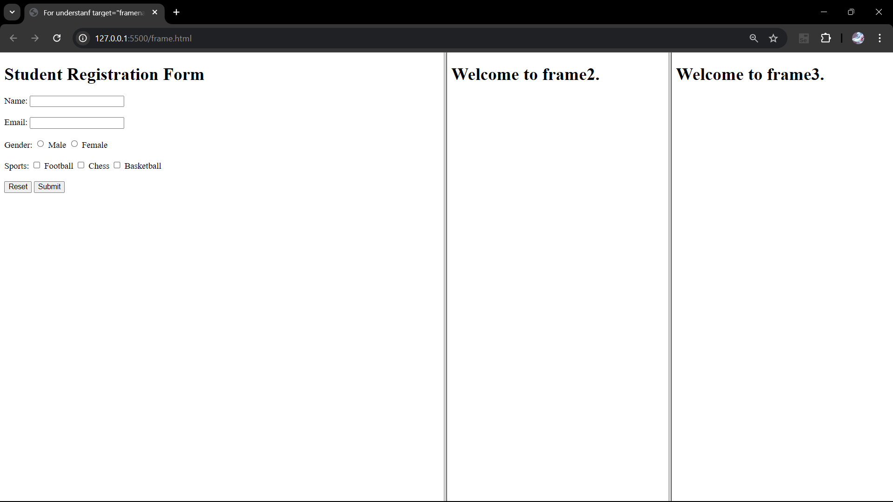

After click on submit as per code response open into place of “frame3”

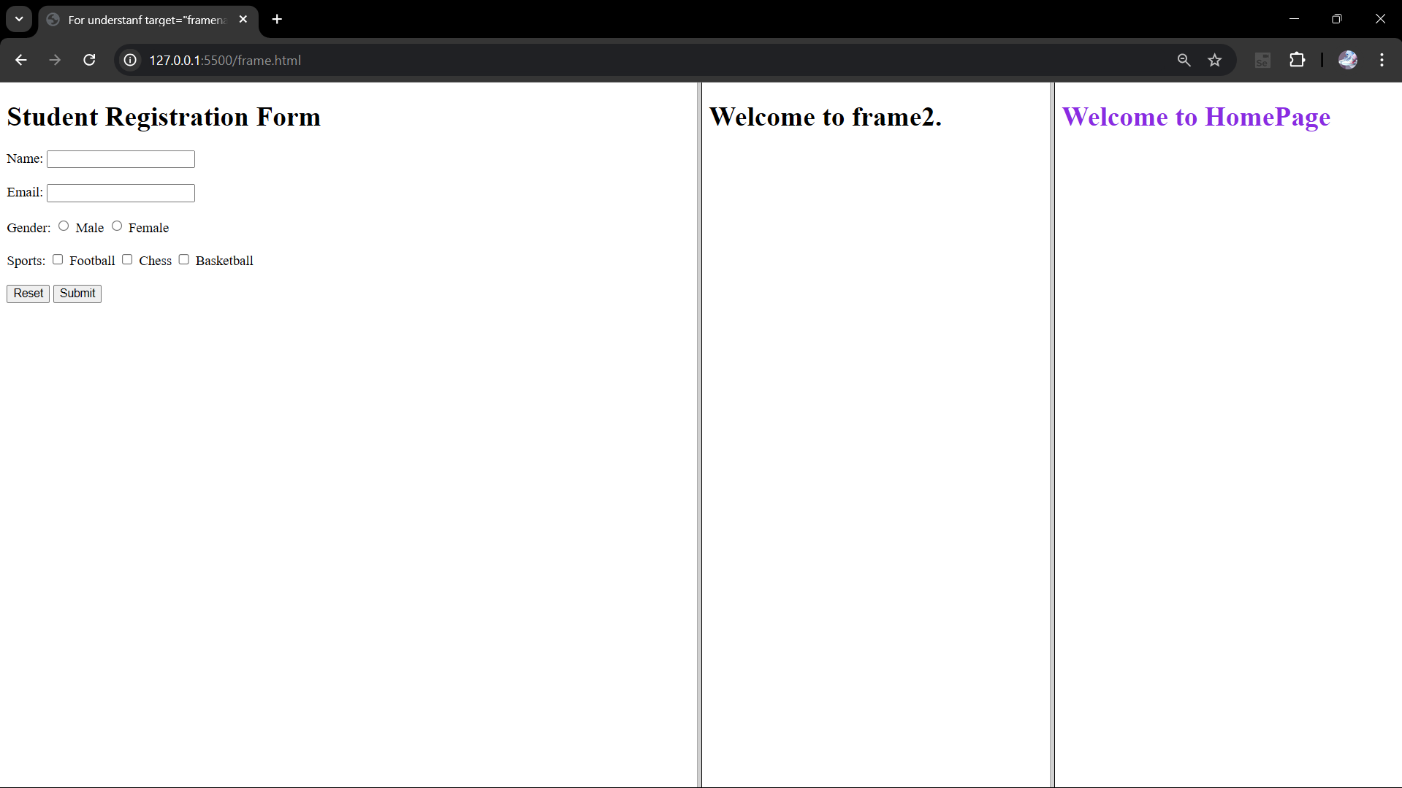

Code:

Frame.html

<!DOCTYPE html>

<html>

    <head>

        <title>For understanf target="framename" </frameset></title>

        <frameset cols="50%, 25%, 25%">

            <!-- <framset> using this tag we can access multiple files into one window  -->

            <frame src="form.html" name="frame1"></frame>

            <frame src="frame2.html" name="frame2"></frame>

            <frame src="frame3.html" name="frame3"></frame>

    </head>

</html>

Frame2.html

<!DOCTYPE html>

<html>

    <head>

        <title>Frame2</title>

    </head>

    <body>

        <h1>Welcome to frame2.</h1>

    </body>

</html>

Frame3.html

<!DOCTYPE html>

<html>

    <head>

        <title>Frame3</title>

    </head>

    <body>

        <h1>Welcome to frame3.</h1>

    </body>

</html>

Form.html

<!DOCTYPE HTML>

<html>

    <head>

        <title>Registration Form</title>

    </head>

    <body>

        <h1>Student Registration Form</h1>

        <form action="/home.html" target="frame3">

            <lable for="name">Name: </lable>

            <input type="text" id="nameInput">

            <br><br>

            <lable for="email">Email: </lable>

            <input type="text" id="emailInput">

            <br><br>

            <lable for="gender">Gender: </lable>

            <input type="radio" id="male" name="gender">

            <lable for="male"> Male</lable>

            <input type="radio" id="female" name="gender">

            <lable for="female"> Female</lable>

            <br><br>

            <label for="sports">Sports: </label>

            <input type="checkbox" id="football" name="sports">

            <label for="football"> Football </label>

            <input type="checkbox" id="chess" name="sports">

            <lable for="chess"> Chess </lable>

            <input type="checkbox" id="basketball" name="sports">

            <label for="basketball"> Basketball </label>

            <br><br>

            <input type="button" id="reset" value="Reset">

            <input type="submit" id="submit">

        </form>

    </body>

</html>

Home.html

<!DOCTYPE html>

<html>

    <head>

        <title>Home</title>

    </head>

    <body>

        <h1 style="color: blueviolet;">Welcome to HomePage</h1>

    </body>

</html>

3) method: specified the HTTP method to be used when submitting the form data.

- HTTP method type:

GET: it appends form data into the URL in form of name/value pair. (default value)

* that’s why it is not use for send sensitive data.
* Limited URL length = 2048 chaaracters
* Use when user wants to bookmark result in submission process and share query parameter
* Good for nonsensitive data.

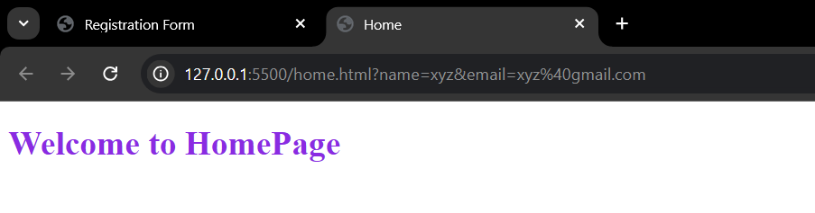

POST: it sends data in form of the body of the HTTP request.

- use when submitting data which modifies server state ex: user registration, form submission.

- Data is not visible into URL that’s why it gives security of data.

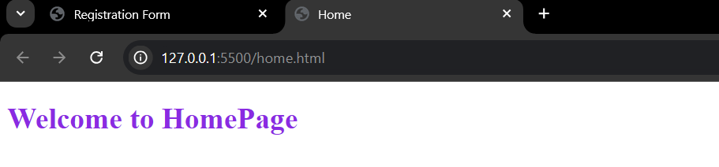

Code:

        <form action="/home.html" target="_black" method="post">

            <lable for="name">Name: </lable>

            <input type="text" id="nameInput" name="name" value="xyz">

            <br><br>

            <lable for="email">Email: </lable>

            <input type="text" id="emailInput" name="email" value="xyz@gmail.com">

4) enctype: it specifies how the form data should be encoded when it submitting to the server.

- It used with POST method type.

- type of it :

1) application/x-www-form-urlencoded (default) : encode data in key-value pairs

2) multipart/data : use to encode form data when it include file like input, it will encode form data into part and each part representing a field.

3) text/plain: in this format whole form data send as plain text.

5) accept-charset: Specifies the character encoding that the server use to interpret the form data.

- useful when server can handle multiple character encoding.

<form action="/home.html" target="_black" method="post" accept-charset="UTF-8">

6) onSubmit: Event handler attribute which execute JavaScript code when form is submitted.

7) onReset: Event handler attribute which execute JavaScript code when form is reset.

8) autocomplete: specifies whether form autocomplete is enable or disable.

- When it is enable it will complete form based on values entered earlier by user.

9) novalidate: (Boolean attribute) specifies that form data should not be validate when it will submit.

10) name: specifies form name.

11) rel: specifies relationship between current form document and linked document.

<form> elements:

1. <input>:

- input type:

Text: single line text input field

Password

Submit

Reset

Button

Radio

Checkbox

Color

Date: (more type: datemax- enter date before date given into “max” and datemin - enter date after date given into “min”)

Datetime-local: we can select time and date together

Email

Image

File

Hidden: data doesnot show to user but it will send to the server when form will be submitted

Month: user can select month and year

Number: take input as numeric values.

Range

Search

Tel: input contains telephone number

Time:

Url

Week: in this we can select week duration from calendar.

**<Input> attributes:**

value: it defines initial value for an input field.

readonly: it specifies that input field is : read-only.

disable: input field should be disabled.

size: specifies visible width of an input field.

maxlength: define how many character allows in an input field.

min & max: specifies minimum and maximum value for an input field.

multiple: it allows use to enter more than one value in an input field.

pattern: define specific input format for an input field.

placeholder: specifies sort hint or give some information related to input format

required: specifies that input field must have some input value before form submitted.

step: specified legel number intervals for an input field like<number> etc.

autofocus: specifies that input field will be automatically focused when form will be open.

height & width: use with<image> input field.

list: it refers <datalist> element.

1. <label>: it defines labels
2. <select>: for defines a drop-down list.

<option> this tag has values which we can select. By default first value is selected

* “selected”: For make any other <option> for bydeafult selected we can make it using : “selected” keyword in that option tag
* “size”: for predefine how many options are visible direct to user.
* “multiple” : this attribute allow user to select more than one option

1. <textarea>
2. <button>
3. <fieldset>: use to group related data.

* <legend> defines caption for <fieldset> element.

1. <datalist>: specified list of pre-defined option for <input> element.

* Note: The list attribute of the <input> element, must refer to the id attribute of the <datalist> element.
* We not able to provide any default value here.

1. <output> : represents result of mathematical calculation.
2. <option> : use with elements like, <select> and<datalist> .
3. <optgroup>: use with elements like <select> for combine some specific common data.

**Input format attributes:**

1) formaction: specifies the URL of the file that will process the input when the form is submitted.

2) formenctype: specifies how the form-data should be encoded of that tag when submitted

3) formmethod: defines the HTTP method for sending form-data to the action URL.

4) formtarget: specifies a name or a keyword that indicates where to display the response that is received after submitting the form.

5) formnovalidate:  specifies that an <input> element should not be validated when submitted.

* Above all mostly work with input fields.

------------------

**Controls’ attribute:**

**id:** Unique identifier for an HTML element within a document.

* It will use for do CSS style and JavaScript code.

**name:** Itspecifies the name of an <input> element.

* It is use to reference element in a JavaScript or reference form data after form submitted.

Ex. In gender selection code in html in both radio button for male and female, name must be same in both input type but id must different.

**class:** specifies class name for an element.

* use for more code in CSS and JS on that element.
* It is global attribute. It can be used with any HTML element.

**value:** it set some default input for an input field.

------------

**<img>:** use to display image into html page

**<meta>:** It defines some information about HTML page.

* It is always inside <head> tag
* Use to specifies: character set, page description, viewport(user’s visible area of a web page) etc.
* in viewport, This gives the browser instructions on how to control the page's dimensions and scaling.
* The “width=device-width “ part sets the width of the page to follow the screen-width of the device
* The “initial-scale=1.0 “part sets the initial zoom level when the page is first loaded by the browser.

**Responsive website:**

It is about creating web pages that look good on all devises.

It will automatically adjust for different screen sizes and viewports.