**CSS**

* It is the language use to style a Web page.
* CSS: Cascading Style Sheets

**Why use CSS?**

* HTML never contains tags for formatting a web page, for solve this problem we include CSS in HTML web pages.

**Three ways to insert CSS:**

* External CSS
* Internal CSS
* Inline CSS

**Priority of follow inserted CSS code:** (use when more than one style code written for same HTML element):

**Inline CSS > External & Internal CSS > Browser default**

**CSS Syntax:**

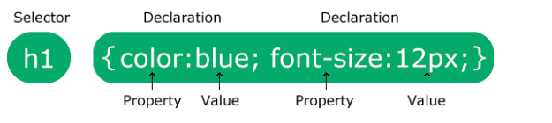

* selector: point to HTML element
* declaration: contains one or more CSS declaration separated by semicolons, which include CSS property name: it’s value.

**CSS Selector:**

[**https://www.w3schools.com/cssref/css_selectors.php**](https://www.w3schools.com/cssref/css_selectors.php)

**CSS color:**

* for background color = background-color: (value of color);
* for font color = color: (value of color);
* for border style = border: (size in px for make it responsive) (width type) (color value);
* color type:
  + - rgb(red color range, green color range, blue color range)
    - **#**(color code)
    - rgba
    - hsla
    - hsl

**CSS margin:**

* margin-left
* margin-right
* margin-top
* margin-bottom
* margin: top bottom right left

**CSS padding:**

* CSS padding is a property used to add space between an element’s content and its border.
* Padding: top, right, bottom, left
* Padding-left
* Padding-right
* Padding-top
* Padding-bottom

**box-shadow:**

**.box {**

**box-shadow: 2px 3px 2px rgba(0, 0, 34, 0.3);**

**}**

Horizontal offset: 2px

Vertical offset: 3px

Blur radius: 2px

Color: rgba(0, 0, 34, 0.3)

**Media Queries:**

* @media rule: it specifies the different style rule for different media type.
* **Media type:**

**Value Description**

all: Used for all media type devices

print: Used for print preview mode

screen: Used for computer screens, tablets, smart-phones etc.

* **Media features:**

**Value Description**

orientation: Orientation of the viewport. Landscape or portrait

max-height: Maximum height of the viewport

min-height: Minimum height of the viewport

height: Height of the viewport (including scrollbar)

max-width: Maximum width of the viewport

min-width: Minimum width of the viewport

width: Width of the viewport (including scrollbar)

* Meaning of the **not**, **only,** and **and** keywords:

**not:** This keyword inverts the meaning of an entire media query.

**only:** This keyword prevents older browsers that do not support media queries from applying the specified styles. **It has no effect on modern browsers.**

**and:** This keyword combines a media type and one or more media features.