CSS
- It is the language use to style a Web page.
- CSS: Cascading Style Sheets
Why use CSS?
- HTML never contains tags for formatting a web page, for solve this problem we include CSS in HTML web pages.
Three ways to insert CSS:
- External CSS
- Internal CSS
- Inline CSS
Priority of follow inserted CSS code: (use when more than one style code written for same HTML element):
Inline CSS > External & Internal CSS > Browser default
CSS Syntax:
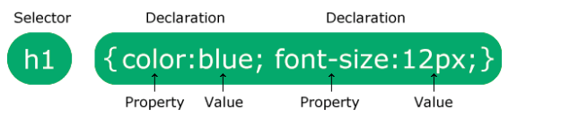
- selector: point to HTML element
- declaration: contains one or more CSS declaration separated by semicolons, which include CSS property name: it’s value.
CSS Selector:
https://www.w3schools.com/cssref/css_selectors.php
CSS color:
- for background color = background-color: (value of color);
- for font color = color: (value of color);
- for border style = border: (size in px for make it responsive) (width type) (color value);
- color type:
    - rgb(red color range, green color range, blue color range)
    - #(color code)
    - rgba
    - hsla
    - hsl
CSS margin:
- margin-left
- margin-right
- margin-top
- margin-bottom
- margin: top bottom right left

CSS padding:
- CSS padding is a property used to add space between an element’s content and its border.
- Padding: top, right, bottom, left
- Padding-left
- Padding-right
- Padding-top
- Padding-bottom
box-shadow:
.box {
box-shadow: 2px 3px 2px rgba(0, 0, 34, 0.3);
}
Horizontal offset: 2px
Vertical offset: 3px
Blur radius: 2px
Color: rgba(0, 0, 34, 0.3)
Media Queries:
- @media rule: it specifies the different style rule for different media type.

- Media type:
Value Description
all: Used for all media type devices
print: Used for print preview mode
screen: Used for computer screens, tablets, smart-phones etc.

- Media features:
Value Description
orientation: Orientation of the viewport. Landscape or portrait
max-height: Maximum height of the viewport
min-height: Minimum height of the viewport
height: Height of the viewport (including scrollbar)
max-width: Maximum width of the viewport
min-width: Minimum width of the viewport
width: Width of the viewport (including scrollbar)

- Meaning of the not, only, and and keywords:
not: This keyword inverts the meaning of an entire media query.
only: This keyword prevents older browsers that do not support media queries from applying the specified styles. It has no effect on modern browsers.
and: This keyword combines a media type and one or more media features.

