JavaScript
Basics:
- console.log(“<contact>”) : print contact into terminal part
- file extension: .js
- use in both backend and frontend part
- Node.js provides env for JS
- const: use to declare constant variable
- var: use to declare global variable
  - if create variable using var in outside of function then you can also use it inside the function.
  - If create variable using var inside the function then scope of that variable is within that function.
- let: use to declare local variable. Improved version of var keyword. Variable can’t access outside of the block.

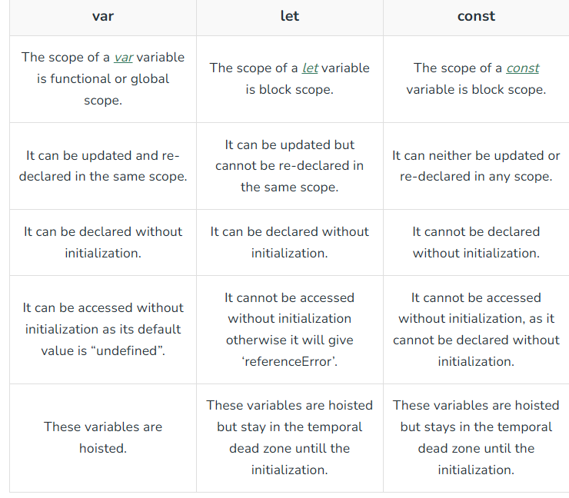

- console.table([<attribute values]): Print data into table format on terminal.
- * not use “var” for declare variable bcz of issue into black scope and functional scope.
- Undefined: default value of variable declares using let.

- “use strict” : write in starting of code after this code will be treated as newer version of JS

