ASSIGNMENT – 3

--create table Department

Create table Department(

dept_id int primary key identity(101,1),

dept_name varchar(50) not null

)

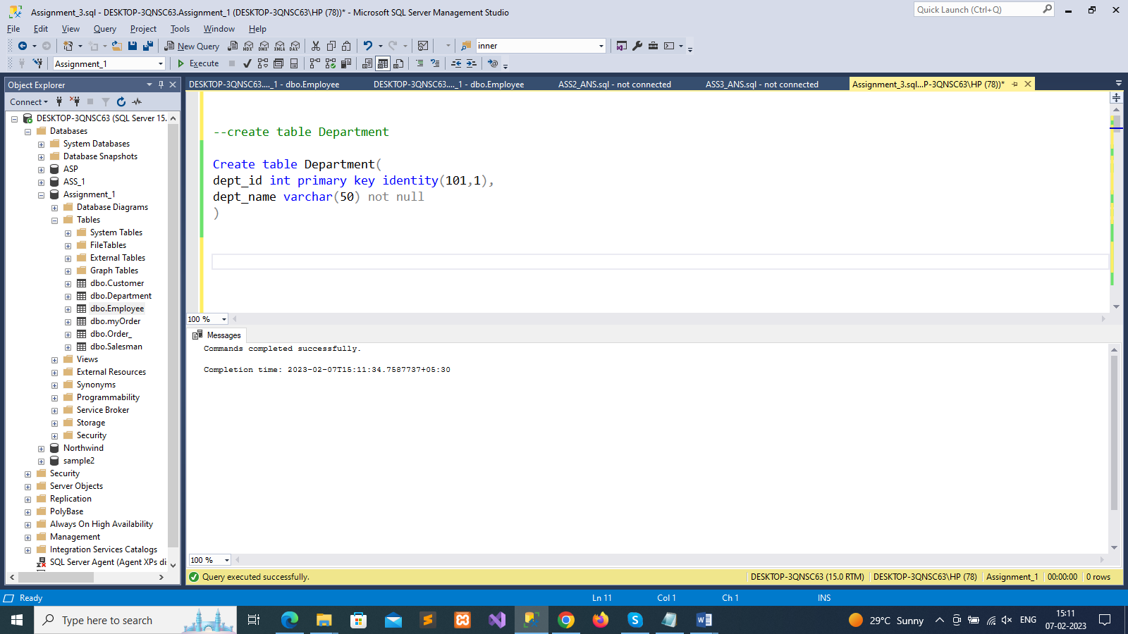

--create table Employee

Create table Employee(

emp_id int primary key identity(1001,1),

dept_id int,

mngr_id int,

emp_name varchar(100) not null,

salary decimal(10,2) not null

)

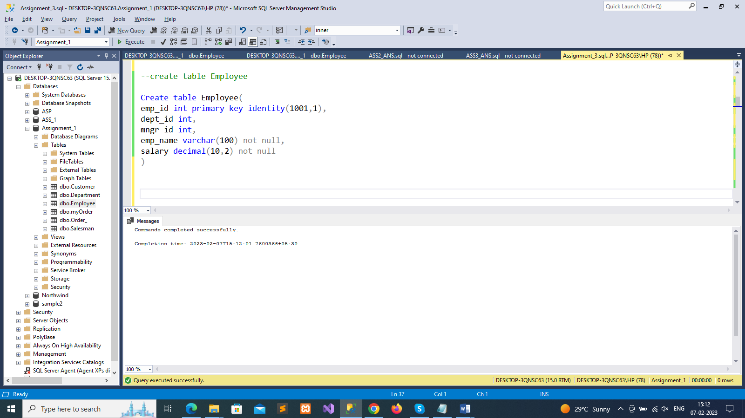

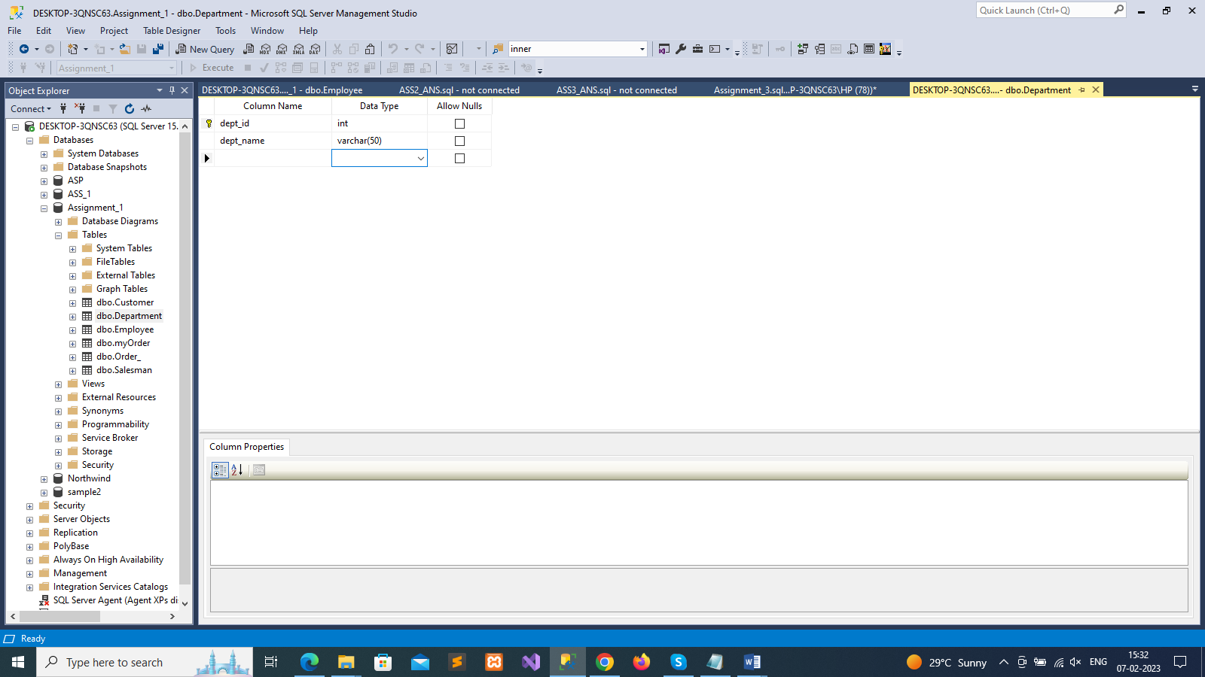

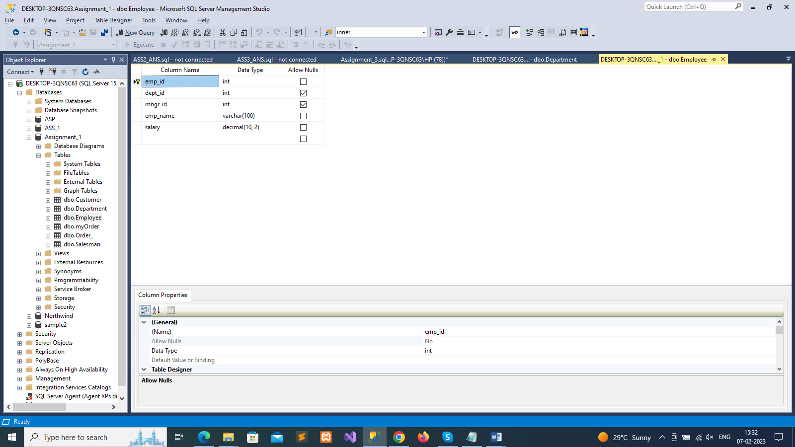

--insert data into Department Table

insert into Department values('HR'),('QA'),('Frontend'),('Backend'),('R & D')

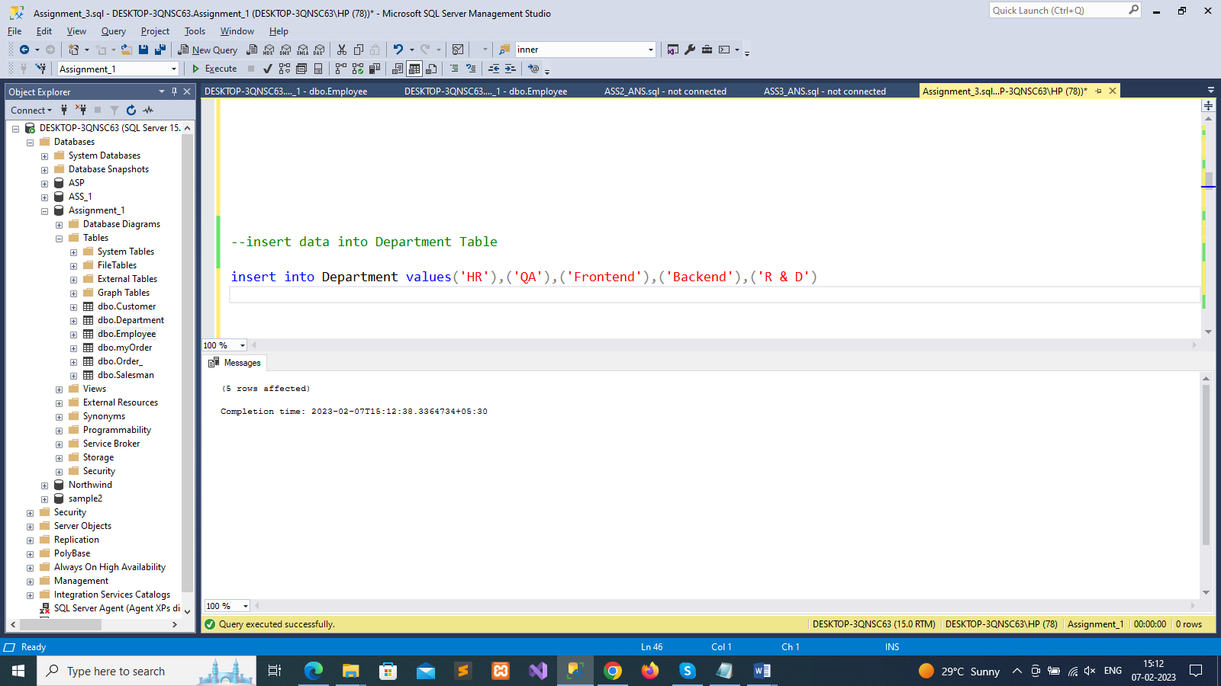

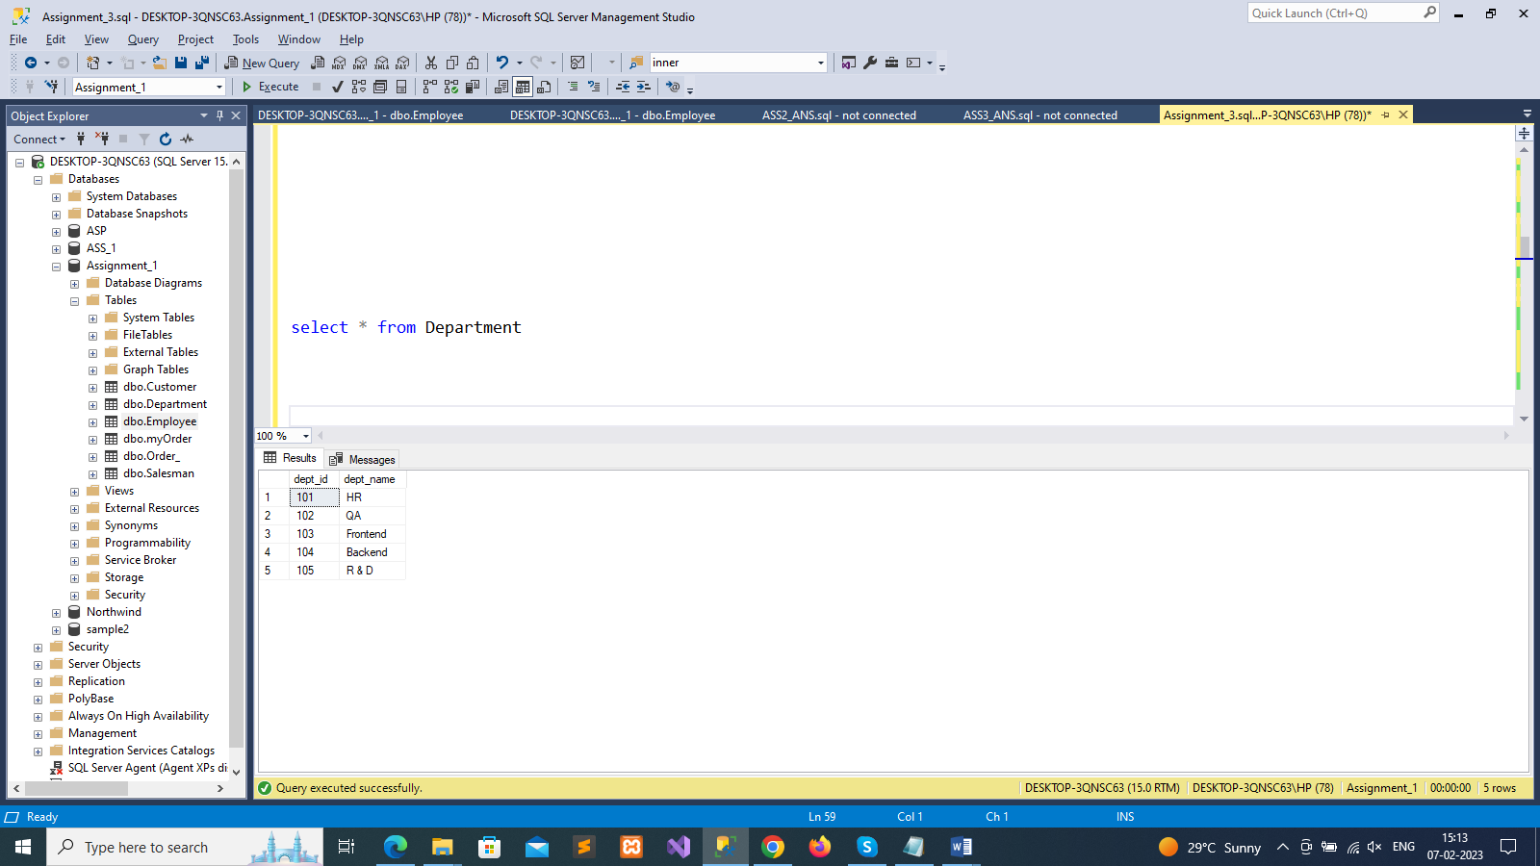

--insert data into employee Table

insert into Employee values(101,10001,'Henil Shah',30000),

(104,10004,'Jaimi Shah',50000),

(103,10004,'Sahil Pithadiya',70000),

(102,10005,'Janvi Patel',80000),

(104,10002,'Hely Patel',50000),

(104,10004,'Shrusti Deshmukh',100000),

(102,10002,'Jiyansh Patel',90000)

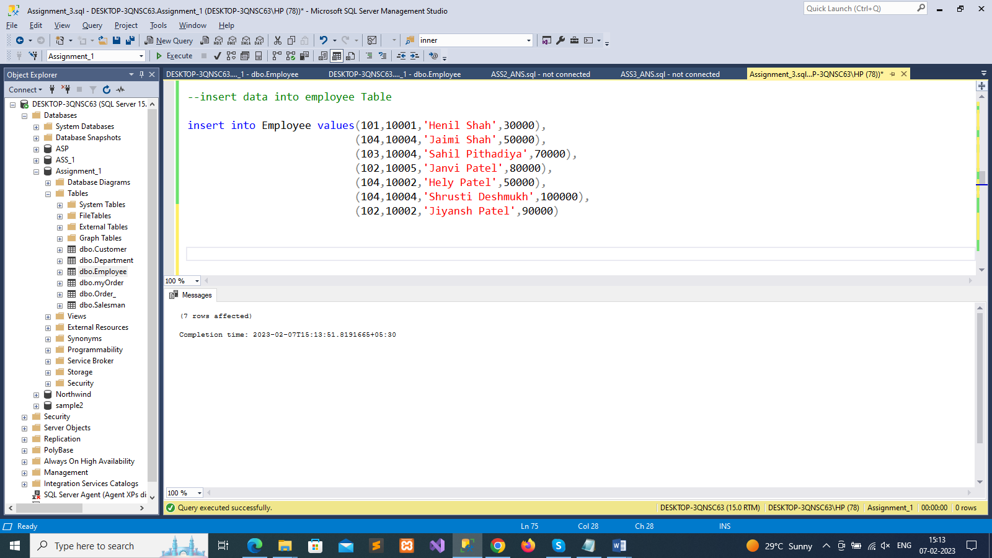

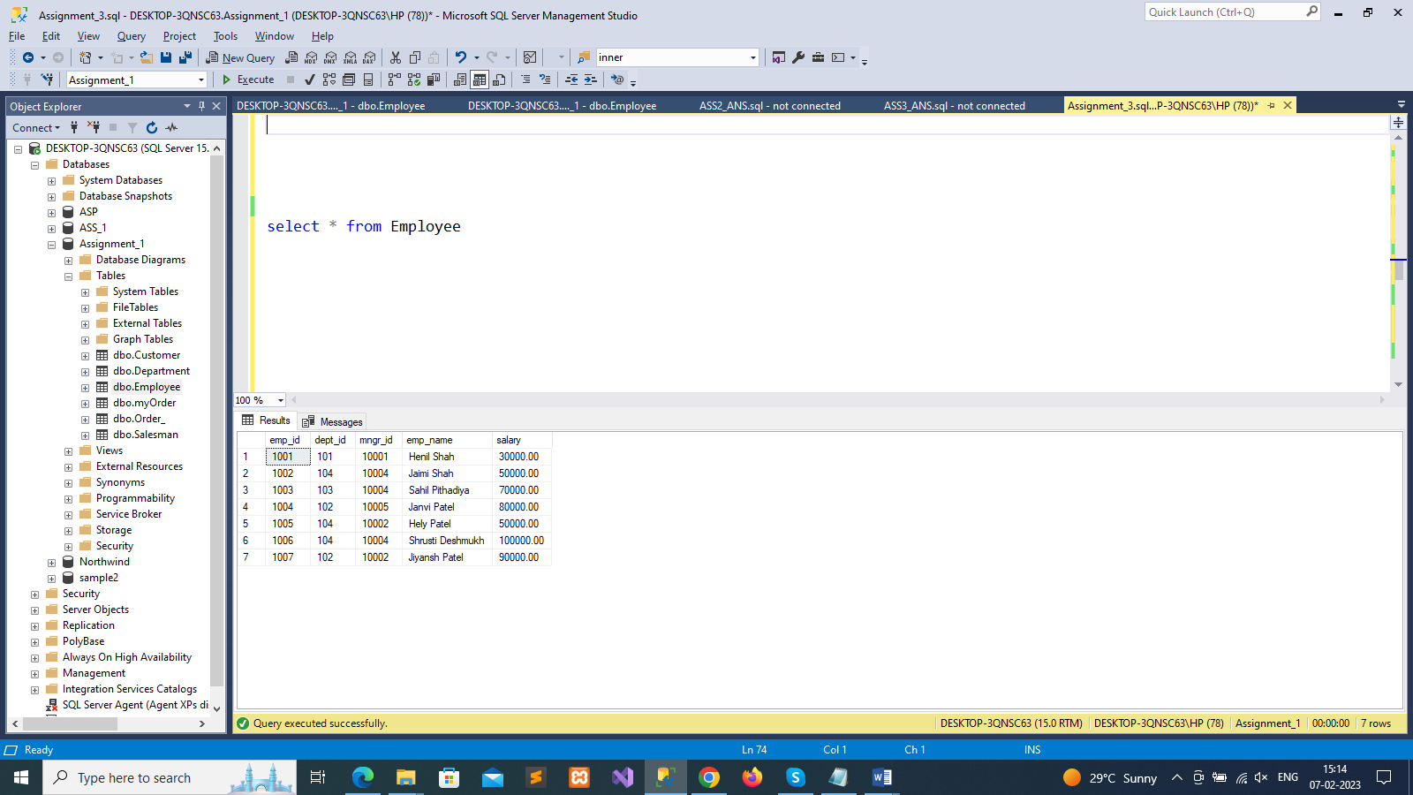

--1. write a SQL query to find Employees who have the biggest salary in their Department

select d.dept_name, e.emp_name,salary

from Department d

join Employee e on e.dept_id=d.dept_id

where salary in(

select Max(salary)

from Employee

group by dept_id

)

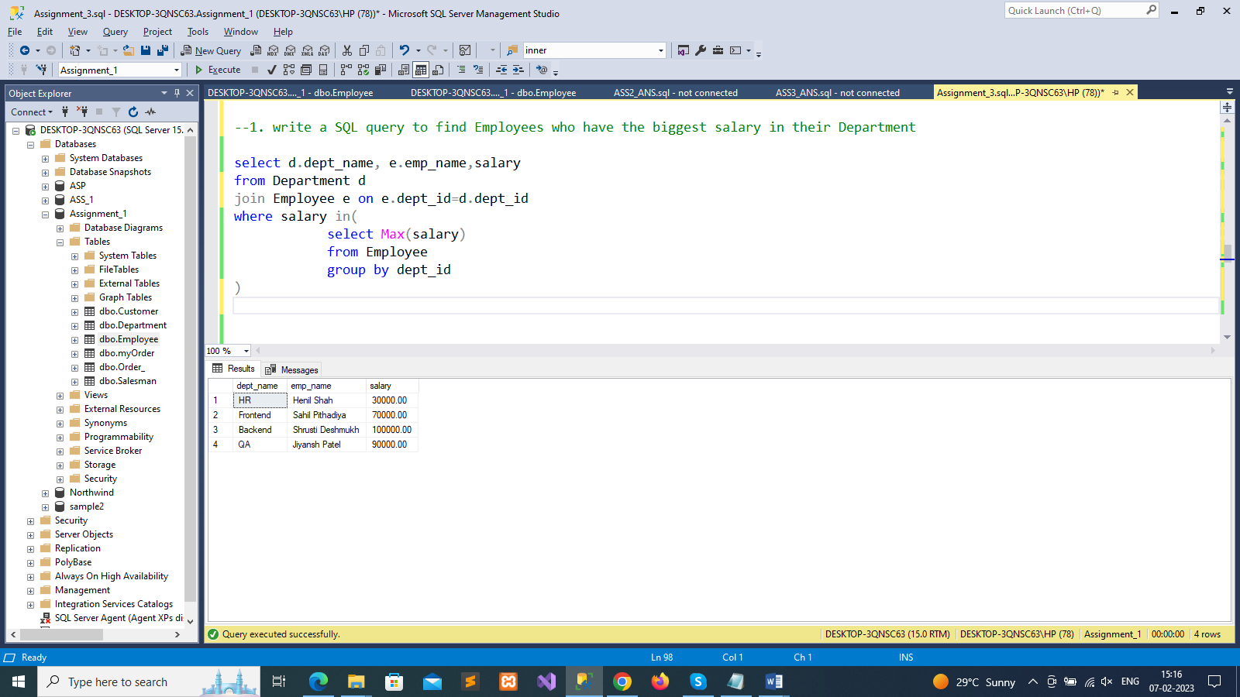

--2. write a SQL query to find Departments that have less than 3 people in it

select d.dept_name,count(e.dept_id) as Less_Than_Three_People

from Department d left join Employee e on e.dept_id=d.dept_id

Group by e.dept_id,d.dept_name

having count(e.dept_id)<3

order by Less_Than_Three_People

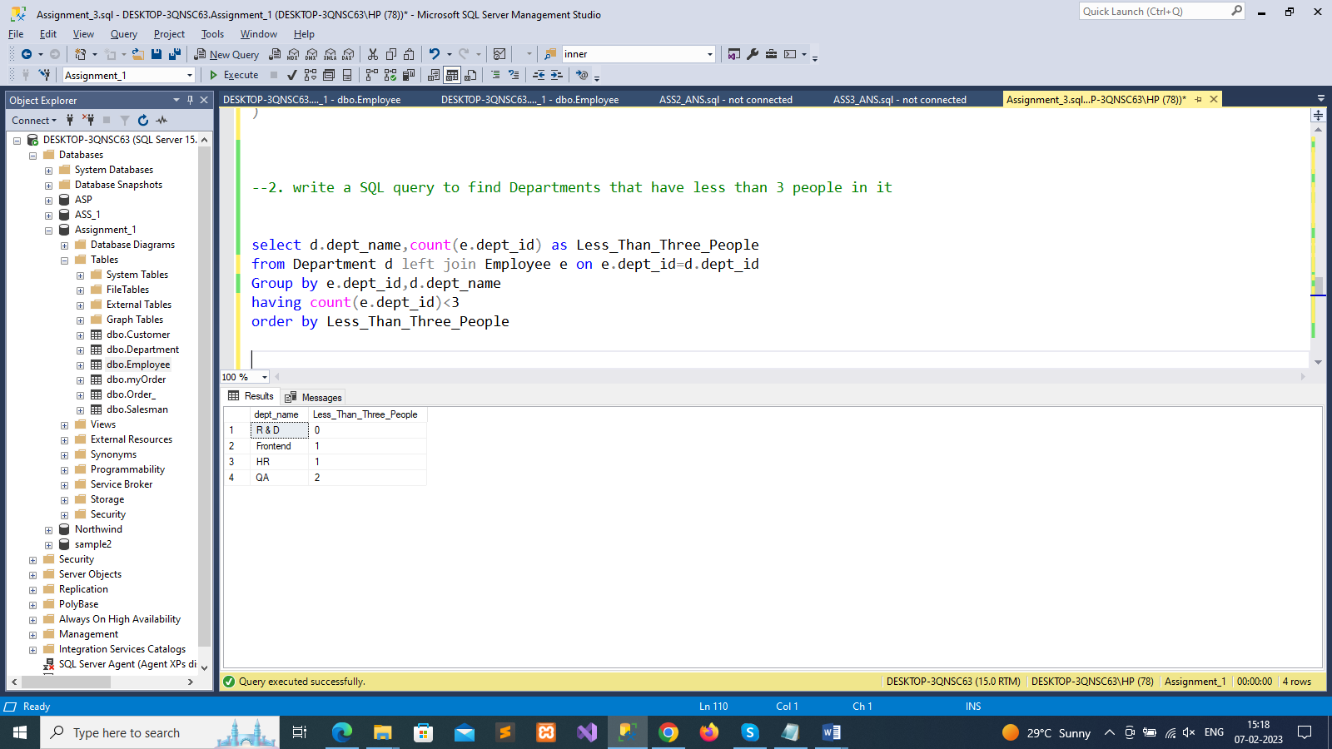

--3. write a SQL query to find All Department along with the number of people there

SELECT d.dept_name, count(e.dept_id) as total_number_of_people

FROM Department d left join Employee e on e.dept_id=d.dept_id

GROUP BY e.dept_id,d.dept_name

order by total_number_of_people

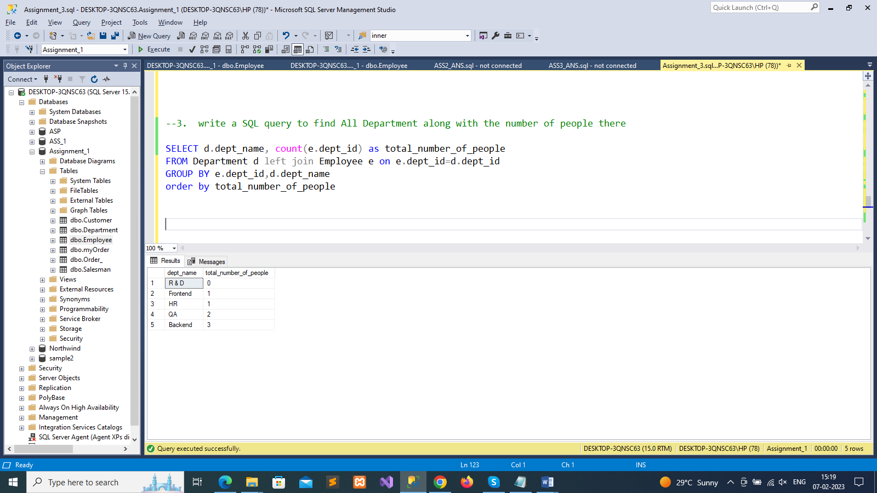

--4. write a SQL query to find All Department along with the total salary there

SELECT d.dept_name, SUM(e.salary) as Total_Salary

FROM Department d left join Employee e on e.dept_id=d.dept_id

GROUP BY d.dept_name

order by Total_Salary

