ASSIGNMENT – 4

--1. Create a stored procedure in the Northwind database that will calculate the average value of Freight for a specified customer.Then, a business rule will be added that will be triggered before every Update and Insert command in the Orders controller,and will use the stored procedure to verify that the Freight does not exceed the average freight. If it does, a message will be displayed and the command will be cancelled.

create procedure spValidateFreight

-- inputted customer

@CustomerID nvarchar(5),

-- returned average freight

@AverageFreight money output

as

begin

select @AverageFreight = AVG(Freight)

from Orders

where CustomerID = @CustomerID

end

Declare @AvgFreight int;

execute spValidateFreight VINET, @AvgFreight output;

Print @AvgFreight

Create trigger trVerifyFreightForInsert

on Orders

Instead of insert

as

begin

Declare @AvgFreightOfOrders money

Declare @CustID nchar(5)

Declare @Freight money

Select @CustId=CustomerID from inserted

Select @Freight=Freight from inserted

-- execute stored procedure

exec spValidateFreight @CustID,

@AverageFreight = @AvgFreightOfOrders output

-- check the freight

if @AvgFreightOfOrders is not null

and @AvgFreightOfOrders < @Freight

begin

Raiserror('Invalid data as Freight value exceeds the average freight value',16,1)

return

end

end

Create trigger trVerifyFreightUpdate

on Orders

Instead of update

as

begin

Declare @AvgFreightOfOrders money

Declare @CustID nchar(5)

Declare @Freight money

Select @CustId=CustomerID from inserted

Select @Freight=Freight from inserted

-- execute stored procedure

exec spValidateFreight @CustID,

@AverageFreight = @AvgFreightOfOrders output

-- check the freight

if @AvgFreightOfOrders is not null

and @AvgFreightOfOrders < @Freight

begin

Raiserror('Invalid data as Freight value exceeds the average freight value',16,1)

return

end

end

Insert into Orders values('VINET',null,null,null,null,null,10,null,null,null,null,null,null);

Insert into Orders values('VINET',null,null,null,null,null,26,null,null,null,null,null,null);

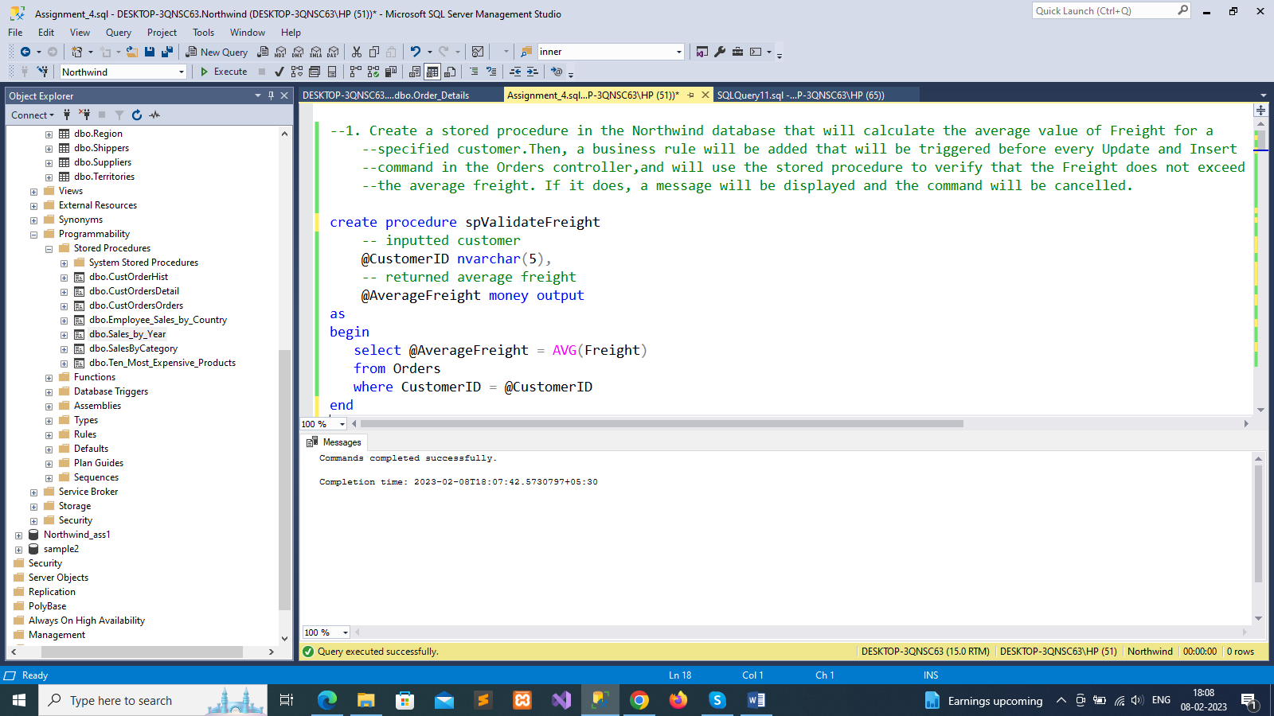

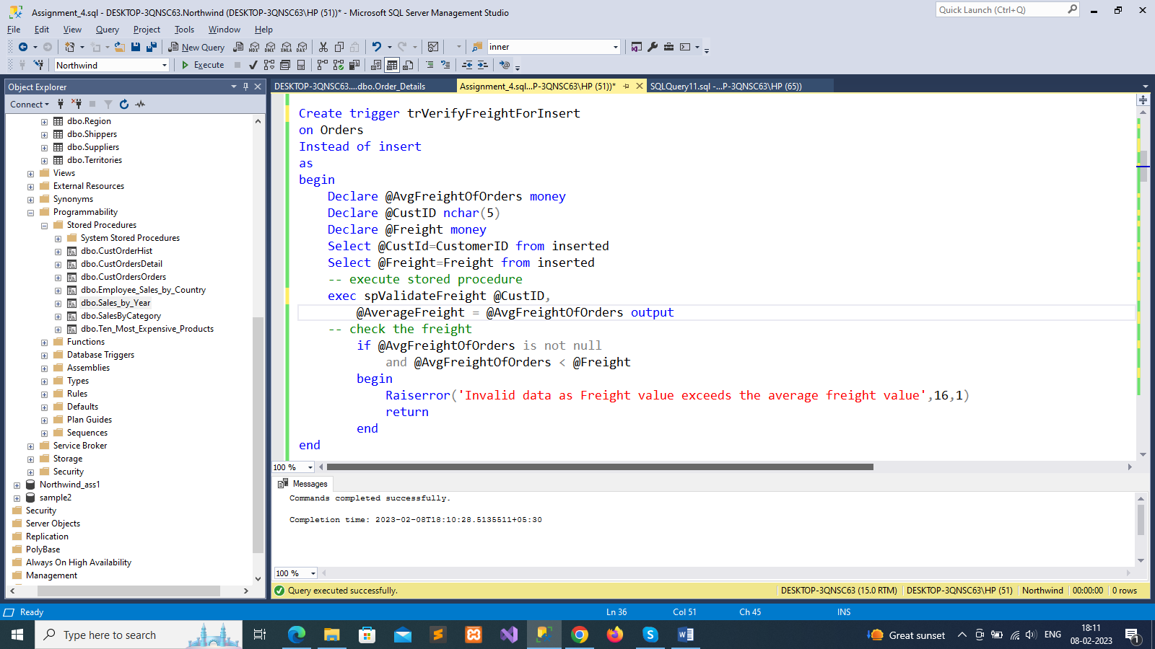

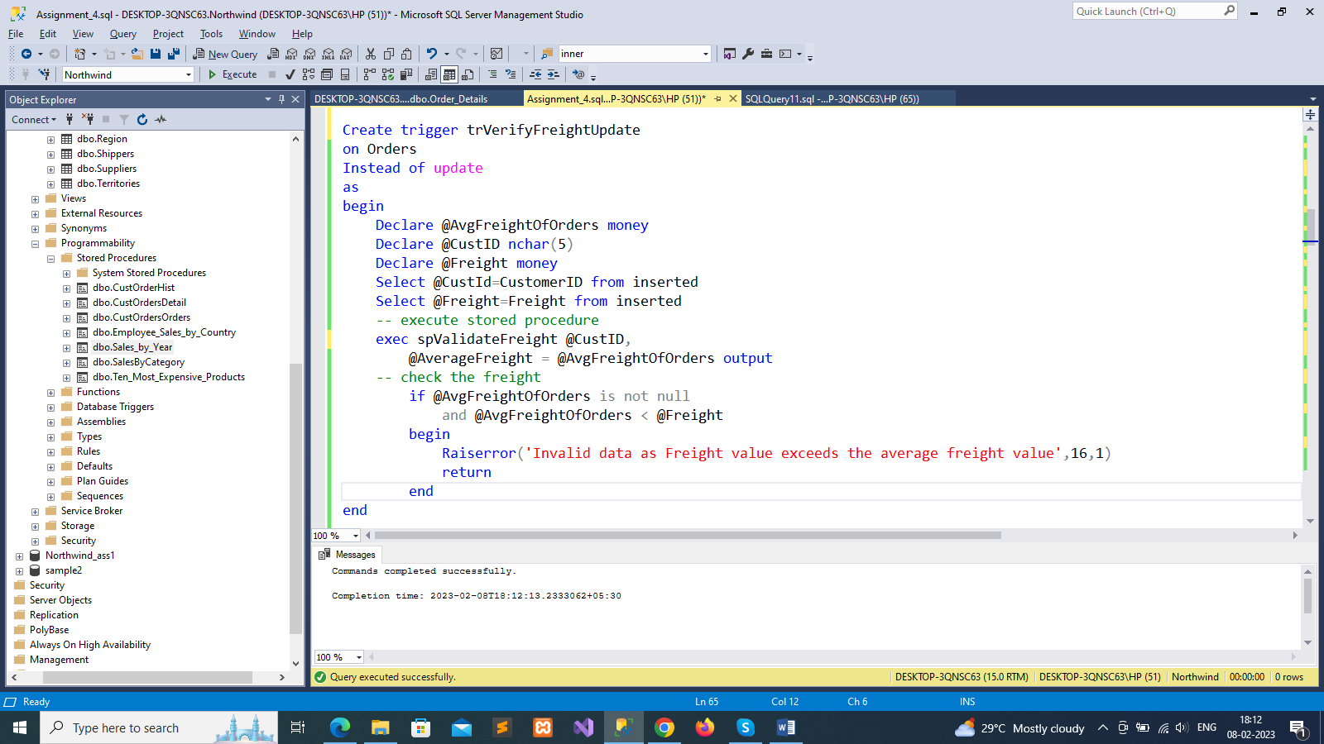

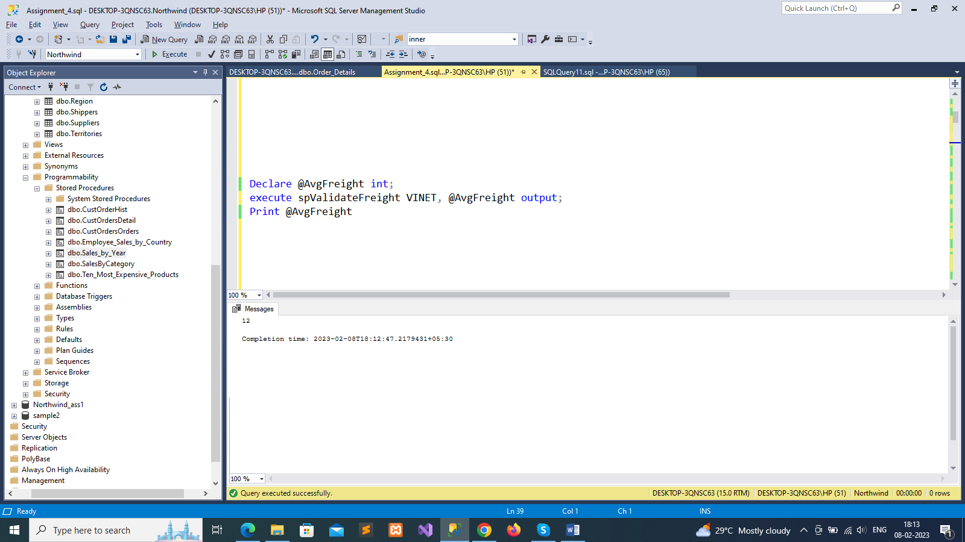

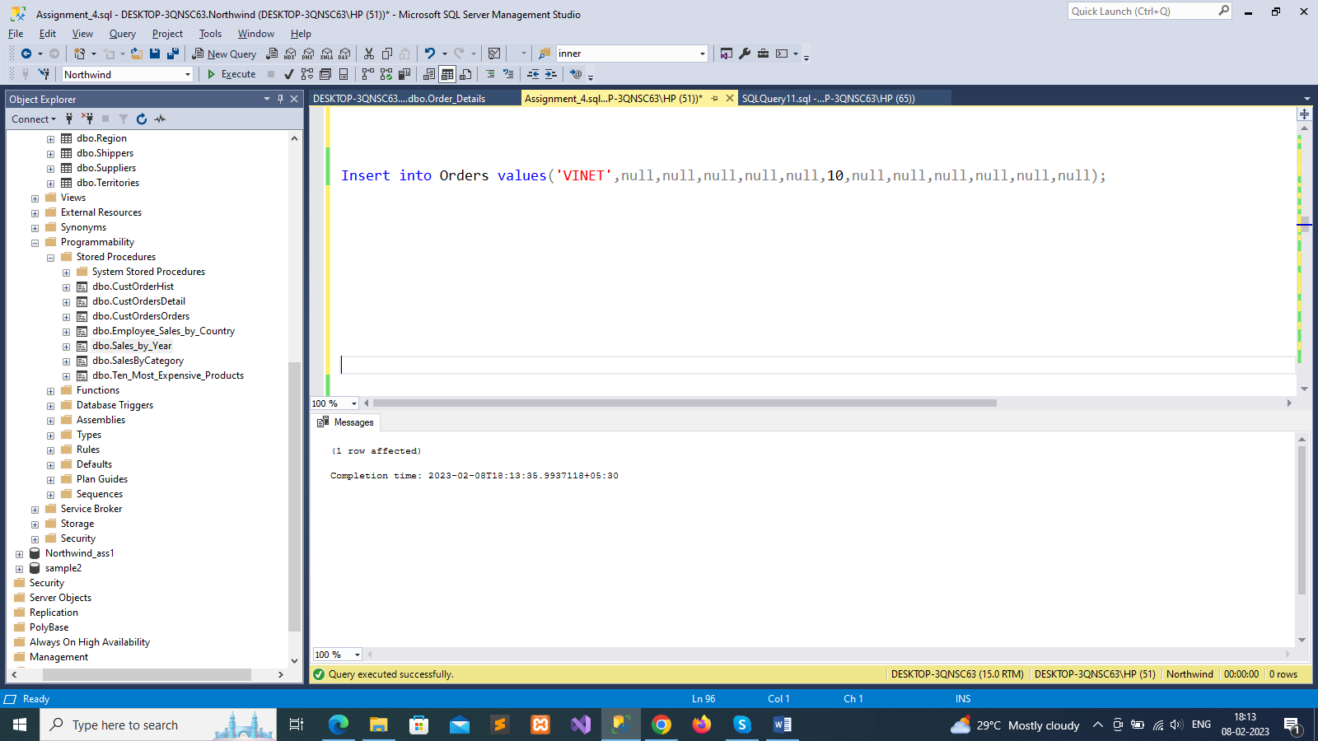

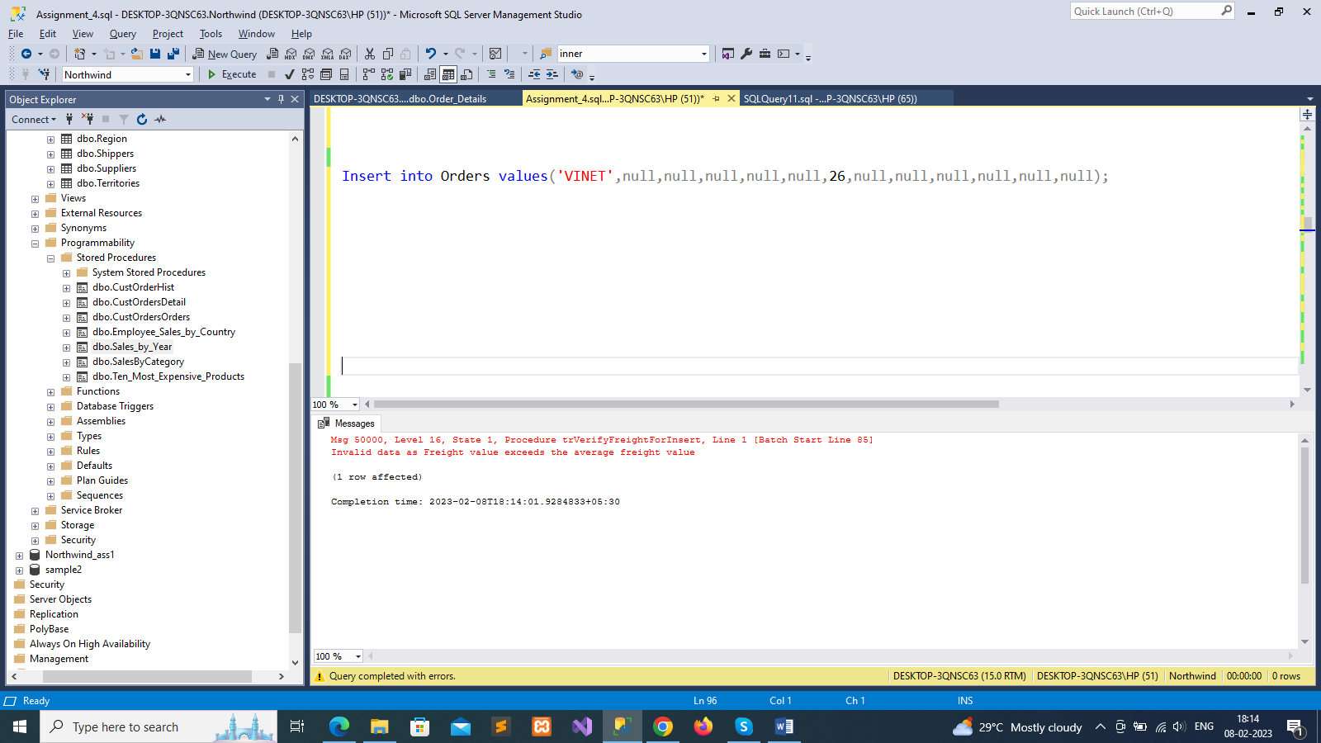

--2. write a SQL query to Create Stored procedure in the Northwind database to retrieve Employee Sales by Country

create procedure spQue_2

(

@Beginning_Date Date,

@Ending_Date Date

)

as

begin

select Employees.Country, Employees.FirstName,Employees.LastName, Orders.ShippedDate, Orders.OrderID, "Order Subtotals".Subtotal AS SaleAmount

from Employees

inner join Orders on Employees.EmployeeID = Orders.EmployeeID

inner join "Order Subtotals" on Orders.OrderID = "Order Subtotals".OrderID

where Orders.ShippedDate Between @Beginning_Date And @Ending_Date

end

exec [spQue_2] @Beginning_Date='1996-01-01', @Ending_Date='1996-08-01'

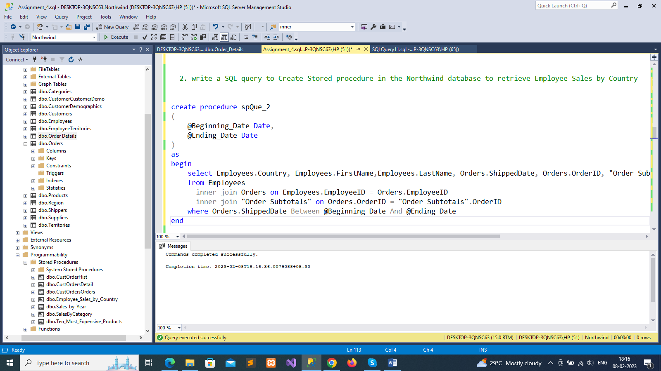

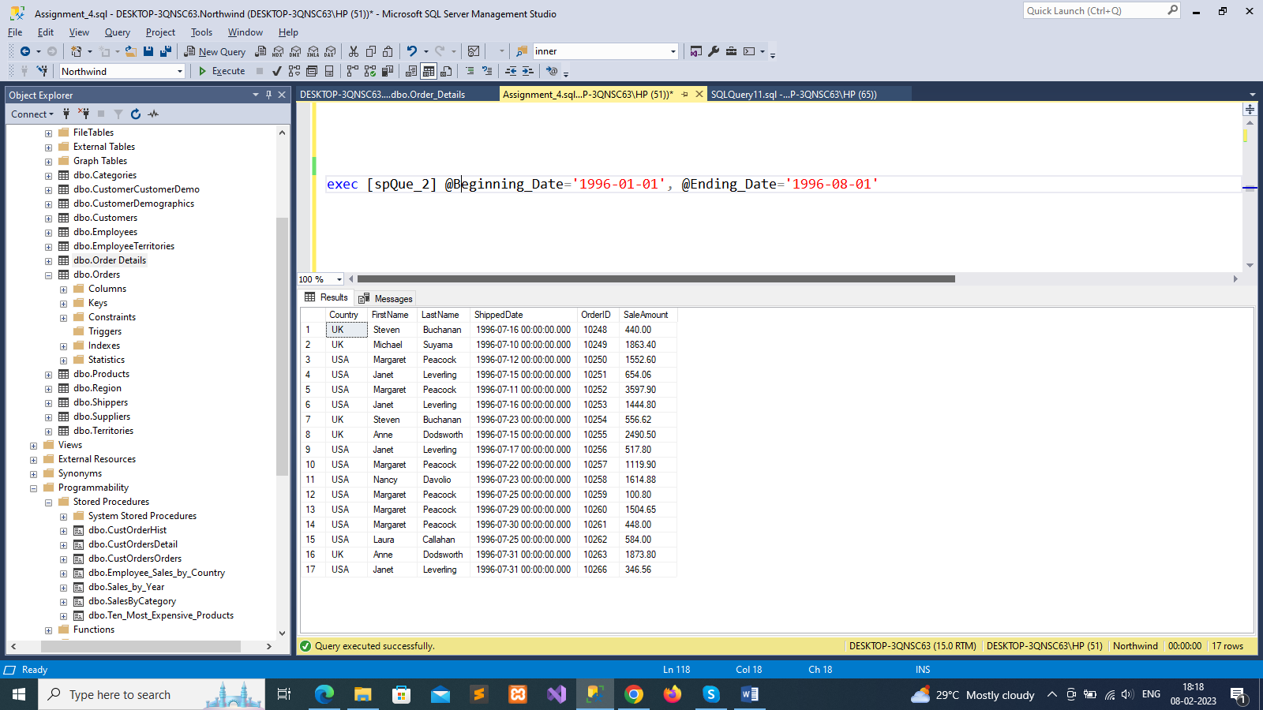

--3. write a SQL query to Create Stored procedure in the Northwind database to retrieve Sales by Year

create procedure spQue_3

(

@Beginning_Date Date,

@Ending_Date Date

)

as

begin

select Orders.ShippedDate, Orders.OrderID, "Order Subtotals".Subtotal, DATENAME(yy,ShippedDate) AS Year

from Orders

inner join "Order Subtotals" ON Orders.OrderID = "Order Subtotals".OrderID

where Orders.ShippedDate Between @Beginning_Date And @Ending_Date

end

exec [spQue_3] @Beginning_Date='1996-01-01', @Ending_Date='1996-08-01'

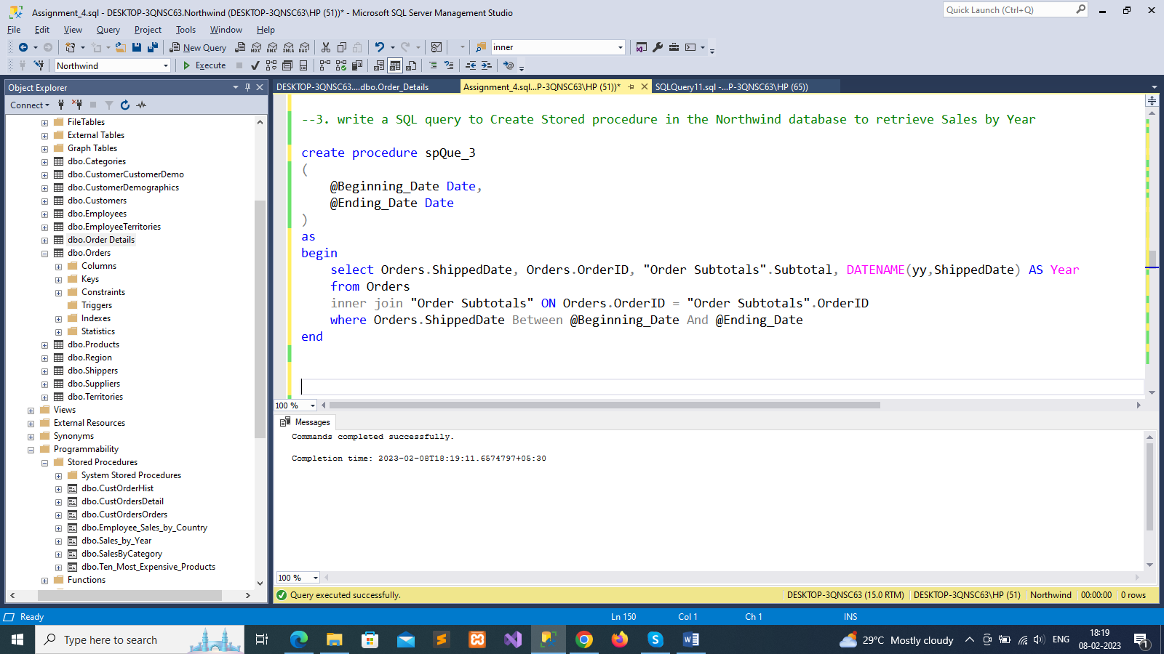

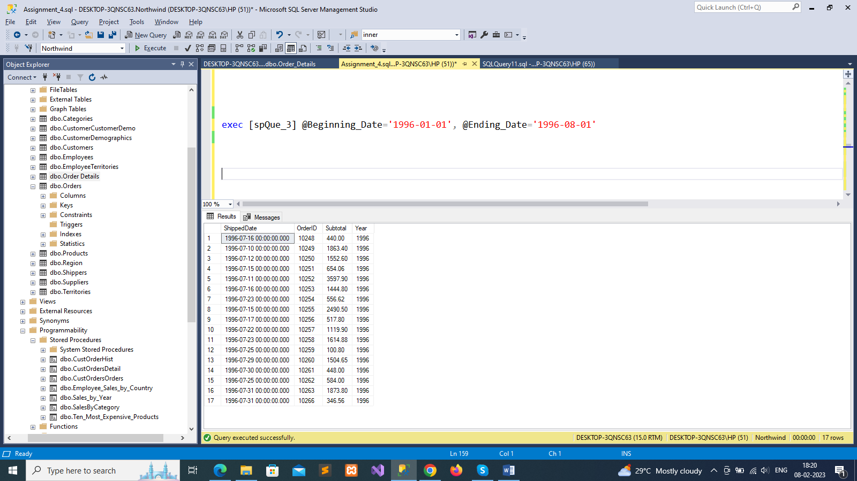

--4. write a SQL query to Create Stored procedure in the Northwind database to retrieve Sales By Category

create procedure spQue_4

(

@CategoryName nvarchar(15),

@OrdYear nvarchar(4) = '1998'

)

as

begin

if @OrdYear != '1996' AND @OrdYear != '1997' AND @OrdYear != '1998'

begin

select @OrdYear = '1998'

end

select ProductName,TotalPurchase=round(sum(convert(decimal(14,2), OD.Quantity * (1-OD.Discount) * OD.UnitPrice)), 0)

from [Order Details] OD, Orders O, Products P, Categories C

where OD.OrderID = O.OrderID

and OD.ProductID = P.ProductID

and P.CategoryID = C.CategoryID

and C.CategoryName = @CategoryName

and substring(convert(nvarchar(22), O.OrderDate, 111), 1, 4) = @OrdYear

group by ProductName

order by ProductName

end

exec [spQue_4] @CategoryName='Produce', @OrdYear=1996

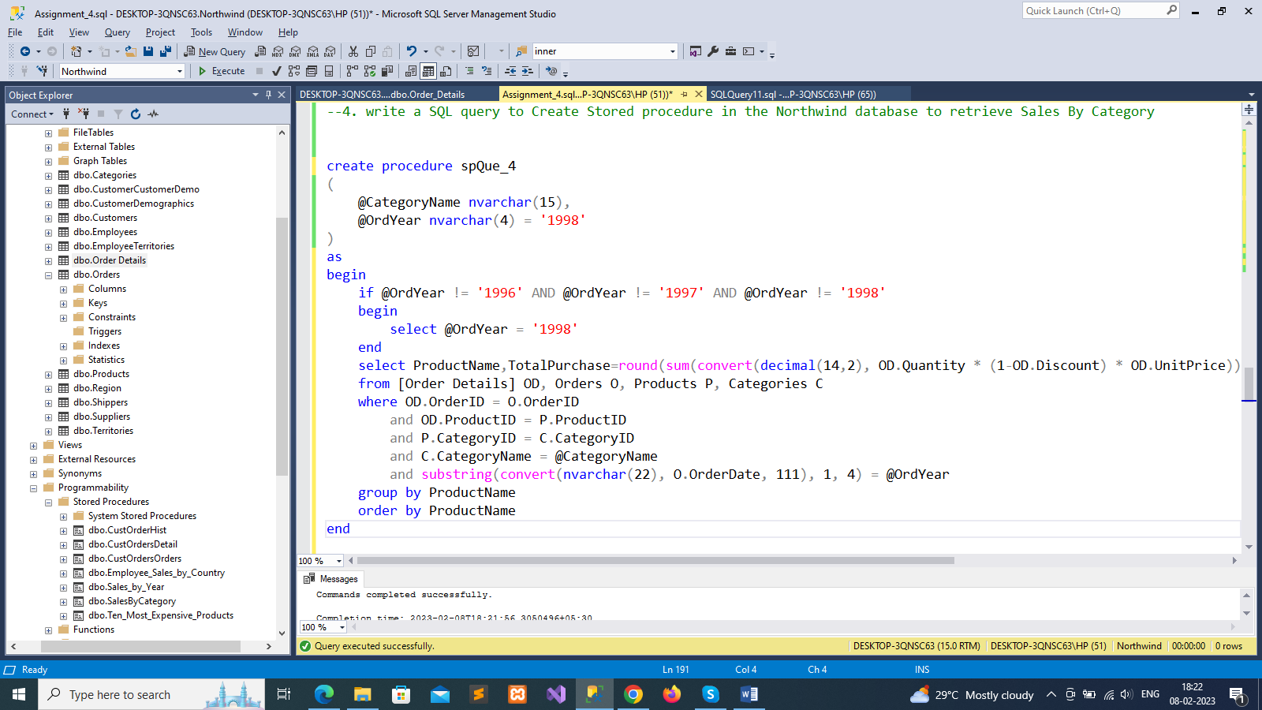

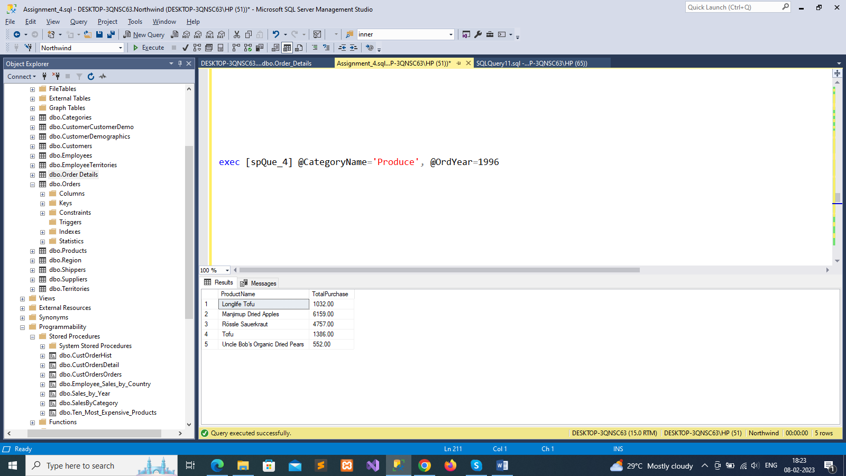

--5. write a SQL query to Create Stored procedure in the Northwind database to retrieve Ten Most Expensive Products

create procedure spQue_5

as

begin

set rowcount 10

select Products.ProductName as Ten_Most_Expensive_Products, Products.UnitPrice

from Products

order by Products.UnitPrice desc

end

exec [Ten_Most_Expensive_Products]

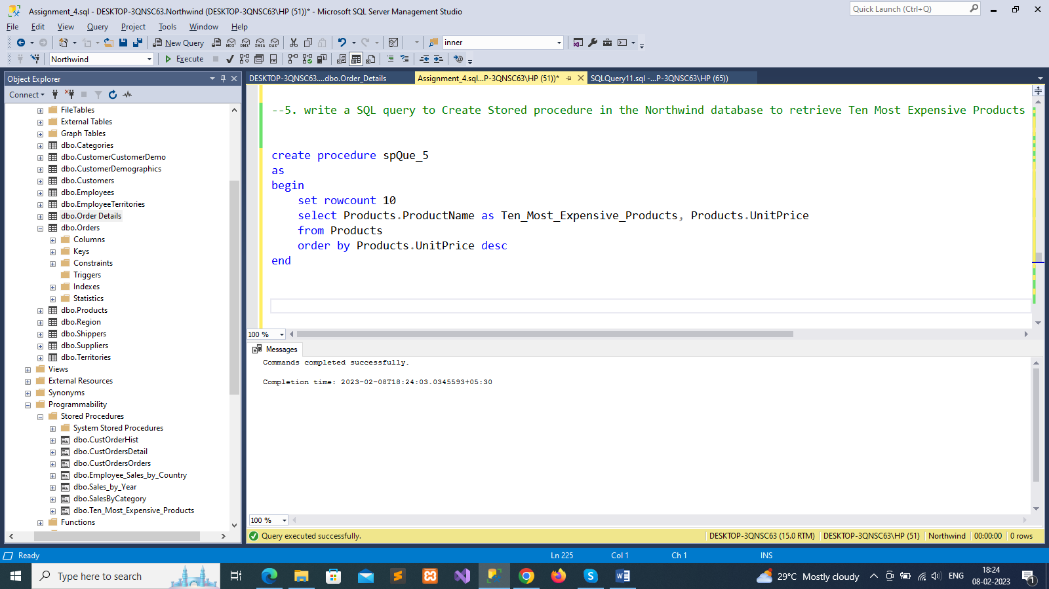

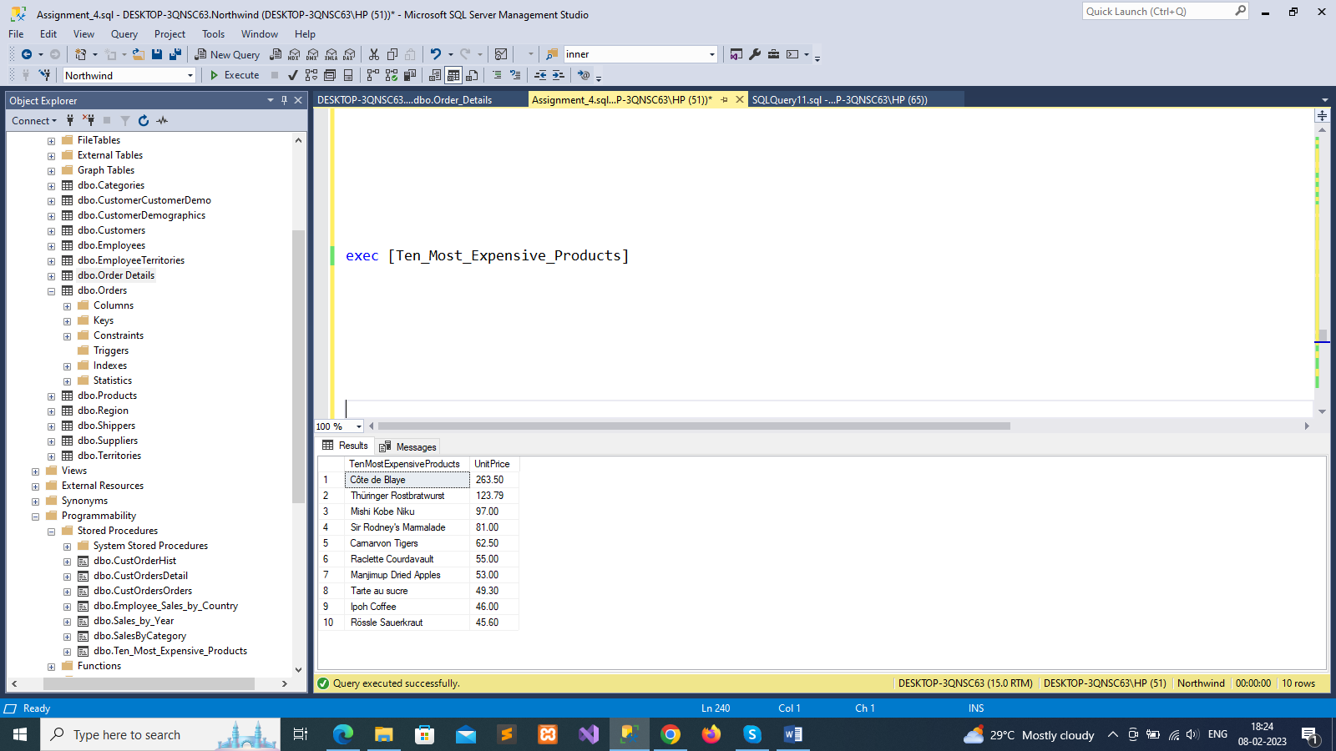

--6. write a SQL query to Create Stored procedure in the Northwind database to insert Customer Order Details

create or alter procedure spQue_6

(

@OrderID int,

@ProductID int,

@UnitPrice money,

@Quantity smallint,

@Discount real

)

as

begin

insert into Order_Details values(@OrderID, @ProductID, @UnitPrice, @Quantity, @Discount)

end

exec spQue_6 @OrderID=11076, @ProductID=02, @UnitPrice=10, @Quantity=1,@Discount=0.03

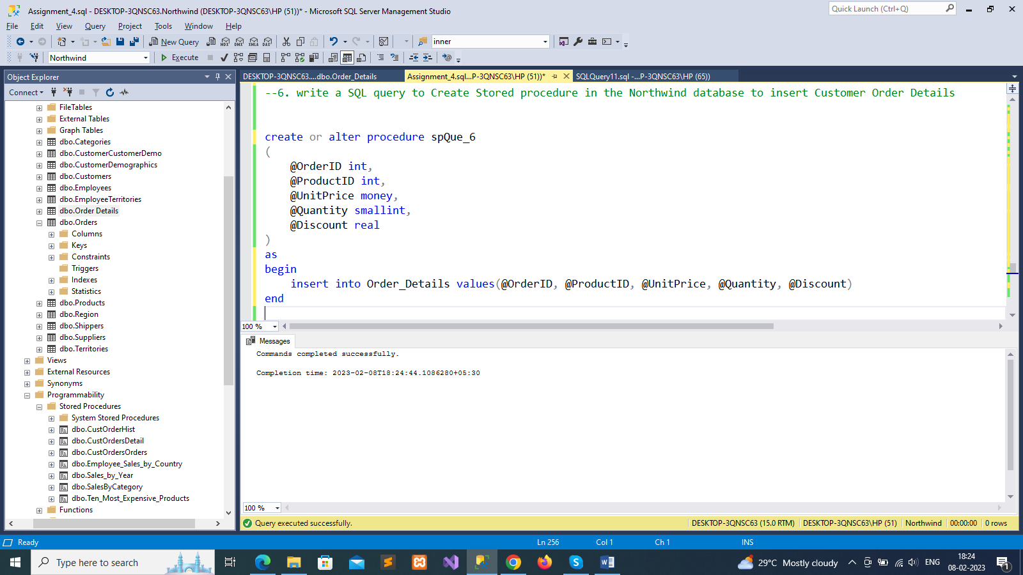

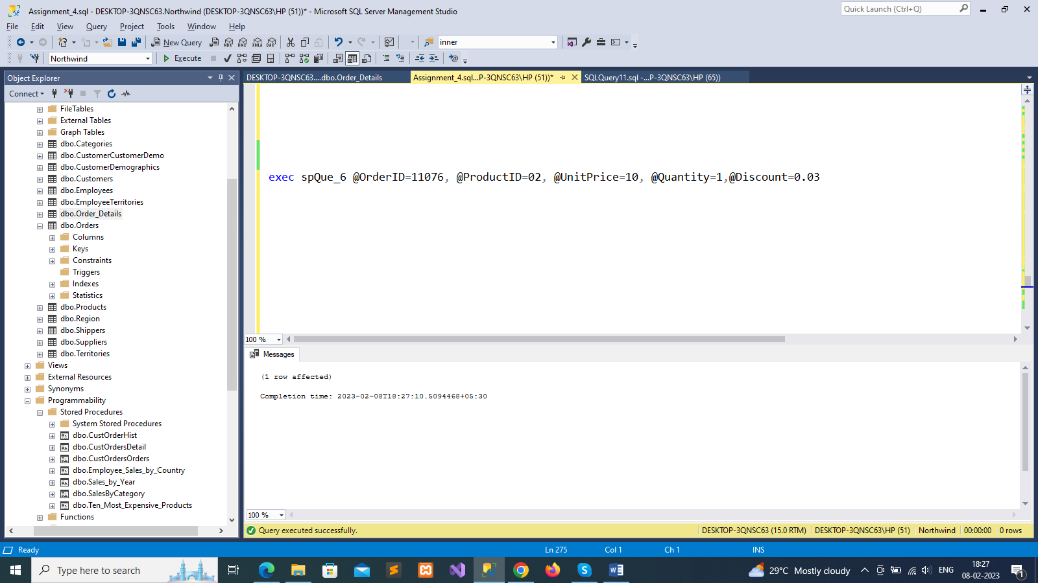

--7. write a SQL query to Create Stored procedure in the Northwind database to update Customer Order Details

create or alter procedure spQue_7

(

@OrderID int,

@ProductID int,

@UnitPrice money,

@Quantity smallint,

@Discount real

)

as

begin

update Order_Details set UnitPrice=@UnitPrice, Quantity=@Quantity, Discount=@Discount

where OrderID=@OrderID and ProductID=@ProductID

end

exec spQue_7 @OrderID=11076, @ProductID=02, @UnitPrice=11, @Quanti

