Software Requirement Specifications
Online Boutique with Virtual Try-On Feature



Submitted by
Hina Ijaz (S23BINFT1M01052)

Submitted to
Ms. Sara Farid

Department of Information Technology
Faculty of Computing
The Islamia University of Bahawalpur

Summary
The Online Boutique with Virtual Try-On Feature represents an online fashion store web platform that will engage the online shopping experience through the integration of the e-commerce services with the artificial intelligence and computer vision. They can virtually test the clothes using their uploaded images in contrast to the traditional online stores, which can only rove them based on the static pictures and size charts. The virtual try-on option tracks body key points and properly superimposes the clothes, which gives the customer a lifelike preview to assist in the selection of the correct size, style, and color.
The site has the option of managing user accounts, browsing products, shopping carts, secure internet payment and tracking orders. Administrators are able to handle products, categories, users, orders as well as produce sales reports. The system minimizes returns of products, enhances customer satisfaction and encourages confidence in online shopping of fashion products.
The project will be focused around the aspects of access, usability, and security and will focus on small- to medium-sized fashion retailers willing to offer a modern, interactive, and personalized online shopping experience. It uses technologies like HTML, CSS, JavaScript, PHP/Python backend, MySQL, OpenCV, MediaPipe and cloud deployment.

Table of Contents
1. Introduction 4
1.1. Purpose 4
1.2. Scope 4
1.3. Product Perspective 5
1.4. User Characteristics 5
1.5. Similar apps and systems/Literature Review 5
1.6. Proposed Technologies 5
2. Requirements 6
2.1. Function Requirements 6
2.1.1 User Management 6
2.1.2 Product Operations 6
2.1.3 Virtual Try-On Functions 7
2.1.4 Admin Functions 7
2.1.5 Sequence Diagram 8
2.2. Non-Functional Requirements 9
2.2.1 Performance Requirements 9
2.2.2 Usability Requirements 9
2.2.3 Reliability Requirements 9
2.2.4 Security Requirements 10
2.2.5. Maintainability Requirements 10
2.2.6 Portability Requirements 11
2.2.7 Compliance Requirements 11
3. Use Cases and Flow of Processes 12
3.1 Actors Description 12
3.1.1 Customer 12
3.1.2 Admin 12
3.2 Use Case Diagram 12
3.2.1 Detail Use Case 13
3.2.2 Process Flow Diagram 17
References 18

1. Introduction
The fashion sector is also moving very fast towards the online platform over the recent years with the growing adoption of digital technologies and access to the internet. Online stores enable clients to shop and order clothing products easily at the comfort of their homes at any time. Nevertheless, even though the e-commerce has expanded in the fashion industry, a significant constraint to customers remains the lack of physical opportunity to feel the clothes and then purchase them. This usually creates confusion on size, fitting, color, and general appearance of clothes.
The majority of the old-fashioned Internet stores are based on fixed product photos and size charts that fail to give a real idea of how clothes will fit various body types. This has caused a lot of dissatisfaction among customers who receive products and have resulted in high returns, cart abandonment, and low trust in internet retailers. Online fashion retail presents more interactive and intelligent solutions that are necessary because of these challenges.
Online Boutique featuring Virtual Try-On will be a solution to these problems as it will combine the means of artificial intelligence and computer vision with an online shopping platform. The system offers the user with a virtual fitting room, in which they can see outfits on their own pictures . This strategy will increase the confidence of the users, make their shopping experience more enjoyable, and minimize the chances of returns of products.

1.1. Purpose
The Online Boutique with Virtual Try-On Feature is meant to conceptualize and establish a web-based site that enables the consumer to shop clothes online but virtually wear the clothing before committing to buying it. The system seeks to bridge the physical shopping and online shopping by providing a virtual preview of clothes on a body of the user.
The project is a solution to customers who have challenges in choosing the right clothes size and design using the traditional online shopping platforms. The system also helps in online transactions, management of online orders, and administrative control and therefore is a full e-commerce solution to the fashion retailers.

1.2. Scope
The Online Boutique system is tailored to include all the significant elements in an online fashion retail website. It allows the users to create personal accounts, shop clothes, use virtual try-on filters, place products into a shopping cart, and buy them using reliable payment options. The users can also see their order history and order status.
The system has an administrative panel, which enables the administrators to handle products, categories, users, and orders effectively. The virtual try-on module involves the use of image processing method to overlay the clothes that the users have selected on the images of the users to give them a realistic shopping experience. The site is created in the form of a mobile web-based application that can be used both on a desktop and a mobile browser.

1.3. Product Perspective
Online Boutique using Virtual Try-On Feature is a one-on-one web-based application that combines the e-commerce functionality with artificial intelligence-based image processing. The architecture is made up of a frontend user interface, a backend server, database containing user and product data, and a virtual try-on engine.
It is a smooth shopping process as the user is able to select the product and then receive virtual fitting recommended and checkout. Regarding system a perspective, images of users are safely processed, body detection is conducted and the garments adjusted accordingly after which the final image becomes visible on the screen in real time.

1.4. User Characteristics
Customers: The customers are generic users and have limited computer and internet knowledge. They are able to shop, have an online trial on, order, and manage their accounts.
Admin: The overall system is handled by the admins. They take care of listing of products, category management, order processing, user accounts and sales reporting. The admins should possess moderate technical knowledge.

1.5. Similar apps and systems/Literature Review
There are a number of online fashion stores like Amazon Fashion, Zara Online and ASOS which offer E-commerce in purchasing clothes. The primary services provided by these systems are product images, size guide, and customer reviews to help the buyers. There are also more sophisticated platforms that have added rudimentary augmented reality capabilities; but these platforms are not yet accurate and personalized enough.
According to research studies regarding virtual try-on system, computer vision and image processing methods have shown their effectiveness in enhancing online shopping. Current solutions show lower returns and higher customer interest, whereas most of them are complicated and costly. This project aims at applying a feasible and user-friendly solution of virtual try-on that can be applied in online boutiques of small to medium sizes.

1.6. Proposed Technologies
The technologies that are suggested to be used in developing the system include:
- Frontend: HTML5, CSS3, JavaScript, Bootstrap or Tailwind CSS.
- PHP (XAMPP) or Python (Django/Flask) backend.
- Database: MySQL
- AI & Image Processing: Python, OpenCV, MediaPipe, NumPy.
- What is version control: Git and GitHub.
- Deployment: Cloud based or Localhost.
- UI/UX Design: Figma or Adobe XD
Such technologies are chosen so as to be scalable, perform and easy to maintain.

2. Requirements
This chapter is an in-depth narration on the functional and non-functional requirements of the Online Boutique with Virtual Try-On Feature. The requirements establish the anticipated behavior of the system and are a guide to the design, development and testing. These requirements are divided into both functional requirements and non-functional requirements, the former outlines system features and the latter outlines quality attributes of the system.

2.1. Function Requirements
Functional requirements stipulate what the system will do. These necessities determine the fundamental characteristics offered to the clients and managers.

2.1.1 User Management
FR-1: User Registration
The system will have a registration interface where new users can register an account by incorporating their name, email address, and password.
FR-2: User Login
The system will enable registered users to use valid credentials to access the system.
FR-3: Password Recovery
The system will enable users to change passwords in case they lose them.
FR-4: Profile Management
A system will be facilitated that allows users to access and edit their individual information such as profile picture and contacts.
FR-5: Order History
The system will enable the users to access their past orders, date of order, and items ordered, as well as the order status.

2.1.2 Product Operations
FR-6: Product Listing
The system will show the list of clothing items available including pictures, description, size, color, and price.
FR-7: Product Search and Filter
The system will enable the user to search and filter the products according to the category, size, color, and price range.
FR-8: Shopping Cart Management
The system will enable users to enter the products into the cart, amend the quantity, or delete products.
FR-9: Checkout and Payment
The system will enable customers to make purchases by way of safe monetary frameworks like PayPal, EasyPaisa or credit/debit cards.
FR-10: Order Tracking
The system will enable the user to monitor their orders (pending, confirmed, shipped, delivered).

2.1.3 Virtual Try-On Functions
FR-11: Image Upload
The system will enable the users to add a front facing picture to virtual try-on.
FR-12: Body Detection
The system will be able to identify body key points like shoulders, waist, and hips with the help of computer vision.
FR-13: Garment Alignment
The system will upscale and align the garment of choice according to the body key points detected.
FR-14: Try-On Visualization
The system will superimpose the garment image on the user image to come up with a realistic preview.
FR-15: Adjustment Controls
The system will enable the user to resize or re-position the overlay of the garment to view it better.

2.1.4 Admin Functions
FR-16: Admin Login
The system will enable administrators to gain access to it via a secure administrative interface.
FR-17: Admin Dashboard
The system will be presented with an admin dashboard on which there will be statistics like the number of users, products and orders.
FR-18: Category Management
The system will enable the admins to add, update, activate, or delete product categories.
FR-19: Product Management
The system will enable the admins to add, update, activate or deactivate products and images as well as prices.
FR-20: Order Management
The system will enable admins to access and revise the order statuses.
FR-21: User Management
The system will enable admins to manage user accounts via viewing and deleting.
FR-22: Sales Reports
The system will enable admins to make daily, weekly, or monthly sales reports.

2.1.5 Sequence Diagram
The sequence diagram shows the communication between the user, system and the virtual try-on module when undergoing the try-on process. This is a threefold problem since the domestic and international markets are already saturated, and nobody will be ready to buy another product type.
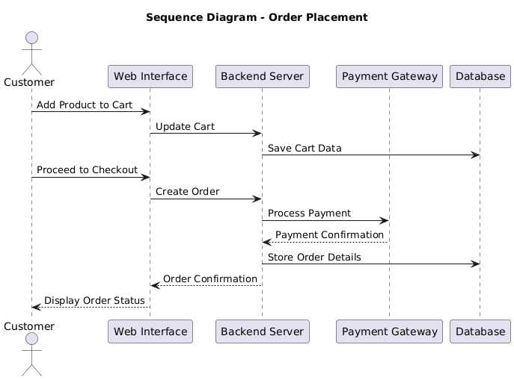
Figure 2.1 Sequence Diagram

2.2. Non-Functional Requirements
Non-functional requirements establish quality characteristics of the system such as performance, usability, security and reliability.

2.2.1 Performance Requirements
NFR-1: Response Time
The system will take a response time of 2 seconds to important user activities including products browsing, viewing try-ons, and checkout.
Rationale:
Ensure efficient and a smooth user experience.
NFR-2: Scalability
The system will be able to accommodate a minimum of 500 simultaneous users without causing any drop in performance.
Rationale:
To manage the extra traffic at the high shopping times.

2.2.2 Usability Requirements
NFR-3: User Interface
The system will come with an easy to use, user-friendly and visual interface.
Rationale:
To ensure that the platform has features that make it easily accessible to users who have different degrees of technical expertise.
NFR-4: Accessibility
The system will be based on the basic web accessibility.
Rationale:
To make it usable to users with different needs.

2.2.3 Reliability Requirements

NFR-5: System Availability
The system will have no less than 99 percent uptime.
Rationale:
So that the users can have continuous access.
NFR-6: Data Backup
The system will carry out frequent database backup.
Rationale:
To avoid the loss of data in case of failure of the system.

2.2.4 Security Requirements
NFR-7: Data Encryption
Sensitive user data will be encrypted when passing through the internet and also when stored.
Rationale:
To ensure privacy and security of users and finance.
NFR-8: Authentication Security.
Hashed user passwords will be stored.
Rationale:
In order to disallow unauthorized access.

2.2.5. Maintainability Requirements
NFR-9: Code Maintainability
The system will be designed based on well-documented and modular code.
Rationale:
In order to permit easy modification and further development.
NFR-10: Documentation
The system will consist of documentation and technical documentation.
Rationale:
To support the developers and end users.

2.2.6 Portability Requirements
NFR-11: Browser Compatibility
The system will be compatible with the major browsers, including Chrome, Firefox, and Edge.
Rationale:
So that there is uniformity in the experience across platforms.
NFR-12: Responsive Design
The system will serve desktop and mobile gadgets.
Rationale:
In order to offer flexibility in use.

2.2.7 Compliance Requirements
NFR-13: Data Privacy
The system will be in line with general data protection principles.
Rationale:
To provide for ethical management of user information.
NFR-14: Legal Compliance
The system will be in compliance with the law on online transactions.
Rationale:
To prevent legal and regulatory problems.

3. Use Cases and Flow of Processes
Use cases are narrations on how the various users will interface with the system to attain certain objectives. They give a clear insight into the functional behavior of the system as seen by the end-users. In the Online Boutique with Virtual Try-On Feature, the use cases are used to establish how the customers would navigate in their products, use the virtual try-on feature, and make purchases and how the system is managed by the administrators.
This chapter explains:
- Participants in the system.
- Use Case Diagram
- In-depth Use Case Descriptions.
- System Process Flow
As this project is designed based on the user-centered approach, use case modeling helps to make sure that all the capabilities of the system are stated according to the needs of the users and business goals.

3.1 Actors Description
The following are the key actors of the system:

3.1.1 Customer
A customer refers to a registered or unregistered user who accesses online boutique. The customers would be able to browse, register/log-in, apply the virtual try-on tool, add products to the cart, place orders and manage their order history.

3.1.2 Admin
The entire system is under the management of the admin. Admin users will have the possibility to take control of product listing, categories, orders, users and create sales reports. Admins maintain a stable running of the systems and consistency of data.

3.2 Use Case Diagram
Use case diagram gives a graphical view of interaction between the system and the actors. It demonstrates the significant features of the product that customers and administrators have.
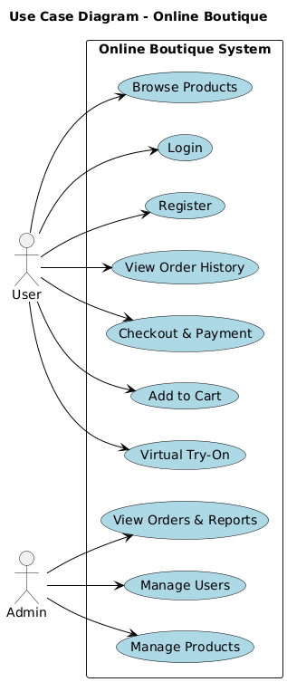
Figure 3.1 Use Case Diagram for Online Boutique

3.2.1 Detail Use Case
All use cases are discussed below in Table 3.1 to 3.10.
TABLE 3.1: UC-1: Signup
Use-Case ID | UC-1
Use-Case Name | Signup
Actors | Customer
Description | Allows a new customer to register on the system
Preconditions | Customer is not registered
Postconditions | A new customer account is created
Normal Flow | • Customer selects signup option  • System displays registration form  • Customer enters details and submits form  • System confirms successful registration
Alternative Flow | If required fields are missing, the system displays an error message

TABLE 3.2: UC-2: Login
Use-Case ID | UC-2
Use-Case Name | Login
Actors | Customer, Admin
Description | Allows users to access the system using valid credentials
Preconditions | User is registered
Postconditions | User gains access to the dashboard
Normal Flow | • User selects login option  • System displays login form  • User enters credentials  • System verifies and grants access
Alternative Flow | If login fails, an error message is displayed

TABLE 3.3: UC-3: Browse Products
Use-Case ID | UC-3
Use-Case Name | Browse Products
Actors | Customer
Description | Allows customers to view available clothing items
Preconditions | None
Postconditions | Product list is displayed
Normal Flow | • Customer selects a category  • System displays related products
Alternative Flow | If no products are available, system shows notification

TABLE 3.4: UC-4: Virtual Try-On
Use-Case ID | UC-4
Use-Case Name | Virtual Try-On
Actors | Customer
Description | Allows customers to virtually try clothing items
Preconditions | Customer must be logged in
Postconditions | Virtual try-on preview is generated
Normal Flow | • Customer selects a product  • Customer clicks “Try On”  • Image is uploaded  • System overlays garment on user image
Alternative Flow | If image quality is poor, system shows error message

TABLE 3.5: UC-5: Add Product to Cart
Use-Case ID | UC-5
Use-Case Name | Add Product to Cart
Actors | Customer
Description | Enables the customer to add a product to the cart
Preconditions | Customer must be logged in
Postconditions | Product is added to cart
Normal Flow | • Customer selects product  • Clicks add to cart  • System confirms addition
Alternative Flow | If product is out of stock, system notifies customer

TABLE 3.6: UC-6: Confirm Order
Use-Case ID | UC-6
Use-Case Name | Confirm Order
Actors | Customer
Description | Allows customer to place an order
Preconditions | Cart contains products
Postconditions | Order is placed successfully
Normal Flow | • Customer proceeds to checkout  • Selects payment method  • Confirms order
Alternative Flow | If payment fails, system requests retry

TABLE 3.7: UC-7: Track Order
Use-Case ID | UC-7
Use-Case Name | Track Order
Actors | Customer
Description | Allows customer to view order status
Preconditions | Order exists
Postconditions | Order status displayed
Normal Flow | • Customer selects order  • System displays order status
Alternative Flow | None

TABLE 3.8: UC-8: Manage Products
Use-Case ID | UC-8
Use-Case Name | Manage Products
Actors | Admin
Description | Allows admin to add, update, or delete products
Preconditions | Admin must be logged in
Postconditions | Product data updated
Normal Flow | • Admin selects product option  •Updates product details  • System saves changes
Alternative Flow | Invalid data produces error message

TABLE 3.9: UC-9: Manage Orders
Use-Case ID | UC-9
Use-Case Name | Manage Orders
Actors | Admin
Description | Allows admin to update order status
Preconditions | Orders exist
Postconditions | Order status updated
Normal Flow | Admin selects order  Updates status
Alternative Flow | None

TABLE 3.10: UC-10: Generate Report
Use-Case ID | UC-10
Use-Case Name | Generate Report
Actors | Admin
Description | Enables admin to generate sales reports
Preconditions | Admin logged in
Postconditions | Report generated
Normal Flow | • Admin selects report type  • System generates report
Alternative Flow | None

3.2.2 Process Flow Diagram
The process flow diagram explains the complete workflow of the system from user login to order completion.
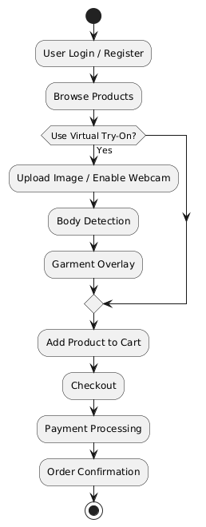

References
I. Sommerville, Software Engineering, 10th Edition, Pearson, 2015.
M. Fowler, UML Distilled: A Brief Guide to the Standard Object Modeling Language, 3rd Edition, Addison-Wesley, 2003.
R. S. Pressman, Software Engineering: A Practitioner’s Approach, 8th Edition, McGraw-Hill Education, 2014.
L. Wang, et al., “A Virtual Try-On System for Fashion E-Commerce Using Deep Learning,” Journal of Visual Communication and Image Representation, vol. 61, pp. 1–12, 2019.
S. Liu, et al., “3D Virtual Try-On Network for Fashion Applications,” IEEE Transactions on Multimedia, vol. 23, no. 4, pp. 1100–1112, 2021.
X. Han, et al., “FashionAI: AI-powered Virtual Try-On for Online Shopping,” Proc. 27th ACM Int. Conf. on Multimedia, pp. 1145–1153, 2019.
OpenCV Documentation, https://opencv.org/.
Mediapipe Documentation, https://mediapipe.dev/.
PlantUML Documentation, https://plantuml.com/.
GeeksforGeeks, “Introduction to MVC Architecture,” https://www.geeksforgeeks.org/mvc-design-pattern/.
W3Schools, “HTML, CSS, JavaScript Tutorial,” https://www.w3schools.com/.
MySQL Documentation, https://dev.mysql.com/doc/.

