**Name:Hinal Panchal**

**Submission: MongoDB Practical**

1) Batch Create with minimum 100 records in MongoDb (create batch).

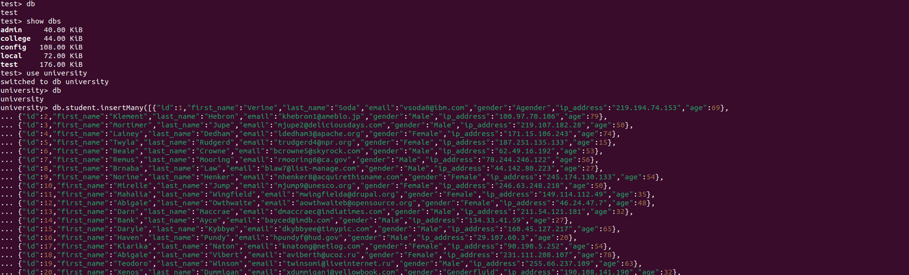

2) Batch Update with minimum 100 records in MongoDB (update batch)

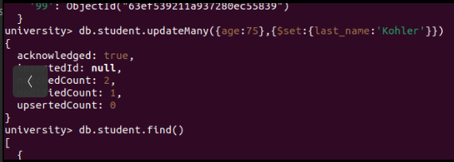

3) Perform indexing on particular 3 fields in MongoDB.

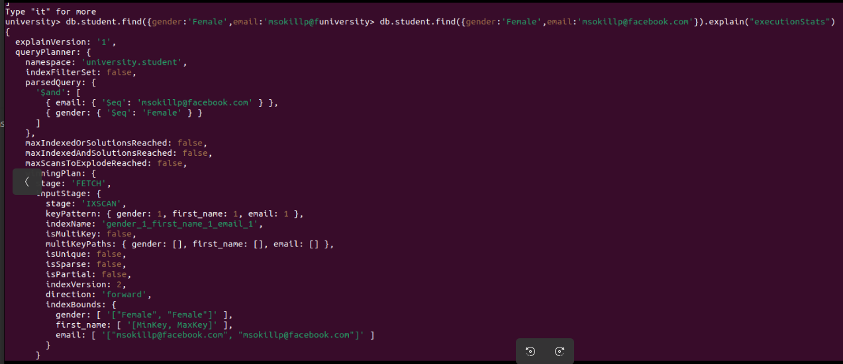

4) Find duplicates using aggregation in MongoDB

