**Name: Hinal Panchal**

**Submission: SQL Practical**

**EmployeeInfo Table:**

CREATE TABLE EmployeeInfo (

EmpID serial Primary Key,

EmpFname VARCHAR(10) NOT NULL,

EmpLname VARCHAR(10) NOT NULL,

Department VARCHAR(10) NOT NULL,

Project VARCHAR(10),

Address VARCHAR(20),

DOB TIMESTAMP NOT NULL,

GENDER VARCHAR(1) NOT NULL

);

**EmployeePosition Table:**

CREATE TABLE EmployeePosition(

EmpID int Primary Key,

EmpPosition VARCHAR(20),

DateOfJoining date,

Salary int,

Foreign Key (EmpID) references EmployeeInfo(EmpID)

);

1. Write a query to fetch the number of employees working in the department ‘Admin’

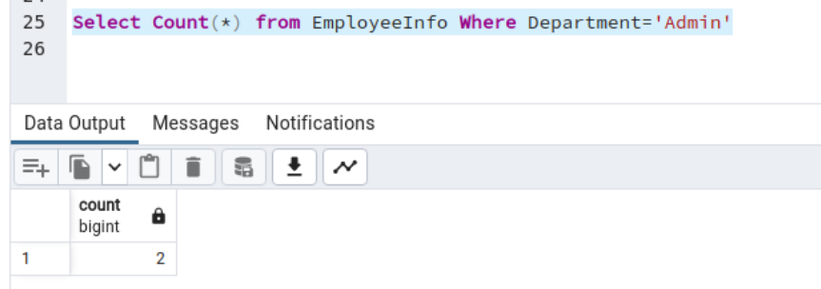

2. Write a query to retrieve the first four characters of EmpLname from the EmployeeInfo table.

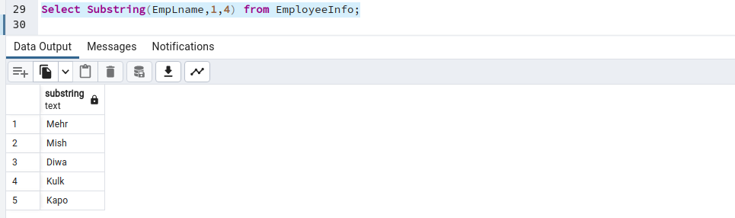

3. Write q query to find all the employees whose salary is between 50000 to 100000.

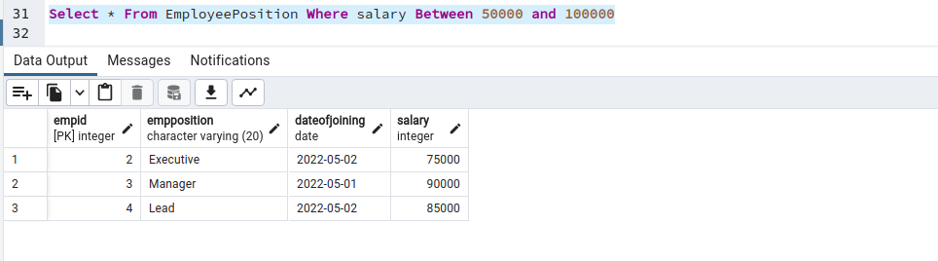

4. Write a query to find the names of employees that begin with ‘S’.

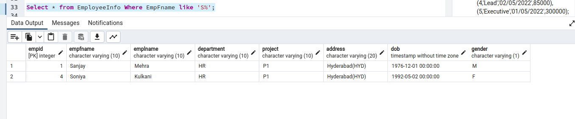

5. Write a query to fetch top N records order by salary. (ex. top 5 records)

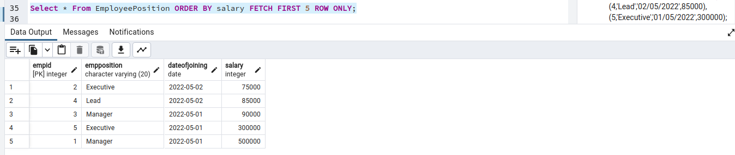

6. Write a query to fetch details of all employees excluding the employees with first names, “Sanjay” and “Sonia” from the EmployeeInfo table.

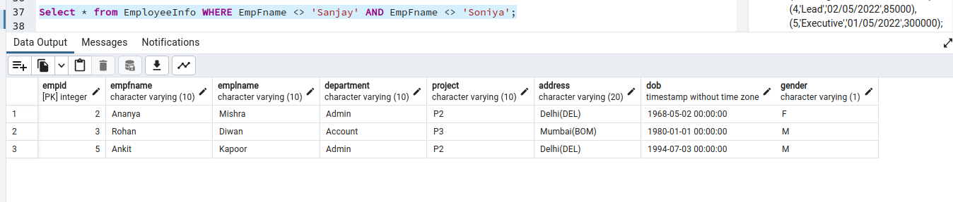

7. Write a query to fetch the department-wise count of employees sorted by department’s count in ascending order.

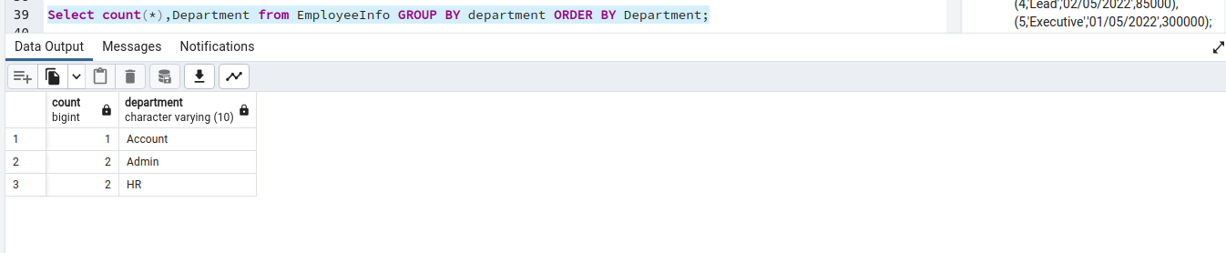

8. Create indexing for any particular field and show the difference in data fetching before and after indexing. (Use External Database)

Before Indexing :

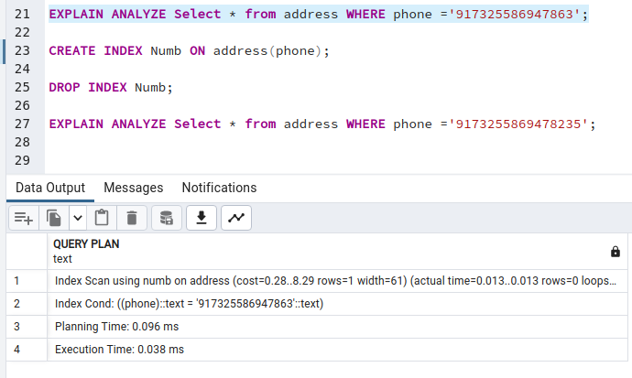

After Indexing :

