CSD2206 Term Project F19

HINALI TEJANI

C0939251

Table of Contents

Company Overview 2

Company Name 2

Company Description 2

Type of Company 2

Product 2

Website Resources 2

Product Attributes 3

Attributes 3

Invoice 4

ER Diagrams 5

Relational Model 7

Create Statements 10

Database Constraints 12

Insert Statements 15

Constraint Testing 27

Views 31

PRODV1 31

PRODV2 31

# Company Overview

### Company Name

GridleGrills

### Company Description

GridleGrills sells variety of griddles & grill pans from various top-rated companies. They offer many sizes and shapes in pans, for all indoor grilling needs at everyday low prices. Along with best nonstick material, they also offer cast iron, square, round, double burner and reversible.

### Type of Company

GridleGrills is a retailer, selling individual griddles & grill pans of a variety of styles.

### Product

Griddles & Grill pans

### Website Resources

* [www.walmart.ca](http://www.walmart.ca/)
* [www.canadiantire.com](http://www.canadiantire.com)
* www.homedepot.ca

# Product Attributes

### Attributes

* Product id (UID)
* Model
* Brand
* Type
* Serial Number
* Description
* Rating
* Color
* Diameter
* Handle Material
* Shape
* Price
* Material
* Dimensions
* weight

**GridleGrills**

Invoice

INVOICE # 28915

DATE May 29, 2019

CUSTOMER ID # 720 ASSOCIATE ID # 22 ASSOCIATE NAME J. Folger

Billing Details:

Dominick Mcdonnell 1080 Oxford Street E London, ON N5Y 3L4

(519) 684-6631

1060 Yonge Street

Toronto, ON M4W 2L4

416-325-2739

|  |  |  |  |  |  |  |
| --- | --- | --- | --- | --- | --- | --- |
| PRODUCT ID | MODEL | BRAND | DESCRIPTION | QTY | UNIT PRICE | TOTAL |
| 9001022 | CE201 | Ninja | BBQ Griddle | 1 | 250.00 | 250.00 |
| 9001046 | KF7150BK | Braun | 3 Burner Gas Griddle | 1 | 199.99 | 199.99 |
| 9001033 | 611247373590 | Keurig | Cast Iron Griddle | 1 | 68.00 | 68.00 |
| 9001014 | KU5055746 | Keurig | Electrical Grill | 1 | 149.99 | 149.99 |
| SUBTOTAL | | | |  |  | 667.98 |
| SALES TAX | | | |  |  | 86.83 |
| SHIPPING & HANDLING | | | |  |  | 0.00 |
| TOTAL DUE | | | |  |  | 754.81 |

**Thank you for shopping with us!**

# ER Diagrams

1. Many-to-many

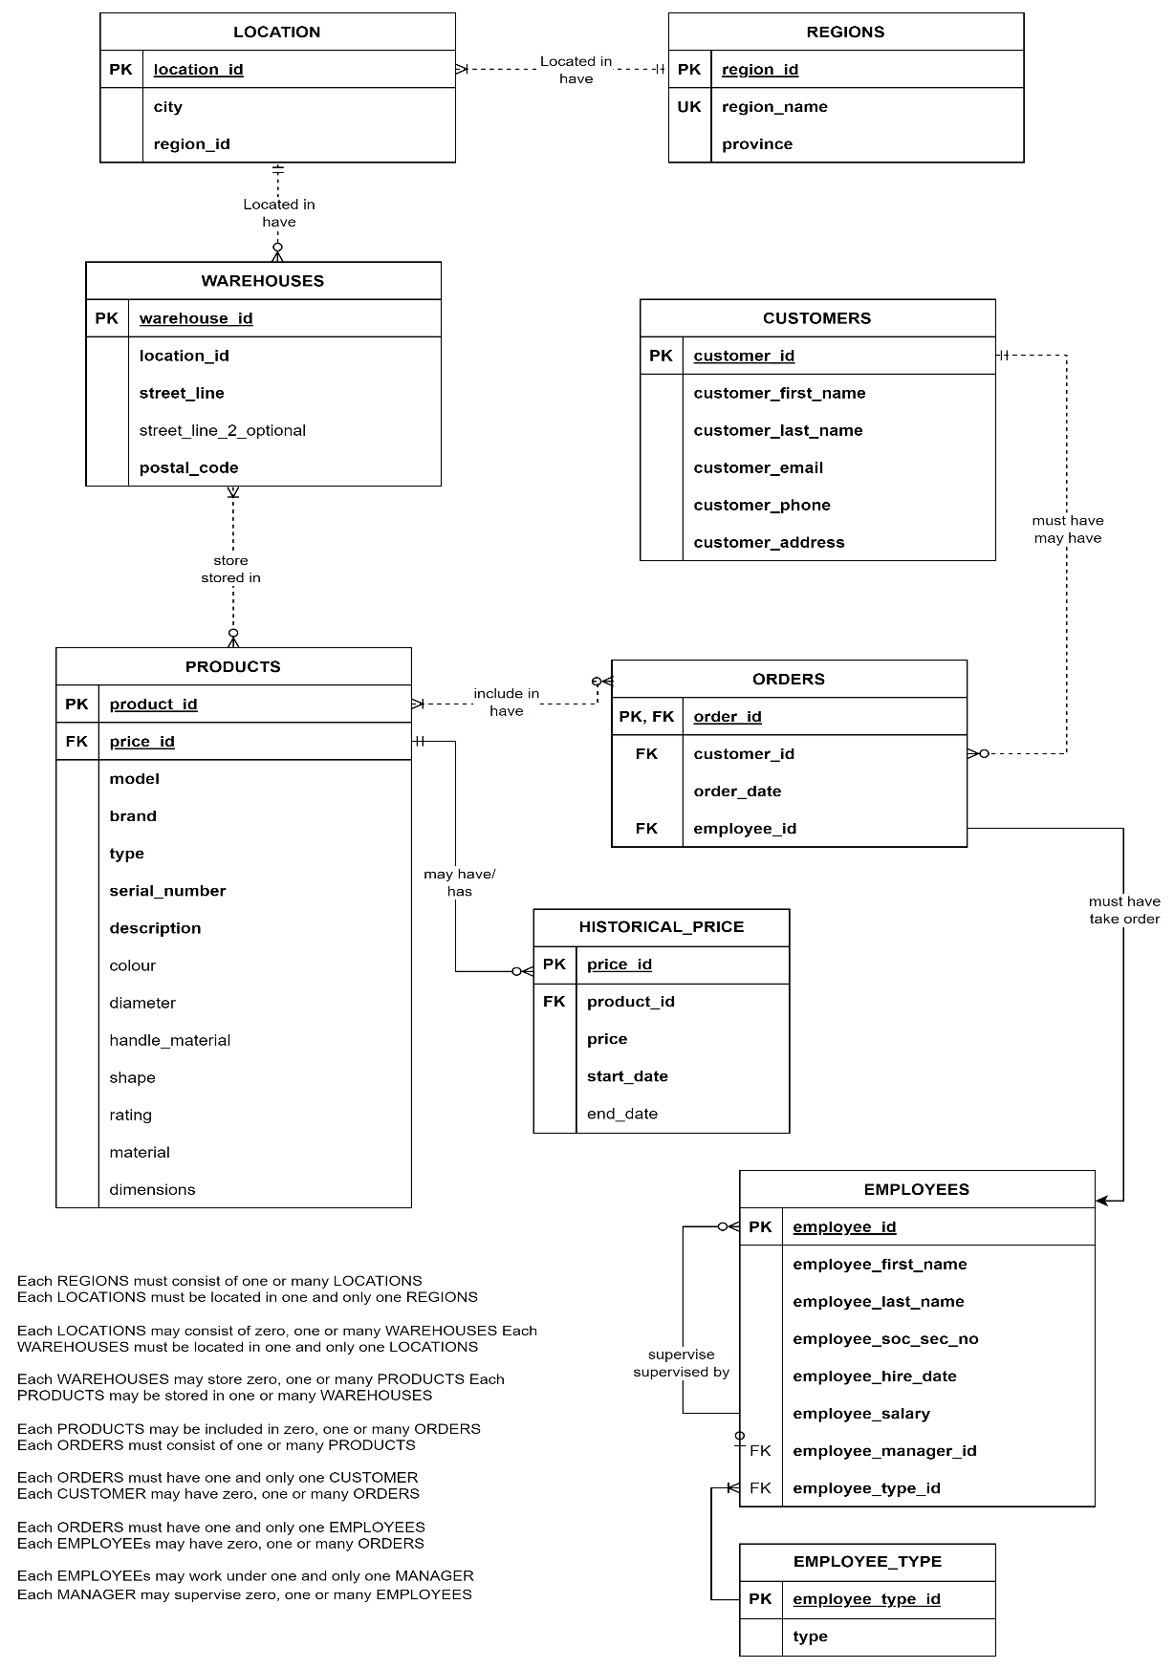

1. Many-to-many resolved

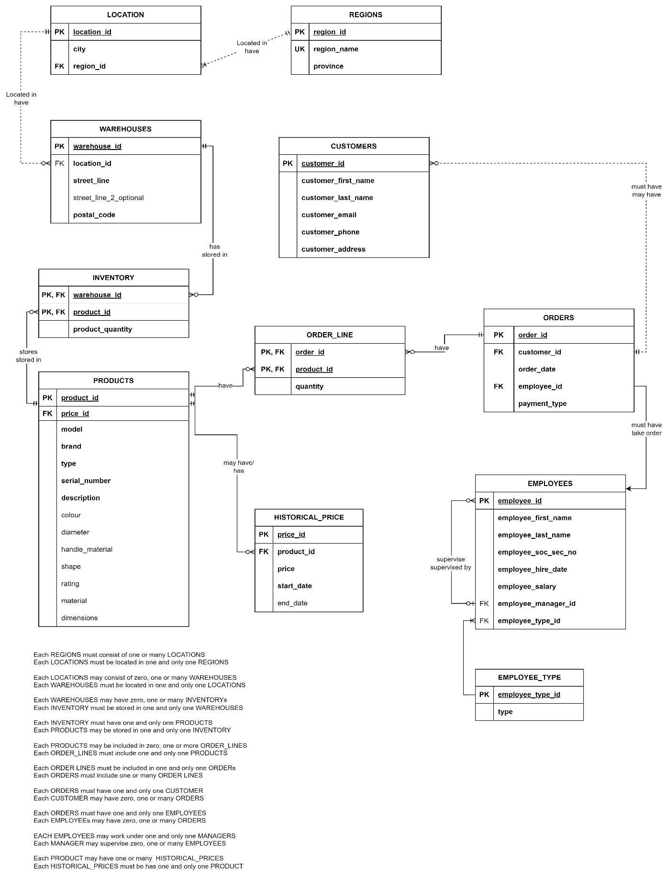

# Relational Model

|  |  |  |  |  |
| --- | --- | --- | --- | --- |
| **PRODUCTS** | | | | |
| **Key Type** | **Optionality** | **Column Name** | **Data Type** | **Length** |
| PK | * | product_id | integer |  |
| UK | * | model | varchar | 20 |
|  | * | brand | varchar | 20 |
|  | * | type | varchar | 20 |
| UK | * | serial_number | varchar | 30 |
|  | * | description | varchar | 60 |
|  | O | color | varchar | 20 |
|  | O | diameter | decimal | 3,2 |
|  | O | handle_material | varchar | 30 |
|  | O | shape | varchar | 20 |
|  | O | rating | decimal | 3,2 |
|  | O | material | varchar | 30 |
|  | O | dimensions | varchar | 20 |

|  |  |  |  |  |
| --- | --- | --- | --- | --- |
| **WAREHOUSES** | | | | |
| **Key Type** | **Optionality** | **Column Name** | **Data Type** | **Length** |
| PK | * | warehouse_id | integer |  |
| FK | * | location_id | integer |  |
|  | * | street_address_line_1 | varchar | 30 |
|  | O | street_address_line_2 | varchar | 30 |
| UK | * | Postal_code | varchar | 7 |

|  |  |  |  |  |
| --- | --- | --- | --- | --- |
| **INVENTORY** | | | | |
| **Key Type** | **Optionality** | **Column Name** | **Data Type** | **Length** |
| PK/FK | * | product_id | integer |  |
| PK/FK | * | warehouse_id | integer |  |
|  | O | quantity | integer |  |

|  |  |  |  |  |
| --- | --- | --- | --- | --- |
| **REGIONS** | | | | |
| **Key Type** | **Optionality** | **Column Name** | **Data Type** | **Length** |
| PK | * | region_id | integer |  |
| UK | * | region_name | varchar | 30 |
|  | * | province | varchar | 30 |

|  |  |  |  |  |
| --- | --- | --- | --- | --- |
| **LOCATIONS** | | | | |
| **Key Type** | **Optionality** | **Column Name** | **Data Type** | **Length** |
| PK | * | location_id | integer |  |
|  | * | city | varchar | 30 |
| FK | * | region_id | integer |  |

|  |  |  |  |  |
| --- | --- | --- | --- | --- |
| **ORDER_LINES** | | | | |
| **Key Type** | **Optionality** | **Column Name** | **Data Type** | **Length** |
| PK/FK | * | order_id | integer |  |
| PK/FK | * | product_id | integer |  |
|  | * | quantity | integer |  |
|  | * | price | decimal | 6,2 |

|  |  |  |  |  |
| --- | --- | --- | --- | --- |
| **ORDERS** | | | | |
| **Key Type** | **Optionality** | **Column Name** | **Data Type** | **Length** |
| PK | * | order_id | integer |  |
| FK | * | customer_id | integer |  |
|  | * | order_date | date |  |
| FK | * | employee_id | integer |  |

|  |  |  |  |  |
| --- | --- | --- | --- | --- |
| **CUSTOMERS** | | | | |
| **Key Type** | **Optionality** | **Column Name** | **Data Type** | **Length** |
| PK | * | customer_id | integer |  |
|  | * | customer_first_name | varchar | 20 |
|  | * | customer_last_name | varchar | 20 |
| UK | * | customer_email | varchar | 30 |
|  | * | customer_phone | varchar | 20 |
|  | * | customer_address | varchar | 60 |

|  |  |  |  |  |
| --- | --- | --- | --- | --- |
| **EMPLOYEES** | | | | |
| **Key Type** | **Optionality** | **Column Name** | **Data Type** | **Length** |
| PK | * | employee_id | integer |  |
|  | * | employee_first_name | varchar | 20 |
|  | * | employee_last_name | varchar | 20 |
|  | * | employee_soc_sec_no | integer |  |
|  | * | employee_hire_date | date |  |
|  | * | employee_salary | decimal | 9,2 |
| FK | * | employee_manager_id | integer |  |
|  | * | employee_type_id | varchar | 20 |

|  |  |  |  |  |
| --- | --- | --- | --- | --- |
| **HISTORICAL_PRICE** | | | | |
| **Key Type** | **Optionality** | **Column Name** | **Data Type** | **Length** |
| PK | * | price_id | integer |  |
| FK | * | product_id | integer |  |
|  | * | price | decimal | 6,2 |
|  | * | start_date | date |  |
|  | O | end_date | date |  |

PRODUCTS (**product_id**, model, brand, type, serial_number, description, color, diameter, handle_material, shape, rating, material, dimensions)

WAREHOUSES (**warehouse_id**, *location_id*, street_address_line_1, postal_code, street_address_line_2)

FK location_id → LOCATIONS

INVENTORY (***product_id***, ***warehouse_id***, quantity)

FK product_id → PRODUCTS

FK warehouse_id → WAREHOUSES

REGIONS (**region_id**, region_name, province)

LOCATIONS (**location_id**, city, *region_id*)

FK region_id → REGIONS

INVOICE(**invoice_id, *order_id***, ***product_id***, quantity, price, payment_type, shipping_type)

FK order_id → ORDERS

FK product_id → PRODUCTS

ORDERS (**order_id**, *customer_id*, order_date, *employee_id*)

FK customer_id → CUSTOMERS

FK employee_id → EMPLOYEES

CUSTOMERS (**customer_id**, customer_first_name, customer_last_name, customer_email, customer_phone, customer_address)

EMPLOYEES (**employee_id**, employee_first_name, employee_last_name, employee_hire_date, employee_salary, employee_*manager_id*)

FK manager_id → EMPLOYEES

HISTORICAL_PRICE(**price_id,**  ***product_id***, price, start_date, end_date)

FK product_id → PRODUCTS

# Create Statements

**CREATE TABLE** products (

product_id **INTEGER NOT NULL**,

model **VARCHAR** (20) **NOT NULL**,

brand **VARCHAR** (20) **NOT NULL**,

type **VARCHAR** (20) **NOT NULL**,

serial_number **VARCHAR** (30) **NOT NULL**, description **VARCHAR** (60) **NOT NULL**,

color **VARCHAR** (20) **NOT NULL**,

diameter **DECIMAL** (3,2),

handle_material **VARCHAR** (30) **NOT NULL**,

shape **VARCHAR** (20) **NOT NULL**,

rating **DECIMAL** (3,2),

material **VARCHAR** (30) **NOT NULL**,

dimensions **VARCHAR** (20)

);

**CREATE TABLE** warehouses (

warehouse_id **INTEGER NOT NULL**,

location_id **INTEGER NOT NULL**,

street_address_line_1 **VARCHAR**(30) **NOT NULL**,

street_address_line_2 **VARCHAR**(30) **NOT NULL**,

postal_code **VARCHAR**(7) **NOT NULL**

);

**CREATE TABLE** inventory (

product_id **INTEGER NOT NULL**, warehouse_id **INTEGER NOT NULL**,

quantity **INTEGER**

);

**CREATE TABLE** regions (

region_id **INTEGER NOT NULL**, region_name **VARCHAR**(30) **NOT NULL,**

province **VARCHAR**(30) **NOT NULL**

);

**CREATE TABLE** locations (

location_id **INTEGER NOT NULL**,

city **VARCHAR**(30) **NOT NULL,**

region_id **INTEGER NOT NULL**,

);

**CREATE TABLE** employees (

employee_id **INTEGER NOT NULL**,

employee_first_name **VARCHAR** (20) **NOT NULL**,

employee_last_name **VARCHAR** (20) **NOT NULL**,

employee_soc_sec_no **INTEGER NOT NULL**,

employee_hire_date **DATE DEFAULT sysdate NOT NULL**,

employee_salary **DECIMAL** (9,2) **NOT NULL**,

employee_manager_id **INTEGER**

);

**CREATE TABLE** customers (

customer_id **INTEGER NOT NULL**,

customer_first_name **VARCHAR** (20) **NOT NULL**,

customer_last_name **VARCHAR** (20) **NOT NULL**,

customer_email **VARCHAR** (20),

customer_phone **VARCHAR** (20),

customer_address **VARCHAR** (60),

);

**CREATE TABLE** orders (

order_id **INTEGER NOT NULL**,

customer_id **INTEGER NOT NULL**,

employee_id **INTEGER NOT NULL**,

order_date **DATE DEFAULT sysdate NOT NULL**,

);

**CREATE TABLE** orders_lines (

order_id **INTEGER NOT NULL**,

product_id **INTEGER NOT NULL**,

quantity **INTEGER NOT NULL**,

price **DECIMAL** (6,2) **NOT NULL**,

);

**CREATE TABLE** historical_price (

price_id **INTEGER NOT NULL**,

product_id **INTEGER NOT NULL**,

price **DECIMAL** (6,2) **NOT NULL**,

quantity **INTEGER NOT NULL**,

start_date **DATE NOT NULL**,

end_date **DATE**

);

# Database Constraints

**PRIMARY KEYS:**

ALTER TABLE warehouses

ADD CONSTRAINT warehouses_pk

PRIMARY KEY (warehouse_id);

ALTER TABLE employees

ADD CONSTRAINT employees_pk

PRIMARY KEY (employee_id);

ALTER TABLE PRODUCTS

ADD CONSTRAINT pk_products

PRIMARY KEY (product_id);

ALTER TABLE INVENTORY

ADD CONSTRAINT pk_inventory

PRIMARY KEY (product_id, warehouse_id);

ALTER TABLE REGIONS

ADD CONSTRAINT pk_regions

PRIMARY KEY (region_id);

ALTER TABLE LOCATIONS

ADD CONSTRAINT pk_location

PRIMARY KEY (location_id);

ALTER TABLE CUSTOMERS

ADD CONSTRAINT pk_customers

PRIMARY KEY (customer_id);

ALTER TABLE ORDERS

ADD CONSTRAINT pk_orders

PRIMARY KEY (order_id);

ALTER TABLE ORDER_LINES

ADD CONSTRAINT pk_order_line

PRIMARY KEY (order_id, product_id);

ALTER TABLE HISTORICAL_PRICE

ADD CONSTRAINT pk_historical_price

PRIMARY KEY (price_id);

ALTER TABLE EMPLOYEE_TYPE

ADD CONSTRAINT pk_employee_type

PRIMARY KEY (employee_type_id);

**FORIEGN KEYS:**

ALTER TABLE EMPLOYEES

ADD CONSTRAINT fk_employees_employee_type

FOREIGN KEY (employee_type_id) REFERENCES EMPLOYEE_TYPE(employee_type_id);

ALTER TABLE EMPLOYEES

ADD CONSTRAINT fk_employees_manager

FOREIGN KEY (employee_manager_id) REFERENCES EMPLOYEES(employee_id);

ALTER TABLE WAREHOUSES

ADD CONSTRAINT fk_warehouses_location

FOREIGN KEY (location_id) REFERENCES LOCATIONS(location_id);

ALTER TABLE LOCATIONS

ADD CONSTRAINT fk_location_regions

FOREIGN KEY (region_id) REFERENCES REGIONS(region_id);

ALTER TABLE INVENTORY

ADD CONSTRAINT fk_inventory_warehouse

FOREIGN KEY (warehouse_id) REFERENCES WAREHOUSES(warehouse_id);

ALTER TABLE INVENTORY

ADD CONSTRAINT fk_inventory_product

FOREIGN KEY (product_id) REFERENCES PRODUCTS(product_id);

ALTER TABLE ORDERS

ADD CONSTRAINT fk_orders_customer

FOREIGN KEY (customer_id) REFERENCES CUSTOMERS(customer_id);

ALTER TABLE ORDERS

ADD CONSTRAINT fk_orders_employee

FOREIGN KEY (employee_id) REFERENCES EMPLOYEES(employee_id);

ALTER TABLE ORDER_LINES

ADD CONSTRAINT fk_order_line_product

FOREIGN KEY (product_id) REFERENCES PRODUCTS(product_id);

ALTER TABLE ORDER_LINES

ADD CONSTRAINT fk_order_line_order

FOREIGN KEY (order_id) REFERENCES ORDERS(order_id);

ALTER TABLE PRODUCTS

ADD CONSTRAINT fk_order_line_order

FOREIGN KEY (price_id) REFERENCES HISTORICAL_PRICE(price_id);

**UNIQUE KEYS:**

ALTER TABLE CUSTOMERS

ADD CONSTRAINT uk_customers_email UNIQUE (customer_email);

ALTER TABLE PRODUCTS

ADD CONSTRAINT uk_MODEL UNIQUE (MODEL);

ALTER TABLE REGIONS

ADD CONSTRAINT uk_region_name UNIQUE (region_name);

ALTER TABLE REGIONS

ADD CONSTRAINT uk_province UNIQUE (province);

ALTER TABLE employees

ADD CONSTRAINT uk_soc_sec_no UNIQUE (employee_soc_sec_no);

**BUSINESS CONSTRAINS:**

ALTER TABLE employees

ADD CONSTRAINT employees_soc_sec_no CHECK (employee_soc_sec_no BETWEEN 111111111 AND 999999999);

ALTER TABLE order_lines

ADD CONSTRAINT order_items_quantity CHECK (quantity > 0);

# Insert Statements

**PRODUCT TABLE:**

INSERT ALL

INTO PRODUCTS (product_id, model, brand, type, serial_number, description, color, diameter, handle_material, shape, rating, material, dimensions)

VALUES (1, 'L9OG3', 'Lodge', 'Griddle', 'L9OG3', 'Cast iron griddle, excellent heat retention', 'Black', 10.5, 'Cast iron', 'Round', 4.8, 'Cast iron', '10.5 x 10.5 x 0.5 in')

INTO PRODUCTS (product_id, model, brand, type, serial_number, description, color, diameter, handle_material, shape, rating, material, dimensions)

VALUES (2, 'B036S3', 'T-fal', 'Griddle', 'B036S3', 'Hard anodized nonstick griddle, durable', 'Black', 11, 'Plastic', 'Rectangular', 4.6, 'Hard anodized aluminum', '11 x 11 x 0.5 in')

INTO PRODUCTS (product_id, model, brand, type, serial_number, description, color, diameter, handle_material, shape, rating, material, dimensions)

VALUES (3, '622-24', 'Cuisinart', 'Griddle', '622-24', 'Nonstick griddle with cool-touch handle', 'Black', 24, 'Stainless steel', 'Rectangular', 4.7, 'Hard-anodized aluminum', '24 x 12 x 0.5 in')

INTO PRODUCTS (product_id, model, brand, type, serial_number, description, color, diameter, handle_material, shape, rating, material, dimensions)

VALUES (4, '176-52', 'Calphalon', 'Griddle', '176-52', 'Nonstick griddle with even heat distribution', 'Black', 11, 'Stainless steel', 'Rectangular', 4.5, 'Hard-anodized aluminum', '11 x 11 x 0.5 in')

INTO PRODUCTS (product_id, model, brand, type, serial_number, description, color, diameter, handle_material, shape, rating, material, dimensions)

VALUES (5, '601007', 'All-Clad', 'Griddle', '601007', 'Stainless steel griddle, even heat distribution', 'Silver', 11, 'Stainless steel', 'Rectangular', 4.6, 'Stainless steel', '11 x 11 x 0.5 in')

INTO PRODUCTS (product_id, model, brand, type, serial_number, description, color, diameter, handle_material, shape, rating, material, dimensions)

VALUES (6, 'LDP3', 'Lodge', 'Grill/Griddle', 'LDP3', 'Reversible grill and griddle, cast iron', 'Black', 20, 'Cast iron', 'Rectangular', 4.7, 'Cast iron', '20 x 10.5 x 0.75 in')

INTO PRODUCTS (product_id, model, brand, type, serial_number, description, color, diameter, handle_material, shape, rating, material, dimensions)

VALUES (7, '17602', 'Rachael Ray', 'Griddle', '17602', 'Durable nonstick griddle with comfortable handle', 'Orange', 11, 'Plastic', 'Rectangular', 4.5, 'Hard-anodized aluminum', '11 x 11 x 0.5 in')

INTO PRODUCTS (product_id, model, brand, type, serial_number, description, color, diameter, handle_material, shape, rating, material, dimensions)

VALUES (8, 'E93808', 'T-fal', 'Griddle', 'E93808', 'Professional nonstick griddle with heat indicator', 'Black', 12, 'Plastic', 'Rectangular', 4.6, 'Hard anodized aluminum', '12 x 12 x 0.5 in')

INTO PRODUCTS (product_id, model, brand, type, serial_number, description, color, diameter, handle_material, shape, rating, material, dimensions)

VALUES (9, 'VGRB', 'Victoria', 'Grill/Griddle', 'VGRB', 'Reversible grill and griddle, cast iron', 'Black', 17, 'Cast iron', 'Rectangular', 4.8, 'Cast iron', '17 x 9 x 0.75 in')

INTO PRODUCTS (product_id, model, brand, type, serial_number, description, color, diameter, handle_material, shape, rating, material, dimensions)

VALUES (10, 'CC002835-001', 'GreenPan', 'Griddle', 'CC002835-001', 'Ceramic nonstick griddle, PFAS-free', 'Gray', 11, 'Bakelite', 'Rectangular', 4.6, 'Ceramic coating', '11 x 11 x 0.5 in')

SELECT 1 FROM DUAL;

**WAREHOUSE TABLE:**  
INSERT ALL

INTO warehouses (warehouse_id, location_id, street_address_line_1, street_address_line_2, postal_code)

VALUES (1, 1, '123 King St W', 'Suite 200', 'M5H 3T9')

INTO warehouses (warehouse_id, location_id, street_address_line_1, street_address_line_2, postal_code)

VALUES (2, 2, '456 Queen St E', 'Suite 300', 'M5A 1T7')

INTO warehouses (warehouse_id, location_id, street_address_line_1, street_address_line_2, postal_code)

VALUES (3, 3, '789 Dundas St W', 'Suite 400', 'M6J 1X5')

INTO warehouses (warehouse_id, location_id, street_address_line_1, street_address_line_2, postal_code)

VALUES (4, 4, '101 Bathurst St', 'Suite 500', 'M5V 2P3')

INTO warehouses (warehouse_id, location_id, street_address_line_1, street_address_line_2, postal_code)

VALUES (5, 5, '202 Bloor St E', 'Suite 600', 'M4W 1A8')

INTO warehouses (warehouse_id, location_id, street_address_line_1, street_address_line_2, postal_code)

VALUES (6, 6, '303 Richmond St W', 'Suite 700', 'M5V 1X3')

INTO warehouses (warehouse_id, location_id, street_address_line_1, street_address_line_2, postal_code)

VALUES (7, 7, '404 College St', 'Suite 800', 'M5T 1S6')

INTO warehouses (warehouse_id, location_id, street_address_line_1, street_address_line_2, postal_code)

VALUES (8, 8, '505 Yonge St', 'Suite 900', 'M4Y 1X6')

INTO warehouses (warehouse_id, location_id, street_address_line_1, street_address_line_2, postal_code)

VALUES (9, 9, '606 Front St W', 'Suite 1000', 'M5V 1E3')

INTO warehouses (warehouse_id, location_id, street_address_line_1, street_address_line_2, postal_code)

VALUES (10, 10, '707 Gerrard St E', 'Suite 1100', 'M4M 1Y1')

SELECT 1 FROM dual;

**REGION TABLE:**  
  
INSERT ALL

INTO regions (region_id, region_name, province)

VALUES (101, 'Greater Toronto Area', 'Ontario')

INTO regions (region_id, region_name, province)

VALUES (102, 'Montreal Area', 'Quebec')

INTO regions (region_id, region_name, province)

VALUES (103, 'Vancouver Area', 'British Columbia')

INTO regions (region_id, region_name, province)

VALUES (104, 'Calgary Area', 'Alberta')

INTO regions (region_id, region_name, province)

VALUES (105, 'Winnipeg Area', 'Manitoba')

INTO regions (region_id, region_name, province)

VALUES (106, 'Regina Area', 'Saskatchewan')

INTO regions (region_id, region_name, province)

VALUES (107, 'Halifax Area', 'Nova Scotia')

INTO regions (region_id, region_name, province)

VALUES (108, 'St. John Area', 'Newfoundland and Labrador')

INTO regions (region_id, region_name, province)

VALUES (109, 'Charlottetown Area', 'Prince Edward Island')

INTO regions (region_id, region_name, province)

VALUES (110, 'Fredericton Area', 'New Brunswick')

SELECT 1 FROM dual;

**LOCATION TABLE:**  
INSERT ALL

INTO locations (location_id, city, region_id)

VALUES (1, 'Toronto', 101)

INTO locations (location_id, city, region_id)

VALUES (2, 'Ottawa', 102)

INTO locations (location_id, city, region_id)

VALUES (3, 'Mississauga', 103)

INTO locations (location_id, city, region_id)

VALUES (4, 'Brampton', 104)

INTO locations (location_id, city, region_id)

VALUES (5, 'Hamilton', 105)

INTO locations (location_id, city, region_id)

VALUES (6, 'London', 106)

INTO locations (location_id, city, region_id)

VALUES (7, 'Windsor', 107)

INTO locations (location_id, city, region_id)

VALUES (8, 'Kitchener', 108)

INTO locations (location_id, city, region_id)

VALUES (9, 'Guelph', 109)

INTO locations (location_id, city, region_id)

VALUES (10, 'Oshawa', 110)

SELECT 1 FROM dual;

**INVENTORY TABLE:**  
  
INSERT ALL

INTO inventory (product_id, warehouse_id, quantity)

VALUES (1, 1, 100)

INTO inventory (product_id, warehouse_id, quantity)

VALUES (2, 2, 150)

INTO inventory (product_id, warehouse_id, quantity)

VALUES (3, 2, 200)

INTO inventory (product_id, warehouse_id, quantity)

VALUES (4, 2, 250)

INTO inventory (product_id, warehouse_id, quantity)

VALUES (5, 3, 300)

INTO inventory (product_id, warehouse_id, quantity)

VALUES (6, 3, 350)

INTO inventory (product_id, warehouse_id, quantity)

VALUES (7, 4, 400)

INTO inventory (product_id, warehouse_id, quantity)

VALUES (8, 4, 450)

INTO inventory (product_id, warehouse_id, quantity)

VALUES (9, 5, 500)

INTO inventory (product_id, warehouse_id, quantity)

VALUES (10, 5, 550)

SELECT 1 FROM dual;

**EMPLOYEES TABLE:**  
INSERT ALL

INTO employees (employee_id, employee_first_name, employee_last_name, employee_soc_sec_no, employee_hire_date, employee_salary, employee_manager_id)

VALUES (1, 'John', 'Doe', 123456789, TO_DATE('2022-01-15', 'YYYY-MM-DD'), 75000.00, NULL)

INTO employees (employee_id, employee_first_name, employee_last_name, employee_soc_sec_no, employee_hire_date, employee_salary, employee_manager_id)

VALUES (2, 'Jane', 'Smith', 234567890, TO_DATE('2021-11-23', 'YYYY-MM-DD'), 80000.00, 1)

INTO employees (employee_id, employee_first_name, employee_last_name, employee_soc_sec_no, employee_hire_date, employee_salary, employee_manager_id)

VALUES (3, 'Emily', 'Johnson', 345678901, TO_DATE('2020-05-30', 'YYYY-MM-DD'), 70000.00, 1)

INTO employees (employee_id, employee_first_name, employee_last_name, employee_soc_sec_no, employee_hire_date, employee_salary, employee_manager_id)

VALUES (4, 'Michael', 'Williams', 456789012, TO_DATE('2019-08-15', 'YYYY-MM-DD'), 72000.00, 2)

INTO employees (employee_id, employee_first_name, employee_last_name, employee_soc_sec_no, employee_hire_date, employee_salary, employee_manager_id)

VALUES (5, 'Linda', 'Brown', 567890123, TO_DATE('2023-03-01', 'YYYY-MM-DD'), 68000.00, 2)

INTO employees (employee_id, employee_first_name, employee_last_name, employee_soc_sec_no, employee_hire_date, employee_salary, employee_manager_id)

VALUES (6, 'James', 'Davis', 678901234, TO_DATE('2021-06-10', 'YYYY-MM-DD'), 71000.00, 3)

INTO employees (employee_id, employee_first_name, employee_last_name, employee_soc_sec_no, employee_hire_date, employee_salary, employee_manager_id)

VALUES (7, 'Patricia', 'Miller', 789012345, TO_DATE('2022-07-22', 'YYYY-MM-DD'), 69000.00, 3)

INTO employees (employee_id, employee_first_name, employee_last_name, employee_soc_sec_no, employee_hire_date, employee_salary, employee_manager_id)

VALUES (8, 'Robert', 'Wilson', 890123456, TO_DATE('2020-12-05', 'YYYY-MM-DD'), 73000.00, 4)

INTO employees (employee_id, employee_first_name, employee_last_name, employee_soc_sec_no, employee_hire_date, employee_salary, employee_manager_id)

VALUES (9, 'Susan', 'Moore', 901234567, TO_DATE('2018-09-18', 'YYYY-MM-DD'), 67000.00, 4)

INTO employees (employee_id, employee_first_name, employee_last_name, employee_soc_sec_no, employee_hire_date, employee_salary, employee_manager_id)

VALUES (10, 'David', 'Taylor', 123098456, TO_DATE('2019-11-30', 'YYYY-MM-DD'), 75000.00, NULL)

SELECT 1 FROM dual;

**CUSTOMER TABLE:**  
  
INSERT ALL

INTO customers (customer_id, customer_first_name, customer_last_name, customer_email, customer_phone, customer_address)

VALUES (1, 'Alice', 'Johnson', 'alice.johnson@example.com', '123-456-7890', '123 Maple St, Toronto, ON')

INTO customers (customer_id, customer_first_name, customer_last_name, customer_email, customer_phone, customer_address)

VALUES (2, 'Bob', 'Smith', 'bob.smith@example.com', '234-567-8901', '456 Oak St, Montreal, QC')

INTO customers (customer_id, customer_first_name, customer_last_name, customer_email, customer_phone, customer_address)

VALUES (3, 'Carol', 'Williams', 'carol.williams@example.com', '345-678-9012', '789 Pine St, Vancouver, BC')

INTO customers (customer_id, customer_first_name, customer_last_name, customer_email, customer_phone, customer_address)

VALUES (4, 'David', 'Brown', 'david.brown@example.com', '456-789-0123', '101 Birch St, Calgary, AB')

INTO customers (customer_id, customer_first_name, customer_last_name, customer_email, customer_phone, customer_address)

VALUES (5, 'Eve', 'Davis', 'eve.davis@example.com', '567-890-1234', '202 Cedar St, Winnipeg, MB')

INTO customers (customer_id, customer_first_name, customer_last_name, customer_email, customer_phone, customer_address)

VALUES (6, 'Frank', 'Miller', 'frank.miller@example.com', '678-901-2345', '303 Elm St, Halifax, NS')

INTO customers (customer_id, customer_first_name, customer_last_name, customer_email, customer_phone, customer_address)

VALUES (7, 'Grace', 'Wilson', 'grace.wilson@example.com', '789-012-3456', '404 Spruce St, Regina, SK')

INTO customers (customer_id, customer_first_name, customer_last_name, customer_email, customer_phone, customer_address)

VALUES (8, 'Hank', 'Moore', 'hank.moore@example.com', '890-123-4567', '505 Fir St, St. John\'s, NL')

INTO customers (customer_id, customer_first_name, customer_last_name, customer_email, customer_phone, customer_address)

VALUES (9, 'Ivy', 'Taylor', 'ivy.taylor@example.com', '901-234-5678', '606 Poplar St, Charlottetown, PE')

INTO customers (customer_id, customer_first_name, customer_last_name, customer_email, customer_phone, customer_address)

VALUES (10, 'Jack', 'Anderson', 'jack.anderson@example.com', '012-345-6789', '707 Willow St, Fredericton, NB')

SELECT 1 FROM dual;

**ORDERS TABLE:**  
  
INSERT ALL

INTO orders (order_id, customer_id, employee_id, order_date)

VALUES (1, 1, 1, TO_DATE('2023-07-01', 'YYYY-MM-DD'))

INTO orders (order_id, customer_id, employee_id, order_date)

VALUES (2, 2, 2, TO_DATE('2023-07-05', 'YYYY-MM-DD'))

INTO orders (order_id, customer_id, employee_id, order_date)

VALUES (3, 3, 3, TO_DATE('2023-07-10', 'YYYY-MM-DD'))

INTO orders (order_id, customer_id, employee_id, order_date)

VALUES (4, 4, 4, TO_DATE('2023-07-15', 'YYYY-MM-DD'))

INTO orders (order_id, customer_id, employee_id, order_date)

VALUES (5, 5, 5, TO_DATE('2023-07-20', 'YYYY-MM-DD'))

INTO orders (order_id, customer_id, employee_id, order_date)

VALUES (6, 6, 6, TO_DATE('2023-07-25', 'YYYY-MM-DD'))

INTO orders (order_id, customer_id, employee_id, order_date)

VALUES (7, 7, 7, TO_DATE('2023-07-30', 'YYYY-MM-DD'))

INTO orders (order_id, customer_id, employee_id, order_date)

VALUES (8, 8, 8, TO_DATE('2023-08-01', 'YYYY-MM-DD'))

INTO orders (order_id, customer_id, employee_id, order_date)

VALUES (9, 9, 9, TO_DATE('2023-08-05', 'YYYY-MM-DD'))

INTO orders (order_id, customer_id, employee_id, order_date)

VALUES (10, 10, 10, TO_DATE('2023-08-10', 'YYYY-MM-DD'))

SELECT 1 FROM dual;

**ORDER_LINES TABLE:**  
  
INSERT ALL

INTO order_lines (order_id, product_id, quantity, price)

VALUES (1, 1, 2, 29.99)

INTO order_lines (order_id, product_id, quantity, price)

VALUES (1, 2, 1, 45.50)

INTO order_lines (order_id, product_id, quantity, price)

VALUES (2, 3, 3, 15.99)

INTO order_lines (order_id, product_id, quantity, price)

VALUES (3, 4, 5, 25.00)

INTO order_lines (order_id, product_id, quantity, price)

VALUES (4, 5, 2, 49.99)

INTO order_lines (order_id, product_id, quantity, price)

VALUES (5, 6, 1, 32.75)

INTO order_lines (order_id, product_id, quantity, price)

VALUES (6, 7, 4, 10.50)

INTO order_lines (order_id, product_id, quantity, price)

VALUES (7, 8, 3, 20.00)

INTO order_lines (order_id, product_id, quantity, price)

VALUES (8, 9, 2, 18.00)

INTO order_lines (order_id, product_id, quantity, price)

VALUES (9, 10, 1, 55.99)

SELECT 1 FROM dual;

# Constraint Testing

-- CONSTRAINT TESTING

-- Constraint Test 1

-- Description: Confirm primary key constraint on product_id column in products table

-- Expected result: Insert fails with duplicate key error

-- Action

**INSERT INTO** products **VALUES** (1, 'L9OG3', 'Lodge', 'Griddle', 'L9OG3', 'Cast iron griddle, excellent heat retention', 'Black', 10.5, 'Cast iron', 'Round', 4.8, 'Cast iron', '10.5 x 10.5 x 0.5 in');

-- Result:

-- unique constraint (WKSP_HINALILAMBTON.PK_PRODUCTS) violated.

-- Constraint Test 2

-- Description: Confirm primary key constraint on ORDER_LINE column in order_line table

-- Expected result: Insert fails with duplicate key error

-- Action

**INSERT INTO** order_lines **VALUES** (1, 1, 2, 29.99);

-- Result:

-- ORA-00001: unique constraint (WKSP_HINALILAMBTON.PK_ORDER_LINE) violated

-- Constraint Test 3

-- Description: Confirm primary key constraint on inventory column in inventorytable

-- Expected result: Insert fails with duplicate key error

-- Action

**INSERT INTO** inventory **VALUES** (1, 1, 100);

-- Result:

-- ORA-00001: unique constraint (WKSP_HINALILAMBTON.PK_INVENTORY) violated

-- Constraint Test 4

-- Description: Can not insert NULL value

-- Expected result: Insert fails, operation not allowed

-- Action

**INSERT INTO** employees **VALUES** (1, 'John', 'Doe', 123456789, TO_DATE('2022-01-15', 'YYYY-MM-DD'), 75000.00, NULL);

-- Result:

-- ORA-01400: cannot insert NULL into ("WKSP_HINALILAMBTON"."EMPLOYEES"."EMPLOYEE_TYPE_ID")

-- Constraint Test 5

-- Description: Insert value larger than defined in data type for POSTAL_CODE

-- Expected result: Operation not allowed for large value constraint

-- Action

**INSERT INTO** warehouses **VALUES** (1, 1, '123 King St W', 'Suite 200', 'M5H 3T39');

-- Result:

-- ORA-12899: value too large for column "WKSP_HINALILAMBTON"."WAREHOUSES"."POSTAL_CODE" (actual: 8, maximum: 7)

# Views

## PRODV1

**CREATE OR REPLACE VIEW** prodV1 **AS**

**SELECT**

p.product_id, p.model, p.brand, p.type, p.description, p.color, p.diameter, p.handle_material, p.shape, p.rating, p.material, p.dimensions, i.warehouse_id, i.quantity

**FROM**

products p

**LEFT JOIN**

inventory i **ON** p.PRODUCT_ID = i.PRODUCT_ID;

## INVENTORY_SUMMARY

**CREATE OR REPLACE VIEW** inventory_summary **AS**

**SELECT**

p.product_id, p.model, p.brand,

**SUM(**i.quantity**) AS** total_quantity

**FROM**

products p

**INNER JOIN**

inventory i **ON** p.product_id = i.product_id

**GROUP BY**

p.product_id, p.model, p.brand;