Prompt Library v1:

usable Actual template:

Role:
You are an experienced Computer Science professor.

Context:
The notes are for undergraduate students preparing for final exams.

Course:
{course}

Topic:
{Topic}

Difficulty:
{Difficulty}

Task:
Create concise and exam-oriented study notes.

Format:
1. Definition
2. Key Concepts
3. Examples
4. Important Exam Points
5. Quick Revision Summary

Constraints:
- Maximum 400 words
- Use simple language
- Use bullet points
- Focus on concepts likely to appear in exams

PROMPT FOR OPERATING SYSTEM:

Role:
You are an experienced Computer Science professor.

Context:
The notes are for undergraduate students preparing for final exams.

Course:
Operating system
Topic:
process scheduling

Difficulty:
Beginner
Task:
Create concise and exam-oriented study notes.

Format:
1. Definition
2. Key Concepts
3. Examples
4. Important Exam Points
5. Quick Revision Summary

Constraints:
- Maximum 400 words
- Use simple language
- Use bullet points
- Focus on concepts likely to appear in exams

OUTPUT:

1. Definition
- Process Scheduling is the OS mechanism that selects an available process from the ready queue and allocates the CPU to execute it.
- Main Objective: Keep the CPU as busy as possible while ensuring fair, fast execution across all active programs.

2. Key Concepts
- Process Queues:
  - Job Queue: All processes stored on secondary disk storage.
  - Ready Queue: Processes residing in main memory waiting for CPU time.
  - I/O Queue: Processes waiting for an input/output device.
- Types of Schedulers:
  - Long-Term Scheduler: Moves processes from disk to main memory (controls degree of multiprogramming).
  - Short-Term Scheduler: Selects a ready process from memory and assigns it to the CPU.
  - Medium-Term Scheduler: Swaps processes between memory and disk to manage memory load.
- Execution Modes:
  - Non-Preemptive: A process holds the CPU until it voluntarily yields or terminates.
  - Preemptive: The OS can forcibly interrupt a running process to allocate CPU time to another.

3. Examples
- First-Come, First-Served (FCFS): Non-preemptive. Processes execute strictly in order of arrival.
- Shortest Job First (SJF): Chooses the process with the smallest CPU burst time. Yields minimum average waiting time.
- Round Robin (RR): Preemptive. Each process gets a fixed time limit called a Time Quantum.

4. Important Exam Points
- Convoy Effect: Occurs in FCFS when small processes wait behind a large CPU-bound process, degrading performance.
- Starvation & Aging: In priority-based scheduling, low-priority tasks may never run (starvation). Aging fixes this by gradually raising a process's priority as it waits.
- Core Metrics Formulas:
  - $\text{Turnaround Time} = \text{Completion Time} - \text{Arrival Time}$
  - $\text{Waiting Time} = \text{Turnaround Time} - \text{Burst Time}$
  - $\text{Response Time} = \text{First CPU Allocation Time} - \text{Arrival Time}$

5. Quick Revision Summary
- FCFS: Simple to implement, but prone to Convoy Effect.
- SJF: Optimal average waiting time, but risks starvation for long tasks.
- Round Robin: Best for time-sharing systems; effectiveness depends heavily on Time Quantum size.
- Starvation Solution: Implement Aging.

PROMPT FOR DATA BASE SYSTEMS:

Role:
You are an experienced Computer Science professor.

Context:
The notes are for undergraduate students preparing for final exams.

Course:
Data Base Systems

Topic:
SQL joins

Difficulty:
Advanced

Task:
Create concise and exam-oriented study notes.

Format:
1. Definition
2. Key Concepts
3. Examples
4. Important Exam Points
5. Quick Revision Summary

Constraints:
- Maximum 400 words
- Use simple language
- Use bullet points
- Focus on concepts likely to appear in exams

1. Definition
- SQL Join: A clause used to combine rows from two or more tables based on a related column (foreign key relationship) between them.
- Main Objective: Reconstruct normalized relational data into flat result sets without duplicate memory allocation.

2. Key Concepts
- Inner Join: Returns only rows where matching values exist in both tables.
- Outer Joins:
  - LEFT JOIN: Returns all records from the left table, plus matched records from the right (unmatched right values become NULL).
  - RIGHT JOIN: Returns all records from the right table, plus matched records from the left (unmatched left values become NULL).
  - FULL OUTER JOIN: Returns all records when there is a match in either left or right table.
- Special Join Types:
  - Self Join: Joining a table to itself using aliases (useful for hierarchical data like employee-manager relationships).
  - Cross Join (Cartesian Product): Combines every row of the first table with every row of the second ($M \times N$ rows).

3. Examples
Consider Employees(EmpID, Name, DeptID) and Departments(DeptID, DeptName):
- Inner Join (Only assigned employees):

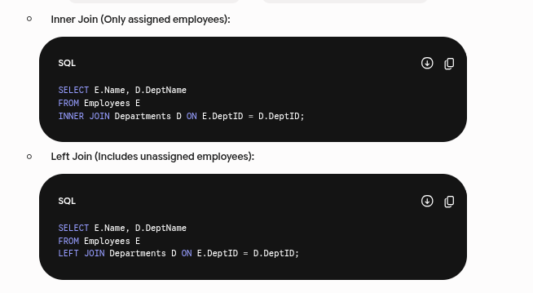

4. Important Exam Points
- NULL Behavior: Outer joins inject NULL for missing matches. Filtering these with WHERE column = NULL fails; always use IS NULL.
- Join Performance & Execution Order:
  - ON vs WHERE: ON filters rows before joining (crucial for outer joins); WHERE filters rows after joining.
- Cartesian Explosion: Forgetting the ON condition defaults to a CROSS JOIN, returning $M \times N$ tuples.
- Set Operations vs. Joins: Joins combine columns horizontally; UNION combines rows vertically (requires matching data types).

5. Quick Revision Summary
- INNER JOIN: $A \cap B$ (Intersection only).
- LEFT JOIN: $A + (A \cap B)$ (All left + matches).
- RIGHT JOIN: $B + (A \cap B)$ (All right + matches).
- FULL JOIN: $A \cup B$ (Union of all records).
- CROSS JOIN: $A \times B$ (No ON clause, returns $M \times N$ rows).

