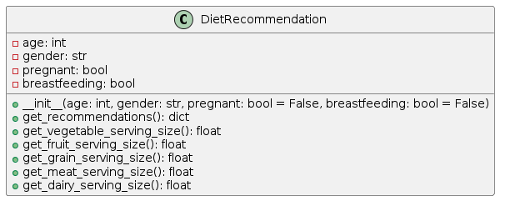
UML Class Diagram:

Assignment2.py Code:
class DietRecommendation:
def __init__(self, age, gender, pregnant=False, breastfeeding=False):
self.age = age
self.gender = gender
self.pregnant = pregnant
self.breastfeeding = breastfeeding
def get_recommendations(self):
recommendations = {
"vegetables": self.get_vegetable_serving_size(),
"fruits": self.get_fruit_serving_size(),
"grains": self.get_grain_serving_size(),
"meats": self.get_meat_serving_size(),
"dairy": self.get_dairy_serving_size()
}
return recommendations
def get_vegetable_serving_size(self):
serving_size = 0
if self.age in range(2, 4):
serving_size = 2.5
elif self.age in range(4, 9):
serving_size = 4.5
elif self.age in range(9, 12):
serving_size = 5
elif self.age in range(12, 14):
if self.gender == 'male':
serving_size = 5.5
elif self.gender == 'female':
serving_size = 5
elif self.age in range(14, 19):
if self.gender == 'male':
serving_size = 5.5
elif self.gender == 'female':
serving_size = 5
elif self.age in range(19, 51):
if self.gender == "male":
serving_size = 6
if self.gender == "female":
serving_size = 5
if self.pregnant and self.gender=='female':
serving_size = 5
if self.breastfeeding and self.gender=='female':
serving_size = 7.5
elif self.age in range(51, 71):
if self.gender == "male":
serving_size = 5.5
elif self.gender == "female":
serving_size = 5
elif self.age >= 71:
serving_size = 5
return serving_size
def get_fruit_serving_size(self):
serving_size = 0
if self.age in range(2, 4):
serving_size = 1
elif self.age in range(4, 9):
serving_size = 1.5
elif self.age in range(9, 12):
serving_size = 2
elif self.age in range(12, 14):
serving_size = 2
elif self.age in range(14, 19):
serving_size = 2
elif self.age in range(19, 51):
serving_size = 2
elif self.age in range(51, 71):
serving_size = 2
elif self.age >= 71:
serving_size = 2
return serving_size
def get_grain_serving_size(self):
serving_size = 0
if self.age in range(2, 4):
serving_size = 4
elif self.age in range(4, 9):
serving_size = 4
elif self.age in range(9, 12):
if self.gender == 'male':
serving_size = 5
elif self.gender == 'female':
serving_size = 4
elif self.age in range(12, 14):
if self.gender == 'male':
serving_size = 6
elif self.gender == 'female':
serving_size = 5
elif self.age in range(14, 19):
serving_size = 7
elif self.age in range(19, 51):
if self.gender == "male":
serving_size = 6
if self.gender == "female":
serving_size = 6
if self.pregnant:
serving_size = 8.5
if self.breastfeeding:
serving_size = 9
elif self.age in range(51, 71):
if self.gender == "male":
serving_size = 6
if self.gender == "female":
serving_size = 4
elif self.age >= 71:
if self.gender == 'male':
serving_size = 4.5
elif self.gender == 'female':
serving_size = 3
return serving_size
def get_meat_serving_size(self):
serving_size = 0
if self.age in range(2, 4):
serving_size = 1
elif self.age in range(4, 9):
serving_size = 1.5
elif self.age in range(9, 12):
serving_size = 2.5
elif self.age in range(12, 14):
serving_size = 2.5
elif self.age in range(14, 19):
serving_size = 2.5
elif self.age in range(19, 51):
if self.gender == "male":
serving_size = 3
if self.gender == "female":
serving_size = 2.5
if self.pregnant:
serving_size = 3.5
if self.breastfeeding:
serving_size = 2.5
elif self.age in range(51, 71):
if self.gender == "male":
serving_size = 2.5
if self.gender == "female":
serving_size = 2
elif self.age >= 71:
if self.gender == 'male':
serving_size = 2.5
elif self.gender == 'female':
serving_size = 2
return serving_size
def get_dairy_serving_size(self):
serving_size = 0
if self.age in range(2, 4):
serving_size = 1.5
elif self.age in range(4, 9):
if self.gender == 'male':
serving_size = 2
else:
serving_size = 1.5
elif self.age in range(9, 12):
if self.gender == 'male':
serving_size = 2.5
elif self.gender == 'female':
serving_size = 3
elif self.age in range(12, 14):
serving_size = 3.5
elif self.age in range(14, 19):
serving_size = 3.5
elif self.age in range(19, 51):
serving_size = 2.5
elif self.age in range(51, 71):
if self.gender == "male":
serving_size = 2.5
if self.gender == "female":
serving_size = 4
elif self.age >= 71:
if self.gender == 'male':
serving_size = 3.5
elif self.gender == 'female':
serving_size = 4
return serving_size
def print_food_descriptions():
print("\nAdditionally, here are detailed descriptions of what constitutes a single serving for each food category:")
print(
"\nVEGETABLES\nSingle serve of vegetable is 75g (100-350kJ). Here are some examples of single serve of Vegetable:")
print("• 0.5 cup of cooked green or orange vegetables (like broccoli, spinach, carrots, or pumpkin)")
print("• 0.5 cup of cooked dried or canned beans, peas, or lentils")
print("• 1 cup of green leafy or raw salad vegetables")
print("• 0.5 cup of sweet corn")
print("• 0.5 of a medium potato or other starchy vegetables (such as sweet potato, taro, or cassava)")
print("• 1 medium tomato")
print("\nFRUITS\nSingle serve of fruit is 150g (350kJ). Here are some examples of single serve of fruit:")
print("• 1 medium apple, banana, orange, or pear")
print("• 2 small apricots, kiwi fruits, or plums")
print("• 1 cup of diced or canned fruit (with no added sugar)")
print("\nGRAINS\nSingle serve of grain is (500kJ). Here are some examples of single serve of grain:")
print("• 1 slice (40g) of bread")
print("• 0.5 medium (40g) roll or flat bread")
print("• 0.5 cup (75-120g) of cooked rice, pasta, noodles, barley, buckwheat, semolina, polenta, bulgur or quinoa")
print("• 0.5 cup (120g) of cooked porridge")
print("• 0.66 cup (30g) of wheat cereal flakes")
print("• 0.75 cup (30g) of muesli")
print("• 3 (35g) crispbreads")
print("• 1 (60g) crumpet")
print("• 1 small (35g) English muffin or scone")
print("\nMEAT\nSingle serve of meat is (500-600kJ). Here are some examples of single serve of meat:")
print("• 65g cooked lean red meats such as beef, lamb, veal, pork, goat, or kangaroo (about 90-100g raw)")
print("• 80g cooked lean poultry such as chicken or turkey (100g raw)")
print("• 100g cooked fish fillet (about 115g raw) or one small can of fish")
print("• 2 large (120g) eggs")
print("• 1 cup (150g) cooked or canned legumes/beans such as lentils, chickpeas, or split peas")
print("• 170g tofu")
print("• 30g nuts, seeds, peanut or almond butter, tahini, or other nut or seed paste")
print("\nDAIRY\nSingle serve of dairy is (500-600kJ). Here are some examples of single serve of dairy:")
print("• 1 cup (250ml) of fresh, UHT long life, reconstituted powdered milk or buttermilk")
print("• 0.5 cup (120ml) of evaporated milk")
print("• 2 slices (40g) or a 4 x 3 x 2 cm cube (40g) of hard cheese, such as cheddar")
print("• 0.5 cup (120g) of ricotta cheese")
print("• 0.25 cup (200g) of yoghurt")
print("• 1 cup (250ml) of soy, rice or other cereal drink with at least 100mg of added calcium per 100ml")
def main():
try:
age = int(input("Enter your age: "))
if age <= 0:
raise ValueError("Age must be a positive integer.")
if age>120:
raise ValueError("This can't be a human's age!")
gender = input("Enter your gender (male/female): ").lower()
if gender not in ['male', 'female']:
raise ValueError("Gender must be 'male' or 'female'.")
pregnant_input = input("Are you pregnant? (yes/no): ").lower()
if pregnant_input not in ['yes', 'no']:
raise ValueError("Please enter 'yes' or 'no'.")
pregnant = pregnant_input == "yes"
breastfeeding_input = input("Are you breastfeeding? (yes/no): ").lower()
if breastfeeding_input not in ['yes', 'no']:
raise ValueError("Please enter 'yes' or 'no'.")
breastfeeding = breastfeeding_input == "yes"
if gender == "male" and (pregnant or breastfeeding):
raise ValueError("Men cannot be pregnant and breastfeeding at the same time.")
if age>=51 and age<=70 and (pregnant or breastfeeding):
raise ValueError("This is not normal to be pregnant in this age")
if age<19 and (pregnant or breastfeeding):
raise ValueError("Too young to be pregnant!")
recommendation = DietRecommendation(age, gender, pregnant, breastfeeding)
recommendations = recommendation.get_recommendations()
print("\nBased on your inputs, the minimum recommended servings are:")
for food_group, serving_size in recommendations.items():
print(f"{food_group.capitalize()}: {serving_size} servings per day")
print_food_descriptions()
export = input("\nWould you like to export these recommendations and serving sizes? (yes/no): ").lower()
if export == "yes":
filename = input("Enter a filename for the export (leave blank for 'DietaryRecommendations.txt'): ").strip()
if filename and not filename.endswith(".txt"):
raise ValueError("Filename must end with '.txt'.")
filename = filename if filename else "DietaryRecommendations.txt"
with open(filename, "w") as file:
file.write("Dietary Recommendations\n\n")
for food_group, serving_size in recommendations.items():
file.write(f"{food_group.capitalize()}: {serving_size} servings per day\n")
file.write(
"\nAdditionally, here are detailed descriptions of what constitutes a single serving for each food category:\n")
file.write(
"\nVEGETABLES\nSingle serve of vegetable is 75g (100-350kJ). Here are some examples of single serve of Vegetable:\n")
file.write("• 0.5 cup of cooked green or orange vegetables (like broccoli, spinach, carrots, or pumpkin)\n")
file.write("• 0.5 cup of cooked dried or canned beans, peas, or lentils\n")
file.write("• 1 cup of green leafy or raw salad vegetables\n")
file.write("• 0.5 cup of sweet corn\n")
file.write(
"• 0.5 of a medium potato or other starchy vegetables (such as sweet potato, taro, or cassava)\n")
file.write("• 1 medium tomato\n")
file.write(
"\nFRUITS\nSingle serve of fruit is 150g (350kJ). Here are some examples of single serve of fruit:\n")
file.write("• 1 medium apple, banana, orange, or pear\n")
file.write("• 2 small apricots, kiwi fruits, or plums\n")
file.write("• 1 cup of diced or canned fruit (with no added sugar)\n")
file.write("\nGRAINS\nSingle serve of grain is (500kJ). Here are some examples of single serve of grain:\n")
file.write("• 1 slice (40g) of bread\n")
file.write("• 0.5 medium (40g) roll or flat bread\n")
file.write(
"• 0.5 cup (75-120g) of cooked rice, pasta, noodles, barley, buckwheat, semolina, polenta, bulgur or quinoa\n")
file.write("• 0.5 cup (120g) of cooked porridge\n")
file.write("• 0.66 cup (30g) of wheat cereal flakes\n")
file.write("• 0.75 cup (30g) of muesli\n")
file.write("• 3 (35g) crispbreads\n")
file.write("• 1 (60g) crumpet\n")
file.write("• 1 small (35g) English muffin or scone\n")
file.write("\nMEAT\nSingle serve of meat is (500-600kJ). Here are some examples of single serve of meat:\n")
file.write(
"• 65g cooked lean red meats such as beef, lamb, veal, pork, goat, or kangaroo (about 90-100g raw)\n")
file.write("• 80g cooked lean poultry such as chicken or turkey (100g raw)\n")
file.write("• 100g cooked fish fillet (about 115g raw) or one small can of fish\n")
file.write("• 2 large (120g) eggs\n")
file.write("• 1 cup (150g) cooked or canned legumes/beans such as lentils, chickpeas, or split peas\n")
file.write("• 170g tofu\n")
file.write("• 30g nuts, seeds, peanut or almond butter, tahini, or other nut or seed paste\n")
file.write(
"\nDAIRY\nSingle serve of dairy is (500-600kJ). Here are some examples of single serve of dairy:\n")
file.write("• 1 cup (250ml) of fresh, UHT long life, reconstituted powdered milk or buttermilk\n")
file.write("• 0.5 cup (120ml) of evaporated milk\n")
file.write("• 2 slices (40g) or a 4 x 3 x 2 cm cube (40g) of hard cheese, such as cheddar\n")
file.write("• 0.5 cup (120g) of ricotta cheese\n")
file.write("• 0.25 cup (200g) of yoghurt\n")
file.write(
"• 1 cup (250ml) of soy, rice or other cereal drink with at least 100mg of added calcium per 100ml\n")
print(f"Recommendations and serving sizes have been exported to {filename}")
except ValueError as e:
print(f"Error: {e}. Please enter valid input.")
except Exception as e:
print(f"An unexpected error occurred: {e}")
if __name__ == "__main__":
main()

Description:
Functionality:
The program is designed to provide personalized dietary recommendations based on user inputs such as age, gender, and whether they are pregnant or breastfeeding. It calculates the recommended servings of various food groups including vegetables, fruits, grains, meats, and dairy products according to established guidelines. Additionally, it allows the user to export these recommendations to a text file if desired.

Design Decisions:
1. Class Structure: The program utilizes a single class DietRecommendation to encapsulate all the functionality related to generating dietary recommendations. This class follows the principle of encapsulation, bundling together data (attributes) and behaviors (methods) that operate on the data.
2. Modular Functions: Each food groups serving size calculation is separated into individual methods within the DietRecommendation class, promoting code readability and maintainability.
3. User Interaction: The program interacts with the user through the command line interface (CLI), prompting for input using input() function calls and displaying output accordingly. This provides a straightforward way for users to input their information and receive recommendations.
4. Export Functionality: The program offers the option to export the recommendations to a text file, enhancing user convenience by allowing them to save the information for future reference.

Exception Handling Approach:
1. ValueError Handling: The program employs try-except blocks to catch ValueError exceptions raised when the user inputs invalid data, such as non-numeric age, non-binary gender, or incorrect responses to pregnancy/breastfeeding questions.
2. Custom Error Messages: Custom error messages are provided to guide the user in correcting their input. For example, if the user enters a negative age or an age over 120, the program informs them that the input must be a positive integer and within a reasonable range.
3. Logical Validation: The program includes logical validations to ensure that certain combinations of inputs are not allowed, such as a male user being pregnant or breastfeeding, or users in specific age ranges being pregnant or breastfeeding, which might not be biologically plausible.
4. Catch-All Exception Handling: An outer except block is included to handle any unexpected errors that may occur during program execution. This helps to prevent crashes and provides a more graceful error handling experience for the user.

Class Attributes:
- age: Represents the age of the individual for whom the dietary recommendations are being calculated.
- gender: Represents the gender of the individual, either male or female.
- pregnant: Represents whether the individual is pregnant. Defaults to False.
- breastfeeding: Represents whether the individual is breastfeeding. Defaults to False.

Methods:
1. __init__(self, age, gender, pregnant=False, breastfeeding=False):
- Constructor method that initializes the DietRecommendation object with the provided age, gender, pregnancy status, and breastfeeding status.
2. get_recommendations(self):
- Method that calculates and returns the recommended servings of different food groups based on age, gender, pregnancy, and breastfeeding status.
- Returns a dictionary containing recommended servings for vegetables, fruits, grains, meats, and dairy.
3. get_vegetable_serving_size(self):
- Method that calculates the recommended serving size for vegetables based on age, gender, pregnancy, and breastfeeding status.
- Returns the recommended serving size in grams.
4. get_fruit_serving_size(self):
- Method that calculates the recommended serving size for fruits based on age, gender, pregnancy, and breastfeeding status.
- Returns the recommended serving size in grams.
5. get_grain_serving_size(self):
- Method that calculates the recommended serving size for grains based on age, gender, pregnancy, and breastfeeding status.
- Returns the recommended serving size in grams.
6. get_meat_serving_size(self):
- Method that calculates the recommended serving size for meats based on age, gender, pregnancy, and breastfeeding status.
- Returns the recommended serving size in grams.
7. get_dairy_serving_size(self):
- Method that calculates the recommended serving size for dairy products based on age, gender, pregnancy, and breastfeeding status.
- Returns the recommended serving size in grams.
Utility Function:
- print_food_descriptions():
- Utility function that prints detailed descriptions of what constitutes a single serving for each food category (vegetables, fruits, grains, meats, dairy). This function is not part of the DietRecommendation class but provides supplementary information to the user.

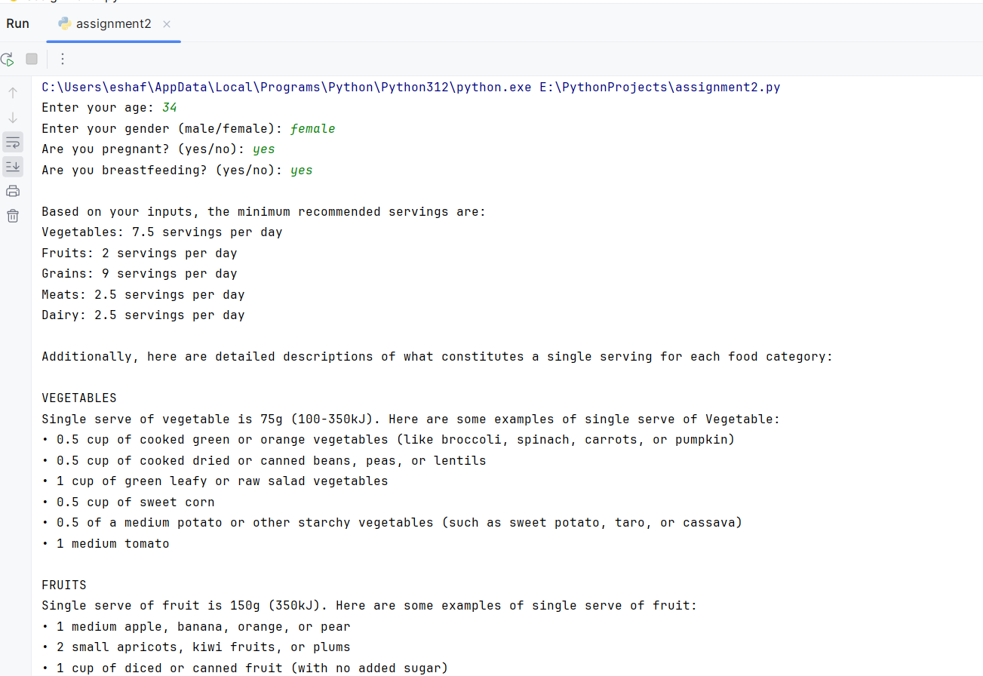
Outputs:

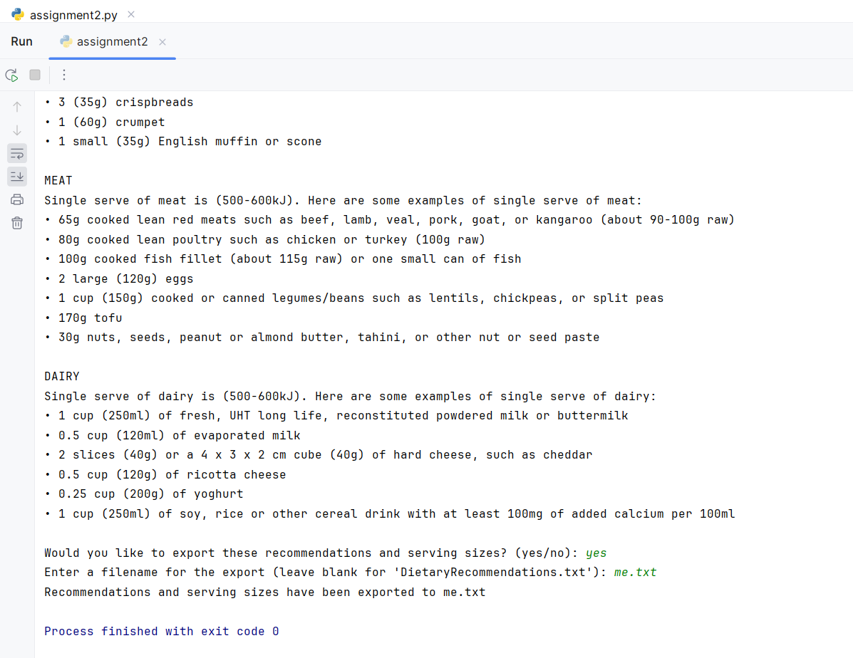
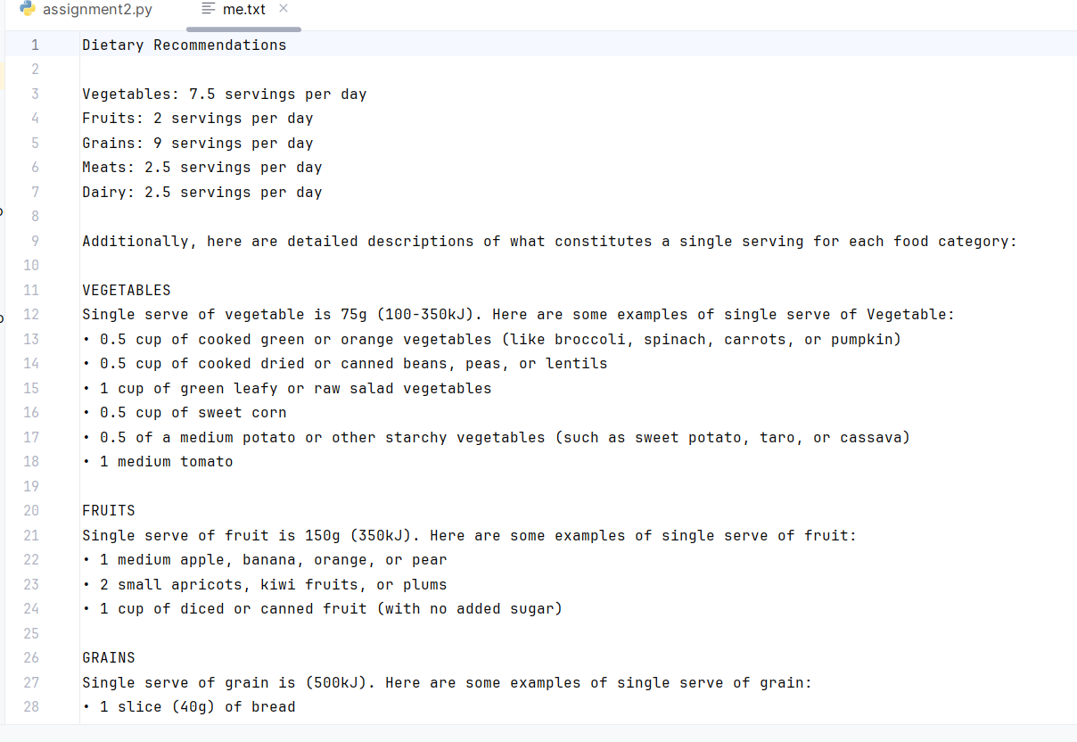
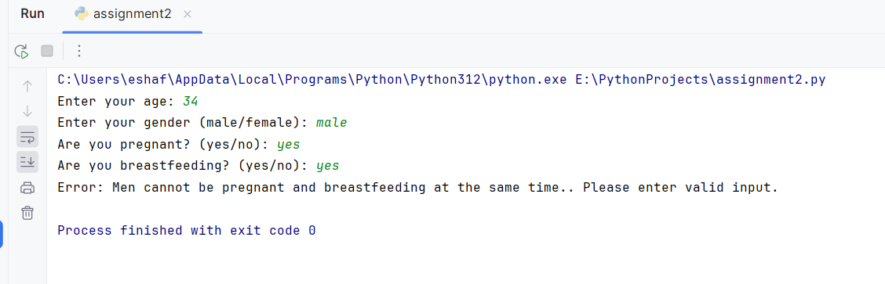
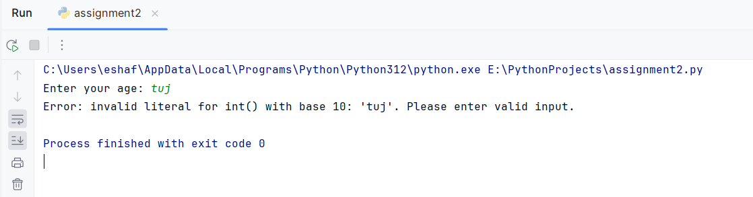
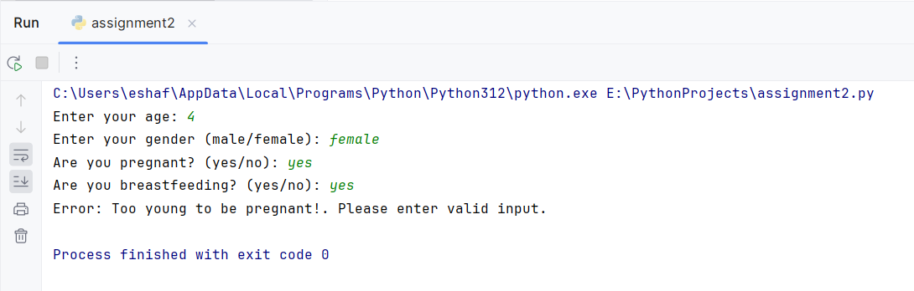
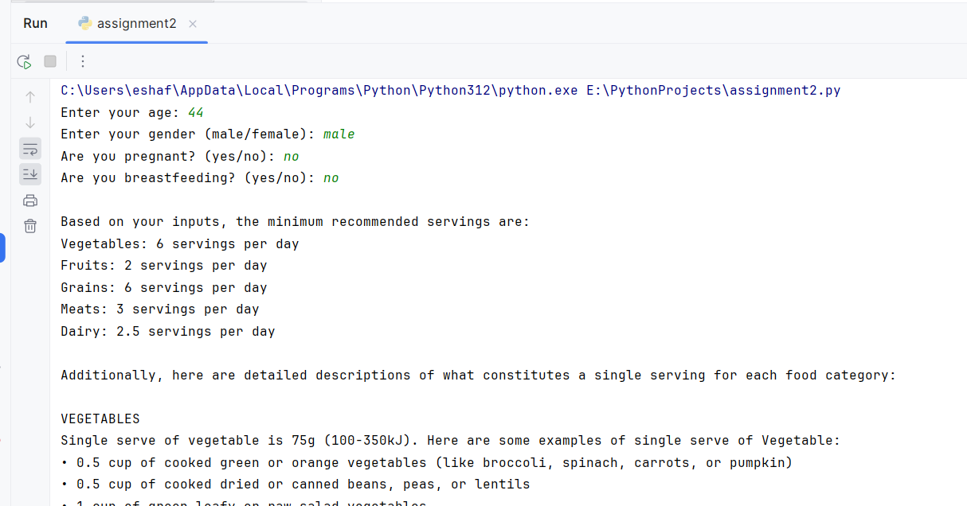
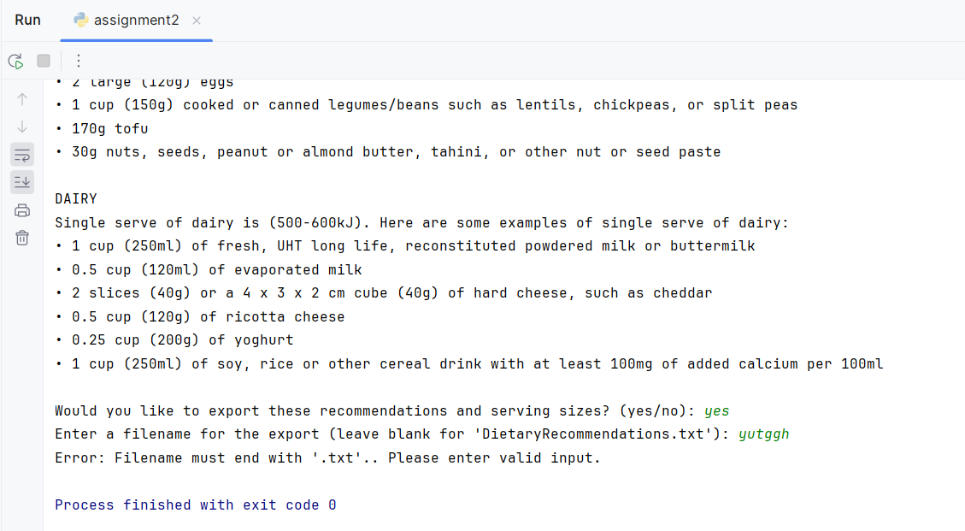
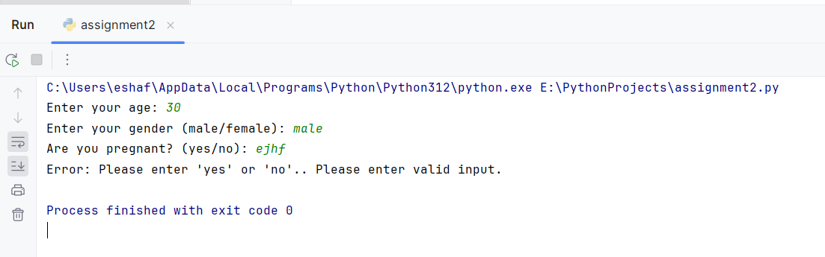
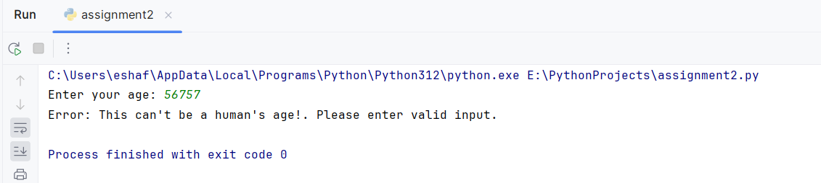

Test_assignment.py code:
import unittest
from assignment2 import DietRecommendation
class TestDietRecommendation(unittest.TestCase):
def test_get_recommendations(self):
# Test case 1: Male, age > 19, not pregnant, not breastfeeding
recommendation1 = DietRecommendation(35, "male", pregnant=False, breastfeeding=False)
expected_recommendations1 = {
"vegetables": 6,
"fruits": 2,
"grains": 6,
"meats": 3,
"dairy": 2.5
}
self.assertEqual(recommendation1.get_recommendations(), expected_recommendations1)
# Test case 2: Female, age < 19, not pregnant, not breastfeeding
recommendation2 = DietRecommendation(17, "female", pregnant=False, breastfeeding=False)
expected_recommendations2 = {
"vegetables": 5,
"fruits": 2,
"grains": 7,
"meats": 2.5,
"dairy": 3.5
}
self.assertEqual(recommendation2.get_recommendations(), expected_recommendations2)

#Test case 2: Male, age>19 , pregnant ,breastfeeding
try:
DietRecommendation(34, "male", pregnant=True, breastfeeding=True).get_recommendations()
except ValueError as e:
self.assertEqual(str(e), "Men cannot be pregnant and breastfeeding at the same time.")
if __name__ == '__main__':
unittest.main()

Code Coverage Report:
