Program Functionlity and Design:
1. FoodComponent:
- calculate_weekly_serves(daily_intake: float): Abstract method to be implemented by subclasses for calculating weekly serves based on daily intake.
- __str__(): Abstract method to be implemented by subclasses for providing a string representation.
2. FoodItem:
- __init__(name: str, recommended_daily_serves: float, single_serve_size: float): Constructor to initialize a FoodItem object with name, recommended daily serves, and single serve size.
- calculate_weekly_serves(daily_intake: float): Calculates weekly serves based on daily intake and single serve size.
- __str__(): Returns a string representation of the FoodItem.
3. FoodCategory:
- Inherits from FoodItem.
- __init__(name: str, recommended_daily_serves: float, single_serve_size: float): Constructor to initialize a FoodCategory object.
- Adds an attribute category to represent the category name.
4. FoodDecorator:
- __init__(decorated_food: FoodComponent): Constructor to initialize a FoodDecorator object with a decorated food component.
- calculate_weekly_serves(daily_intake: float): Delegates calculation of weekly serves to the decorated food component.
- __str__(): Returns a string representation of the decorated food component.
5. NutritionalInfoDecorator:
- Inherits from FoodDecorator.
- __init__(decorated_food: FoodComponent): Constructor to initialize a NutritionalInfoDecorator object.
- Extends the functionality of FoodDecorator by adding nutritional information.
6. UserData:
- __init__(age: int, gender: str, weight: float, height: float, daily_intake: dict): Constructor to initialize a UserData object with age, gender, weight, height, and daily intake data.
- calculate_bmi(): Calculates the BMI based on user's weight and height.

7. Visualization Functions:
- visualize_bar_chart(user_data, food_categories): Generates a bar chart to visualize user's daily serving intake compared to recommended values across different food categories.
- visualize_pie_charts(user_data, food_categories): Generates pie charts to visualize user's daily serving intake compared to recommended values across different food categories.
- visualize_line_chart(user_data, food_categories): Generates a line chart to visualize user's daily serving intake compared to recommended values across different food categories.
- visualize_bubble_chart(user_data, food_categories): Generates a bubble chart to visualize user's daily serving intake compared to recommended values across different food categories.
- visualize_bmi_chart(bmi): Generates a BMI chart to visualize the user's BMI category based on calculated BMI value.

Design Pattern:
Decorator Pattern: Utilized in FoodDecorator and NutritionalInfoDecorator classes to add functionality dynamically to food components without modifying their structure.
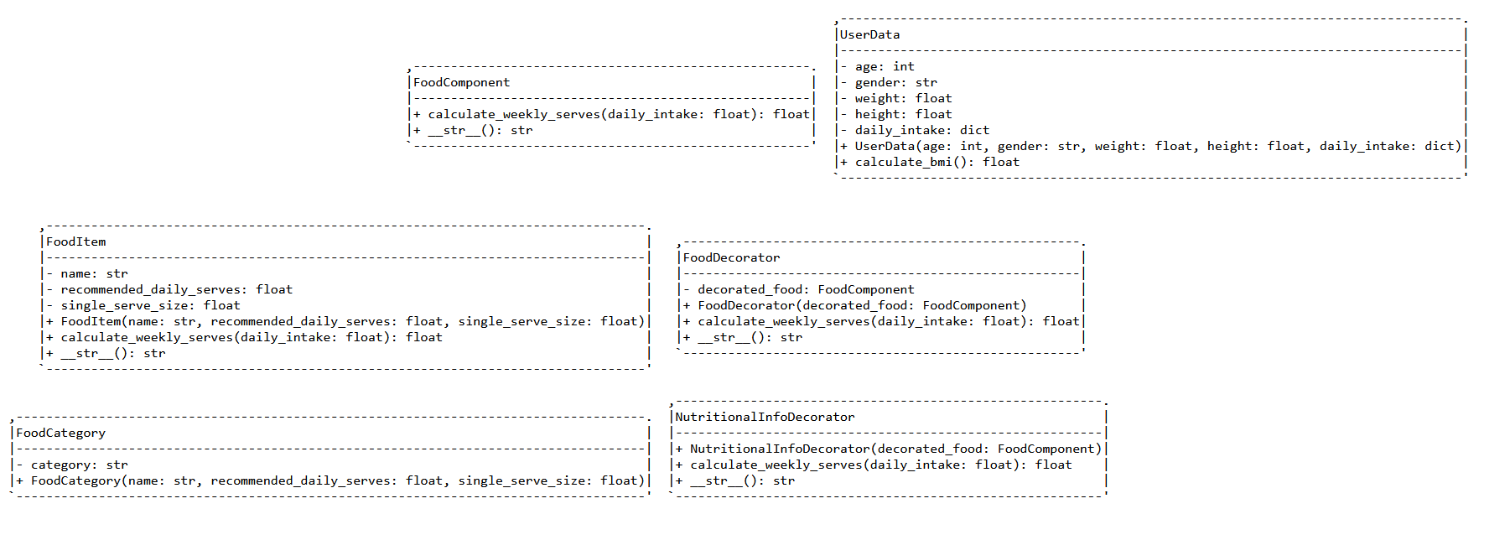

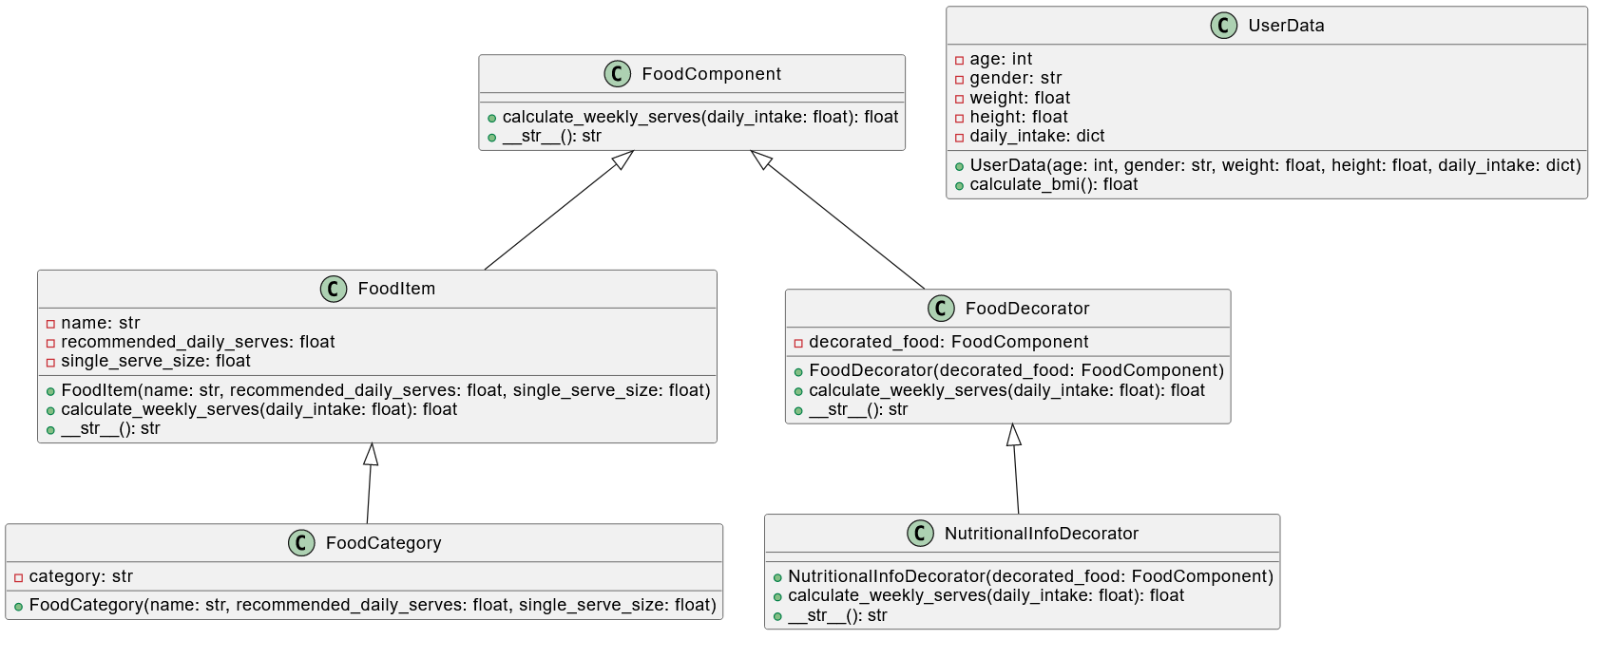

Screenshots of Test Results:

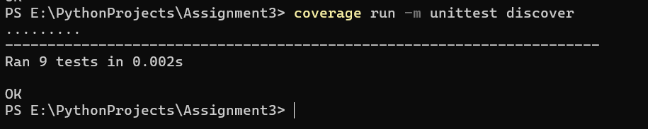
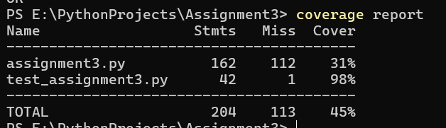

Demo Video Link: https://youtu.be/wZJKM_E4ms0?si=DqfYMcXKnIUDTs1o

