Description of Object Oriented Design:
Sure, here's the description of each class in the library management system code along with their attributes, methods, and relationships:

1. LibraryItem Class:
- Attributes:
- title: Stores the title of the library item.
- Methods:
- __init__(self, title): Initializes a new library item with its title.

2. Book Class (Inherits from LibraryItem):
- Attributes:
- id: A unique identifier for the book.
- author: The author of the book.
- available: A boolean indicating whether the book is currently available for borrowing.
- Methods:
- __init__(self, id, title, author): Initializes the book with a unique id, title, author, and sets availability to True.

3. Member Class:
- Attributes:
- member_id: A unique identifier for the library member.
- name: The name of the library member.
- borrowed_books: A list to keep track of the books borrowed by the member.
- Methods:
- __init__(self, member_id, name): Initializes the member with a member_id, name, and an empty list for borrowed_books.

4. Library Class:
- Attributes:
- books: A list to store all books in the library.
- members: A list to store all members of the library.
- next_book_id: An integer to keep track of the next unique book ID for new books.
- Methods:
- add_book(self, title, author): Adds a new book to the library with the given title and author.
- display_books(self): Displays the entire book collection along with their availability.
- search_book_by_name(self, name): Searches for books by name and displays matching results.
- display_members(self): Displays the list of current members in the library.
- add_member(self, name): Adds a new member to the library with the given name.
- search_member_by_id(self, member_id): Searches for a member by their ID and returns the member object if found.
- borrow_book(self, member_id, book_id): Allows a member to borrow a book from the library.
- return_book(self, member_id, book_id): Allows a member to return a borrowed book to the library.
- find_book_by_id(self, book_id): Helper method to find a book by its ID.

Relationships:
- The Book class inherits from the LibraryItem class, indicating an "is-a" relationship, where a book "is-a" library item.
- The Library class has compositions of Book and Member classes, meaning it contains instances of these classes as part of its own instance. This represents a "has-a" relationship, where a library "has" books and members.
- The Member class has an association with the Book class through the borrowed_books attribute, indicating that a member can borrow multiple books.

UML Class Diagram:

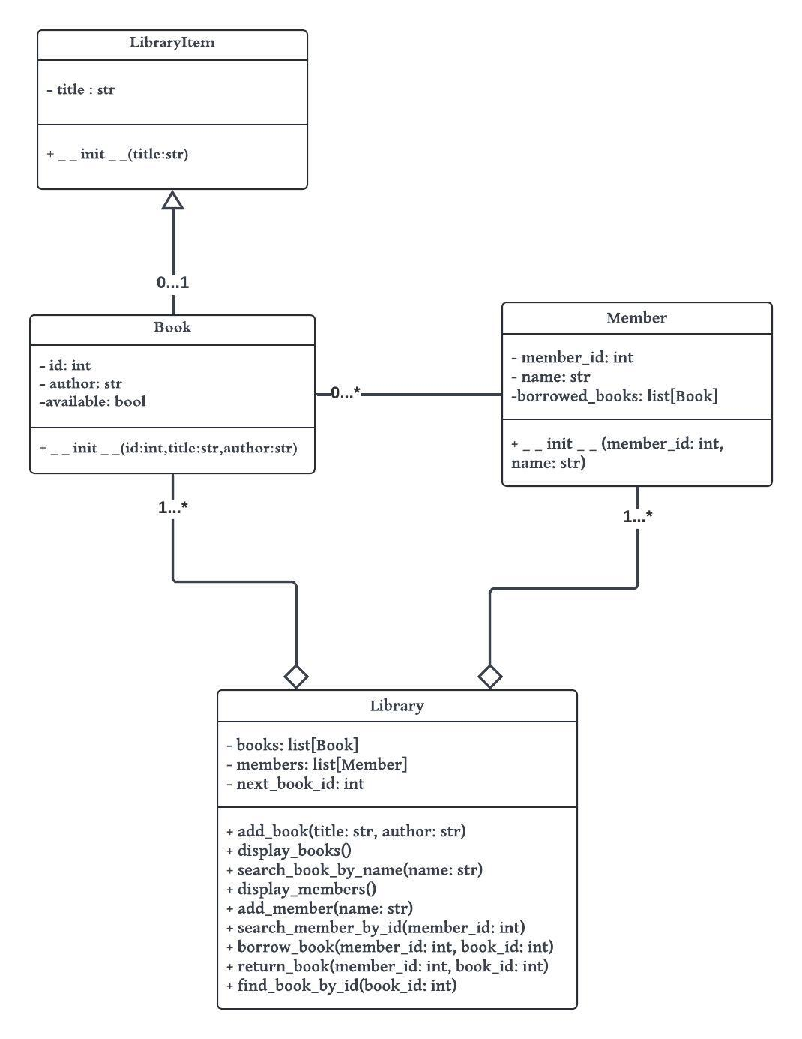
Screenshots of Running Results:
Show book collection:
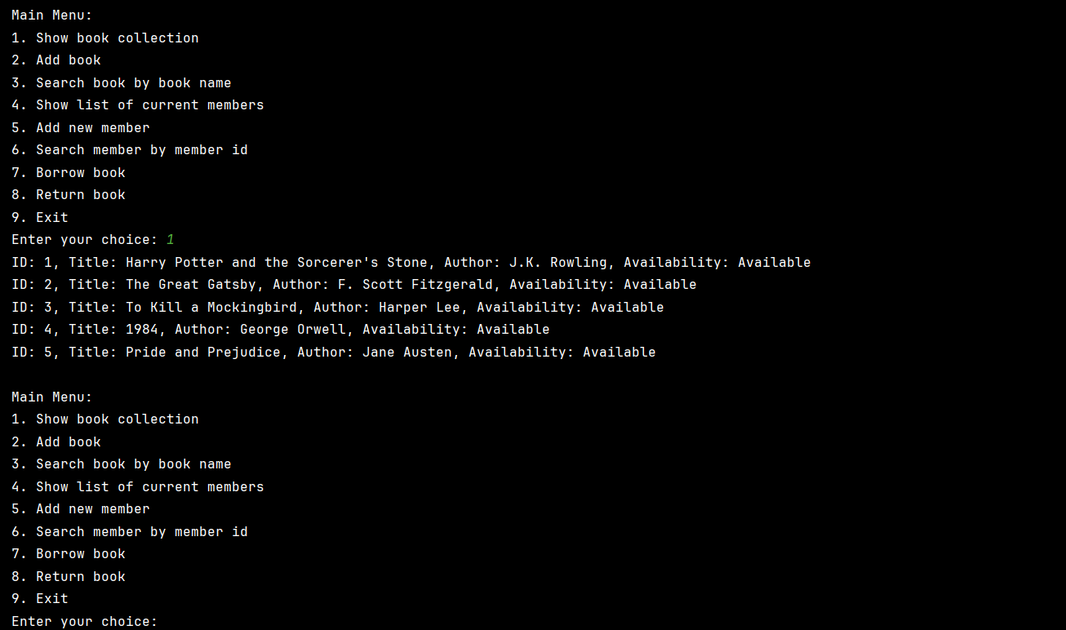
Add book:
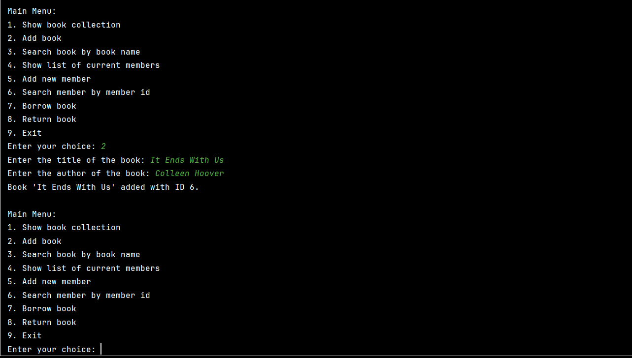

Search book by book name:
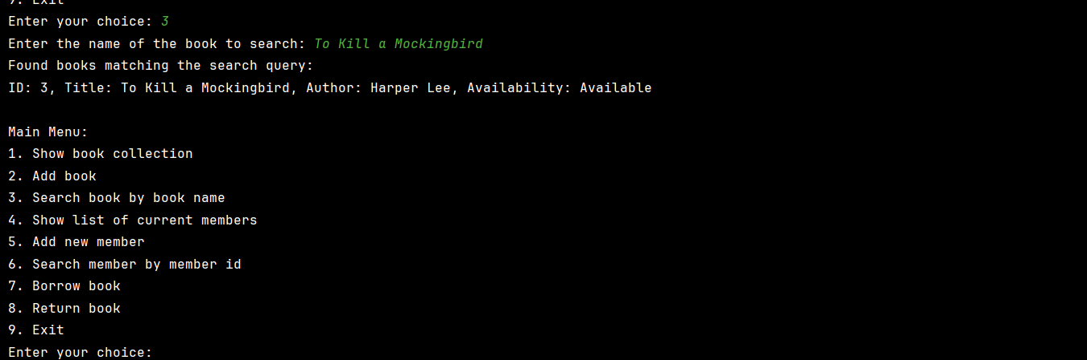
Show list of current members:
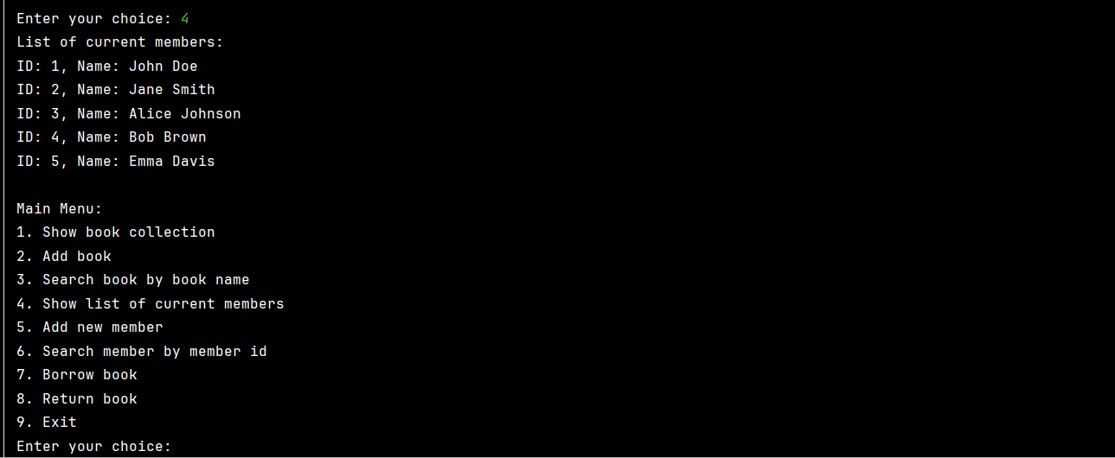
Add new member:
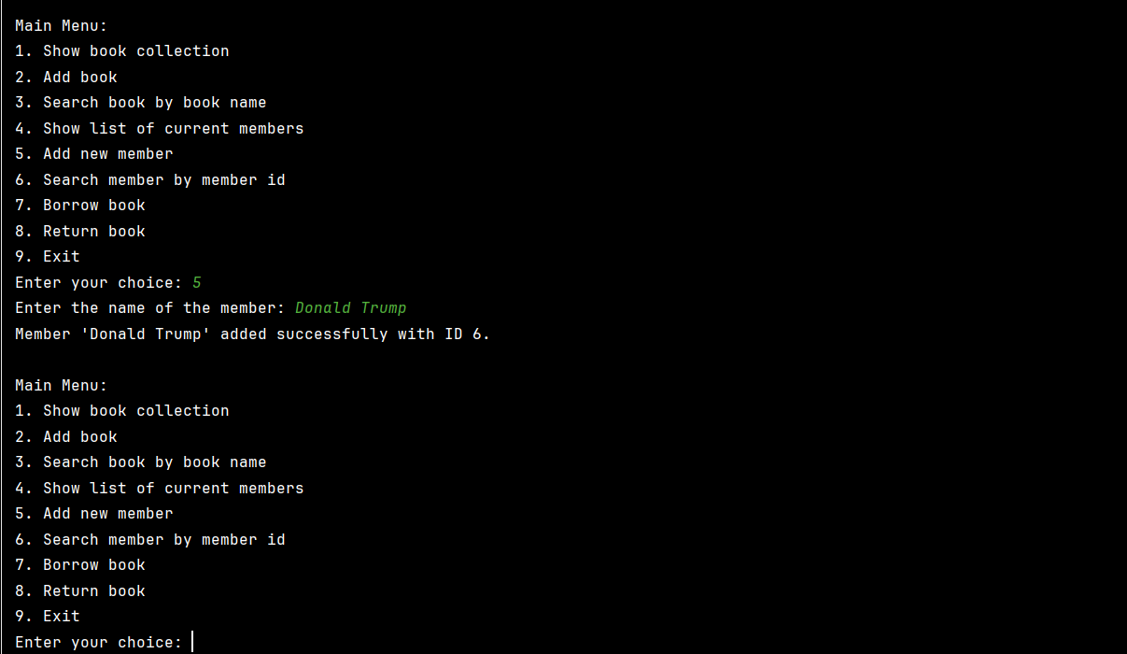
Search member by member id:
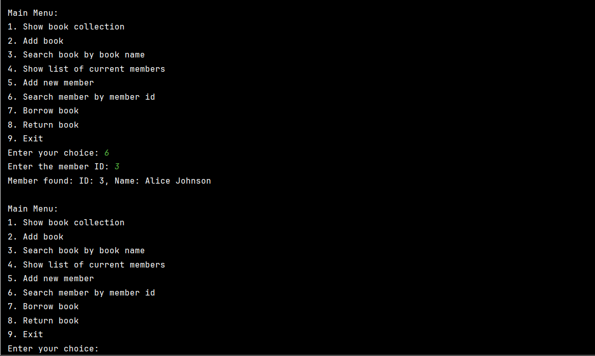
Borrow book:
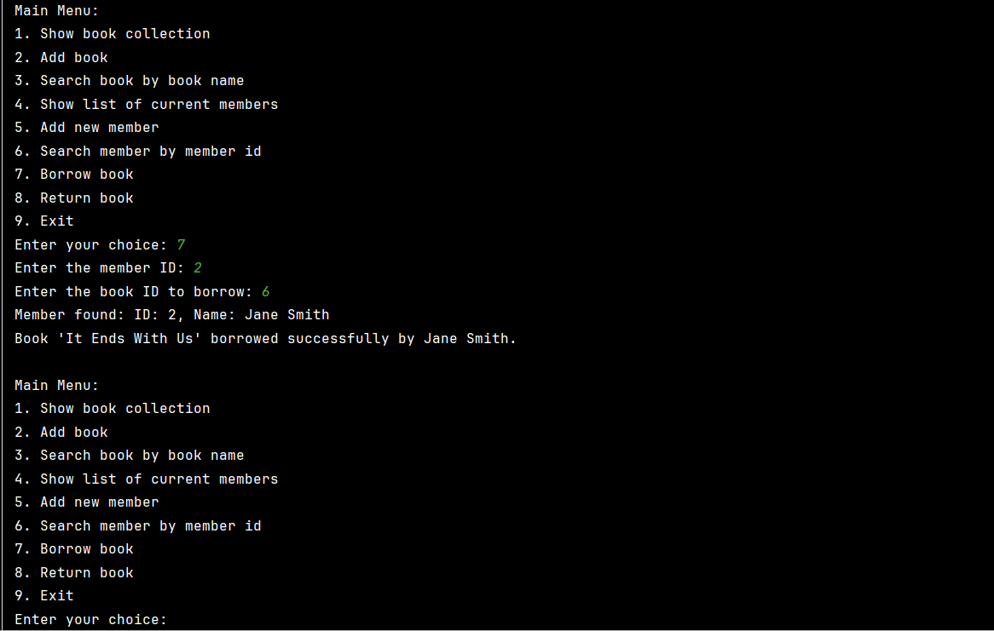

Return book:
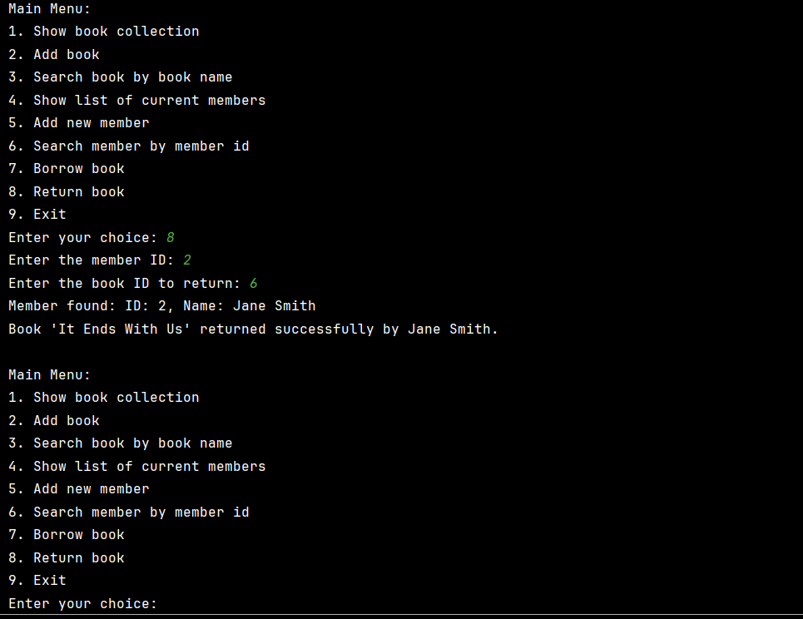
Exit:
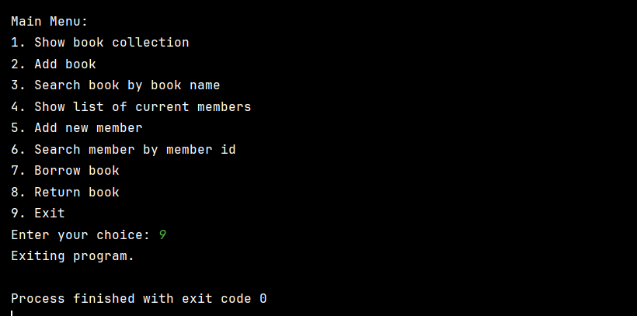

Source Code:
class LibraryItem:
def __init__(self, title):
self.title = title
class Book(LibraryItem):
def __init__(self, id, title, author):
super().__init__(title)
self.id = id
self.author = author
self.available = True
class Member:
def __init__(self, member_id, name):
self.member_id = member_id
self.name = name
self.borrowed_books = []
class Library:
def __init__(self):
self.books = []
self.members = []
self.next_book_id = 1
def add_book(self, title, author):
book = Book(self.next_book_id, title, author)
self.books.append(book)
self.next_book_id += 1
return book
def display_books(self):
if not self.books:
print("No books available in the library.")
return
for book in self.books:
availability = "Available" if book.available else "Not Available"
print(f"ID: {book.id}, Title: {book.title}, Author: {book.author}, Availability: {availability}")
def search_book_by_name(self, name):
found_books = [book for book in self.books if name.lower() in book.title.lower()]
if found_books:
print("Found books matching the search query:")
for book in found_books:
availability = "Available" if book.available else "Not Available"
print(f"ID: {book.id}, Title: {book.title}, Author: {book.author}, Availability: {availability}")
else:
print("No books found with the given name.")
def display_members(self):
if not self.members:
print("No members in the library.")
return
print("List of current members:")
for member in self.members:
print(f"ID: {member.member_id}, Name: {member.name}")
def add_member(self, name):
member_id = len(self.members) + 1 # Generating unique member ID
member = Member(member_id, name)
self.members.append(member)
return member
def search_member_by_id(self, member_id):
for member in self.members:
if member.member_id == member_id:
print(f"Member found: ID: {member.member_id}, Name: {member.name}")
return member
print("Member not found.")
return None
def borrow_book(self, member_id, book_id):
member = self.search_member_by_id(member_id)
if not member:
print("Cannot borrow book. Member not found.")
return
book = self.find_book_by_id(book_id)
if not book:
print("Cannot borrow book. Book not found.")
return
if not book.available:
print("Sorry, the book is not available for borrowing.")
return
member.borrowed_books.append(book)
book.available = False
print(f"Book '{book.title}' borrowed successfully by {member.name}.")
def return_book(self, member_id, book_id):
member = self.search_member_by_id(member_id)
if not member:
print("Cannot return book. Member not found.")
return
for book in member.borrowed_books:
if book.id == book_id:
book.available = True
member.borrowed_books.remove(book)
print(f"Book '{book.title}' returned successfully by {member.name}.")
return
print("Cannot return book. Book not found in the member's borrowed list.")
def find_book_by_id(self, book_id):
for book in self.books:
if book.id == book_id:
return book
return None
def main():
library = Library()
# Adding some initial book and member data for testing
library.add_book("Harry Potter and the Sorcerer's Stone", "J.K. Rowling")
library.add_book("The Great Gatsby", "F. Scott Fitzgerald")
library.add_book("To Kill a Mockingbird", "Harper Lee")
library.add_book("1984", "George Orwell")
library.add_book("Pride and Prejudice", "Jane Austen")
library.add_member("John Doe")
library.add_member("Jane Smith")
library.add_member("Alice Johnson")
library.add_member("Bob Brown")
library.add_member("Emma Davis")
while True:
print("\nMain Menu:")
print("1. Show book collection")
print("2. Add book")
print("3. Search book by book name")
print("4. Show list of current members")
print("5. Add new member")
print("6. Search member by member id")
print("7. Borrow book")
print("8. Return book")
print("9. Exit")
choice = input("Enter your choice: ")
if choice == "1":
library.display_books()
elif choice == "2":
title = input("Enter the title of the book: ")
author = input("Enter the author of the book: ")
new_book = library.add_book(title, author)
print(f"Book '{new_book.title}' added with ID {new_book.id}.")
elif choice == "3":
name = input("Enter the name of the book to search: ")
library.search_book_by_name(name)
elif choice == "4":
library.display_members()
elif choice == "5":
name = input("Enter the name of the member: ")
new_member = library.add_member(name)
print(f"Member '{new_member.name}' added successfully with ID {new_member.member_id}.")
elif choice == "6":
member_id = int(input("Enter the member ID: "))
library.search_member_by_id(member_id)
elif choice == "7":
member_id = int(input("Enter the member ID: "))
book_id = int(input("Enter the book ID to borrow: "))
library.borrow_book(member_id, book_id)
elif choice == "8":
member_id = int(input("Enter the member ID: "))
book_id = int(input("Enter the book ID to return: "))
library.return_book(member_id, book_id)
elif choice == "9":
print("Exiting program.")
break
else:
print("Invalid choice. Please enter a number between 1 and 9.")
if __name__ == "__main__":
main()

