
Department of Computer Science
Computer Science Internship
Summer 2026

Internship Logbook
______________________________________

Prepared by:
Hind Alzaabi 100064650

Mentors:
Dr. Mohammed Shafique (supervisor)
Abdul Basit (mentor)

Submission Date:
08/08/2026

Week 1
I was introduced to the lab supervisors and mentors and was shown around the lab and the facilities provided. The mentors spoke about the type of research and application the eBrain Lab does. The rest of the week was spent reviewing machine learning coding, specifically Pytorch, as it was the required library for the internship and I was more familiar with Tensorflow. I utilized the Github repository: PyTorch for Deep Learning: Zero to Mastery course.

Week 2
I was tasked with reading and analysing 5 research papers, focusing on their core contributions, methodology and experimental results. I was also tasked with preparing a presentation that provides the main problem the paper addresses, the suggested solutions and their overall methodology, and results or conclusions of them. At the end of the presentation, I was required to display and speak about my past experience with machine learning and Pytorch.
The papers given were: Deep Compression, Distilling the Knowledge in a Neural Network, EfficientNet, MobileNet, MCUNet, which discuss methods to improve model performance and/or make models smaller for cheaper deployment while not reducing the accuracy significantly. The methods suggested varied from software, such as adding variables to the optimization function, to hardware, such as better utilization of memory during model execution.

Week 3
During this week, I was tasked with initial exploration of different EEG models on one common EEG dataset, where I had to deploy at least one baseline model and one state of the art model. I began by choosing the dataset and exploring it using the MOABB library. I then wrote a simple neural network model using Pytorch, where the model had 3 blocks of 2D convolutions and maxpooling, followed by softmax pooling. I then deployed EEGNet using a publicly available model from the original paper and then rewrote it from keras to pytorch. Finally, I ran another simple model that extracts common spatial patterns (csp) and then runs a linear discriminant analysis (LDA), which I used the MOABB library to create and test.
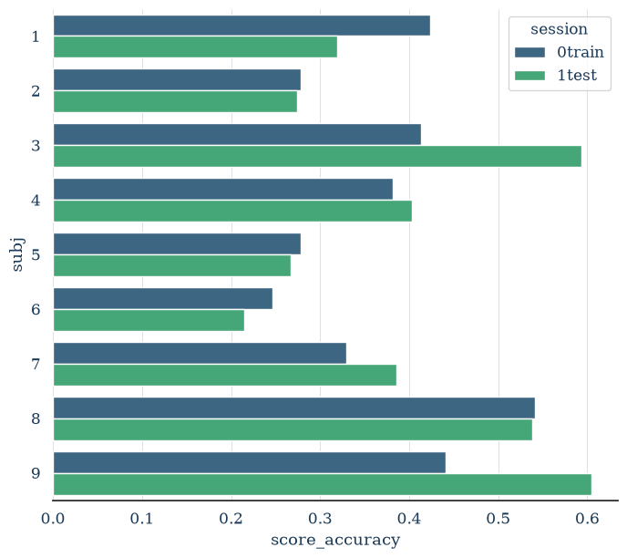
Figure 1: CSP + LDA leave one subject out performance per subject.
I determined that the LDA model was the most accurate and fastest model, where the 2 EEGNet models followed, but the pytorch one was significantly faster, the simple neural network model was the least accurate, which I presented to the mentors along with their interns.

Week 4
This week I was tasked with exploring the robustness of the LDA model by adding data augmentation methods to both the train and test datasets, this includes adding gaussian noise, removing random channels, scaling the amplitude of the EEG waves, removing random durations from the motor imagery sessions, and finally removing frequencies from different bandwidths.
I ran the tests using different scales to see how the model behaves, and presented them to my mentor, the results can be summarized as follows:
- Channel removal: the fronto-central nodes caused the largest drops in accuracy, specifically FC3 and FC4
- Scaling: the model performance was not affected by any level of scaling
- Adding noise: accuracy linearly dropped as noise was added.
- Removing durations: different durations caused varying effects on the accuracy, with no clear pattern, but the accuracy decrease was not too significant. Closer analysis of which segments on the motor imagery (MI) was removed showed that there could be a specific duration at the very beginning of the MI segment that is most informative.
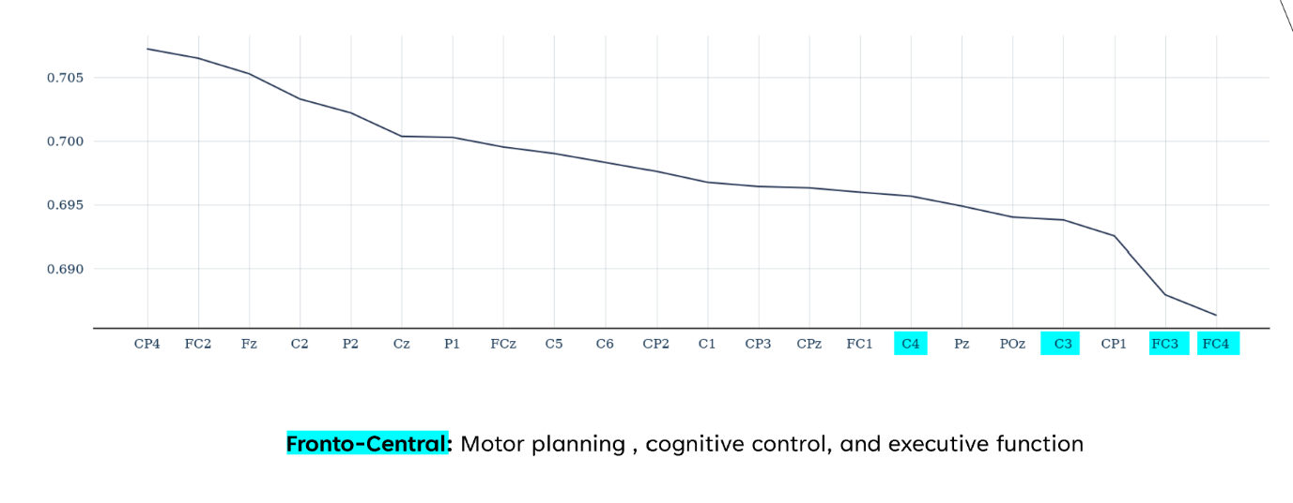
- Removing frequencies: accuracy decreased somewhat linearly as the bandwidth increased.
Figure 2: effect of removing channels on the accuracy.

Week 5
I continued my tests, but this time I applied the augmentation on either the training dataset alone, or the testing dataset alone, to imitate real, raw or imperfect data. I was given access to the lab’s GPU and was able to connect to it using remote controller on vscode. I presented my findings to the supervisor and both mentors along with their interns, the results can be summarized as follows:
- Channel removal: the test preprocessing caused the most significant drop in accuracy, with the informative channels generally being the same.
- Scaling: the train alone and test alone cases all were significantly affected by scaling, showing significant drops in accuracy
- Added noise: the train only set was more robust to noise, which the test only set reached 25% (randomized prediction) accuracy.
- Missing durations: all conditions were relatively robust across all missing durations, showing that the model generally uses the entire duration to learn and predict.
- Missing frequencies: This case was the most robust one, where accuracy drops were minimal across all conditions.

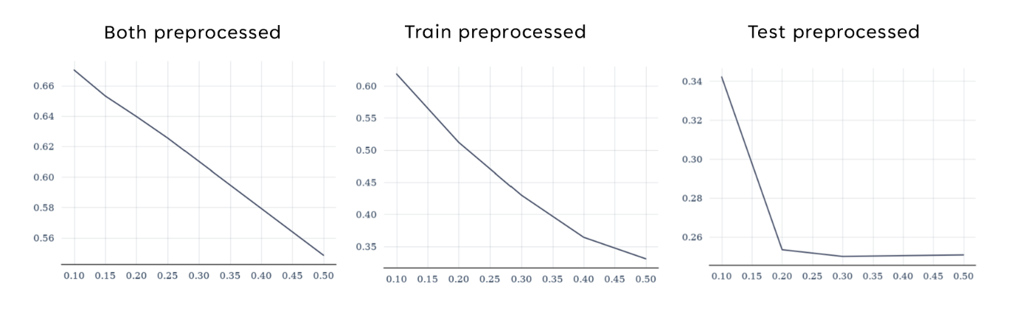
Figure 3: effect of adding noise in 3 conditions.
Week 6
This week I moved from testing the robustness of the LDA model to the EEGNet model, where I ran leave one session out tests on cases identical to the ones run in the previous week, I presented the findings to my supervisor and mentor, the main findings are:
- Scaling: Model is more robust when the test is scaled larger than train, with all cases dropping in accuracy as scale gets too large. Class 1 degraded the most in all cases, and larger scales cause all classes to be confused as class 4.
- Noise: There was a linear decrease in all cases, but adding noise to train outperformed all cases, which shows that adding noise to training data could improve robustness. As scale increased, all classes were confused as class 1.
- Missing durations: the test only case had the only drop in accuracy as the length of missing durations increased, with the train only set outperforming all cases, which also could be used to increase model robustness. In the test only preprocessed case, as duration increased, class 1 was getting confused as other classes.
- Missing frequencies: all cases had constant accuracy as bandwidth increased, with the test set case having the least accuracy.
Generally, I found that Class 1 was the hardest class and was often confused with and getting confused as Class 4, Classes 2 and 3 were the most robust and often confused with one another, class 4 was robust but gets confused as scales get larger.

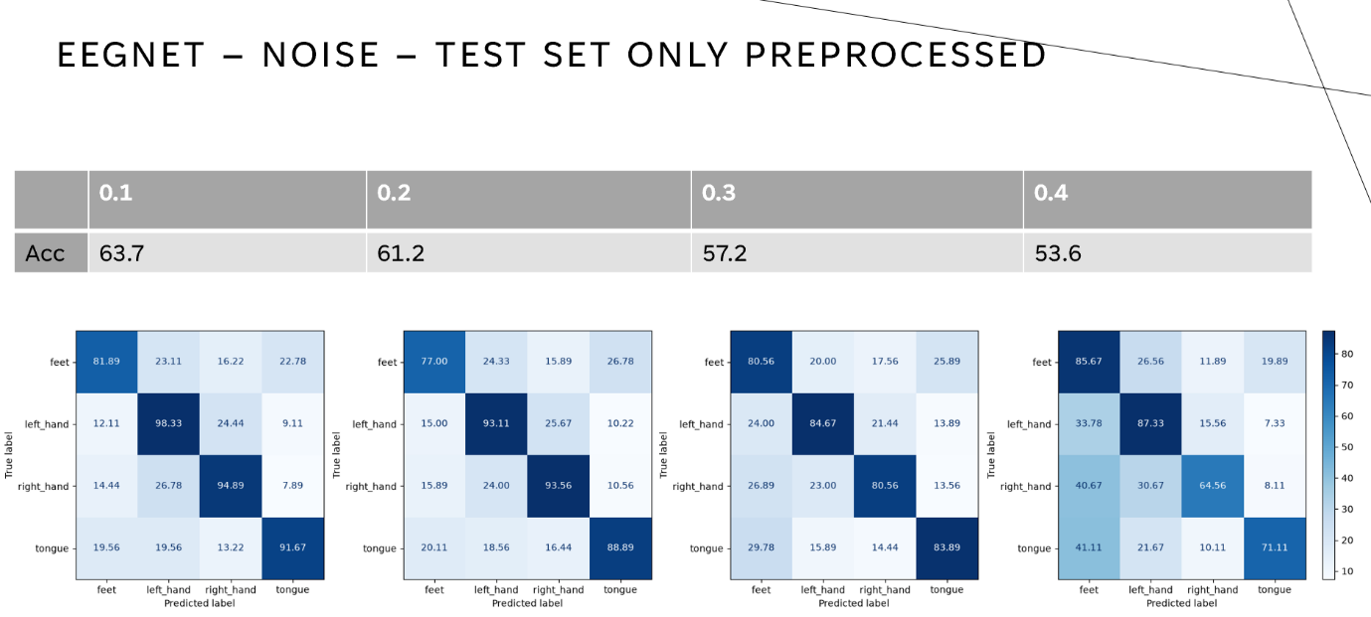
Figure 4: Performance of EEGNet as noise increases in the test set.
Week 7
I reran the tests but this time using leave one subject out to assess the model performance, but the patterns generally remained the same, but some robustness notes are:
- The model was robust when the test set was a different scale to the train set.
- The model performed best when a little noise was added to the train set.
- The model performs best when some durations are removed from the train set.
- All bandwidths cause the same accuracy decrease, almost no accuracy decrease when only the train set is missing frequencies, but there is a decrease in the test set case.
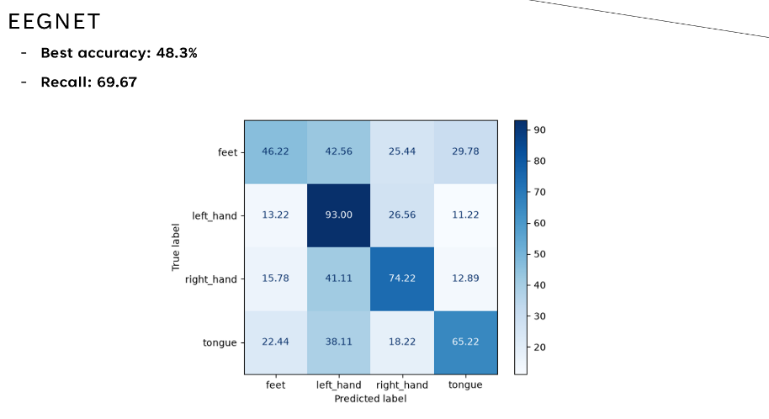
EEGNet accuracy was higher than the LDA model, however when looking at the subjects specifically, EEGNet has more extreme highs and extreme lows, while LDA has shown a lower deviation.
Figure 5: Average confusion matrix of EEGNet using leave one subject out as test.
Week 8
I was tasked with analyzing the causes behind the cases where accuracy decreased the most, notably some specific subjects performed worse than others, and why class 4 (MI of feet movement) always had the least accuracy and often was confused as/by other classes.
I looked into the logs from the previous week and plotted the accuracy changes for each subject under the 3 cases, and I found that while there were some general patterns, the accuracy changes were not very significant. What stood out most was a gap in accuracy in all conditions and cases, where subjects: 1, 3, 8, and 9 consistently outperformed subjects 2, 4, 5, 6, and 7. When comparing to LDA, the pattern was almost the same, except for subjects 4 and 7, which had similar performance to the “good” subjects.
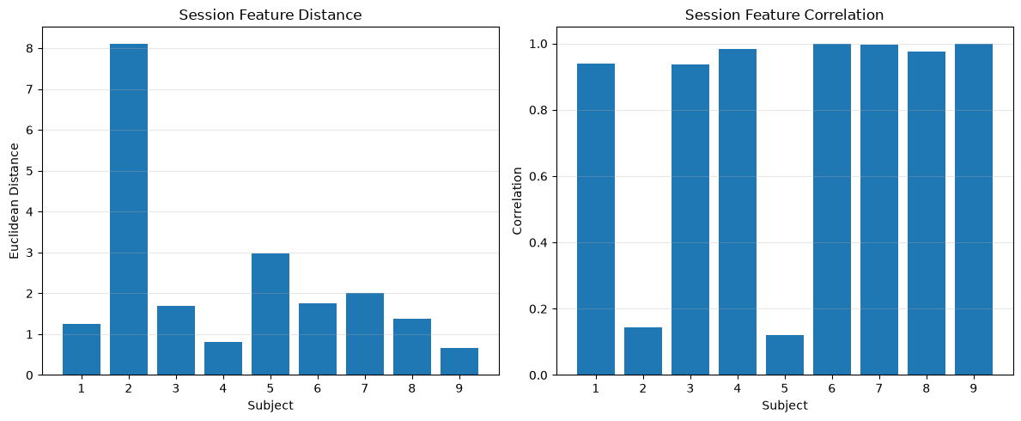
Looking into this, I analyzed the statistical variables such as mean, variance and any abnormal or noisy trials, where I found that subjects 2 and 5 had drastically less correlation across their session data compared to the other subjects.
Figure 6: correlation of each subject’s sessions
I also explored the power spectral density of each subject and the consistency within the trials of each class, but the results were inconclusive.
I then moved to exploring the class accuracy discrepancy, I began by running the LDA model onto pairwise cases for all the classes to determine whether the Feet class was inherently difficult, however the results showed good performance across all cases, and there was no significance when assessing the p-value. So, I looked into the recall for each class, and it was clear that the Feet class struggled a lot with it, and looking into where the feet predictions were going, I found that the model was rarely predicting feet, rather it was going to the other 3 classes.

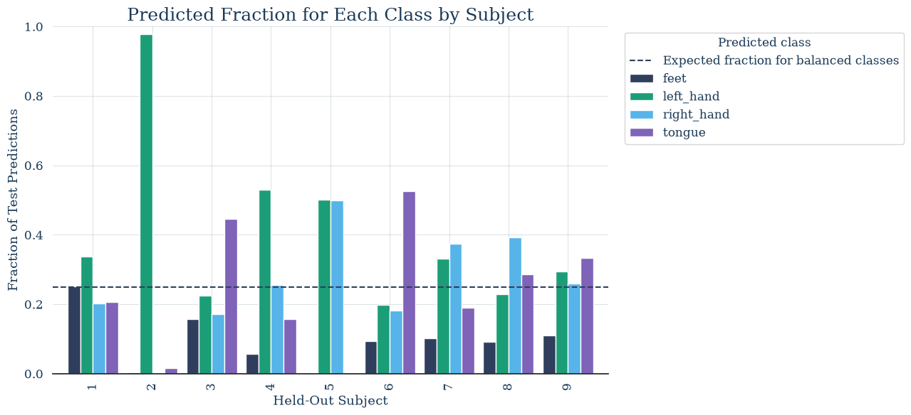
Figure 7: Fraction of classes being predicted as feet.
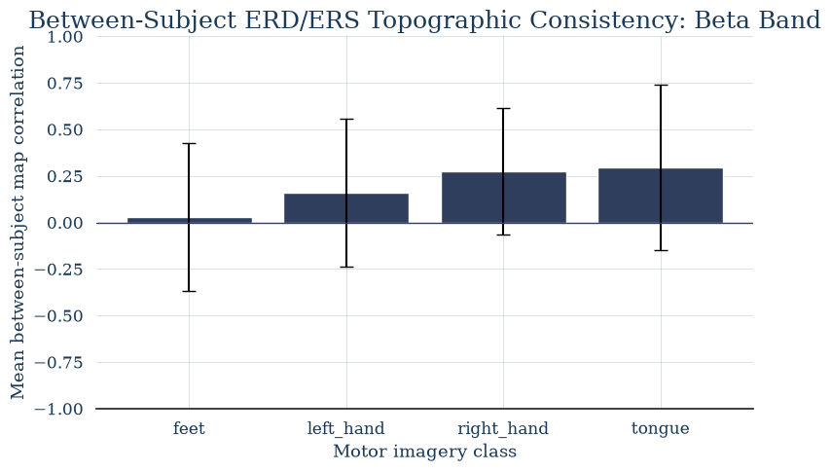
I looked at the ERD/ERS topographies of different classes, but there was no clear reason to the confusion there. So, I moved on to look at the variability of the beta and mu bands, where I found across the subjects, the feet class had the least correlation, which I looked into the corrected p-value and found that the feet vs right hand and feet vs left hand had significance, which could point to the model struggling with how different each person’s feet imagery is.
Figure 8: Between subject consistency

