BABU BANARASI DAS UNIVERSITY
SCHOOL OF COMPUTER APPLICATIONS

No SQL project

BBDU STUDENT MANAGEMENT SYSTEM USING MONGODB

Submitted By | Hinda sahani
Roll No. | 1250258224
Class | BCA DS & AI 23
Submitted To | Mr. Harendra Singh Rajpoot
Academic Session | 2026–2027
Submission Date | 25 September 2026

ACKNOWLEDGEMENT
I would like to express my sincere gratitude to Babu Banarasi Das University, School of Computer Applications, for providing me with the opportunity to complete this assignment. I am thankful to my faculty member, Mr. Harendra Singh Rajpoot, for his guidance and support throughout the practical work. I also appreciate the learning environment and resources provided by the university, which helped me understand MongoDB and its practical application in a Student Management System.
CREATE & USE DATABASE

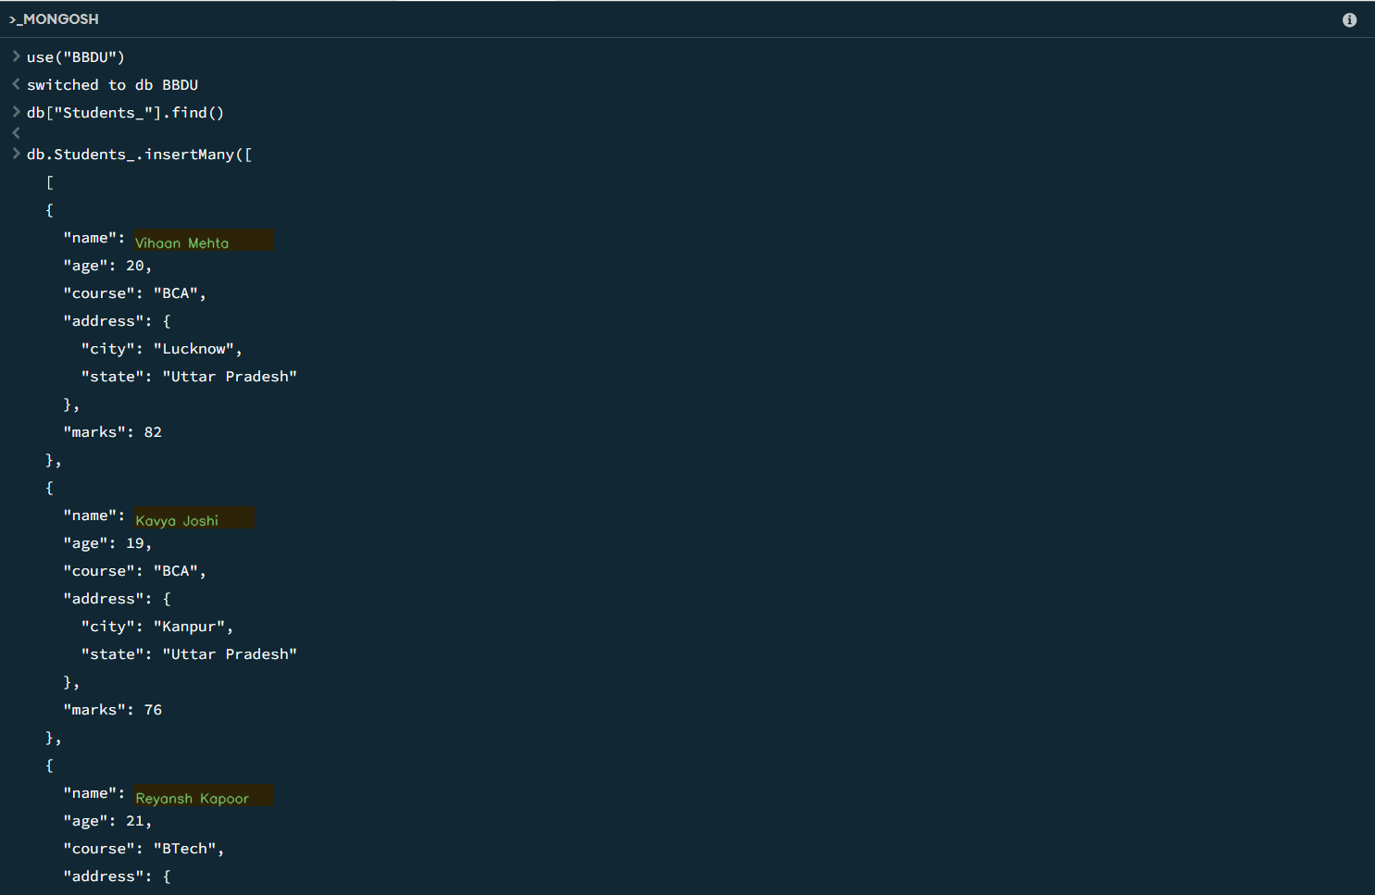

- INSERT 50 STUDENTS DATA

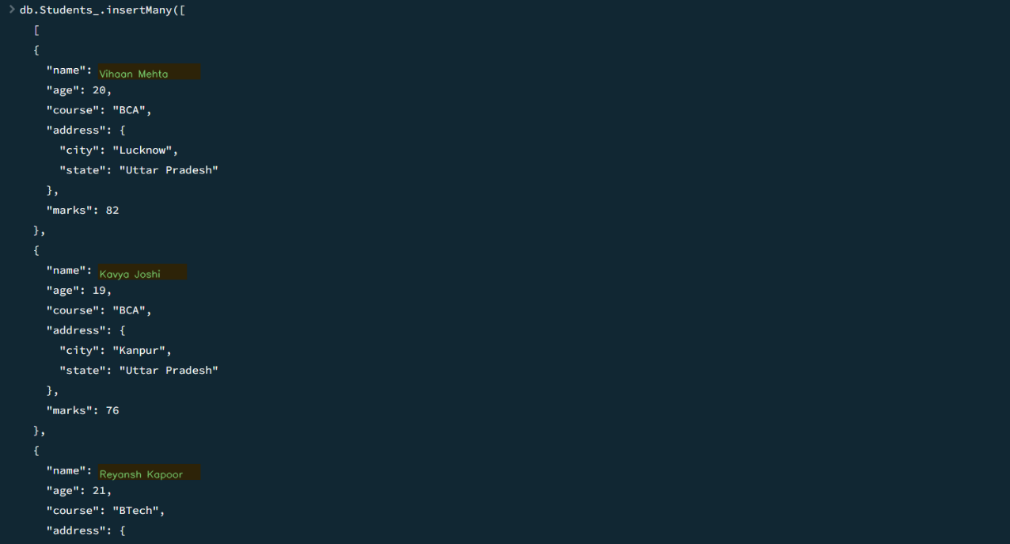

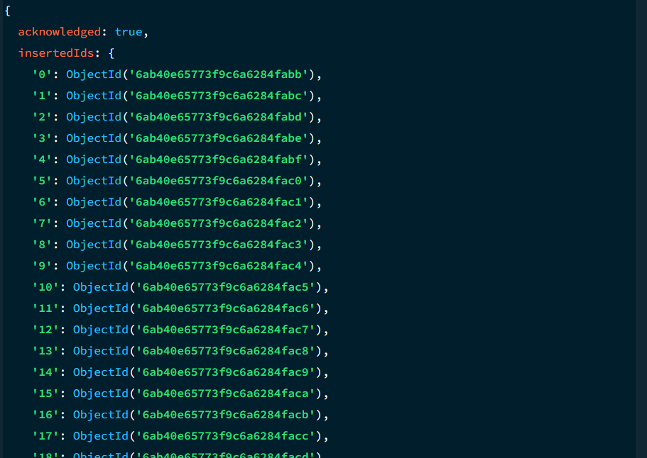

Theory
The insertMany() operation is used to add multiple student documents to the Students collection. Each document stores details such as name, age, course, marks and address. In this practical, 50 student records are inserted into the database.
- SHOWING THE DATA

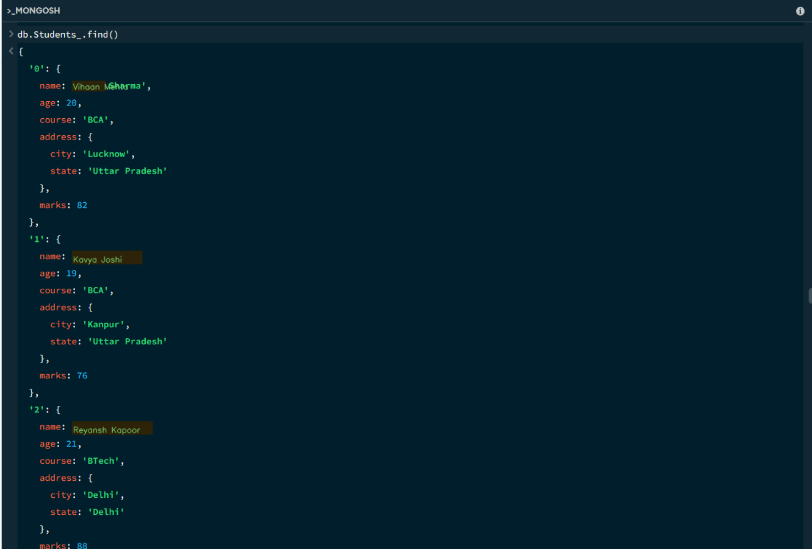

Theory
The find() method is used to retrieve documents from the Students collection. When no condition is specified, it displays the available student records. This is useful for checking the data stored in the database.
- FIND DATA BY CONDITION (FIND ONE)

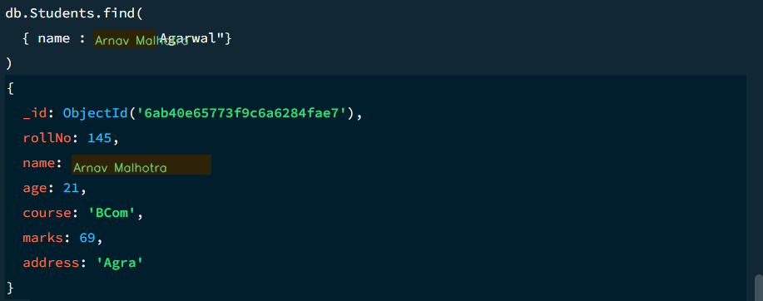

Theory
A conditional find query is used to search for a particular student record. A condition such as a student's name can be used to return the matching document. This helps in locating specific information without displaying unrelated records.
- FINDING MULTIPLE DATA BY CONDITIONS (FIND MANY)

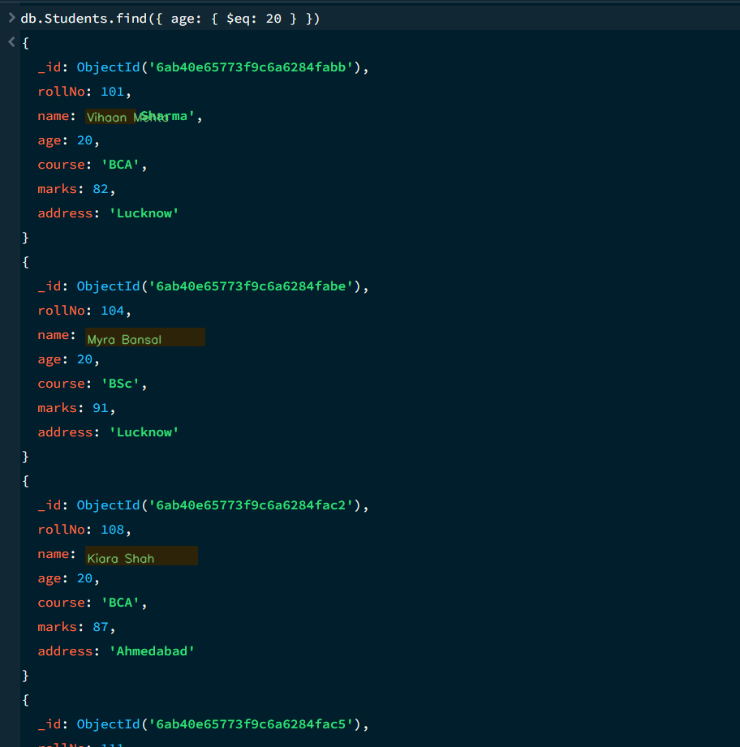
Theory
The find() method can return multiple documents when several records satisfy a given condition. For example, students can be filtered by age, marks or course. This makes it possible to retrieve a group of students from the collection.
- NOT EQUAL ($ne)
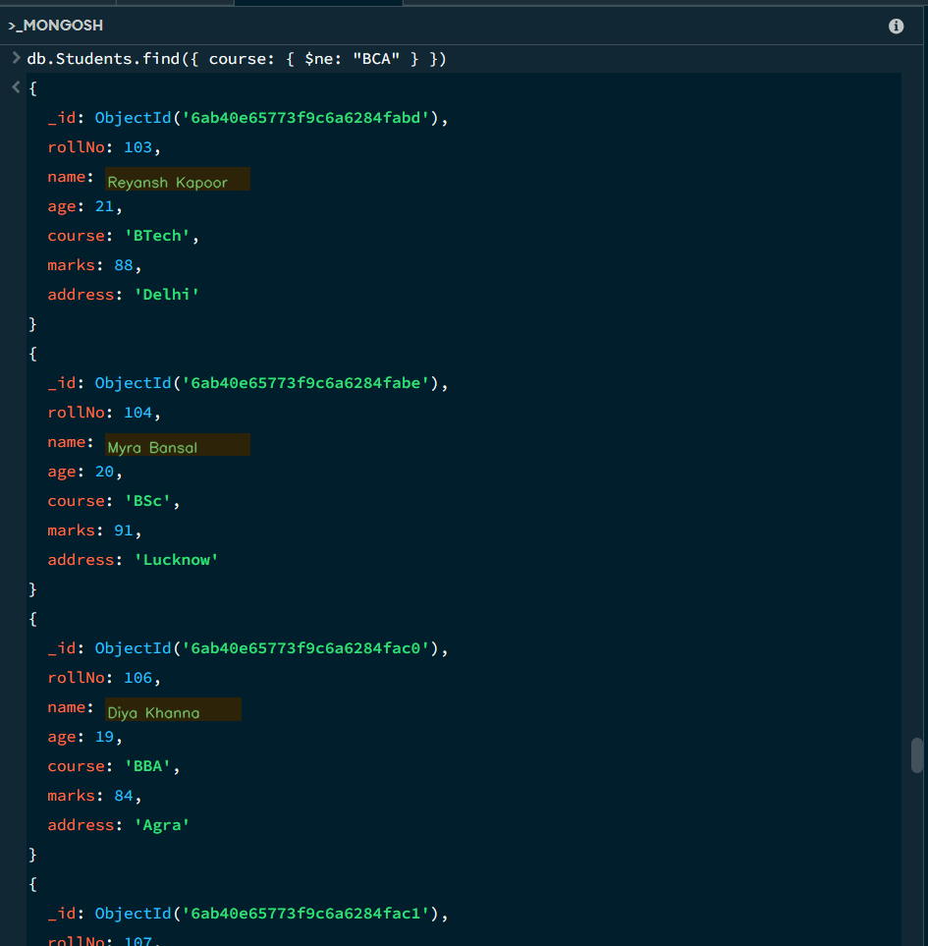

Theory
The $ne operator means 'not equal'. It finds documents whose field value is different from the specified value. In this practical, it is used to filter students whose course is not equal to BCA.
- GREATER THAN ($gt)

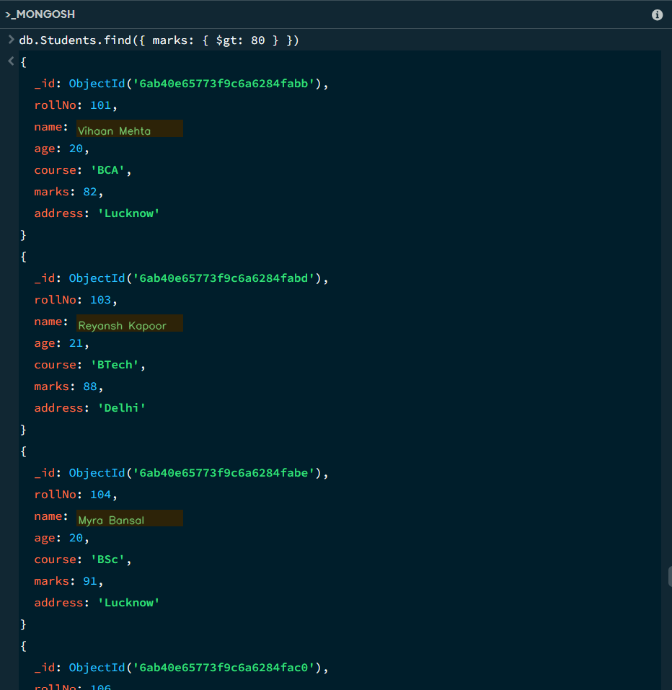

Theory
The $gt operator means 'greater than'. It returns documents where the selected field has a value greater than the given value. Here, it is used to find students whose marks are greater than the specified marks.
- GREATER THAN EQUAL ($gte)

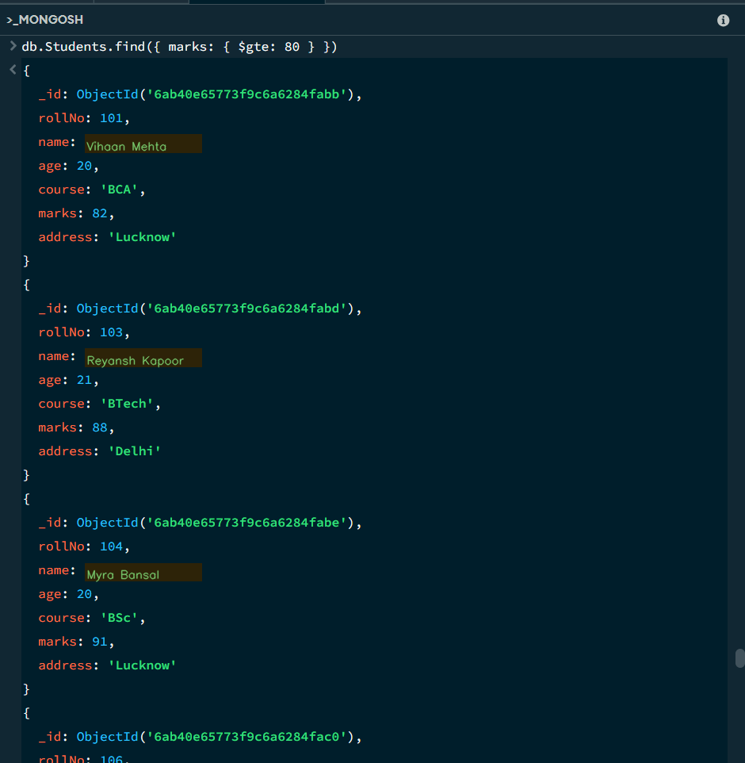

Theory
The $gte operator means 'greater than or equal to'. It returns records where the field value is equal to or greater than the specified value. It is useful for finding students who have achieved at least a particular marks value.
- Less than ($lt)
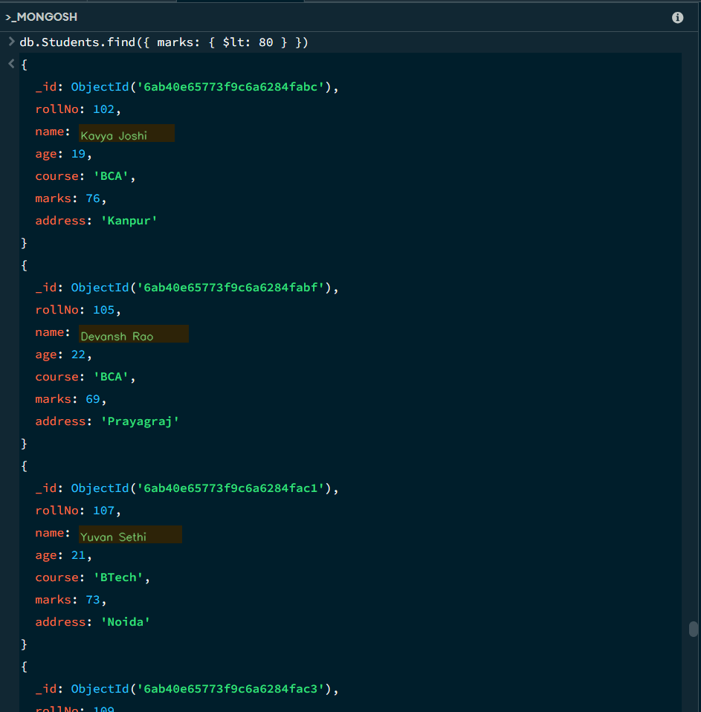

Theory
The $lt operator means 'less than'. It returns documents where the selected field contains a value smaller than the specified value. In this practical, it is used to filter students according to their marks.
9.Less than equal ($lte)

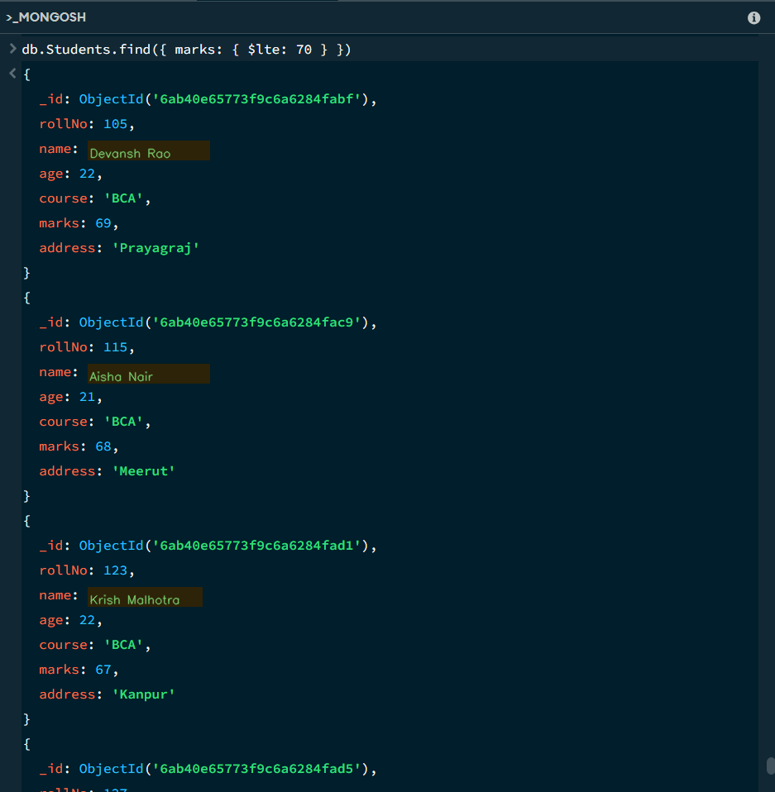

Theory
The $lte operator means 'less than or equal to'. It returns documents where the field value is less than or equal to the specified value. This can be used to find students whose marks fall at or below a particular limit.
10.IN ($in)

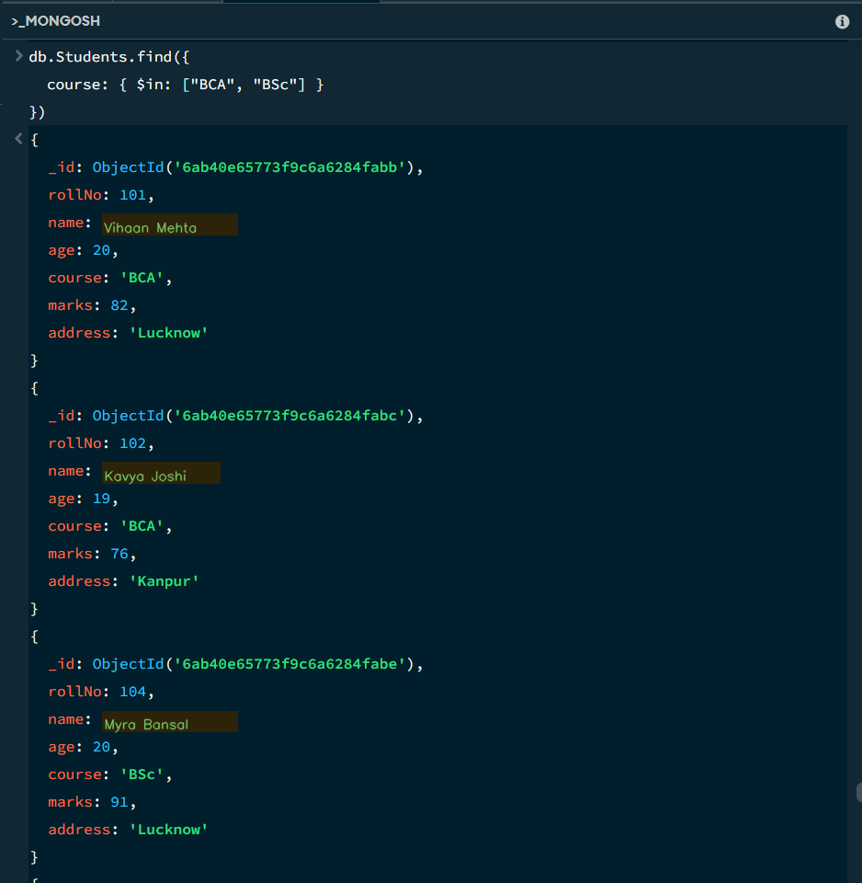

Theory
The $in operator checks whether a field matches any value from a specified list. For example, it can retrieve students whose course is either BCA or BSc. It is useful when several acceptable values are required in one query.
11.Not in ($nin)

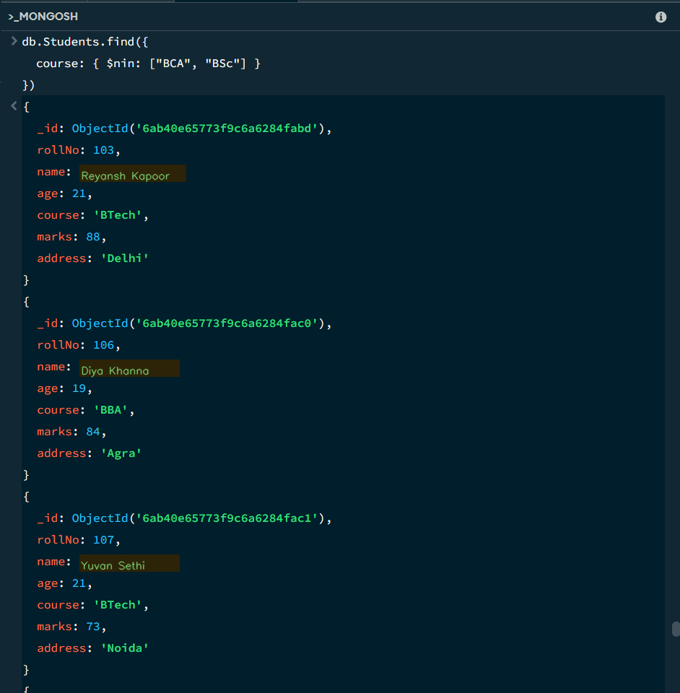

Theory
The $nin operator means 'not in'. It returns documents whose field value does not match any value from the specified list. It is useful for excluding selected courses or other values from the query result.
12.AND OPERATOR ($and)

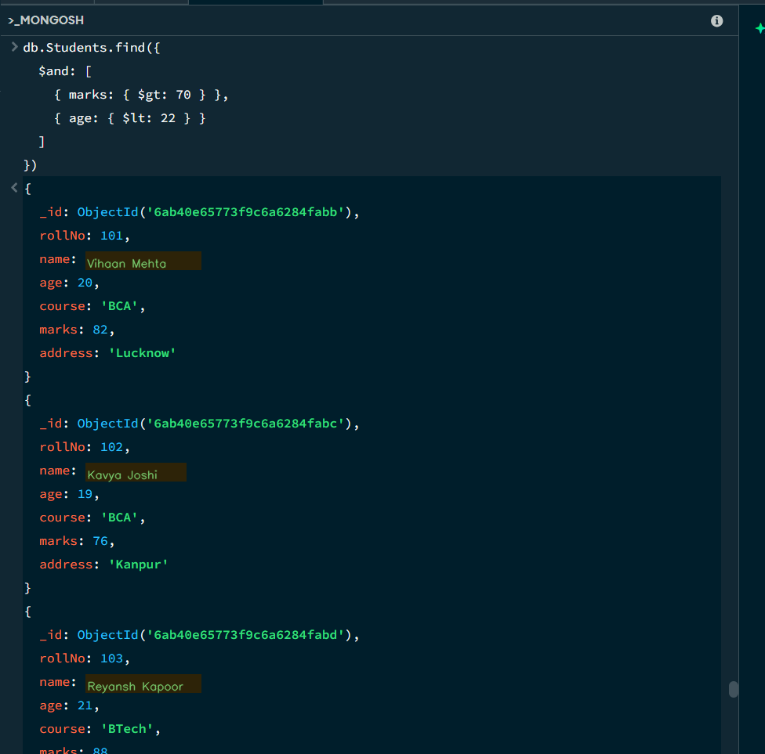

Theory
The $and logical operator requires all specified conditions to be true. For example, a query can select students whose marks are greater than a given value and whose age is within a specified range. It is useful when multiple conditions must be satisfied together.
13.OR OPERATOR ($or)

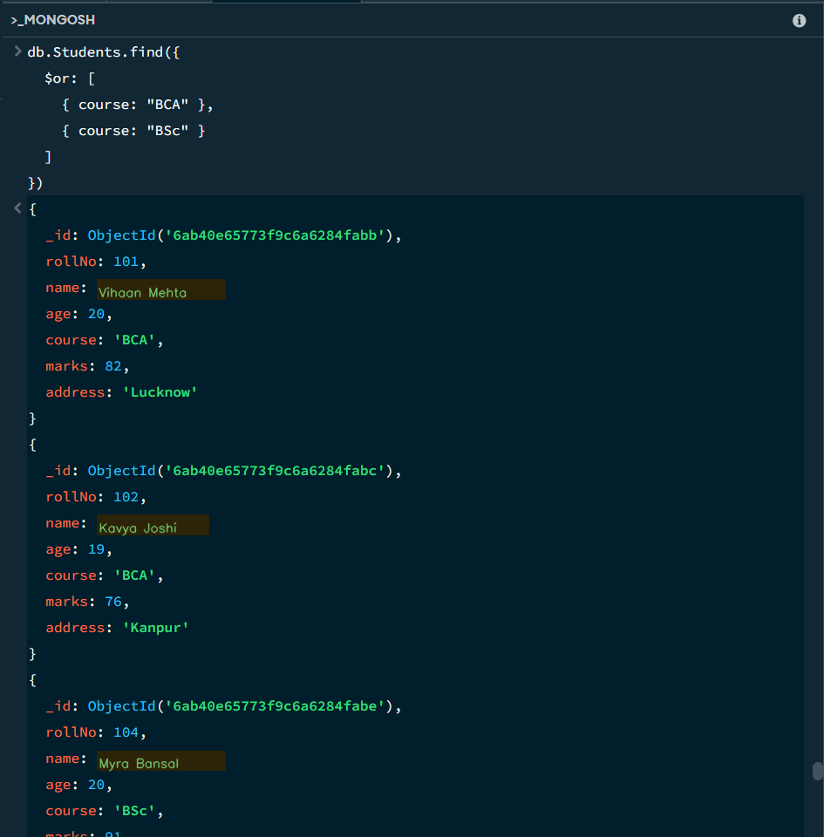

Theory
The $or logical operator returns documents when at least one of the specified conditions is true. For example, it can be used to find students belonging to either BCA or BSc. This allows alternative conditions to be combined in one query.
14. NOT OPERATOR ($NOT)

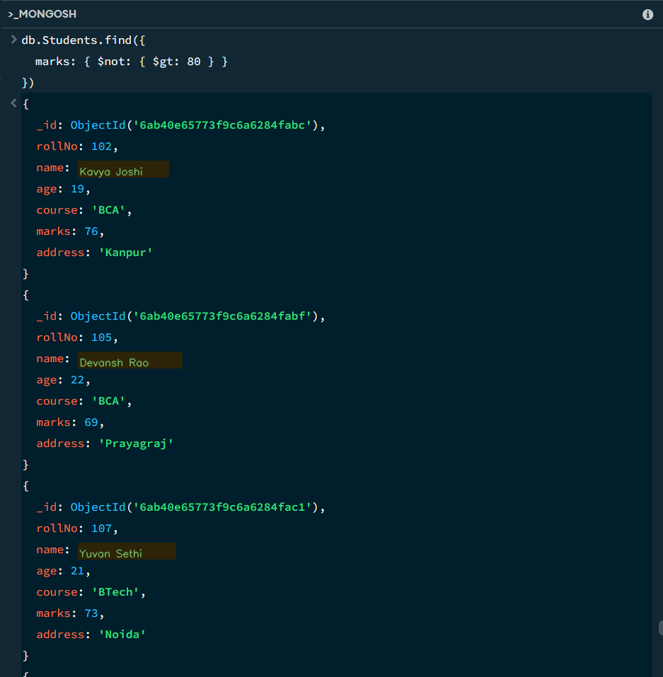

Theory
The $not operator is used to negate a condition. It returns documents that do not match the condition specified inside it. This is useful when a query needs to exclude a particular range or condition.
15. NOR OPERATOR ($nor)
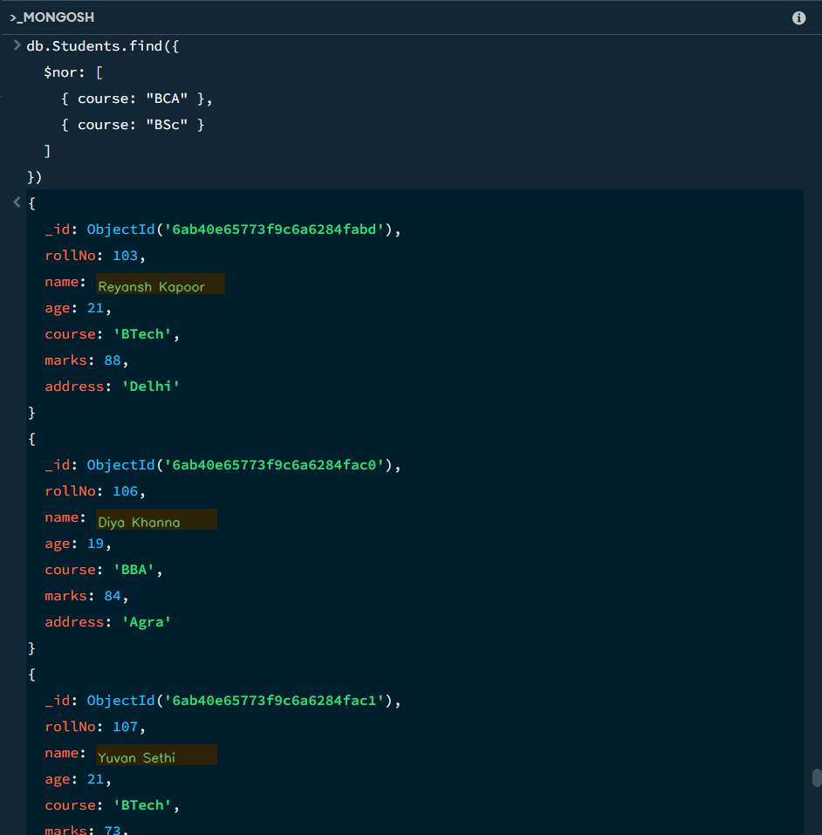

Theory
The $nor operator returns documents that fail all of the conditions listed inside the operator. It is useful when multiple unwanted conditions need to be excluded from the query result.
16. CURSOR OPERATOR (LIMIT)

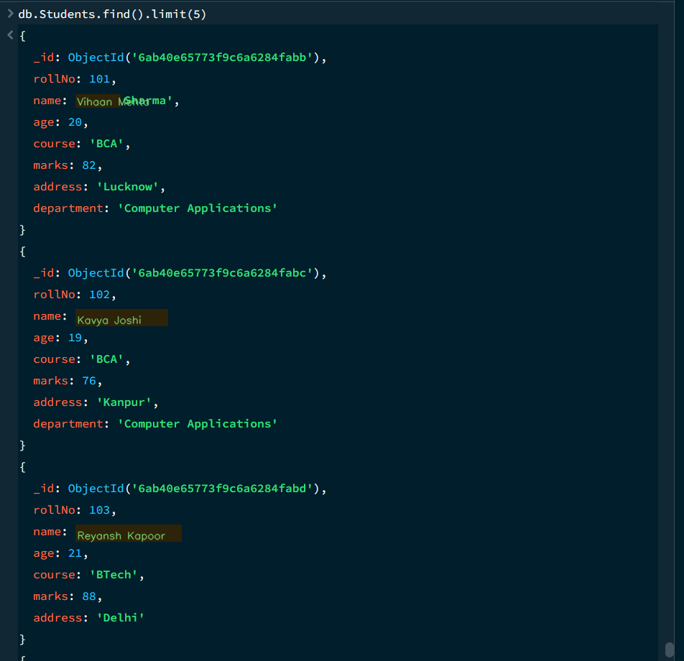

Theory
The limit() cursor operator restricts the number of documents returned by a query. For example, limit(5) displays only five matching student records. This is useful when only a fixed number of results are required.
- CURSOR OPERATOR (SKIP)
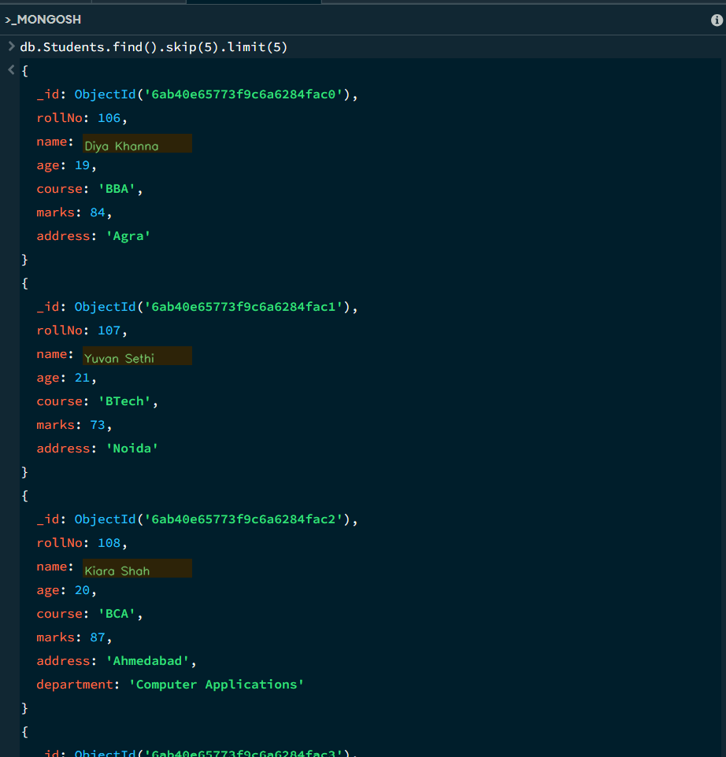

Theory
The skip() cursor operator skips a specified number of documents before returning the remaining results. It is useful for moving past the first few records and viewing later documents in a query result.
- CURSOR OPERATOR (SORT)
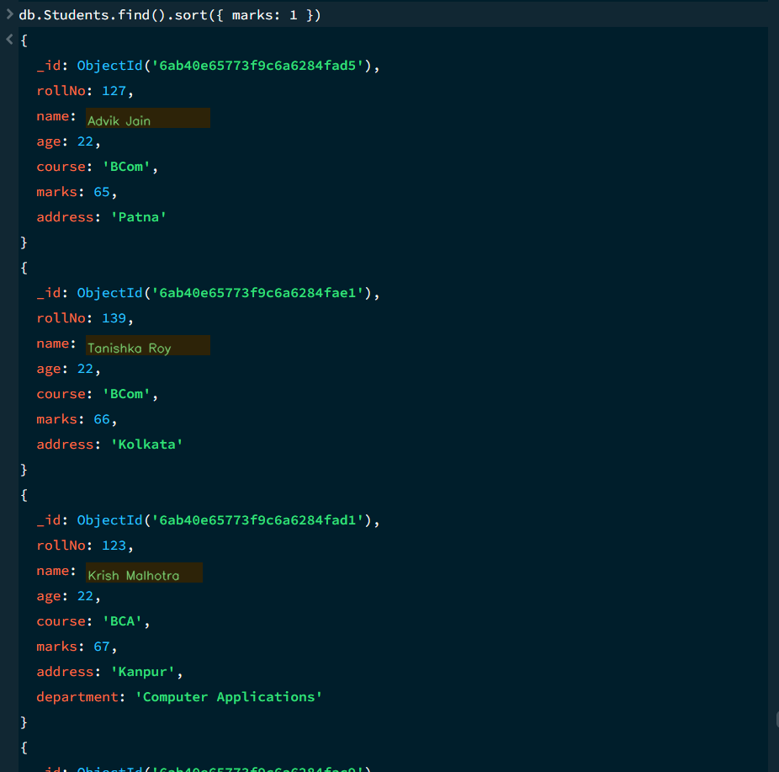

Theory
The sort() cursor operator arranges query results according to a selected field. A value of 1 represents ascending order, while -1 represents descending order. In this practical, student records are arranged according to their marks.
- MONGODB OPERATOR USED

Operator | Meaning | Example
$eq | Equal to | marks: {$eq:88}
$gt | Greater than | marks: {$gt:85}
$lt | Less than | marks: {$lt:60}
$gte | Greater than or equal to | marks: {$gte:90}
$lte | Less than or equal to | marks: {$lte:70}
$and | All conditions true | $and:[...]
$or | At least one condition true | $or:[...]

Theory
MongoDB operators provide conditions for comparing, filtering and combining document values. The practicals demonstrate operators such as $ne, $gt, $gte, $lt, $lte, $and and $or. Together, these operators make student-data queries more flexible and useful.
Overall Theory: The practical work demonstrates how MongoDB stores student records as documents and how queries, operators and cursor methods can be used to retrieve, filter and organize those records efficiently.

20. CONCLUSION
This project provided practical knowledge of NoSQL databases using MongoDB. A Student Management System containing student information was created and different MongoDB operations were performed on the data.
Through this project, I learned how to insert, retrieve and filter documents. I also learned how ascending and descending sorting works, how comparison operators such as $ne, $gt, $lt, $gte and $lte work, and how logical operators such as $and and $or can be used to filter data.
Overall, this project helped me understand how MongoDB can be used to manage and query student data efficiently.

