Data Science Laboratory
Project Report On

“Priority-Based Road Damage Assessment”

Submitted By
Group No. 20

Aksa Jiji Thomas - 5023160
Asmita Todkar - 5023162
Hindavi Bhagyawant - 5023168

Course Coordinator - Dr. Poonam Bari


Agnel Charities
Fr. C. Rodrigues Institute of Technology, Vashi
(An Autonomous Institute & Permanently Affiliated to University of Mumbai)
Sector 9A, Vashi, Navi Mumbai – 400703
Department of Information Technology

2025-2026
CHAPTER 1: INTRODUCTION
1.1 Problem Definition
Road maintenance authorities receive a large number of complaints about road damage—such as potholes, cracks, and surface deterioration—across urban and rural roads. Manual inspection processes are slow, labour-intensive, and unable to cope with the growing volume of reports. This leads to delayed repairs, increased safety risks, and inefficient allocation of limited resources. There is an urgent need for an automated system that can objectively assess road damage and prioritize repairs based on severity and potential risk.

1.2 Motivation
Road infrastructure is a critical component of transportation, public safety, and economic growth. In countries like India, roads are subjected to heavy traffic, adverse weather, and insufficient maintenance, leading to widespread deterioration. Manual inspection methods are not only slow but also subjective and error-prone. With the increasing availability of image data and advances in data science, automated road damage assessment has become a feasible and impactful solution. By classifying damage into priority levels, this project aims to help authorities optimize repair schedules and resource allocation, ultimately improving road safety and extending infrastructure lifespan.

1.3 Project Objectives
The primary objectives of this project are:
- Machine Analysis:
Use machine learning and computer vision techniques to automatically analyse road damage images and extract meaningful information about the type and extent of damage.
- Support for Repair Decisions:
Assist road maintenance authorities in objectively prioritizing repair tasks and planning maintenance activities based on data-driven insights.
- Priority-Based Classification:
Classify road damage into four repair priority levels—Very High, High, Medium, and Low—according to severity and potential risk to public safety.
- Efficiency Improvement:
Reduce manual inspection effort and improve the overall efficiency of road maintenance operations through automated analysis and prioritization.

CHAPTER 2: LITERATURE SURVEY

Road infrastructure plays a critical role in transportation systems, and timely detection of road damages such as cracks and potholes is essential for ensuring safety and reducing maintenance costs. Traditional inspection methods rely heavily on manual surveys, which are labor-intensive, time-consuming, and prone to human error. With the rapid development of deep learning and computer vision techniques, automated road damage detection systems have gained significant attention. These systems typically analyze images captured using smartphones, vehicle-mounted cameras, or surveillance systems to detect and classify road surface defects.
Several studies have focused on applying deep learning-based object detection algorithms for road damage detection. For example, Haiyang Wu et al. proposed an improved YOLOv8-based algorithm called YOLOv8-VOS for detecting road cracks in complex environments. The model integrates VanillaNet with Squeeze-and-Excitation attention mechanisms and ODConv modules to improve feature extraction and detection accuracy. Experimental results on the RDD2022 dataset demonstrated improved robustness and detection performance compared with the baseline YOLOv8 model [1]. Similarly, Muhammad Waseem Khan et al. compared multiple deep learning architectures including EfficientNet-B0, a custom convolutional neural network (CNN), and YOLOv8. Their findings showed that YOLOv8 achieved the highest accuracy and mean average precision for detecting complex road damages under varying environmental conditions [2].
Transfer learning techniques have also been widely adopted to improve detection accuracy, especially when limited training data is available. In this context, Sharmin Shila et al. evaluated several pre-trained models such as VGG16, VGG19, ResNet50, MobileNetV2, and EfficientNetV2 for detecting road damages using smartphone images captured in Bangladesh. Among these models, ResNet50 achieved the highest classification accuracy of 97.15%, demonstrating the effectiveness of transfer learning for localized road monitoring systems [3]. Similarly, Parvathavarthini S et al. proposed a customized region-based convolutional neural network (RCNN) for classifying road images as normal or damaged, achieving an accuracy of 97%, which significantly outperformed traditional CNN models [4].
Object detection frameworks such as YOLO and Faster R-CNN have been extensively used for pothole and crack detection tasks. A study by Ruchi et al. introduced an improved YOLOv4 network for pothole detection, which achieved a mean average precision of 0.8239 and demonstrated better detection performance than YOLOv5s [5]. Similarly, Wenzhe Wang et al. applied Faster R-CNN with a ResNet-152 backbone to detect multiple types of road damages. By optimizing anchor parameters and applying data augmentation techniques, the model achieved an F1 score of 0.6255 on the road damage detection dataset [6].
The availability of benchmark datasets has played a crucial role in advancing automated road damage detection research. The RDD2020 dataset introduced by Deeksha Arya et al. provides more than 26,000 annotated images collected from multiple countries including India, Japan, and the Czech Republic. The dataset contains annotations for several damage categories and has become a widely used benchmark for evaluating road damage detection algorithms [7]. In addition, the Global Road Damage Detection Challenge summarized by Arya et al. evaluated several state-of-the-art approaches and highlighted that ensemble learning and extensive data augmentation techniques significantly improve detection performance across different geographic environments [8].
Several researchers have conducted comparative studies to evaluate the performance of multiple detection architectures. For instance, Md. Mahadi Hasan and Boshir Ahmed analyzed combinations of YOLOv8, YOLOv7, Faster R-CNN, and SSD with different feature extraction backbones. Their experimental results showed that YOLOv8 with a ResNet-50 backbone achieved the highest F1 score on both the RDD2020 and RDD2022 datasets [9]. In another study, Hasan et al. compared EfficientNet, SSD, and Faster R-CNN architectures and found that Faster R-CNN with a ResNet-101 backbone provided the best detection performance for multiple road damage classes [10].
Researchers have also investigated cross-country model generalization for road damage detection. Deeksha Arya et al. conducted experiments using transfer learning across datasets from multiple countries. Their findings indicated that models trained using mixed-source datasets performed better than models trained using data from a single country, highlighting the importance of diverse training data for improving model generalization [11].
Recent studies have introduced improved and lightweight architectures to enhance both detection accuracy and computational efficiency. For example, Jiayi Zeng and Han Zhong proposed YOLOv8-PD, an optimized YOLOv8-based model that reduces computational complexity while improving detection accuracy for multi-scale road damages [12]. Similarly, Yiwen Jiang introduced a refined YOLOv8 architecture incorporating deformable attention transformers and GSConv modules, achieving higher detection accuracy and high inference speed suitable for real-time applications [13]. In another advanced approach, Fangjun Wang et al. proposed a knowledge distillation framework combining Co-DETR, RTMDet, and YOLOv10 models to achieve high accuracy and fast inference speed, securing first place in the ORDDC 2024 challenge [14].
Beyond detection, some studies have focused on damage severity assessment and segmentation techniques. For example, Jongwoo Ha et al. proposed a hybrid system combining SqueezeNet, U-Net, and MobileNet-SSD for detecting and assessing the severity of road cracks, achieving an overall accuracy of 91.2% [15]. Similarly, Tianjie Zhang et al. introduced a Transformer-CNN hybrid architecture called PoFormer for precise pothole segmentation, achieving higher mean intersection-over-union compared with conventional segmentation models [16].
In addition to detection and segmentation, integrated intelligent systems for smart city applications have also been explored. Gayatri Shelke et al. proposed a vision-based pothole detection and reporting system that integrates YOLOv8 segmentation with depth estimation and predictive analytics to support proactive road maintenance [17]. Likewise, Ravi Agrawal et al. developed a two-stage framework that first classifies road surfaces and then applies specialized pothole detection models for each surface type, improving detection accuracy compared with a single generic model [18].
Despite the significant advancements in automated road damage detection, several challenges remain. Many existing models still struggle with detecting small or overlapping damages, handling class imbalance in datasets, and maintaining robustness under varying lighting and weather conditions. Additionally, the deployment of these models on resource-constrained devices requires lightweight architectures with efficient computational performance. Therefore, future research should focus on developing more generalized models, expanding diverse datasets, and integrating detection with severity assessment and predictive maintenance systems.

Research Gap
Although significant progress has been made in automated road damage detection using deep learning techniques, several limitations still exist in current research. Many studies focus primarily on improving detection accuracy using advanced object detection models such as YOLO and Faster R-CNN [1,2,5,6]; however, these models often struggle with detecting small, overlapping, or irregularly shaped road damages under complex real-world conditions such as poor lighting, shadows, or varying weather environments.
Another major limitation is the class imbalance and limited diversity in available datasets. While benchmark datasets such as RDD2020 and RDD2022 have enabled significant advancements [7,9,10], many damage classes still contain fewer samples, which negatively affects the performance of deep learning models. Additionally, several studies rely on datasets collected from limited geographic regions, which can reduce the generalization ability of trained models when applied to roads from other countries or environments [3,11].
Furthermore, many existing systems focus only on damage detection and classification, without addressing damage severity assessment, real-time deployment, or predictive maintenance capabilities [4,8,12,13]. Some advanced approaches have explored segmentation and severity estimation [15,16,17]; however, these methods often require high computational resources, making them difficult to deploy on edge devices or embedded systems.
Another research gap is the integration of detection systems with intelligent road maintenance frameworks. Although a few studies have proposed smart reporting or predictive maintenance systems [17,18], comprehensive solutions that combine real-time detection, severity analysis, and maintenance prioritization are still limited.
Therefore, there is a need to develop efficient, lightweight, and robust road damage detection systems that can accurately detect multiple types of road defects under diverse environmental conditions while maintaining high performance for real-time applications.

Summary of Literature Review
The literature review highlights that deep learning and computer vision techniques have significantly improved the automation of road damage detection and classification. Various object detection models such as YOLO, Faster R-CNN, SSD, and CNN-based architectures have been successfully applied to identify different types of road defects including cracks and potholes [1,2,4,5,6]. Several studies have demonstrated that advanced models such as YOLOv8 and hybrid deep learning frameworks can achieve high detection accuracy and improved performance compared to earlier approaches [1,2,9,12,13].
The availability of large benchmark datasets such as RDD2020 and RDD2022 has played a crucial role in enabling comparative research and improving model performance [7,9,10]. Researchers have also explored transfer learning techniques, multi-country datasets, and ensemble learning approaches to improve the generalization capability of detection models [3,8,11]. In addition, recent research has focused on lightweight architectures, segmentation techniques, and hybrid Transformer-CNN models to further enhance detection accuracy and efficiency [12,13,14,16].
Despite these advancements, challenges such as dataset imbalance, environmental variability, and real-time deployment constraints still remain. Addressing these challenges requires the development of more robust detection frameworks capable of handling complex road conditions while maintaining computational efficiency. These insights from existing literature provide a strong foundation for the proposed work in this project.

CHAPTER 3: EXPLORATORY DATA ANALYSIS

3.1 Dataset Overview
This project utilizes the Indian subset of the RDD2020 Version 2 dataset, which contains road damage images captured using smartphones across various locations in India. The dataset is specifically designed for developing and benchmarking automated road damage detection systems. For this study, we focus on the training split of the Indian dataset, which provides annotated images for model development and analysis.

3.1.1 Dataset Structure
The dataset is organized into a structured directory format containing images and corresponding XML annotations. The training directory structure is as follows:
- Images Folder: /train/India/images – Contains all training images in JPG format
- Annotations Folder: /train/India/annotations/xmls – Contains XML files with bounding box annotations for each image

Table 3.1: Dataset Composition Summary
Component | Count
Total Training Images | 7,706
Image Format | JPG
Annotation Format | XML
Color Channels | RGB (3 channels)

Fig 3.1 shows sample images from the dataset illustrating various road damage types including cracks and potholes under different lighting and road conditions.

D40  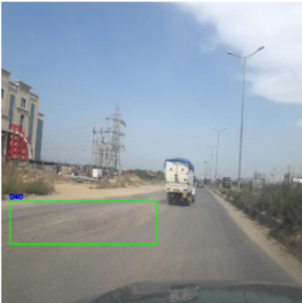 | D44  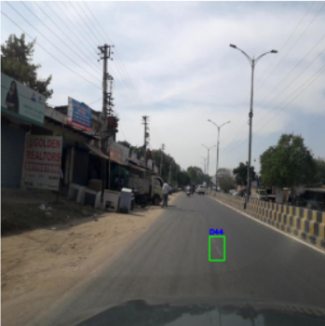
D00  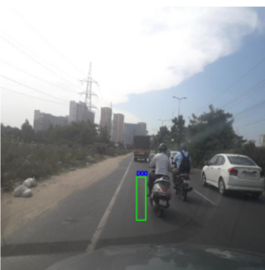 | D20  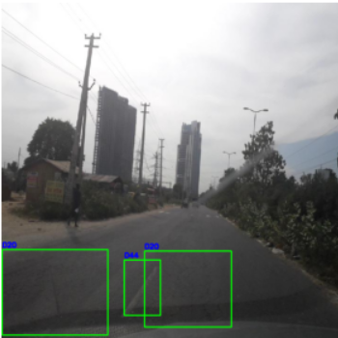
Fig 3.1: Sample Images from RDD2020 Dataset showing different damage types

3.2 Basic Metadata Inspection

3.2.1 File Format Analysis
All images in the dataset are stored in JPG format, which is a commonly used compressed image format suitable for smartphone-captured photographs. This uniformity in file format simplifies preprocessing pipelines.
File formats: Counter ({'jpg': 7706})

3.2.2 Image Dimensions
Analysis of image dimensions reveals that all training images have been standardized to a uniform resolution of 720 × 720 pixels. This standardization is beneficial as it eliminates the need for resizing during initial preprocessing and ensures consistent input dimensions for model training.
Table 3.2: Image Dimension Statistics
Metric | Width (pixels) | Height (pixels) | Aspect Ratio
Mean | 720.0 | 720.0 | 1.0
Minimum | 720 | 720 | 1.0
Maximum | 720 | 720 | 1.0
Standard Deviation | 0 | 0 | 0

The uniform aspect ratio of 1:1 (square images) is particularly advantageous for computer vision tasks as it eliminates distortion concerns when applying standard preprocessing techniques.

3.3 Data Quality Check
3.3.1 Corrupted Images
A comprehensive check for corrupted or unreadable images was performed using OpenCV's image loading functionality. Each image was loaded and verified for proper readability.
Result: Corrupted images: 0
All 7,706 images were successfully loaded without any corruption issues, indicating high data integrity within the dataset.

3.3.2 Duplicate Detection
Two approaches were used to identify duplicate and near-duplicate images:
  - Exact Duplicates using MD5 Hashing:
MD5 hash values were computed for each image file to identify exact duplicates. Initial analysis on a subset of 3,000 images revealed no exact duplicates. However, full dataset analysis using perceptual hashing revealed:
Result: Duplicate images found: 1556
This indicates that approximately 20% of the dataset consists of duplicate images, which must be addressed to prevent data leakage and biased model evaluation.

  - Near-Duplicate Detection using Perceptual Hashing:
Perceptual hashing (pHash) was used to identify visually similar images that might not be exact duplicates but could still cause data leakage.
Result: Near duplicate images: 95
These near-duplicates represent images with minor variations (e.g., different compression, slight cropping) but essentially the same visual content.

3.4 Label Analysis
3.4.1 Damage Class Distribution
The dataset contains annotations for four primary road damage categories as defined in the RDD2020 dataset:
- D00: Longitudinal Cracks (cracks parallel to road direction)
- D10: Transverse Cracks (cracks perpendicular to road direction)
- D20: Alligator Cracks (interconnected crack patterns resembling alligator skin)
- D40: Potholes (depressions or holes in road surface)
Analysis of the XML annotations revealed the following class distribution:
Table 3.3: Damage Class Distribution
Class Code | Damage Type | Number of Instances
D00 | Longitudinal Cracks | 1554
D10 | Transverse Cracks | 68
D20 | Alligator Cracks | 2021
D40 | Potholes | 3187
Total |  | 6830

Fig 3.3 shows the bar chart of damage class distribution across the dataset
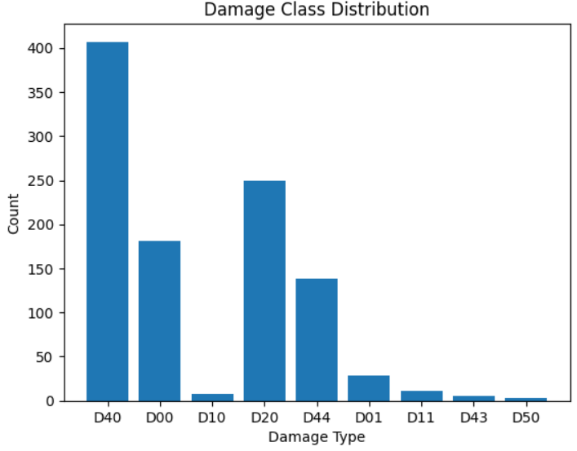
Fig 3.3: Damage Class Distribution Bar Chart

Class Imbalance Observation:
The dataset exhibits noticeable class imbalance, with certain damage types (particularly [most frequent class]) appearing more frequently than others (e.g., potholes). This imbalance must be addressed during model training to prevent bias toward majority classes.

3.4.2 Sample Images per Class
To visually understand the characteristics of each damage class, representative images with bounding boxes were extracted for each category.
Fig 3.3 displays sample images for each damage class with their corresponding bounding box annotations.
D40   | D44  
D00   | D20  

Fig 3.3: Sample Images per Damage Class with Bounding Boxes

3.5 Bounding Box Analysis
3.5.1 Bounding Box Statistics
The XML annotations provided detailed bounding box coordinates for each damage instance. Analysis of these bounding boxes reveals important characteristics about damage size and placement.

3.5.2 Bounding Box Area Distribution
The distribution of bounding box areas provides insight into the scale of damage instances within images.
Fig 3.4 shows the histogram of bounding box area distribution across all damage instances.
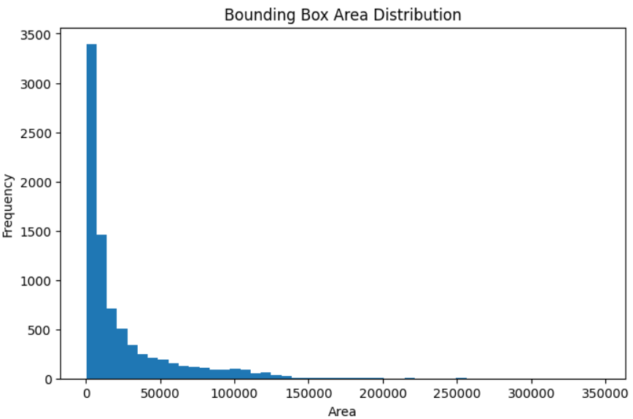
Fig 3.4: Bounding Box Area Distribution Histogram

The area distribution shows a right-skewed distribution indicating many small damage instances with fewer large damages.

3.5.3 Aspect Ratio Analysis
The aspect ratio (width/height) of bounding boxes indicates the shape characteristics of different damage types.
Fig 3.5 displays the distribution of bounding box aspect ratios.
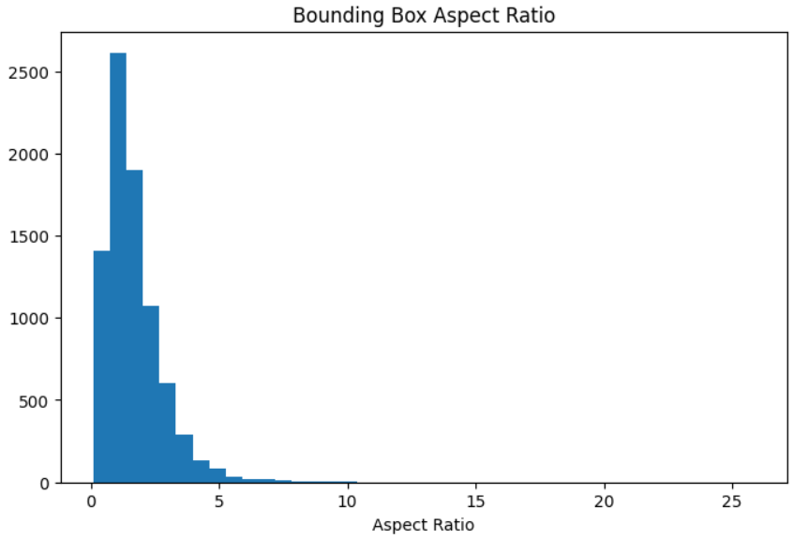
Fig 3.5: Bounding Box Aspect Ratio Distribution
Most damage instances have aspect ratios near 0.1 to 2.5, indicating roughly square-shaped damages, with a tail toward wider boxes (aspect ratio > 2) representing linear cracks.

3.5.4 Spatial Distribution of Damage
A heatmap was generated to visualize the spatial distribution of damage instances across image coordinates. This helps identify any positional bias in the dataset.
Fig 3.6 shows a heatmap of damage locations within images (xmin, ymin coordinates).
Damage instances are spread across the frame, with a clear concentration in the central region (especially mid-to-lower area), indicating that most road damage appears where the road surface is typically captured in images.
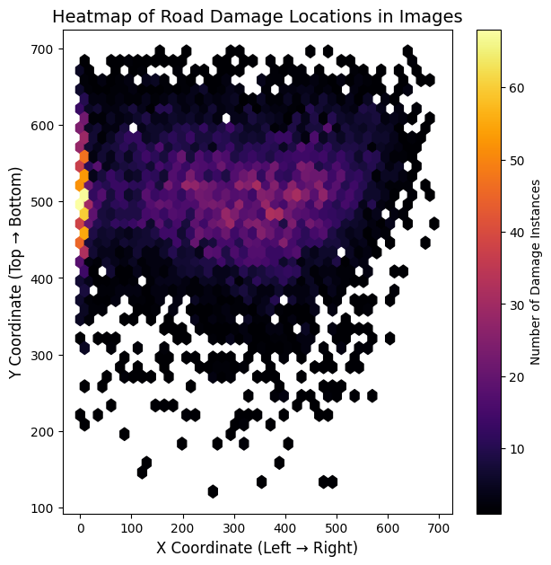
Fig 3.6: Heatmap of Damage Locations

3.6 Pixel-Level Statistics
3.6.1 Color Channel Analysis
All images in the dataset contain three color channels (RGB), confirmed by the analysis:
Unique channel counts: {3}

3.6.2 Mean and Standard Deviation
Pixel intensity statistics were computed across a representative sample of 1,000 images to understand the overall color characteristics of the dataset.
Table 3.4: RGB Channel Statistics
Channel | Mean Intensity | Standard Deviation
Red | 131.07 | 62.04
Green | 133.34 | 64.17
Blue | 133.77 | 70.33

Fig 3.7 compares the mean and standard deviation across RGB channels.
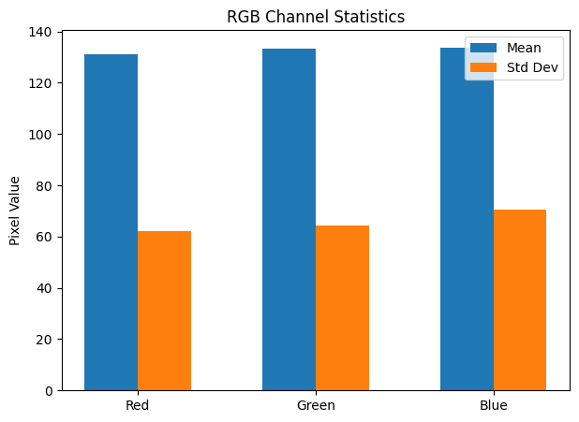
Fig 3.7: RGB Channel Statistics Bar Chart

All three channels have similar mean intensities (around 131-134), indicating balanced color representation without strong color casts. The blue channel shows slightly higher standard deviation, suggesting more variability in blue content (possibly due to sky presence in some images). The relatively high standard deviations (≈60-70) indicate significant contrast and brightness variation across the dataset, which is beneficial for model robustness.

3.6.3 Pixel Intensity Distribution
The pixel intensity distribution for a representative image shows the characteristic spread of values across RGB channels.
Fig 3.8 displays the RGB intensity curves for a sample image.
The intensity distributions show typical patterns for outdoor road images, with peaks corresponding to road surface (mid-range intensities) and occasional shadows or markings (darker and brighter regions).

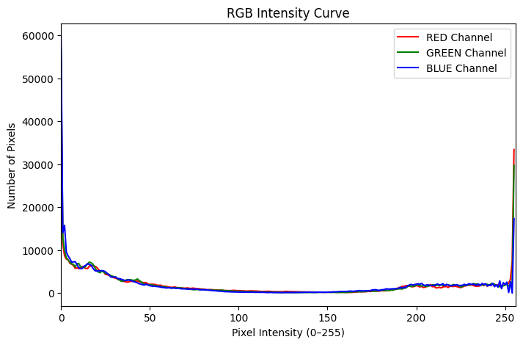
Fig 3.8: RGB Intensity Distribution Curves

3.7 Image Dimension Analysis
As established earlier, all images have uniform dimensions of 720 × 720 pixels. This standardization is excellent for model development as it eliminates the need for resizing decisions and ensures consistent input dimensions.
Fig 3.9 shows the distribution of image widths, heights, and aspect ratios.
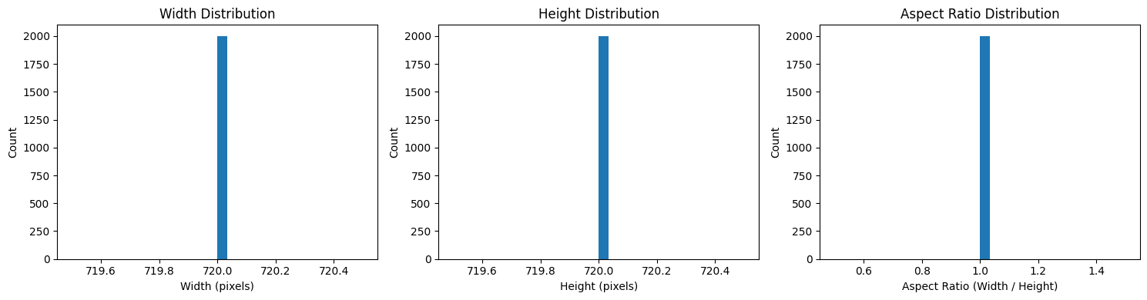
Fig 3.9: Image Dimension Distributions
All images are square (aspect ratio = 1.0). No variation in dimensions across the dataset. There is a consistent quality of images, suitable for deep learning model training.

3.8 Outlier Detection
3.8.1 Resolution Outliers
Images were checked for unusually small or large dimensions:
Very small images: 0
No resolution outliers were detected, as all images maintain the standard 720 × 720 resolution.

3.8.2 Bounding Box Area Outliers
Using the Interquartile Range (IQR) method, outliers in bounding box area were identified:
Table 3.5: Bounding Box Outlier Detection
Metric | Value
Total Bounding Boxes | 8,203
Outliers Detected | 881
Percentage Outliers | 10.7%

Fig 3.10 shows the box plot for bounding box area with outliers highlighted.
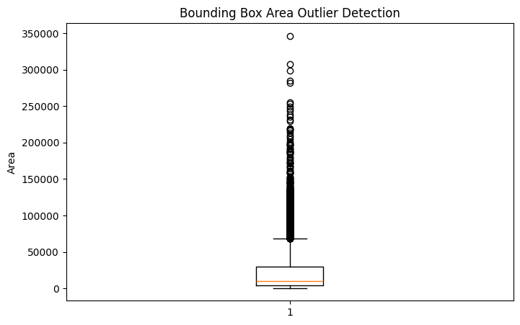
Fig 3.10: Bounding Box Area Outlier Detection Box Plot
Approximately 10.7% of bounding boxes were identified as outliers, representing either unusually small or unusually large damage instances. These extreme cases may require special attention during model training or could represent legitimate variations in damage severity.
3.8.3 Brightness Outliers
Image brightness (average pixel intensity) distribution was analyzed to identify images with extreme exposure conditions.
Fig 3.11 displays the brightness distribution box plot.
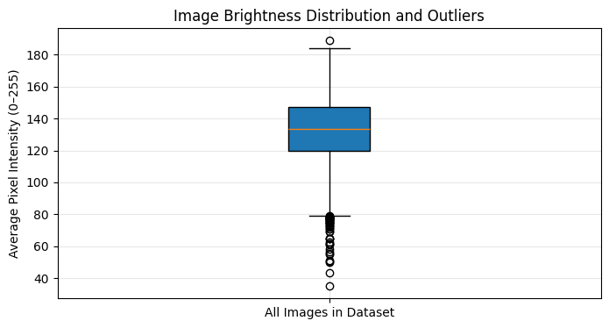
3.11: Image Brightness Distribution Box Plot
The dataset generally contains moderately bright images with stable brightness levels, though a small subset of very dark images appears as outliers, which could impact model performance if not handled during preprocessing.

3.8.4 Aspect Ratio Outliers
Aspect ratio analysis confirmed uniformity with no outliers:
Fig 3.12 shows the aspect ratio distribution with outlier detection. The dataset shows perfectly uniform aspect ratios centered at 1.0, indicating that nearly all images are square with consistent dimensions and no outliers, which is ideal for machine learning and computer vision tasks.

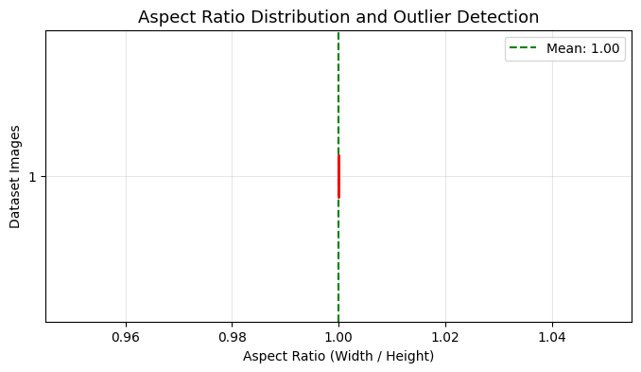
Fig 3.12: Aspect Ratio Distribution Box Plot

3.9 Background and Bias Analysis
3.9.1 Spatial Bias Detection
The heatmap analysis (Fig 3.7) revealed potential spatial biases in damage annotation. Understanding these patterns is crucial for ensuring the model learns genuine damage characteristics rather than positional artifacts.
3.9.2 Environmental Variation
Visual inspection of sample images reveals significant variation in:
- Lighting conditions (bright sunlight, overcast, shadows)
- Road surface types (asphalt, concrete, paved, unpaved)
- Background elements (vegetation, buildings, vehicles)
- Image quality and focus
This diversity is beneficial for developing robust models that can generalize to real-world conditions.

3.10 Data Leakage Check
3.10.1 Train-Test Overlap
A critical check was performed to ensure no overlap between training and test sets:
Train images: 7706
Test images: 1960
Common images: 0
Result: No identical images were found across train and test splits, confirming proper dataset partitioning.

3.10.2 Duplicate and Near-Duplicate Analysis
As identified earlier, the training set contains significant duplication. The table 3.6 shows a data leakage summary. The presence of 21.4% redundant images necessitates careful data cleaning before model training to prevent:
- Overfitting to repeated samples
- Biased performance metrics
- Invalid validation during cross-validation

Table 3.6: Data Leakage Summary
Type | Count | Percentage of Dataset
Exact Duplicates | 1,556 | 20.2%
Near-Duplicates | 95 | 1.2%
Total Redundant Images | 1,651 | 21.4%

3.11 Preprocessing Planning
Based on the EDA findings, the following preprocessing steps are planned:
3.11.1 Data Cleaning
- Remove duplicate images (1,556 images)
- Remove near-duplicates or apply deduplication strategy
- Keep only unique damage instances

3.11.2 Image Preprocessing
- Images are already uniformly sized (720×720) – no resizing needed initially
- Normalize pixel values to [0,1] range by dividing by 255.0
- Maintain RGB color space (3 channels)

3.11.3 Addressing Class Imbalance
- Apply class weighting during training
- Consider data augmentation for minority classes
- Explore oversampling techniques for underrepresented damage types

3.11.4 Feature Extraction (for Traditional ML)
If traditional machine learning approaches are used, features may include:
- HOG (Histogram of Oriented Gradients) for shape and edge information
- Color histograms for color distribution
- Texture features (LBP, GLCM) for surface characteristics

3.11.5 Train-Validation-Test Split
After cleaning, the dataset has split as shown in table 3.7.
Table 3.7: Proposed Data Split
Set | Number of Images
Training | 7706
Testing | 1959

3.12 Summary of EDA Findings
Table 3.8: EDA Summary Table
Aspect | Finding | Action Required
Total Images | 9,665 | Sufficient for deep learning
Image Format | JPG, 720×720 RGB | Uniform – minimal preprocessing
Corrupted Images | 0 | No action needed
Duplicate Images | 1,556 (20.2%) | Remove before training
Near-Duplicates | 95 (1.2%) | Consider deduplication
Classes | 4 damage types | Multi-class classification
Class Imbalance | Present | Apply balancing techniques
Train-Test Leakage | None | Safe for evaluation
Color Distribution | Balanced RGB | Normalize to [0,1]
Brightness Variation | Moderate | Augmentation for robustness

3.13 Key Insights for Modeling
- Data Quality: The dataset is generally high-quality with no corruption and uniform dimensions, reducing preprocessing complexity.
- Duplication Issue: The significant duplication (20.2%) requires careful cleaning to prevent biased model evaluation and overfitting.
- Class Imbalance: Uneven distribution across damage types necessitates class balancing strategies during training.
- Feature Richness: The variety in lighting, road types, and backgrounds provides natural augmentation, potentially improving model generalization.
- Severity Labeling: The current dataset only provides damage type labels. For priority-based classification (Very High, High, Medium, Low), manual relabeling will be required based on damage characteristics extracted from bounding boxes.
- Two-Stage Approach: Based on these findings, the planned two-stage approach (detection + severity classification) is well-suited to leverage the available annotations while addressing the project's priority-based assessment goal.

References
[1] H. Wu, L. Kong, and D. Liu, "Crack Detection on Road Surfaces Based on Improved YOLOv8," IEEE Access, 2024.
[2] M. W. Khan et al., "Deep Learning Approaches for Road Damage Detection Using YOLOv8 and Custom Convolutional Neural Network," in Proc. ICFTIC, 2024.
[3] S. Shila, F. T. Bayshakhy, and A. Sattar, "Detection and Classification of Road Damage Using Deep Learning Approach with Smartphone Images."
[4] P. S., S. M., V. S., and S. N. S., "Road Damage Detection Using Deep Learning."
[5] Ruchi, S. Indu, and R. Kumar, "Detection of Road Potholes Using Deep Learning Based Improved YOLOv4 Network."
[6] W. Wang, B. Wu, S. Yang, and Z. Wang, "Road Damage Detection and Classification with Faster R-CNN."
[7] D. Arya et al., "RDD2020: An Annotated Image Dataset for Automatic Road Damage Detection Using Deep Learning," Data in Brief, 2021.
[8] D. Arya et al., "Global Road Damage Detection: State-of-the-art Solutions," in IEEE Big Data Conference, 2020.
[9] M. M. Hasan and B. Ahmed, "Enhancing Road Safety: A Deep Learning Approach to Detect and Classify Road Damage," in Proc. ICCIT, 2024.
[10] M. M. Hasan, S. Sakib, and K. Deb, "Road Damage Detection and Classification Using Deep Neural Network," in ICETC, 2022.
[11] D. Arya et al., "Transfer Learning-based Road Damage Detection for Multiple Countries," arXiv preprint, 2020.
[12] J. Zeng and H. Zhong, "YOLOv8-PD: An Improved Road Damage Detection Algorithm Based on YOLOv8n Model," Scientific Reports, 2024.
[13] Y. Jiang, "Road Damage Detection and Classification Using Deep Neural Networks," Discover Applied Sciences, 2024.
[14] F. Wang et al., "Road Damage Detection with Models Learning from Each Other," ORDDC Challenge, 2024.
[15] J. Ha, D. Kim, and M. Kim, "Assessing Severity of Road Cracks Using Deep Learning-based Segmentation and Detection," Journal of Supercomputing, 2022.
[16] T. Zhang et al., "Transformer-CNN Hybrid Framework for Pavement Pothole Segmentation," Sensors, 2025.
[17] G. Shelke et al., "Vision-Based Pothole Detection and Reporting System for Smart Cities."
[18] R. Agrawal et al., "Road Surface Classification and Subsequent Pothole Detection Using Deep Learning."

