1. State what is database and DBMS. Give example. (2+2) [Remembering]

A database is a structured collection of data that is organized in a way that enables efficient storage, retrieval, and manipulation of data. It serves as a repository for various types of information, such as text, numbers, images, and multimedia. Databases are crucial components in virtually all modern information systems, ranging from small-scale applications to large scale enterprise systems.

Examples of databases are SQL.

A Database Management System is a software that provides an interface for users to interact with databases. It facilitates the creation, maintenance, and use of databases by providing mechanisms for storing, organizing, retrieving and managing data efficiently. DBMS also ensures data integrity, security, and concurrency control.

Example of DBMS is MySQL.

1. Compare Database Management System and File based management System. (5) [Remembering]

|  |  |  |
| --- | --- | --- |
| Aspect | DBMS | File-based management system |
| Data Structure | Data is organized in a structured format using tables, with relationships between entities defined by keys and constraints. | Data is typically stored in flat files or hierarchical structures, lacking inherent relationships between different pieces of data. |
| Data integrity | DBMS ensures data integrity through mechanisms such as constraints, foreign key relationships, and transaction management. | Data integrity depends upon the application logic or manual enforcement, making it prone to inconsistencies and errors. |
| Data Redundancy | DBMS minimizes redundancy through normalization techniques, reducing the likelihood of inconsistencies and saving storage space. | Redundancy is common, as data may be duplicated across multiple files or records, leading to increased storage requirements and update anomalies. |
| Query and Retrieval | DBMS provides a Query language (E.g. SQL) for complex querying and retrieval operations, supporting efficient search and manipulation of data. | Retrieval and querying are often limited to basic file operations, requiring manual iteration through records or files. |
| Concurrent Access | DBMS supports concurrent access to multiple users, managing access control, concurrency control and transaction isolation to ensure data consistency and integrity | Concurrent access may lead to data corruption or inconsistency issues, as file locks and manual synchronization mechanisms are often required to prevent conflicts. |

1. Explain with diagram what is Specialization and Generalization in ER diagram.

Using the ER model for bigger data creates a lot of complexity while designing a database model. So, in order to minimize the data complexity, generalization, specialization and aggregation were introduced in the ER model. These are used for data abstraction in which an abstraction mechanism is used to hide details of a set of objects.

Generalization: It is the process of extracting common properties from a set of entities and creating a generalized entity from it. It is a bottom-up approach in which two or more entities can be generalized to a higher-level entity if they have some attributes in common.

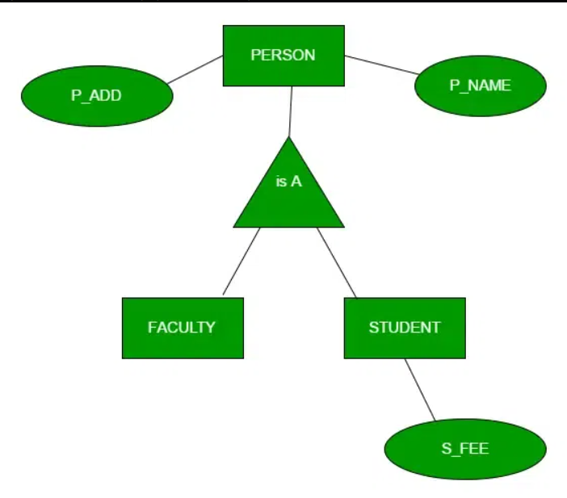

Specialization: Here, an entity is divided into sub-entities based on its characteristics. It is a top-down approach where the higher-level entity is specialized into two or more lower-level entities.

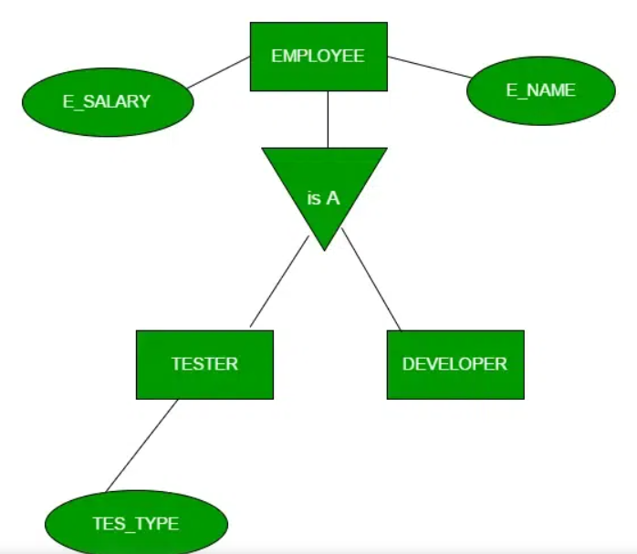

1. How can we convert them into table?
2. Explain with diagram what do you mean by three level database abstractions.

The 3-layer database architecture, also known as the ANSI/SPARC architecture, provides a conceptual framework for understanding and designing database management systems. It consists of three levels of attractions:

* External Level (View Level)
* The external level represents the user’s view of the database.
* It contains multiple external schemas, each tailored to the specific needs and requirements of different user groups or applications.
* Each external schema defines the portion of the database that is relevant to a particular user or application.
* Conceptual Level (Logical Level)
* The conceptual level represents the logical structure of the whole database.
* It provides the unified and abstract view of the data, independent of any specific user’s perspective.
* The conceptual schema, also known as global schema, defines the logical organization of data, including entities, relationships and constraints.
* Internal Level (Storage Level)
* The internal level represents the physical storage and implementation of details of the database.
* It describes how data is stored, indexed, and accessed on the underlying storage devices, such as disks.
* The internal schema defines the low-level data structures, storage organization and access methods used to represent and manage data efficiently.

1. Define Weak Entity Set and partial key. State their symbol in ER diagram.

An entity type should have a key attribute which uniquely identifies each entity in the entity set, but there exist some entity types for which key attribute can’t be defined. These are called Weak Entity types.

The entity sets which do not have sufficient attributes to form a primary key, are known as weak entity sets and the entity sets which have a primary key are known as strong entity sets. As the weak entities do not have primary keys, they cannot be identified on their own, so they depend on some other entity (owner entity).

Weak entity types have partial keys which are a set of attributes, with the help of which, the tuples of weak entities can be distinguished and identified. Weak entity has total participation but strong entity may not have total participation.

Symbols:

Weak Entity: Double rectangle

Partial key: Dashed underline.

1. State then process how can we convert Specialization/Generalization into table/s. Give example.