**DBMS**

**What is DBMS?**

Database Management System is a software or technology used to manage data from a **#**database. Some popular databases are MySQL, Oracle, MongoDB, etc.

***# database is a collection of related data***

DBMS provides many operations e.g. creating a database, storing in the database, updating an existing database, delete from the database. DBMS is a system that enables you to store, modify and retrieve data in an organized way. It also provides security to the database.

**Types of Data Bases**

1. **Structured database** : can be stored in a particular structure – e.g RDBMS (Relational DBMS) -> used in Indian Railways, School / College management Systems

Structured data is stored in the forms of relation. [relation -> technical term fort tables ]

1. **Unstructured databse:** there is no predefined way for storing the data. Most of the data stored nowadays is unstructured data. **Used in Big Data.**

**Advantages of DBMS**

*#* ***Note:*** *File system stores the data in the hierarchical format, but we use client-server data at present, for which the file system is not efficient*

1. **Faster, efficient Searching:** The Database management system (DBMS) helps to produce quick answers to database queries thus making data access faster and more accurate.
2. **Better memory utilisation.**
3. **Ease of searching**: Users do not need to know the address of the stored data to access the data. No metadata is required for searching of data (which is mandatory in the case of a file sytem).
4. **Concurrency:** Multiple users search data at the same time (concurrently), this will be problematic in the case of file systems, but there are protocols present in DBMS which solve those problems.
5. **Security:** Supports ***role-based access to data***, that is specific data is visible to the viewer according to their authority.
6. **Prevents data redundancy:** When working with a structured database, DBMS provides the feature to prevent the input of duplicate items in the database. e.g. – If there are two same students in different rows, then one of the duplicate data will be deleted.
7. **Scalability and flexibility**: DBMS is highly scalable and can easily accommodate changes in data volumes and user requirements. It provides flexibility in data storage, retrieval, and manipulation, allowing users to easily modify the structure and content of the database as needed.

**Disadvantages of DBMS**

1. **Cost of hardware is software:** For DBMS, it is mandatory to have a high-speed processor and also a large memory size.
2. **Requires trained staff** to use DBMS, hence cost of staff training involved before implementation.
3. **Cost of data conversion:** We need to convert our data into a database management system, there is a requirement of a lot of money as it adds to the cost of the database management system.

**Types of architecture in DBMS**

*# note : tier -> layer*

1. **2-Tier Architecture:** A client-server architecture where the user interface and the application logic are separated into two separate components. The client component is typically the user interface and the server component is responsible for handling the data and business logic.

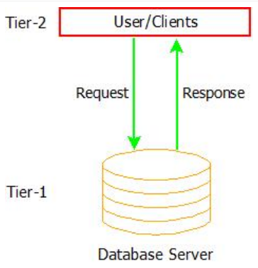

**2-Tier Architectur**

e.g: Bank management sytem, railway management system.

**Advantage(s):**

Maintainence is easy as user is limited

**Disadvantage(s):**

**Security:** Client directly interacts with the database, this can cause problems.

**Scalability:** When number of user and amount of data being accessed concurrently, this architecture fails(lead s to bottle neck problem)

1. **3-Tier Architecture:** The 3-tier architecture divides an application's components into three tiers or layers. Each layer has its own set of responsibilities. Here the client does not directly communicate with the server. Instead, it interacts with an application server which further communicates with the database system and then the query processing and transaction management takes place.

