**External Project Report on Computer Networking (CSE3034)**

Voice Over WiFi

(Vo-WiFi) System



**Submitted by**

|  |  |
| --- | --- |
| **SARTHAK DAS** | ***2141004005*** |
| **PIYUSH TARAI** | ***2141020005*** |
| **HINDU MOHANTY** | ***2141013185*** |
| **AGNEE MOHANTY** | ***2141013186*** |
| **SUBHANKAR SARKAR** | ***2141019215*** |

**B. Tech. CSE 5th Semester (Section ‘ A ’)**

**INSTITUTE OF TECHNICAL EDUCATION AND RESEARCH**

**(FACULTY OF ENGINEERING)**

i

**SIKSHA ‘O’ ANUSANDHAN (DEEMED TO BE UNIVERSITY), BHUBANESWAR,**

**ODISHA**

# Declaration

We, the undersigned students of B. Tech. of **CSE** Department hereby declare that we own the full responsibility for the information, results etc. provided in this PROJECT titled “**Voice Over Wifi (Vo-WiFi)**” submitted to **Siksha ‘O’ Anusandhan (Deemed to be University), Bhubaneswar** for the partial fulfillment of the subject **Computer Networking (CSE 3034)**. We have taken care in all respect to honor the intellectual property right and have acknowledged the contribution of others for using them in academic purpose and further declare that in case of any violation of intellectual property right or copyright we, as the candidate(s), will be fully responsible for the same.

|  |  |
| --- | --- |
| SARTHAK DAS  **(*2141004005*)** | **PIYUSH TARAI**  ***(2141020005)*** |
| **HINDU MOHANTY**  ***(2141013185)*** | **AGNEE MOHANTY**  ***(2141013186)*** |
| **SUBHANKAR SARKAR**  ***(2141019215)*** | |

**DATE : 10 / 1 / 2024**

# Abstract

# This project presents the development of a Voice over Wi-Fi (VoWi-Fi)

# system utilizing Java socket programming, designed to facilitate real-time

# audio communication within a local network. VoWi-Fi, an integral part of

# contem porary communication systems, enables users to make voice calls

# over Wi-Fi networks, offering flexibility and efficiency. Our implementat-

# ion encompasses two main components: the client-side (sender) responsible

# for audio capture and transmission, and the server-side (receiver) tasked

# with receiving, storing, and playing back the transmitted audio.

# The client-side incorporates Java libraries, specifically javax.sound.sampled,

# to capture audio from the microphone. A socket connection is established

# for seamless communication with the server. On the server-side, a server

# socket actively listens for incoming client connections. Upon acceptance, a dedicated socket is initiated for data exchange, allowing the reception and

# storage of transmitted audio. The server employs Java's javax.sound.sampled library for audio playback.

# The project's modular structure highlights the essential components of a

# VoWi-Fi system, making it an ideal starting point for enthusiasts and devel-

# opers interested in understanding the intricacies of audio transmission over

# local networks. Rigorous testing ensures the reliability of audio capture, transmission, reception, and playback, fostering iterative refinement for syst-

# em robustness. This project contributes to the foundational knowledge

# required for the development and enhancement of VoWi-Fi systems,

# encouraging further exploration and innovation in the field of voice communication technologies.

# Contents

|  |  |  |  |
| --- | --- | --- | --- |
| **Serial**  **No.** | **Chapter No.** | **Title of the Chapter** | **Page No.** |
| 1. | 1 | Introduction | 5 |
| 2. | 2 | Problem Statement | 6 |
| 3. | 3 | Methodology | 7 |
| 4. | 4 | Implementation | 8-10 |
| 5. | 5 | Results and interpretation | 11 |
| 6. | 6 | Conclusion | 12 |
| 7. | 7 | References | 13 |
|  |  |  |  |

**Introduction -**

In the realm of distributed computing and networked applications, the utili-

zation of client server architectures stands as a cornerstone for efficient data exchange and remote processing . The advent of socket programming in

Java has facilitated the seamless communication between disparate sys-

tems, enabling the development of interactive and collaborative applications across networks.

This project delves into the creation of a Voice over Wi-Fi (Vo-WiFi) system within a single access point the client-server paradigm and harnessing Java's socket programming capabilities . The goal is to demons-

trate how to capture audio from a microphone on the client side, transmit it

over a local network using sockets, and play it back on the server side.

As traditional telecommunication methods continue to evolve, the converg-

ence of voice and data over Wi-Fi networks offers enhanced flexibility and efficiency. VoWi-Fi leverages the ubiquity of wireless connectivity, provid-

ing users with the ability to make calls using Voice over Internet Protocol

(VoIP) technology, thus reducing dependence on cellular networks.

By implementing this basic VoWi-Fi system, we aim to showcase the fundamental principles of audio transmission over a local network using

socket programming in Java project provides a starting point for more

advanced features and optimizations in VoWi-Fi systems.

# Problem Statement -

Implement a basic Voice over Wi-Fi (VoWi-Fi) system within a single access point using socket programming. Demonstrates how to capture audio from a microphone on the client side, transmit it over a local network using sockets, and play it back on the server side. (Using Java Programming)

# Methodology -

Requirement Analysis:

* Identify and define the project requirements, including audio capture, socket communication, and playback functionalities.
* Determine the specifications for the client and server components.

**Environment Setup:**

* Install and configure the necessary development environment, including Java Development Kit (JDK) and any additional libraries required for audio processing (e.g., javax.sound.sampled).

Client-Side Development:

* Implement the audio capture module using Java's javax.sound.sampled library.
* Develop the client-side socket communication to establish a connection with the server.
* Integrate error handling and exception management for robustness.

Server-Side Development:

* Create a server socket to listen for incoming client connections.
* Accept client connections and initiate a dedicated socket for data exchange.
* Implement the server-side audio reception and storage module.
* Develop the audio playback module using Java's javax.sound.sampled library.

# Implementation -

* Server Side -

* Client Side –

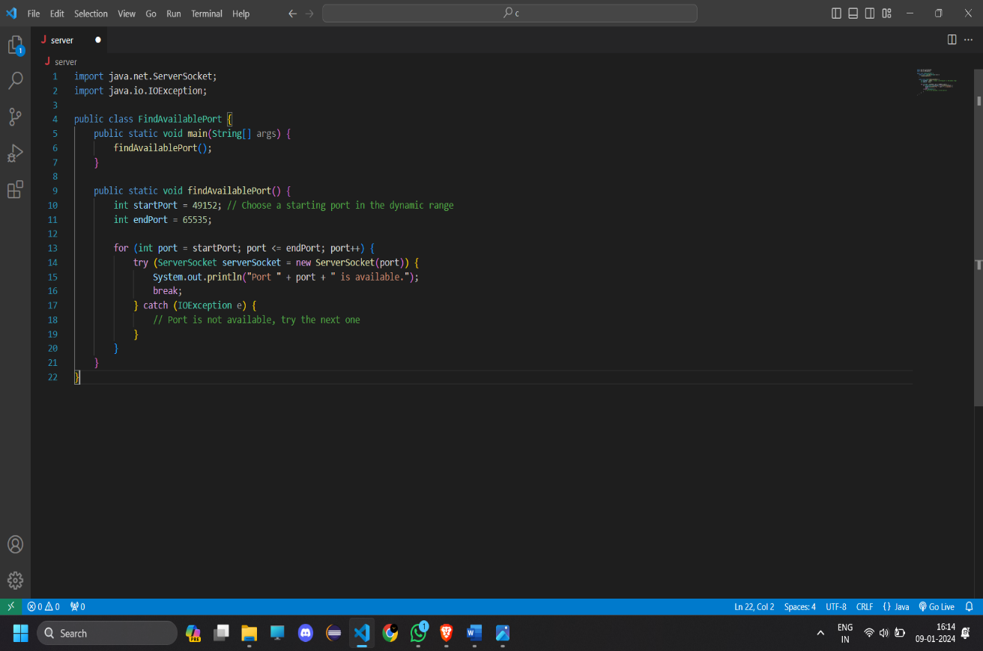

* Finding Port –

# Results & Interpretation

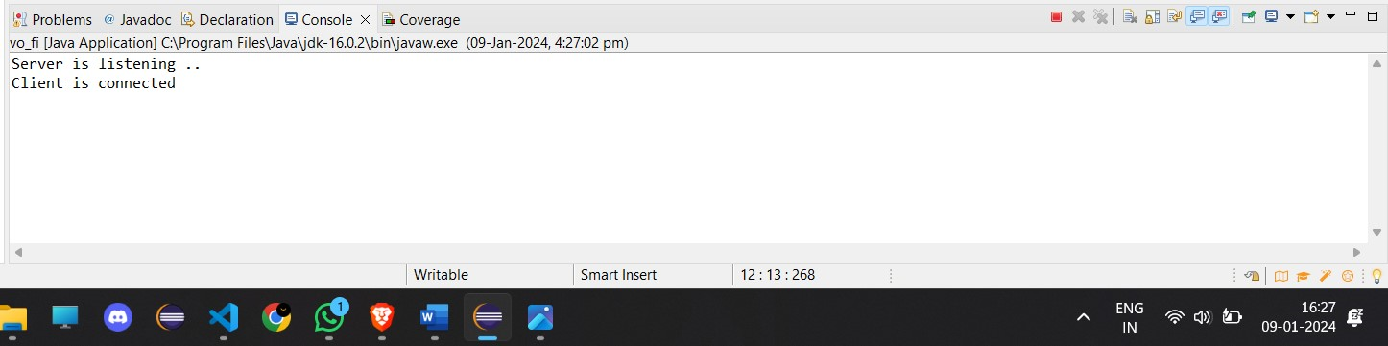

**Conclusion -**

The development and implementation of the Voice over Wi-Fi (VoWi-Fi) system using Java socket programming have provided valuable insights into the fundamental aspects of real-time audio communication over local networks. This project successfully demonstrated the capture of audio from a client's microphone, its transmission via sockets, and playback on the server side.

In the demonstration phase, the VoWi-Fi system showcased its ability to seamlessly transmit and play back audio in a local network environment. The successful integration of audio capture, socket communication, and playback functionalities validates the project's primary objectives.

In summary, the VoWi-Fi system developed through this project serves as a practical illustration of socket programming in Java for real-time audio communication. As technology continues to advance, this foundational work contributes to the ongoing evolution of voice communication systems, empowering developers to innovate and refine the future landscape of audio communication technologies.

**References**

**[1] Computer Networks, Andrew S. Tannenbaum, Pearson India.**

[2] Java Network Programming by Harold, O’Reilly (Shroff Publishers).

**[3] Git-Hub**

**[4] Google.com**