psiog | Learning & Development
IMPACT pSiddhi 3.0
Mid-Term Submission Document

1. Participant & Project Identification
Topic ID (as finalised by L&D) | S4-I-21
Topic Title | Unified Sales Operations System
Participant Name | Hindujashiri Gopu
Employee ID | P403
Track | ☐ Custom ☑ Data ☐ Platform
Semester & Category | Semester 4 — Integration Mastery (Capstone)
Participation Type | ☑ Regular ☐ pSiddhi Lite
Approved Budget Ceiling | ₹2,500 (fixed)
Mid-Term Review Window | Week 10 (13-Jul-26 to 17-Jul-26)

2. Approved Proposal Recap

2.1 Problem Statement (as approved)
The sales function suffers four interlocking failures. (1) CRM data integrity: pipeline stages, deal values and close dates are updated late, so managers forecast and allocate resources against stale data. (2) Stage-weighted forecasting applies fixed percentages per stage, treating unequal deals as equivalent and producing systematically inaccurate forecasts. (3) Account-health signals (falling engagement, rising tickets, stalling expansion) stay invisible until churn is already happening. (4) No ML/AI intelligence means prioritisation defaults to intuition. SalesIQ addresses all four through one unified, AI-powered platform.

2.2 Proposed Solution Summary (as approved)
SalesIQ is a unified sales-operations platform with four integrated layers. Layer 1 — a Python/FastAPI integration layer ingests three CRM domains (pipeline, account health, rep performance) from a JSON Server mock CRM, validates them on ingestion, and persists a normalised unified dataset in SQLite. Layer 2 — a React portal on Azure with four screens. Layer 3 — an ML analytics engine (scikit-learn/MLflow) for revenue forecasting, win-probability scoring and account-health classification. Layer 4 — an AI intelligence engine (Gemini 2.5 Flash) generating scenario-based sales narratives. QA is embedded throughout with a ≥80% coverage target.

2.3 Core Tools & AI Components (as approved)
Language/API: Python + FastAPI; JavaScript/React. Persistence: SQLite. Mock CRM: JSON Server (3 REST domains). ML: scikit-learn, PyCaret (auto model selection), MLflow (experiment tracking). AI: Google Gemini 2.5 Flash (narratives) with Ollama/Llama for offline dev. Portal/charts: React + Recharts. Data: Faker (500+ synthetic records). QA/CI: pytest, pytest-cov, Playwright, httpx, GitHub Actions. Hosting: Azure Static Web Apps + App Service F1. Full reconciliation is in Section 7.

3. Progress Against Approved Plan (up to Week 9)
ID | Planned Deliverable (per approved proposal) | Planned Window (eg:Week 4) | Status | Evidence ID(s)
D-01 | Mock CRM (JSON Server) + unified schema + FastAPI scaffold | Week 4 | Done | EV-01, EV-02
D-02 | FastAPI integration — pipeline + rep domains ingested to SQLite | Week 5 | Done | EV-02
D-03 | Account-health domain; all 3 domains normalised & queryable | Week 6 | Done | EV-02
D-04 | React portal — Pipeline Overview + Account Detail + API endpoints | Week 7 | Done | EV-04, EV-05, EV-06
D-05 | ML models — Revenue Forecaster + Win Probability Scorer + MLflow | Week 8 | Done | EV-02, EV-04, EV-08
D-06 | Gemini connected; initial AI narrative (Strong Quarter scenario) | Week 9 | Done | EV-07
D-07 | QA embedded — unit/integration/API/ML/AI tests, ≥80% coverage | Weeks 4–9 | Done | EV-03

3.1 Overall Mid-Term Self-Assessment
RFP-defined Week 10 checkpoint (summarise in 2–3 lines) | Phase 1 (Weeks 4–9): 3 CRM domains integrated into SQLite with schema validation; 2 portal screens live; 2 ML models trained to target; 1 AI narrative scenario; QA embedded with ≥80% coverage.
% of checkpoint completed (honest estimate) | ~100% of the Week 4–9 checkpoint. Phase-2 items (3rd ML model, 2 remaining screens, 2 remaining AI scenarios, Azure deploy) are intentionally not claimed.
Is the current working state demonstrable live at the review? | ☑ Yes, end-to-end ☐ Yes, partially ☐ No, screenshots/recording only

4. Evidence Pack (entire mid-term period)

4.1 Evidence Index
Evidence ID | Caption — what does this prove? | Deliverable ID(s) | Verifiable link (if any)
EV-01 | Synthetic CRM data generated — 660 records (500 deals, 120 accounts, 40 reps) with 15 invalid records injected for schema validation | D-01 | See repo: data/generate_data.py
EV-02 | End-to-end pipeline: 3-domain ingest (15 invalid rejected); Win AUC-ROC 0.9643 and Revenue MAPE 0.0537 both meet target; 485 deals scored | D-02, D-03, D-05 | See repo: backend/pipeline_cli.py
EV-03 | QA suite — 28 tests passing, 93% measured coverage (pytest-cov) across all layers (target ≥80%) | D-07 | See repo: backend/tests
EV-04 | FastAPI serving live data — /api/pipeline/overview shows ML forecast ₹7,31,17,841 vs naive stage-weighted ₹5,59,33,250 | D-04, D-05 | http://localhost:8000/docs
EV-05 | Pipeline Overview portal screen (React + Recharts) — KPIs, stage-weighted vs ML bar chart, top deals by expected revenue | D-04 | http://localhost:5173
EV-06 | Account Detail portal screen — account-health KPIs, deals table with win probability, portfolio health mix | D-03, D-04 | http://localhost:5173/accounts
EV-07 | AI Sales Intelligence narrative (Strong Quarter) grounded in live pipeline state and ML outputs | D-06 | http://localhost:8000/api/intelligence/narrative
EV-08 | MLflow experiment tracking — win_scorer & revenue_forecaster runs with logged params (algorithm) and metrics (auc_roc/mape) | D-05 | http://localhost:5000

4.2 Evidence Blocks (paste screenshots here)
EV-01 — Synthetic CRM data generated (660 records, 15 invalid)
What this proves | 500+ synthetic CRM records generated across all 3 domains (pipeline, accounts, reps) with 15 invalid deal records deliberately injected to exercise schema validation. Proves the data layer and unified schema (D-01).
Deliverable ID (Sec 3) | D-01
Date captured | 15-Jul-2026
Verifiable link | See repo: data/generate_data.py
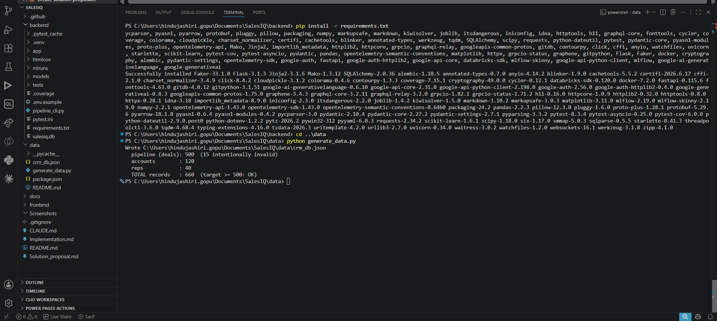

EV-02 — End-to-end pipeline: ingest + ML training + scoring
What this proves | The integration → ML → AI pipeline runs end to end: 3 domains ingested with 15 invalid deal records rejected by schema validation; both ML models trained and meeting targets (Win AUC-ROC 0.9643 > 0.75; Revenue MAPE 0.0537 < 0.15); 485 deals scored. Proves D-02, D-03, D-05.
Deliverable ID (Sec 3) | D-02, D-03, D-05
Date captured | 15-Jul-2026
Verifiable link | See repo: backend/pipeline_cli.py
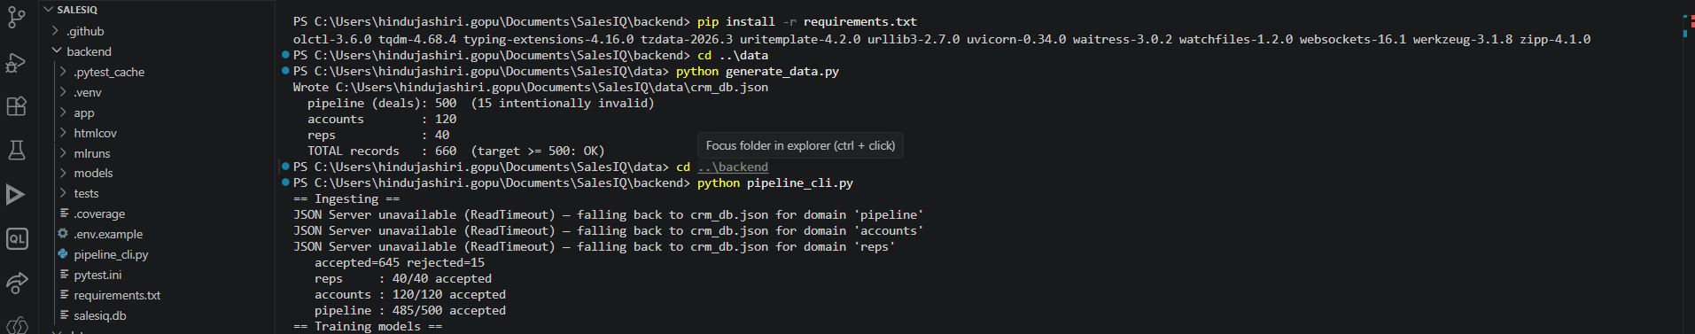

EV-03 — QA suite: 28 tests passing, 93% coverage
What this proves | QA suite executed with pytest — 28 tests passing and 93% measured code coverage (pytest-cov), spanning schema validation, 3-domain integration, API endpoints, ML accuracy/ranges and AI narrative. Exceeds the ≥80% target. Proves D-07.
Deliverable ID (Sec 3) | D-07
Date captured | 15-Jul-2026
Verifiable link | See repo: backend/tests + backend/htmlcov
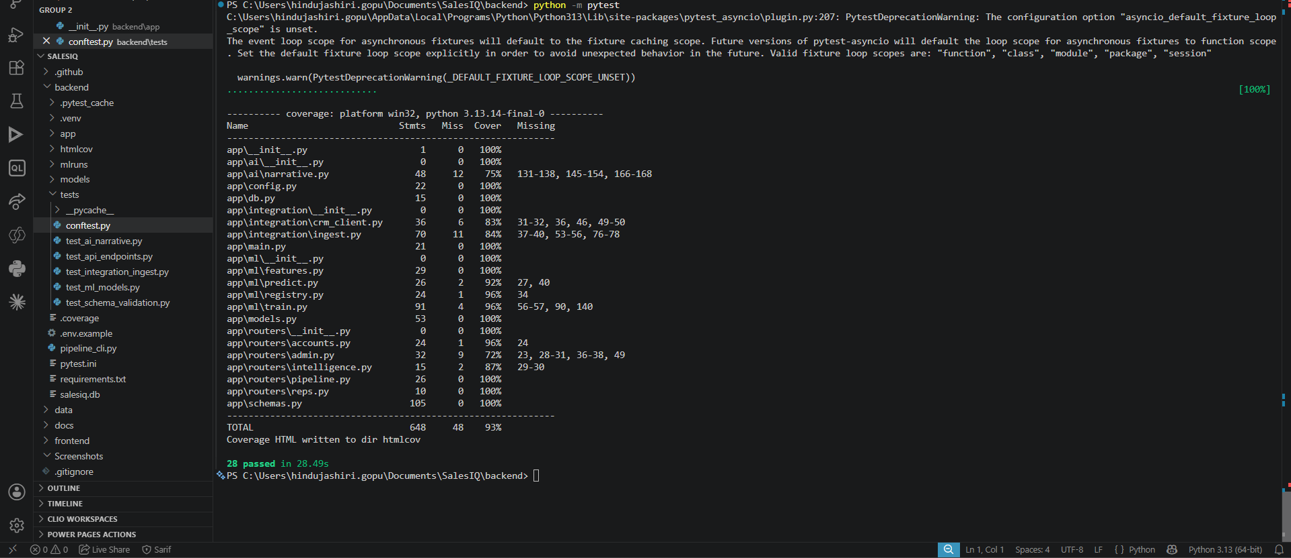

EV-04 — FastAPI serving live data (ML vs stage-weighted forecast)
What this proves | FastAPI backend serving live data. /api/pipeline/overview returns the ML forecast (₹7,31,17,841) alongside the naive stage-weighted forecast (₹5,59,33,250), showing the ML engine changes the number leadership plans against. Proves D-04, D-05.
Deliverable ID (Sec 3) | D-04, D-05
Date captured | 15-Jul-2026
Verifiable link | http://localhost:8000/docs
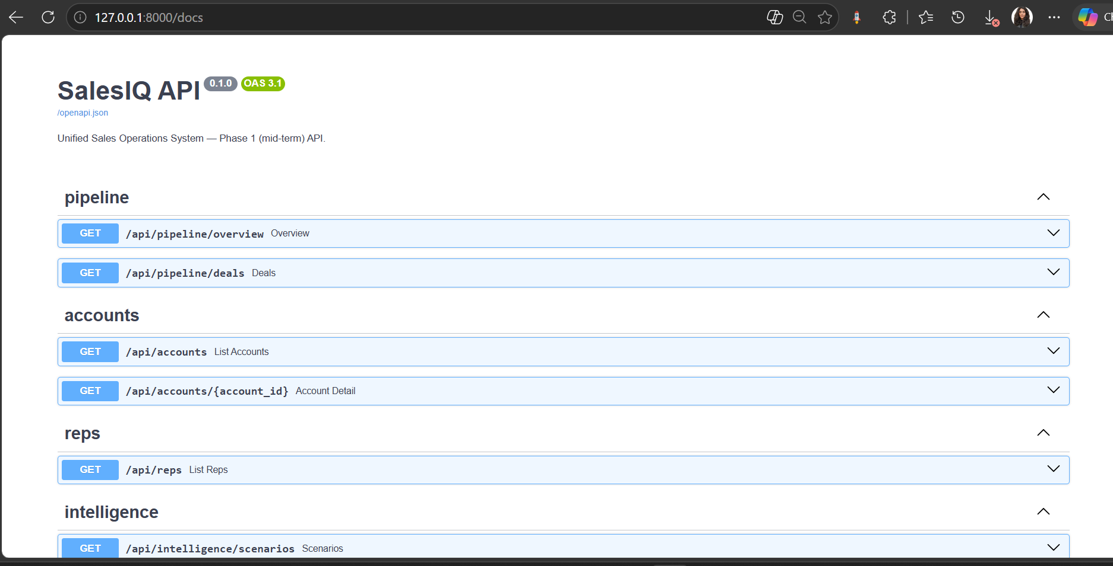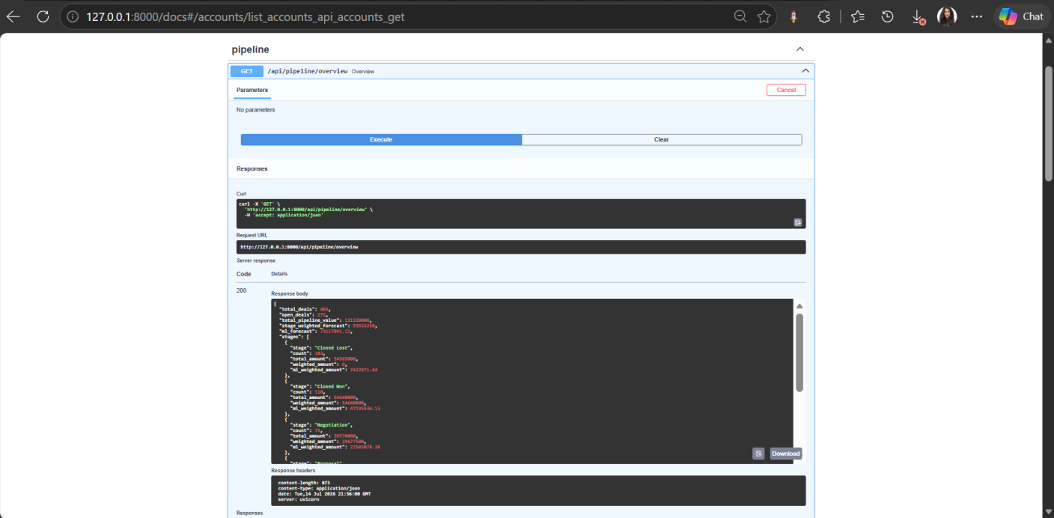

EV-05 — Pipeline Overview portal screen
What this proves | Pipeline Overview screen (React + Recharts) rendering live API data — KPI cards, stage-weighted-vs-ML forecast bar chart, and top deals ranked by expected revenue. Proves D-04.
Deliverable ID (Sec 3) | D-04
Date captured | 15-Jul-2026
Verifiable link | http://localhost:5173
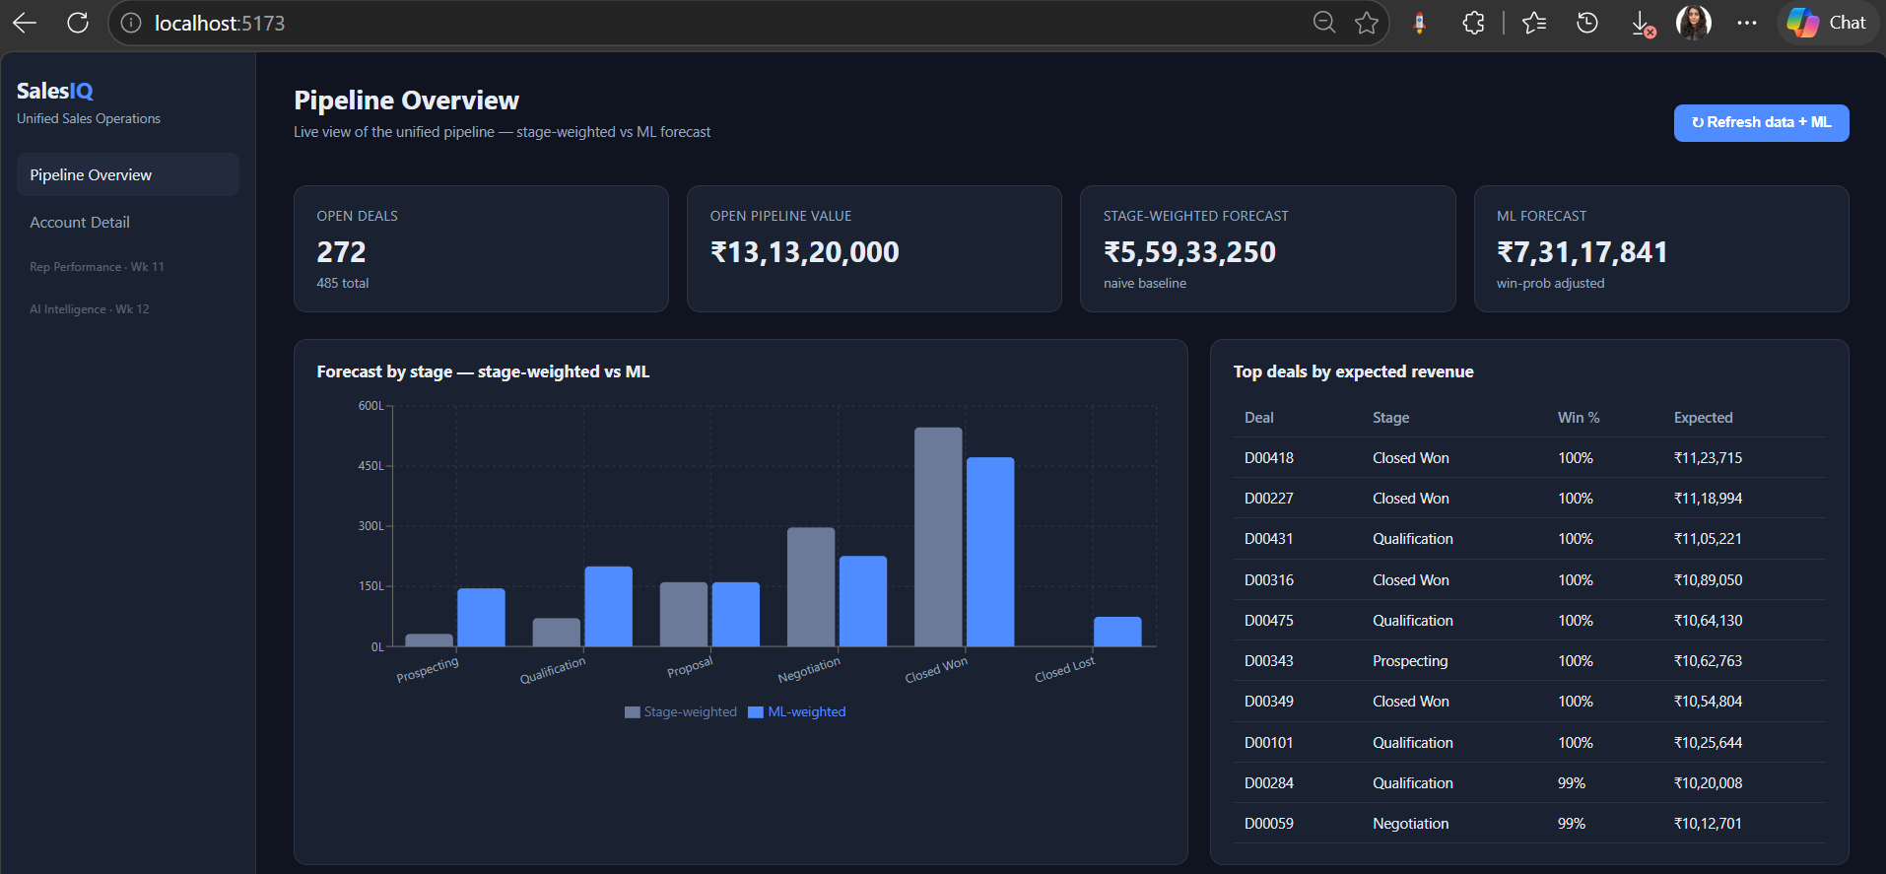

EV-06 — Account Detail portal screen
What this proves | Account Detail screen — account-health KPIs (health band, risk, renewal), the account's deals with win probability, and the portfolio health-mix chart. Proves the account-health domain integration and screen (D-03, D-04).
Deliverable ID (Sec 3) | D-03, D-04
Date captured | 15-Jul-2026
Verifiable link | http://localhost:5173/accounts
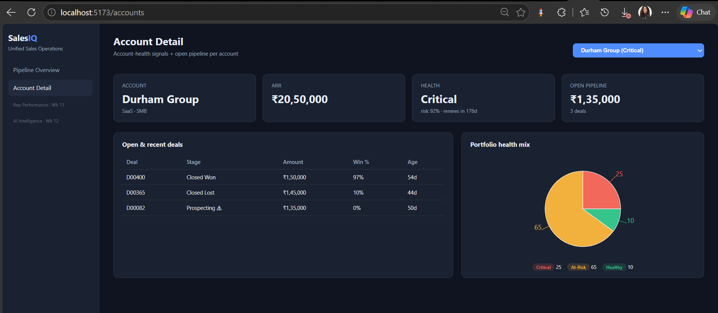

EV-07 — AI Sales Intelligence narrative (Strong Quarter)
What this proves | AI Sales Intelligence narrative for the Strong Quarter scenario, grounded in real pipeline state and ML outputs (open deals, ML vs stage-weighted forecast, top deals with win probability). Proves the Week-9 AI deliverable D-06.
Deliverable ID (Sec 3) | D-06
Date captured | 15-Jul-2026
Verifiable link | http://localhost:8000/api/intelligence/narrative?scenario=strong_quarter
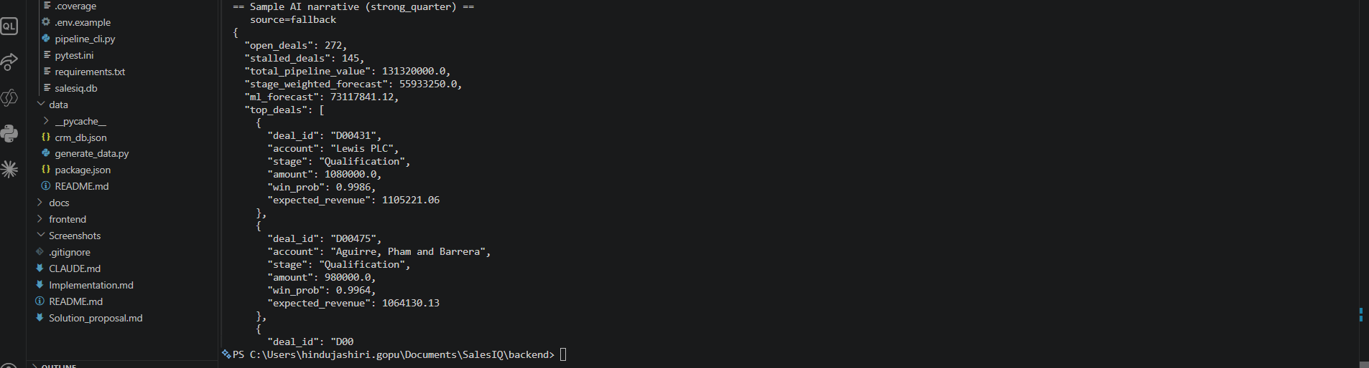

EV-08 — MLflow experiment tracking
What this proves | MLflow experiment tracking — win_scorer and revenue_forecaster runs logged with parameters (chosen algorithm) and metrics (auc_roc / mape). Proves ML experiments are tracked (D-05).
Deliverable ID (Sec 3) | D-05
Date captured | 15-Jul-2026
Verifiable link | http://localhost:5000
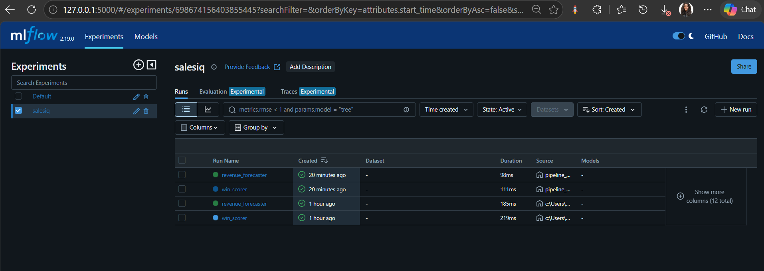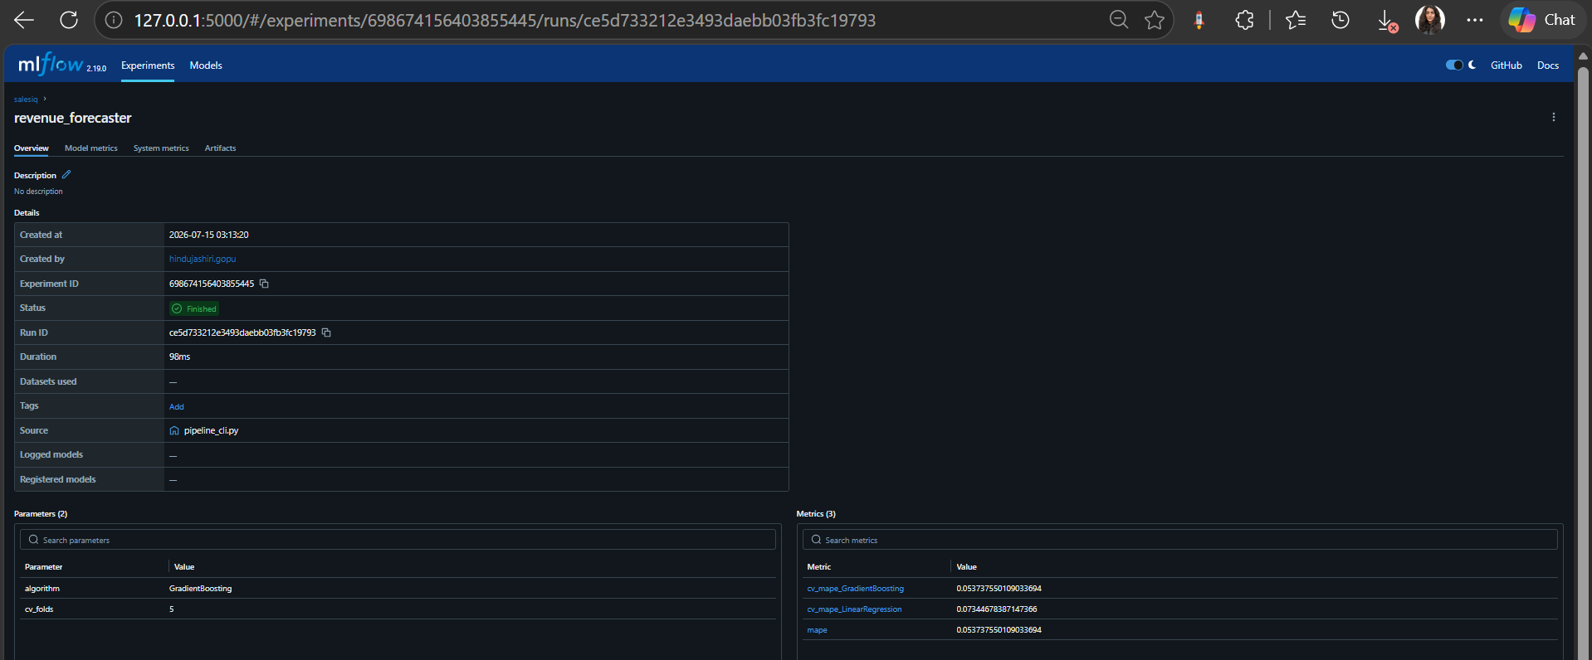

5. Working Demo & Repository Links
Code repository URL (GitHub/GitLab) | https://github.com/HindujaShiriG/pSiddhiSalesQ
Latest commit ID + date (as of submission) | Latest commit on branch `main` — see repository (as of 15-Jul-2026)
Deployed / hosted URL (if any) | N/A — Azure deployment is a Phase-2 deliverable (Week 13)
Demo video or recording link (optional) | N/A
Notebook / dashboard / other artefact links | MLflow UI (local): http://localhost:5000 — see EV-08; coverage report: backend/htmlcov/index.html

6. QA Progress (up to Week 9)
Test Type (per approved QA strategy) | Tests written / run so far | Coverage achieved (measured) | Target (per proposal) | Evidence ID(s)
Unit Tests | 6 (schema validation, ML prediction ranges, normalisation) | 93% overall (measured, pytest-cov) | >80% coverage | EV-03
Integration Tests | 5 (FastAPI→SQLite, all 3 CRM domains, referential integrity) | included in 93% | All 3 domains | EV-02, EV-03
API Endpoint Tests | 7 (pipeline, accounts, reps, intelligence, admin) | included in 93% | All screen APIs | EV-03, EV-04
ML Accuracy Tests | 5 (AUC-ROC 0.96, MAPE 0.05, prediction ranges) | targets met | AUC>0.75, MAPE<15% | EV-02, EV-03
AI Quality Assertions | 5 (narrative grounding + scenario checks) | 1 scenario validated | 3 scenarios (1 at mid-term) | EV-03, EV-07

7. Tool & Budget Reconciliation
Tool / Service (approved) | Approved tier & cost | Used by Wk 9? | Actual cost (₹) | Reason if changed / not yet used
Azure Backend Hosting | Paid · ₹800 | ☐ Yes ☑ No ☐ Partial | ₹0 | Azure deployment scheduled Week 13 (Phase 2); not provisioned yet
Azure App Service F1 (Linux) | Free · ₹0 | ☐ Yes ☑ No ☐ Partial | ₹0 | Backend hosting begins at the Week-13 deployment
Python FastAPI + SQLite | Open source · ₹0 | ☑ Yes ☐ No ☐ Partial | ₹0 | Core integration + persistence layer — in use
JSON Server | Open source · ₹0 | ☑ Yes ☐ No ☐ Partial | ₹0 | Mock CRM (3 REST domains) — in use
scikit-learn + PyCaret + MLflow | Free · ₹0 | ☐ Yes ☐ No ☑ Partial | ₹0 | scikit-learn + MLflow in use; PyCaret replaced by scikit-learn auto-select (Python 3.13 incompatibility) — see Section 8
Google Gemini 2.5 Flash | Free tier · ₹0 | ☐ Yes ☐ No ☑ Partial | ₹0 | Integrated with deterministic offline fallback; live API key optional — see Section 8
React + Recharts | Free · ₹0 | ☑ Yes ☐ No ☐ Partial | ₹0 | Portal + charts — 2 screens in use
Ollama + Llama 4 Scout (8B) | Free · ₹0 | ☐ Yes ☑ No ☐ Partial | ₹0 | Offline LLM not required yet; fallback covers offline dev
GitHub (CI/CD) | Free · ₹0 | ☐ Yes ☐ No ☑ Partial | ₹0 | Repo published; CI workflow authored (.github/workflows/ci.yml) — first CI run at Week 13
pytest + pytest-cov + Playwright + httpx | Free · ₹0 | ☐ Yes ☐ No ☑ Partial | ₹0 | pytest/pytest-cov/httpx in use (93% cov); Playwright E2E is Phase 2 (Week 15)
Faker | Free · ₹0 | ☑ Yes ☐ No ☐ Partial | ₹0 | Synthetic data generation (660 records) — in use
Contingency Buffer | — · ₹500 | ☐ Yes ☑ No ☐ Partial | ₹0 | Reserved; no overages incurred

7.1 Budget Summary
Approved budget ceiling | ₹2,500
Estimated spend at approval | ₹1,300
Actual spend till Week 9 | ₹0 (all tools used so far are free / open-source; Azure not yet provisioned)
Buffer remaining | ₹2,500
Anticipated spend before Week 17 | ₹1,300 (Azure hosting ₹800 + contingency ₹500 as needed)

8. Deviations from Approved Proposal
Item | Approved plan | Actual implementation | Reason for change
Model auto-selection library | PyCaret auto-select | scikit-learn compare-and-select (same candidate algorithms) | PyCaret dependency pins incompatible with Python 3.13; behaviour + MLflow tracking preserved
AI narrative generation | Gemini 2.5 Flash | Gemini + deterministic offline fallback grounded in the same ML brief | Free-tier rate limits + offline development (Risk #3); output identical in structure
E2E test tooling (timing) | Playwright E2E | API-level E2E at mid-term; Playwright scheduled Week 15 | No portal E2E surface until all screens exist; matches approved Phase-2 timing (not a scope change)

9. What Is NOT Completed Yet + Plan for Weeks 11–16
Pending item (be specific) | Why it is pending | Plan to complete (target week)
Account Health Classifier (3rd ML model) | Phase-2 deliverable; account labels already prepared | Week 11
Rep Performance + AI Intelligence portal screens | Phase-2 screens; data/endpoints already exposed | Weeks 11–12
At-Risk Quarter & Recovery AI scenarios | Briefs computed; narratives pending | Week 12
Azure end-to-end deployment + live GitHub Actions CI run | Deployment is Phase-2; ₹800 hosting to be provisioned | Week 13
Playwright E2E tests; ≥80% coverage confirmed on full system | Requires all 4 screens deployed | Week 15

10. Risks & Blockers
Risk / Blocker | Status (Open / Mitigated / Realised) | Mitigation taken so far | Impact on remaining timeline / support needed
ML accuracy below target on synthetic data | Mitigated | Faker 660-record set with realistic variance + scikit-learn auto-select — models hit AUC 0.96 / MAPE 0.05 | Low; will re-validate on larger/real-shaped data
Azure free-tier limits exceeded / unexpected cost | Open | Not yet deployed; will set ₹200 budget alert and deploy only during demo/test windows | Revisit at Week-13 deployment
Gemini API rate limits during demo | Mitigated | Deterministic offline fallback + caching implemented; live key optional | Low
FastAPI + SQLite performance | Mitigated | Indexes on hot columns; ML scores pre-computed at ingestion; screens load fast | Low
Azure App Service F1 cold-start | Open | Mitigation (health-check ping) deferred to deployment | Address at Week 13

11. Declaration & Pre-Submission Checklist
☑ All fields in Section 1 match my L&D Final Decision record exactly (correct Topic ID, no original/corrected mismatch).
☑ Section 3 lists every deliverable my approved proposal committed for Weeks 4–9, each with a D-ID and a status.
☑ Every "Done" or "Partial" status in Section 3 points to at least one Evidence ID in Section 4.
☑ Every evidence block in Section 4 has a specific caption, a pasted full-size screenshot, and a verifiable link where applicable.
☑ The repository link in Section 5 is accessible to the L&D team and the stated commit exists.
☑ Section 6 coverage figures are measured (tool output attached as evidence), not estimated.
☑ Section 7 lists every tool from my approved proposal, including ones I did not use.
☑ Section 8 discloses every deviation, including advisories I chose not to act on.
☑ Section 9 is consistent with Sections 3 and 4 — no contradictions.
☑ I have deleted all grey italic instruction text.
☑ I have not renamed, deleted, or reordered any section of this template.
☑ Document is saved as [TopicID]_[ParticipantName]_MidTermDoc.docx and uploaded to Moodle before the deadline.
Declaration: I confirm that all progress claims, evidence, costs, and coverage figures in this document are true and reflect my own individual work.
Participant signature / name | Hindujashiri Gopu
Date of submission | 15-Jul-2026
Submission deadline: End of Week 9 / start of the Week 10 review window (13-Jul-26), as per programme schedule. Late or incomplete documentation may affect your mid-term evaluation score.

