MOLBILE-DI (Assignment)

**PURPOSE**

The purpose of this project is to develop an application which displays the employee Details who work in corresponding departments.

**PRODUCT FEATURES**

The major features of this application database system as shown in below [**entity–relationship model**](https://en.wikipedia.org/wiki/Entity%E2%80%93relationship_model) (**ER model**)

Department_Details

Deptno (PK)

deptName

deptLocation



**OPERATING ENVIRONMENT**

Operating environment for this application is as listed below.

* Operating system : Windows.
* database: sql+ database(MYSQL / ORACLE 10g)
* platform: Java
* Rest Client (Debugger for Rest Full web services)
* JSON

**Architecture :**

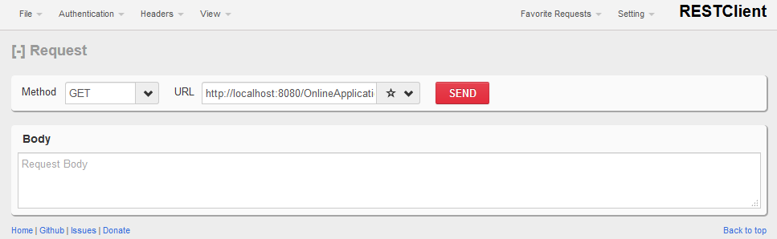

Request (<http://localhost:8080/OnlineApplication/addNewEmployeeDepartment>)

(or)

(http://localhost:8080/OnlineApplication/getEmpInfomration/10)

Model

Business Objects (DAO) Hibernate Beans

Controller

Data Base

View

(Jsp/Html)

**Project Structure :-**

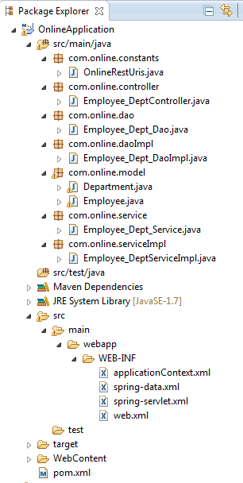

Model classes i.e. POJO classes

Controller

Rest uniform resource identifiers

**Case #1**

To add the employee details along with department details :-

# <http://localhost:8080/OnlineApplication/addNewEmployeeDepartment>

Make use of JSON object to pass the data to entities

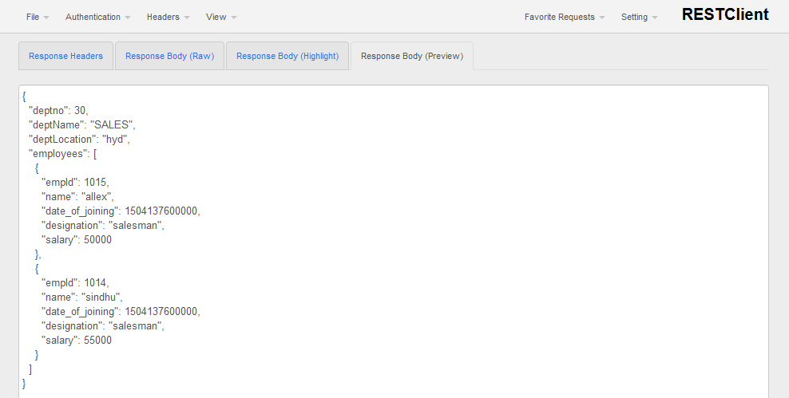

**Case #2**

To get the employee details along by passing department Number in URI :-

# [http://localhost:8080/OnlineApplication/ getEmpInfomration/30](http://localhost:8080/OnlineApplication/%20getEmpInfomration/30)

It will display the employee’s who are working in 10 department