PARIKINO MARAE
Booking & Facilities Guide
909 Whanganui River Road, Parikino, Whanganui
Booking Officer: Mereana Stanley | medz-rauz@hotmail.co.nz | 063 425 836 | 022 406 0228
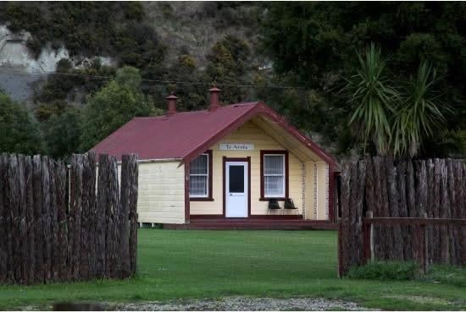
Te Aroha
Parikino Marae is nestled on the banks of the Whanganui River — a place for weddings, birthdays, meetings and tangihanga, welcoming all whānau and visitors.

1. About Parikino Marae
Parikino Marae holds a unique role in preserving the heritage of Ngāti Tuera, Ngāti Hinearo and Ngāti Tūmango. It is the perfect venue for any event — weddings, birthdays, meetings and tangihanga.

2. Marae Hireage Rates
All rates are per booking period as listed below.
Type | Rate
Corporate — Per Night | $350.00
Corporate — Per Day | $250.00
Whānau — Per Night | $200.00
Whānau — Per Day | $150.00
Tangihanga | Koha

3. What's Included
- Manaakitia, Te Aroha, Kōwharewhiti and the Virtual Awa ablution
- Gas oven, gas cookers and hāngī cookers
- Wood, tables and chairs
- Pots, cutlery, dinnerware and crockery
- Mattresses, sheets and pillowcases
- Chiller, fridge and freezer
- Marae WiFi and marae landline
- Emergency generator, radio and defibrillator, and fire extinguishers
- Skip bin and pig bin, playground and parking

4. Booking Notes
- Numbers: Please provide the number of people attending or staying at your kaupapa. Numbers are not required for tangihanga.
- Te Rangimarie: The Kaumātua Room is not to be used for sleeping at any time.
- Queries: If you have any queries about booking the marae, please contact Mereana Stanley on the details above.

5. Facilities Guide
A reference for whānau staying at or organising an event at the marae.
- Sleeping Houses (Wharepuni): Te Aroha and Kōwharewhiti are both wharepuni. Mattresses, pillows and sheets are provided in each.
- Ablutions (Virtual Awa): Located at the back of the dining hall — men's urinal, toilets and showers; women's showers and toilets; and a disabled toilet and shower.
- Wharekai / Dining Hall (Manaakitia): Includes Te Rangimarie (Kaumātua room, not for sleeping), the top kitchen and bottom cookhouse. Tables are stacked at the front end of the wharekai — please restack them there when finished. The stage is strictly out of bounds at all times.
- Kauta (Kitchen): The top kitchen has a gas oven and gas elements (instructions on the wall above the oven; there is only one oven). Gas burners are set up in the bottom cookhouse. Gas bottles are located outside the cookhouse and are used for cooking only — these are always on.
- Power & Water: The big meter box is in the old men's toilet at the rear of the dining hall; the small meter box is in the bottom kitchen/cookhouse above the sink. To turn the water on: switch it on at the meter box, turn the power on at the wall by the water tank, then turn the two blue levers either side of the pump. To reset the pump, push the red button on its side.
- Heating, Wood & Cooling: The fireplace in the bottom cookhouse heats water for the kitchen and showers. Wood is stacked in the shed out front of the cookhouse and/or in the bottom cookhouse. The fridge freezer and big freezer are in the top kitchen; the chiller is at the bottom of the cookhouse and is turned on at the cookhouse meter box.
- Rubbish & Bins: Kitchen rubbish bins are for use in the kitchen and hall only. Skip bins, for marae and locals' rubbish only, are out the front on the left-hand side of the marae. Pig bins are provided — please leave them outside by the tank when you leave.

6. Marae Tikanga and Kawa
Parikino Marae is governed by the kawa and tikanga of Ngāti Tuera, Ngāti Hinearo and Ngāti Tūmango, put in place to support your stay and uphold the mana of the hapū. These apply to all bookings, including tangihanga — please share this with your group or organisation.
- Zero Tolerance: Illegal drugs, alcohol and fighting are strictly prohibited anywhere on the marae grounds.
- Smoke and Vape Free: Not permitted inside any buildings, including the dining hall, top kitchen, both wharepuni, and the Virtual Awa building.
- Vehicles and Parking: Driving on the marae grass or parking in the entranceways is strictly prohibited. Please use the designated parking areas.
- Upkeep: Whānau are responsible for maintaining the cleanliness and upkeep of all areas throughout their stay.

7. Breaches of Policy
Any breach of the above may result in forfeiture of your booking, a marae fee being charged, and the decline of future bookings.

Nā Parikino Marae Reservation Trust
Mereana Stanley (Bookings Officer) — medz-rauz@hotmail.co.nz | 063 425 836 / 022 406 0228

