PARIKINO MARAE RESERVATION TRUST
PARIKINO MARAE
Marae Guidelines & Tautoko for Tangihanga
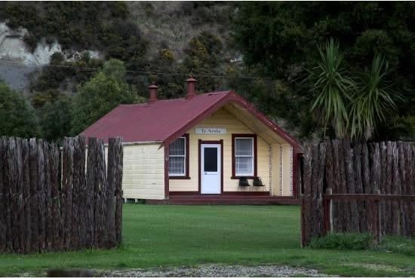
Te Aroha, Parikino Marae
He aroha ki te whānau e whakahokia mai ai ngā uri o Ngāti Tuera, o Hinearo, me Tumango ki tō tātou ūkaipō, ki te Marae o Parikino, ki te tangi, ki te poroporoaki.
909 Whanganui River Road, Parikino, Whanganui
Mereana Stanley, Booking Officer · medz-rauz@hotmail.co.nz · 063 425 836 / 022 406 0228

01
Koha & Financial Support
- Marae Operations: When the marae is used for a tangihanga, we operate on a koha basis to help cover expenses.
- Manaakitanga: To support the whānau during this time, the marae will provide a koha toward your first meal (kai) upon arrival.
- Grants: Financial support and tangihanga grants are available and can be accessed through Ngā Tāngata Tiaki and Ātihau. Whānau are encouraged to follow these up directly.

02
Roles & Responsibilities
- Hapū Support: The organisation and facilitation of a tangihanga is the collective responsibility of the wider hapū, rather than the role of the Marae Trustees.
- Dining Area: The layout, setup, and general day-to-day management of the dining room is the responsibility of the organising whānau.
- Tent & Whare: The marae does not supply tents for tangihanga. Sourcing and setting up a tent is the responsibility of the whānau. Alternatively, you are more than welcome to utilise the whare.
- Equipment Location: Pallets for the tent are stored in the old toilet building behind Te Aroha. The carpet is located inside the church.

03
Marae Tikanga and Kawa
Our marae is a reflection of our hapū, and we require all users to uphold its safety and mana.
- Zero Tolerance: Illegal drugs, alcohol, and fighting are strictly prohibited anywhere on the marae grounds.
- Smoke and Vape Free: Smoking and vaping are not permitted inside any buildings, including the dining hall, top kitchen, both wharepuni, and the Virtual Awa building.
- Vehicles and Parking: Driving on the marae grass or parking in the entranceways is strictly prohibited. Please utilise the designated parking areas.
- Upkeep: Whānau are responsible for maintaining the cleanliness and upkeep of all areas throughout their stay.

04
Breaches of Policy
Please note that any breach of the above rules may result in the immediate forfeiture of your current booking, additional cleaning or penalty fees, and the decline of any future booking requests.
Using the kitchen, water or power? Step-by-step instructions for the kauta, meter boxes, water pump, fireplace and rubbish bins are in the companion Booking & Facilities Guide.

Nā Parikino Marae Reservation Trust
Mereana Stanley (Bookings Officer) — medz-rauz@hotmail.co.nz | 063 425 836 / 022 406 0228

