

សកលវិទ្យាល័យ​ ពុទ្ធិសាស្រ្តា

University of Puthisastra

Website Project

**Topic:** Promotion Ads

Lecturer : Lypengleang Seang

Course : Dynamic Web App

Year : III

Semester : II

Academic Year: 2019 – 2020

**By Group I**

Mr. Hing Kosal (Leader)

Mr. Chhorn SokTheng (Deputy)

Ms. Kong Sreya

Mr. Koiy Bottra

Mr. Soy Trikea

Mr. Ly Visal

Mr. Smai Phouchhet

Date: 25 / 08 / 2020

**Dynamic Web Development Report**

**Week I**

**What is the project about?**

* We advertise product promotions for companies and seller to the customers through our website.

**Why we choose this topic?**

* We choose this topic for 3 main reasons
  + - We focusing on developing an alternative for people to get all promotions productions from different companies and seller from the market in to one place so people easy to find and buy better.
    - Help seller to published there promotions productions to the world so their target customer will easy to see.
    - In future it can grow to become online market for people over the world can sell and buy many products easy in one place.

**What is our goal of making this happen?**

**Our Goal:**

This website provides sellers and customers the best experience to post their promotion products to customer and all the promotion ads will post on the website and give many different promotions products so all people over the world will see. First, seller need to register in our system to become our user then they can post their promotion products in different categories to the website. Second, all posts will display in website in different categories and with detail of product and company with sell that product such ask product old price, discount(%), company name, contact, location…etc. We start this process in Cambodia the first location then push to publish over the world. Next Goal when we get a lot of our client and this website popular for all people we will develop this website not only promotions ads but we can sell and buy it will make more easy life. Final goal we want to see this website is become a big online market or people all over the world.

**How my team build this platform?**

Basically, we use PHP Framework called “Laravel” for our platform and we decide to have 2 different platforms:

* Frontend: for customer to see all promotions
* Backend: for seller (our client) where they can post all their promotions products. We have 7 members so we give different job for everyone:

**Hing Kosal:**

-Team Leader and Full stack

**Chhorn Soktheng:**

-Team Deputy and Full stack

-Create Project Files Structure Frontend and Backend (MVC)

-Authentication

**Kong Sreya:**

-Create UI (Dashboard, Manage Promotion, and Manage Users)

-Manage on Dashboard, Mange Promotion, and Manage Users

-Documentation (project report and presentation slide)

**Koiy Bottra:**

-Create UI (Configuration, and Backend Categories)

-Manage on Configuration (Size, Brand, Company) and Category

**Soy Trikea:**

-Create UI (Home, All Frontend Categories, and About)

-Manage on Frontend (Homepage, Categories, and About)

**Ly Visal + Chhorn Soktheng:**

-Create UI (Contact Us and Free Ads Post (Register Form and Login Form))

-Authenthication

**Smai Phouchhet:**

First, we use our old php project which already had frontend and backend and we upgrade it to php’s framework called “Laravel”. Second, we create Laravel project by using our php platform. Third, we also got support from W3school web, YouTube and especially plenty of method and tool from our instructor. Last but not least, we use Laravel to make our website into dynamic like input data into database and call data back and using MYSQL as a database management system.

**Week II**

We are going to update our Promotion Ads Platform to become a dynamic web by using Laravel connect with MYSQL and update more standard interface.

Our Site Map

**Database Structure**

* **Tables Relationship Structure**

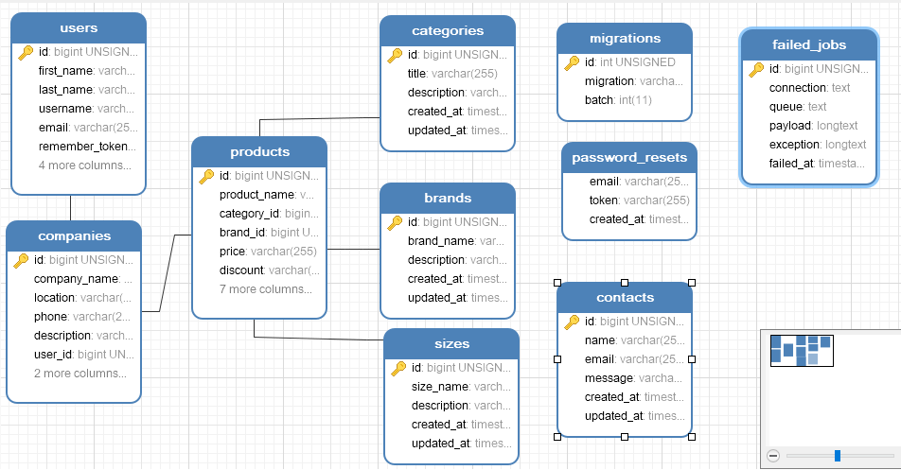

**Our Platform**

* **Frontend**

**Homepage**

Where we can view all promotion product by category.

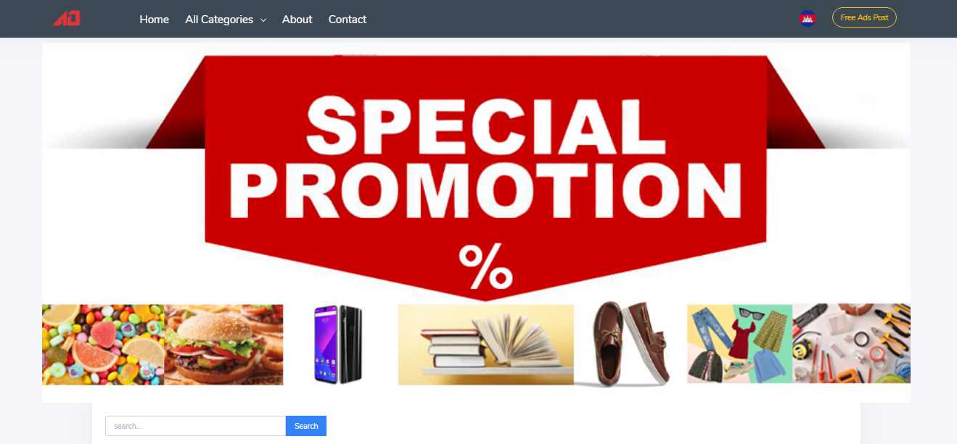

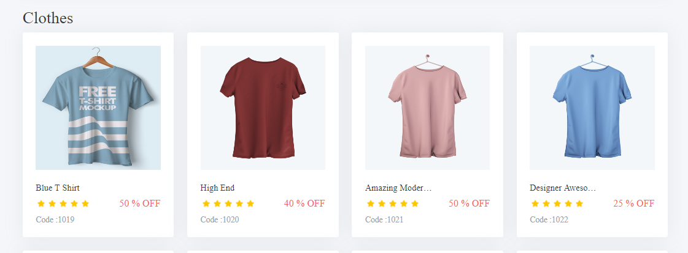

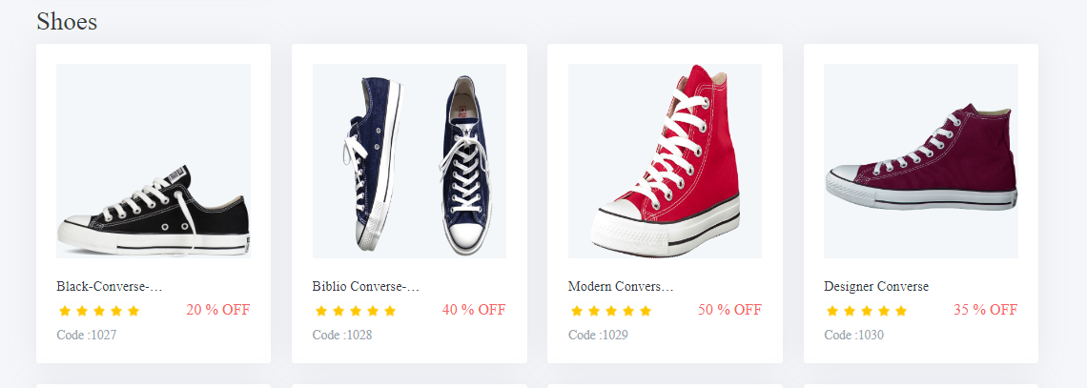

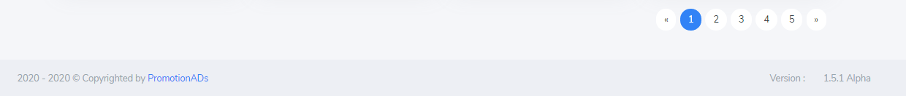

**Product’s Detail**

* When we click on icon product which show on Home page, it will go to product detail which show the detail of product.

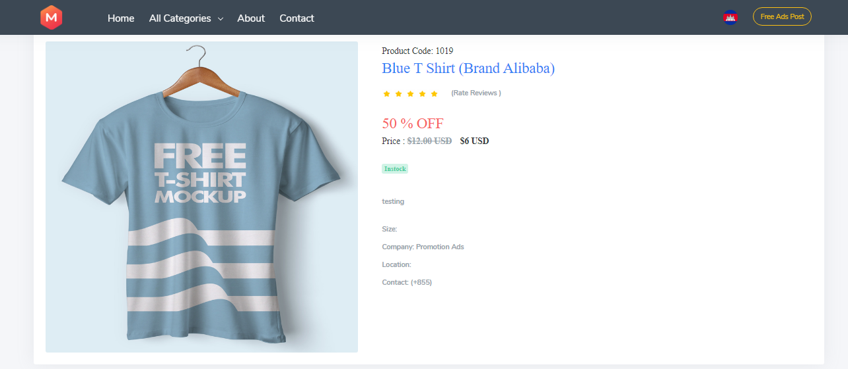

**All Category**

All Categories is Dropdown on the Header Menu. We can View All promotion Products in different category.

**About**

* About is where you will see our future goal and our team members.

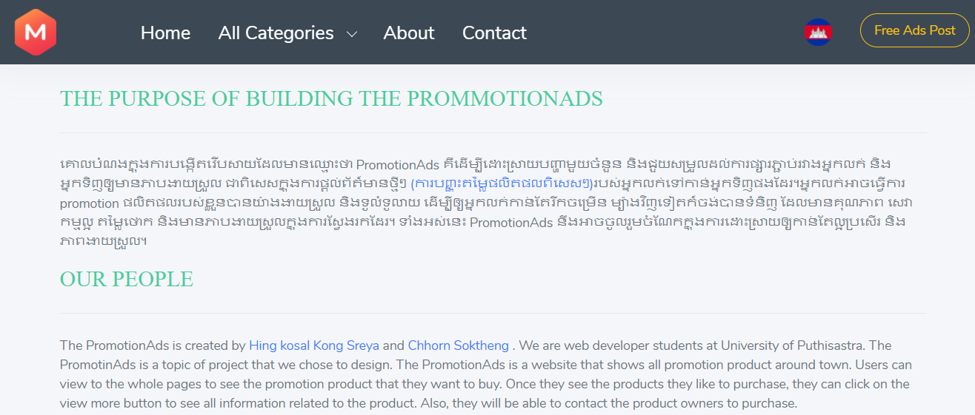

**Contact Us**

* Where you can send us message and contact us over the social media and Phone

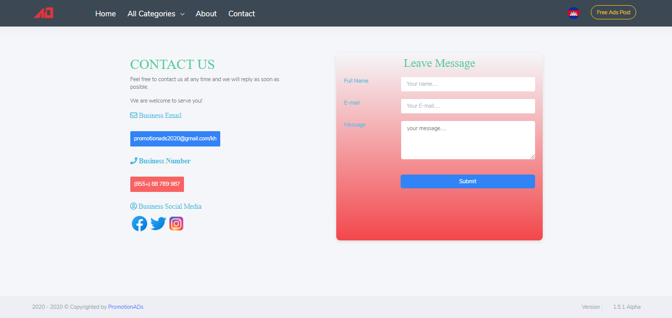

**Register Form**

* Where we can register new user account use for login to backend system management

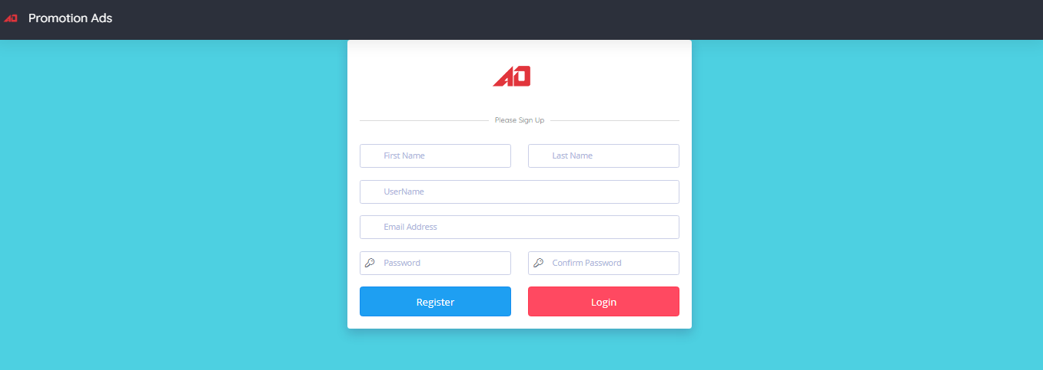

**Login Form**

* You need to have Email and password from user account that already register to login into backend then you can post your promotion ads.



* **Backend**

**Dashboard**

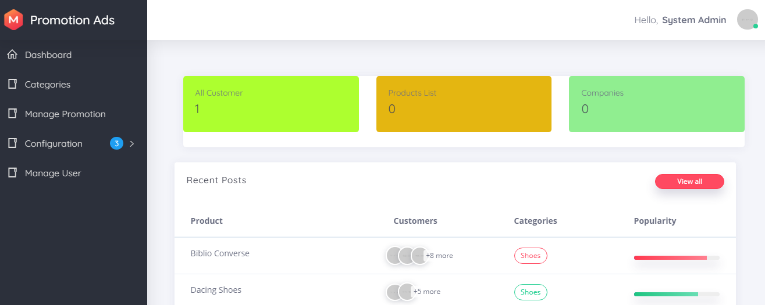

**Categories**

Category is different kinds of products.

- View lists: view all category system have.

- We can add, update and delete and Search by title

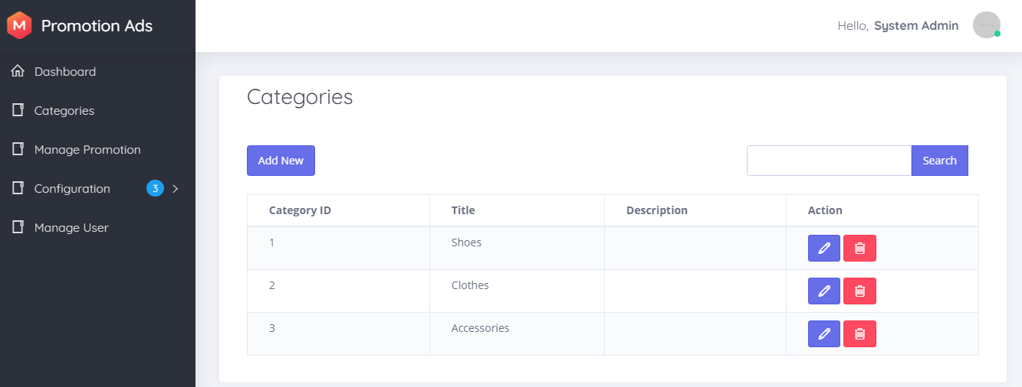

**Create New Categories**

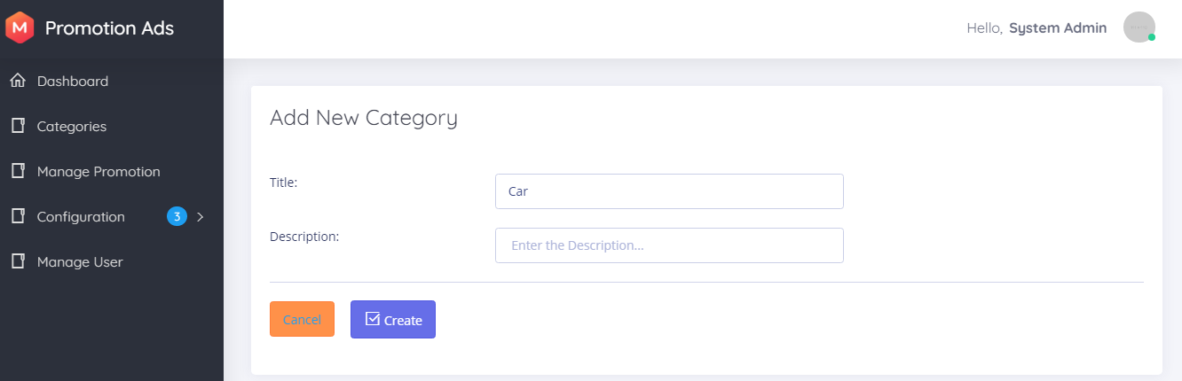

**Update Categories**

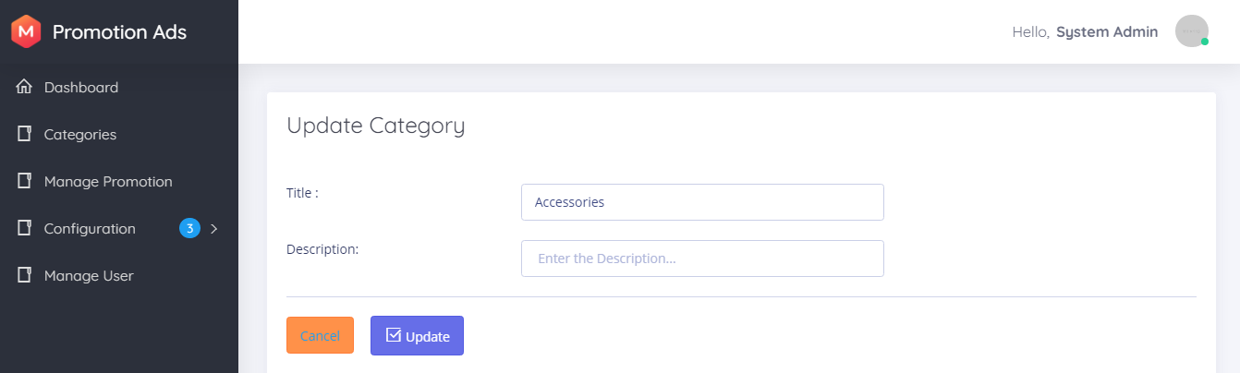

**Manage Promotion**

* Promotion Products

Promotion Product is where we can see all promotion post.

We can add, update, delete, view, and search by id

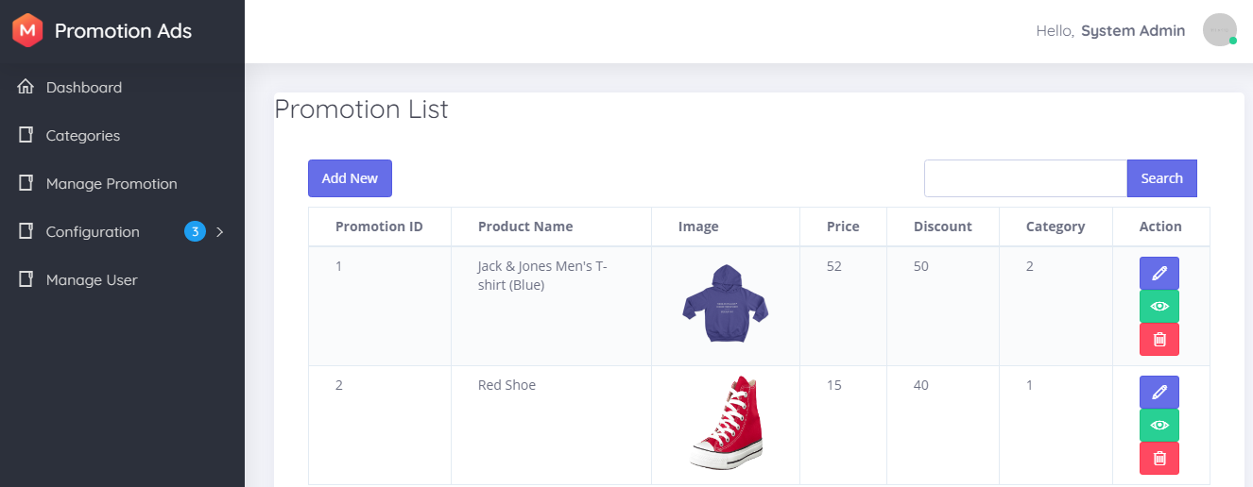

**Create New Promotion**

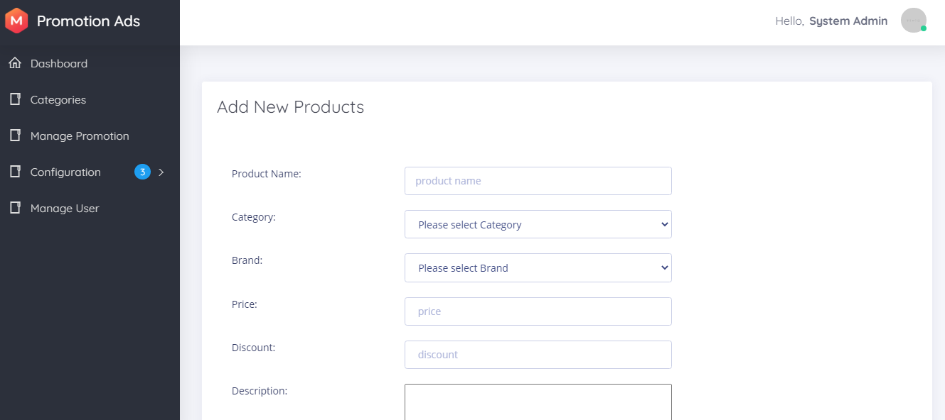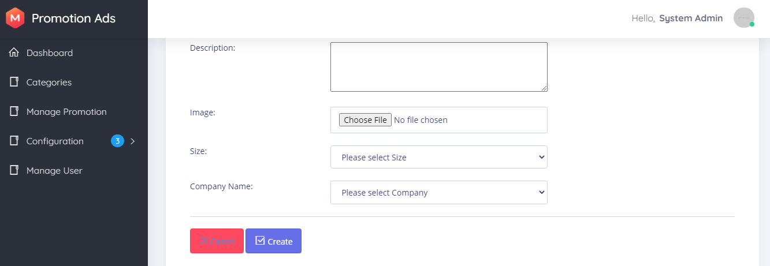

**Update Promotion**

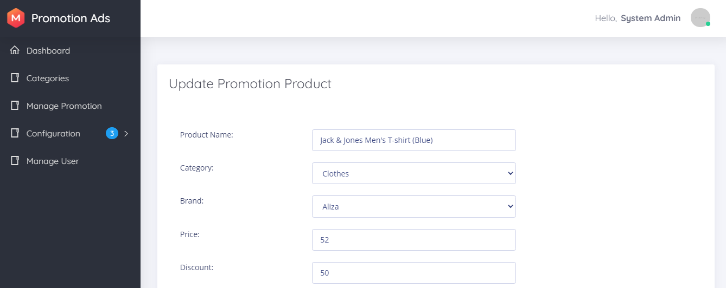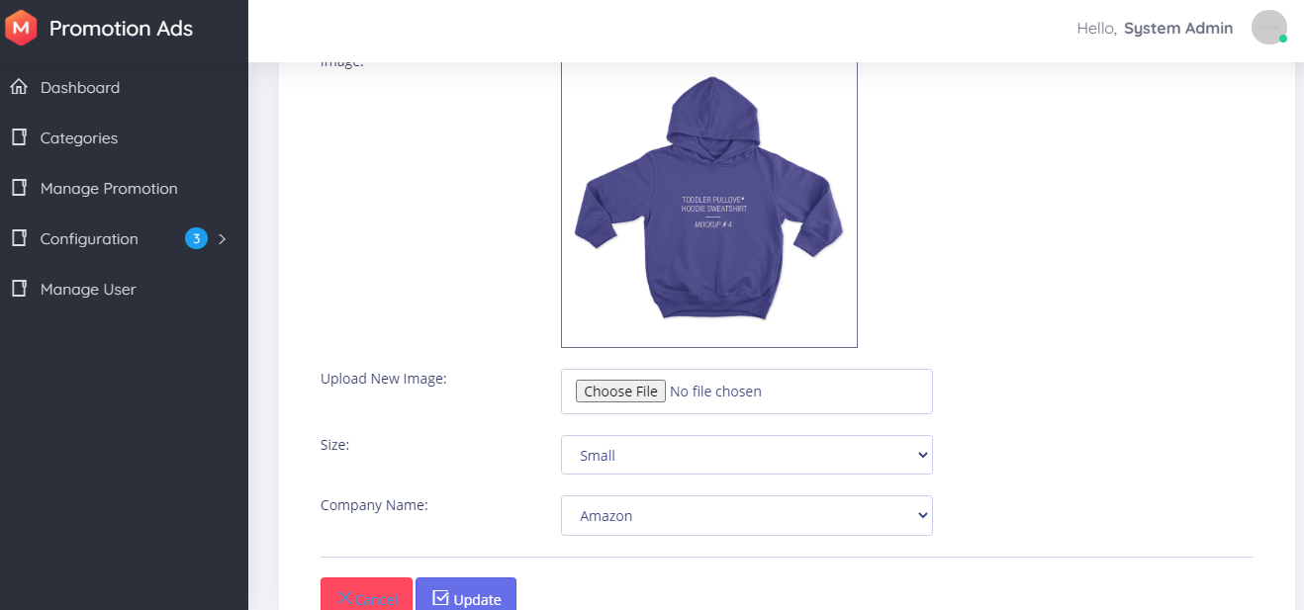

**View Promotion**

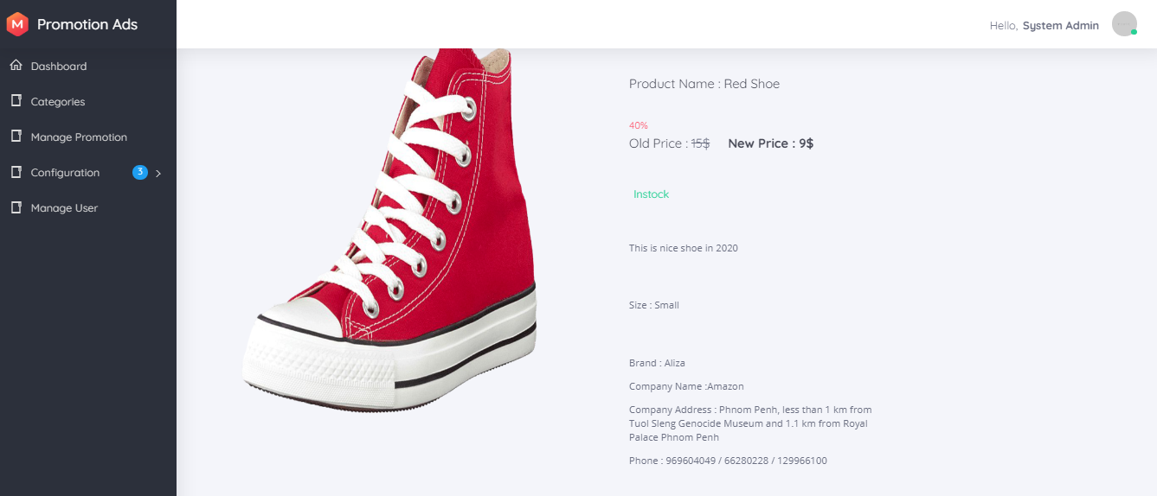

**Configuration**

**Company**

Company of product before post promotion ads all product need to have company.

View lists: view all Company.

We can add, update delete, and Search by name

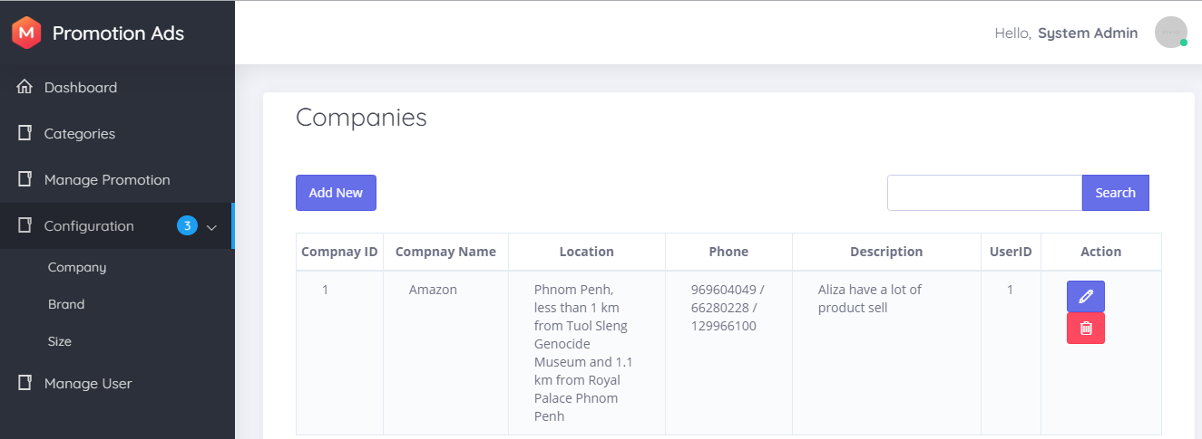

**Create Company**

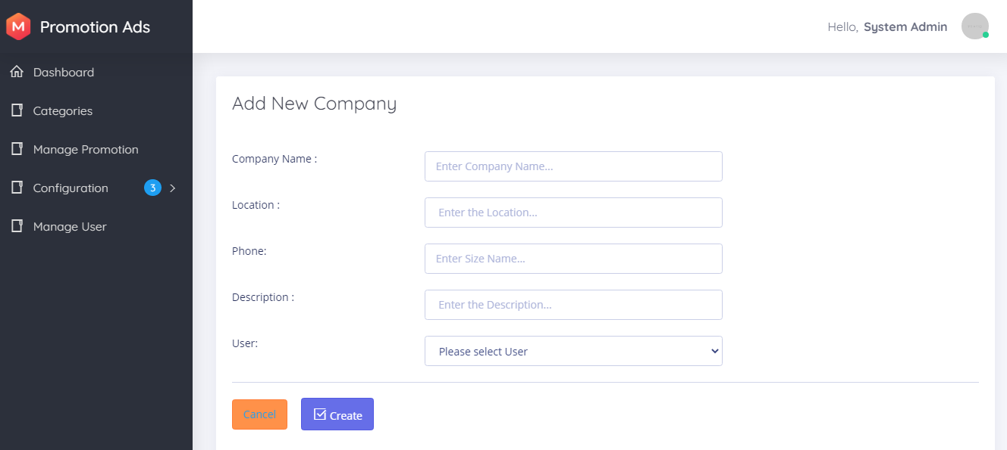

**Update Company**

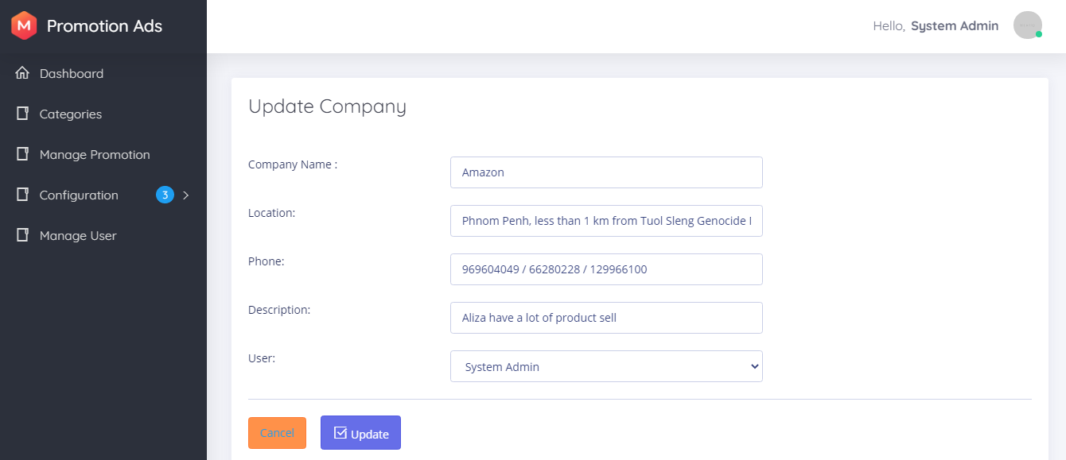

**Brand**

Brand is focus on product brand.

- View lists: view all product brand in the system.

- We can add, update, delete and search By name

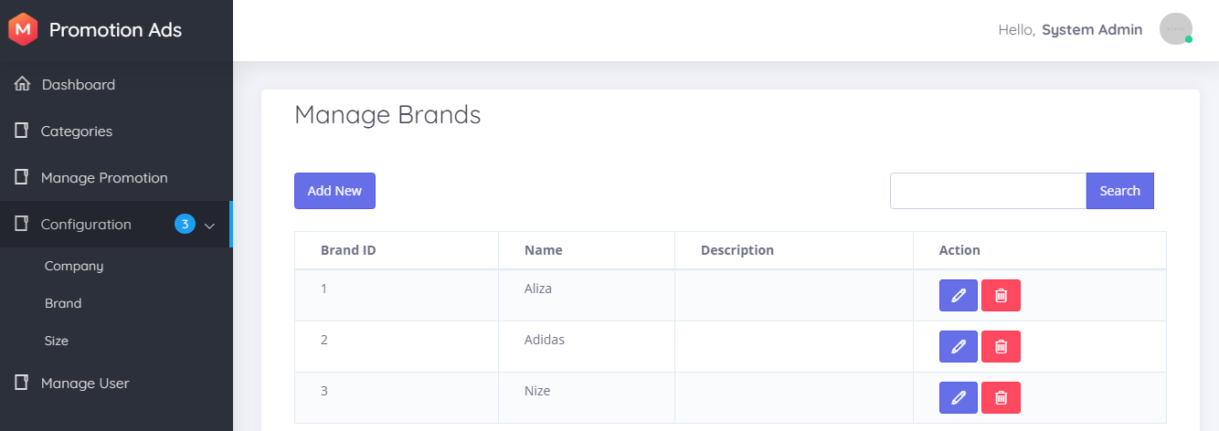

**Create Brand**

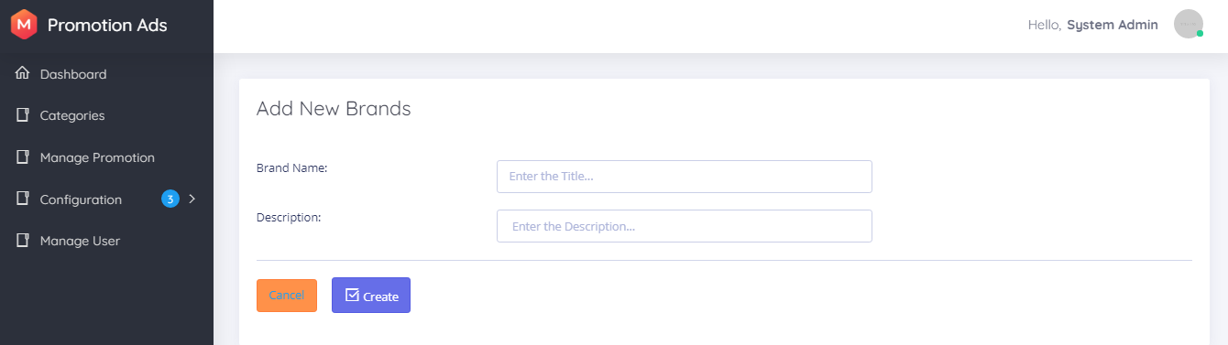

**Update Brand**

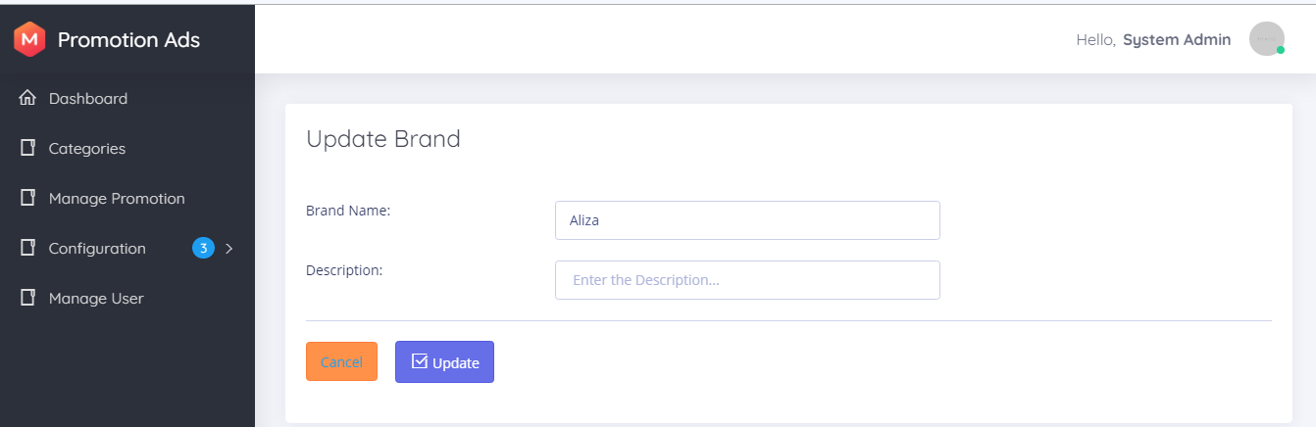

**Size**

Size is about product size like clothes or shoes...

- View lists: view all size.

- We can add, update, delete and search by name

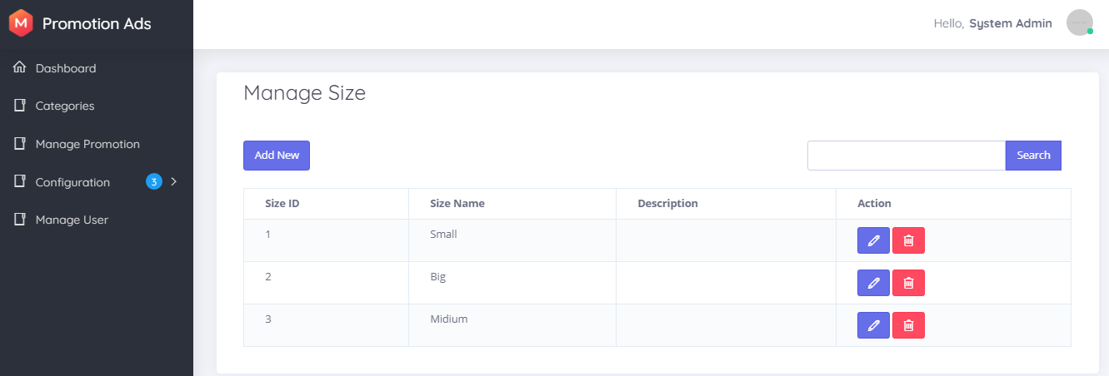

**Create Size**

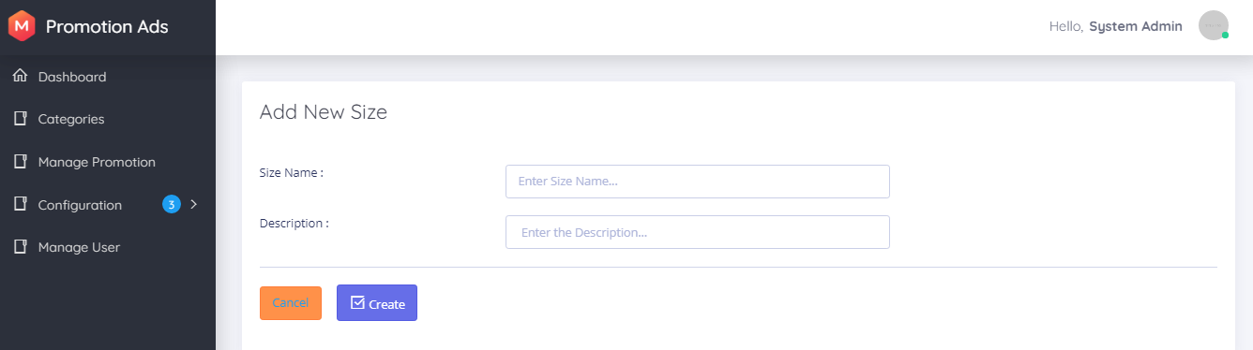

**Update Size**

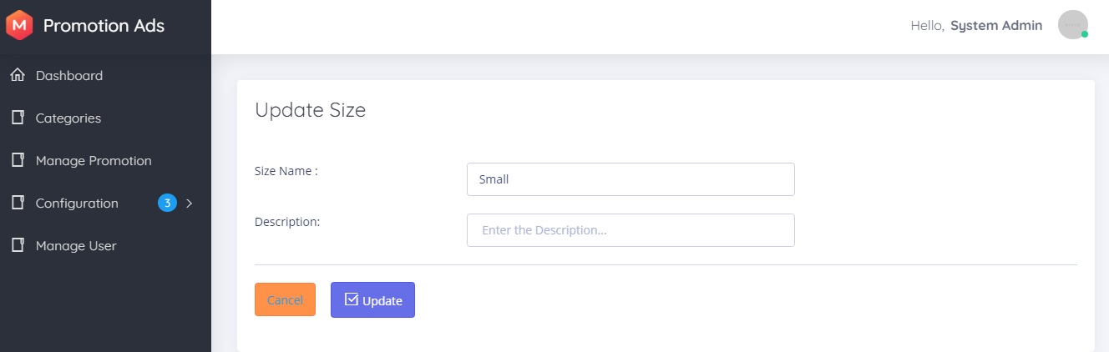

**Manage User**

User use to login the backend of the system and can post new promotion ads.

We can edit, delete, reset password and view list of users

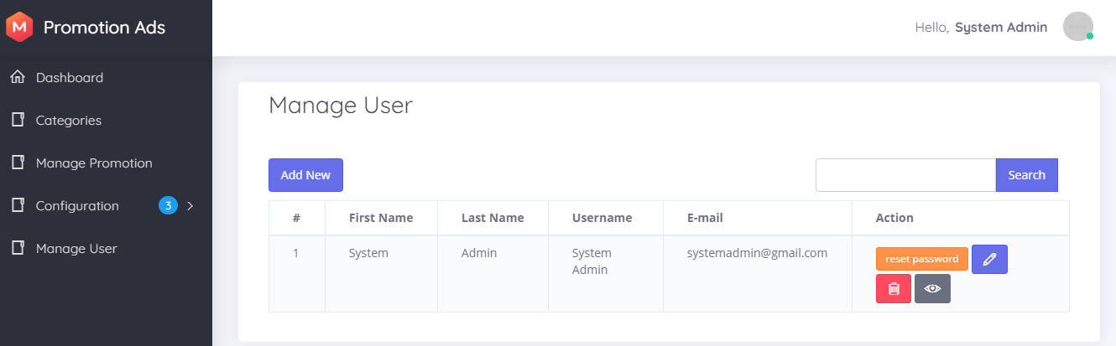

**Create User**

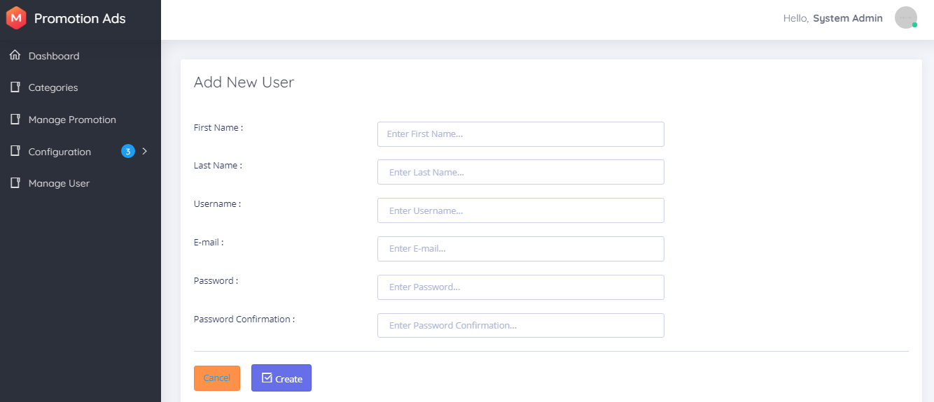

**Update User**

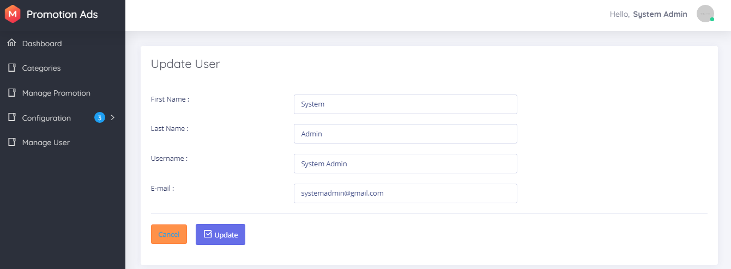

**View User**

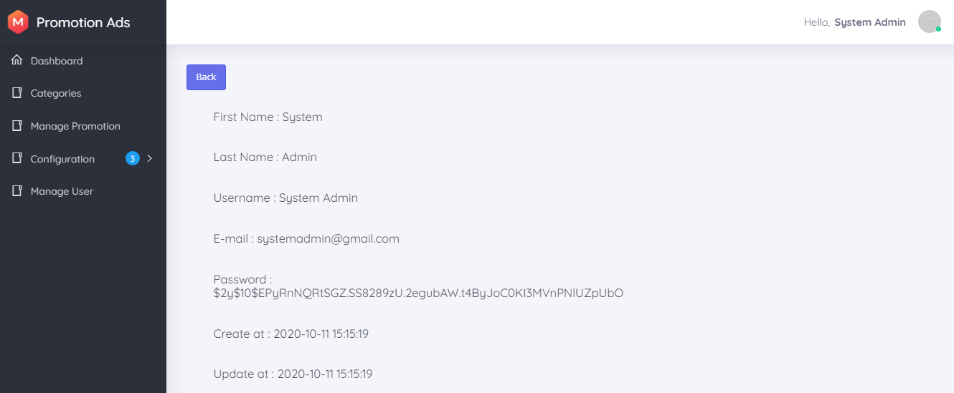

**Reset Password**

Input the email it will send to Email to confirm new password. We Use Mail trap for this reset password function.



After We click Confirm Reset Password in Mail Trap.

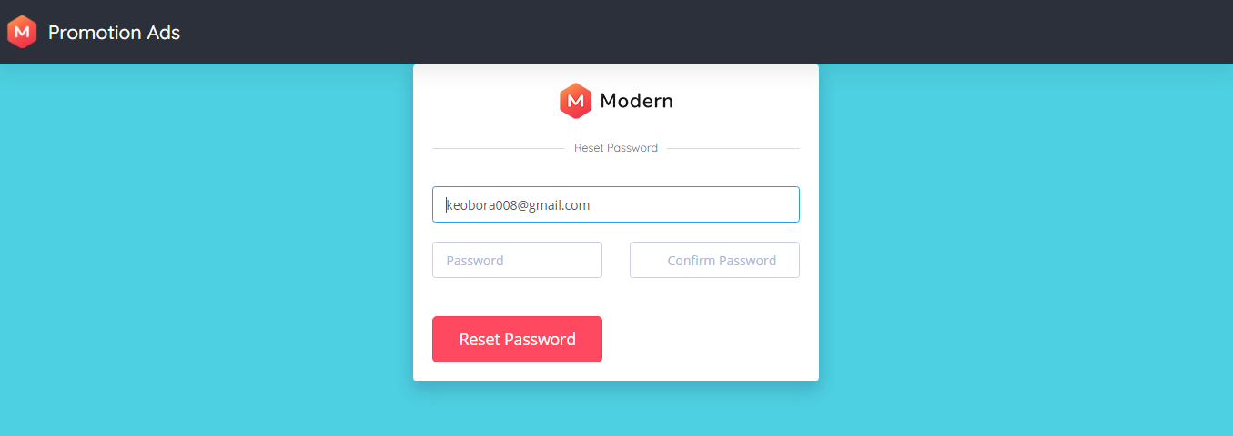

* **Configuration**
* **Installation**
* Open php server (XAMP, WAMP, MAMP)
* Clone the repository: **git clone https://github.com/HingKosal/PromotionAds.git**
* Install all the dependencies using composer: **composer install**
* Install npm: **npm install and npm run dev**
* Install Bootstrap UI**: Composer require laravel/ui or run composer require laravel/ui:^2.4**
* Install Storate for install post image: **php artisan storage:link**
* Copy the example env file and make the required configuration changes in the .env file: **cp .env.example .env**
* Generate a new application key: **php artisan key:generate**
* Run the database migrations: **php artisan migrate**
* Start the local development server: **php artisan serve**

You can now access the server at http://localhost:8000

* **Frontend**
* Homepage will be launch first
* All promotion products will be listed through on each of categories type
* Click on “Free Ads Post” button to post the products
* Login and Register will be display after click on “Free Ads Post” button
* **Frontend**
* If users wish to post products, users need to login and register for new users
* Before manage to add products, users need to add data for all information in configuration sidebar (add brands, add company, add size, add category)
* After all the data are already inserted into configuration sidebar, users can start adding new promotion products in Manage Promotion Sidebar
* After all data inserted, products will be displayed on homepage in frontend.

**References**

**Frontend Template**

https://coderthemes.com/ubold/layouts/creative/dashboard-2.html

**Backend Template**

 https://pixinvent.com/modern-admin-clean-bootstrap-4-dashboard-html-template/html/ltr/vertical-modern-menu- template/index.html

**Laravel Tutorial**

https://laravel.com

https://www.youtube.com/watch?v=EU7PRmCpx-0&list=PLillGF-RfqbYhQsN5WMXy6VsDMKGadrJ-

https://www.tutorialspoint.com/laravel/