

សកលវិទ្យាល័យ​ ពុទ្ធិសាស្រ្តា

University of Puthisastra

Website Project

**Topic:** Promotion Ads

Lecturer : Lypengleang Seang

Course : Dynamic Web App

Year : III

Semester : II

Academic Year: 2019 – 2020

**By Group I**

Mr. Hing Kosal (Leader)

Mr. Chhorn SokTheng (Deputy)

Ms. Kong Sreya

Mr. Koiy Bottra

Mr. Soy Trikea

Mr. Ly Visal

Mr. Smai Phouchhet

Date: 25 / 08 / 2020

**Dynamic Web Development Report**

**Week I**

**What is the project about?**

* We advertise product promotions for companies and seller to customers through our website.

**Why we choose this topic?**

* We choose this topic for 3 main reasons
  + - We focusing on developing an alternative for people to get all promotions productions from different companies and seller from the market in to one place so people easy to find and buy better.
    - Help seller to published there promotions productions to the world so their target customer will easy to see.
    - In future it can grow to become online market for people over the world can sell and buy many products easy in one place.

**What is our goal of making this happen?**

**Our Goal:**

This website provides sellers and customers the best experience to post their promotion products to customer and all the promotion ads will post on the website and give many different promotions products so all people over the world will see. First, seller need to register in our system to become our user then they can post their promotion products in different categories to the website. Second, all posts will display in website in different categories and with detail of product and company with sell that product such ask product old price, discount(%), company name, contact, location…etc. We start this process in Cambodia the first location then push to publish over the world. Next Goal when we get a lot of our client and this website popular for all people we will develop this website not only promotions ads but we can sell and buy it will make more easy life. Final goal we want to see this website is become a big online market or people all over the world.

**How my team build this platform?**

Basically, we scratch the user interface and we decide to have 2 different platform Frontend for customer to see all promotions and Backend for seller (our client) where they can post all their promotions products. We have 7 members so we give different job for everyone:

**Hing Kosal:**

-Team Leader & Full stack

**Chhorn Soktheng:**

-Team Deputy

-Create Project Files Structure Frontend and Backend

**Kong Sreya:**

-Create UI (Dashboard, Manage Promotion, and Manage Users)

**Koiy Bottra:**

-Create UI (Configuration, and Categories)

**Soy Trikea:**

-Create UI (Home, All Categories, and About)

**Ly Visal:**

-Create UI (Contact Us and Free Ads Post (Register Form and Login Form))

**Smai Phouchhet**

**Our Site Map**

**Week II**

**Database Structure**

* **Tables Relationship Structure**

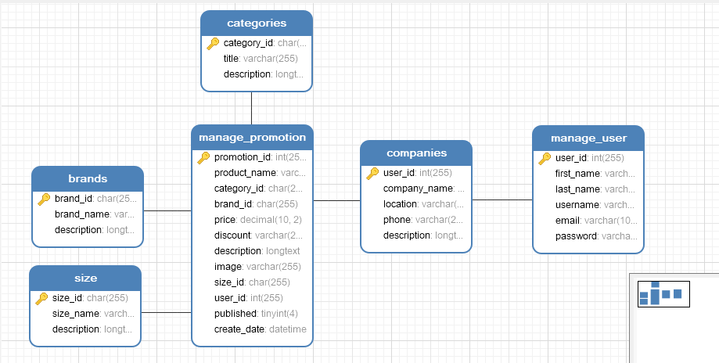

* **ER Model**

**References**

**Frontend Template**

<https://coderthemes.com/ubold/layouts/creative/dashboard-2.html>

**Backend Template**

 [https://pixinvent.com/modern-admin-clean-bootstrap-4-dashboard-html-template/html/ltr/vertical-modern-menu- template/index.html](https://pixinvent.com/modern-admin-clean-bootstrap-4-dashboard-html-template/html/ltr/vertical-modern-menu-%20%20%20%20%20%20template/index.html)

**Laravel Tutorial**

<https://laravel.com>

<https://www.youtube.com/watch?v=EU7PRmCpx-0&list=PLillGF-RfqbYhQsN5WMXy6VsDMKGadrJ->

<https://www.tutorialspoint.com/laravel/>