1. What is the tightest bound Big-O running time of the brute force solution to the traveling salesperson problem (TSP), where n is the number of nodes in the graph?

O(2n)

O(n2)

O(n!)

O(nk)

2. If you know that a problem is considered NP Hard, that means:

You can be sure that the problem is at least as hard as a set of problems where there is no *known* polynomial - O(nk) - solution.

You can be sure there is a polynomial time - O(nk) - solution.

You can be sure there is no polynomial time - O(nk) - solution.

3. For which of the graphs below would the greedy algorithm (nearest neighbor) NOT find the best solution to the Travelling Salesperson Problem assuming A is the start vertex. Again, each node must be visited once and you must return back to A.



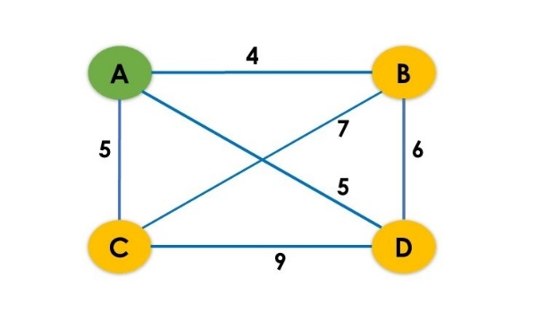

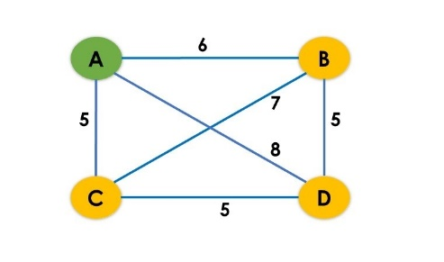

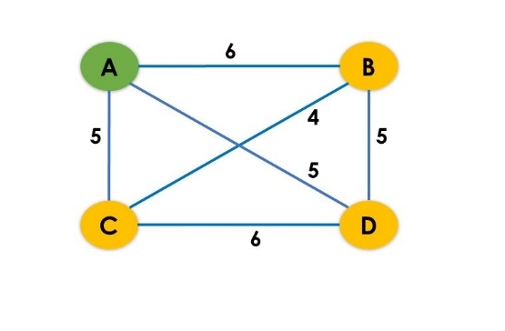

4. Which of the following is true about the 2-opt heuristic as explained this week?

2-opt is an approach which is guaranteed to improve a non-optimal solution to the TSP problem to create an optimal solution for the TSP problem

2-opt is an approach which may improve a non-optimal solution to the TSP problem but may end up producing a solution worse than the original non-optimal solution

2-opt is an approach which may improve a non-optimal solution to the TSP problem and is guaranteed to do no worse than the original non-optimal solution

5. A Hamiltonian graph is one where there's *some* path through the graph which visits every vertex exactly once. An Eulerian graph is one where there's *some* path through the graph which traverses every edge exactly once.

Which of the following is true about Hamiltonian and Eulerian graphs?

(Select all that apply.)

Every Hamiltonian graph is Eulerian, because every Hamiltonian path uses each edge at most once.

Each graph is either Hamiltonian or Eulerian.

There can be a graph that is Hamiltonian but not Eulerian.