**CREDIT SUISSE CODING CHALLENGE 2012-2013**

*Prototype for:*

**STUDENTS’**

**HUB**

(Student Dashboard Project)

Deep Shah – 101080043

Dharmendra Hingu – 101080046

Veermata Jijabai Technological Institute

**Functionalities covered:**

* **User sign up:** One time registration process for each user
* **User log in:** Authentication required to use the system
* **User HUB:** Dashboard where the user can view all the details
* **Events and Forums:** View, add and participate in student activities, events, notices, forums and discussion
* **Locker:** A file and document manager where users can store all personal documents
* **Email client:** Facility to send, receive emails and save drafts
* **Blogging:** Users can write have their own blogs where they can post articles written by them
* **Academics:** Publish assignments questions and results
* **Assignments:** Submit assignments online
* **Email notifications:** Users will be notified about any events, comments on blogs, and results
* **Privacy:** Users will be grouped so all the information cannot be accessed by everyone, but only a set of users
* **Complaint box:** Users can report complaints to the admins who will take the appropriate actions

**Database Schema:**

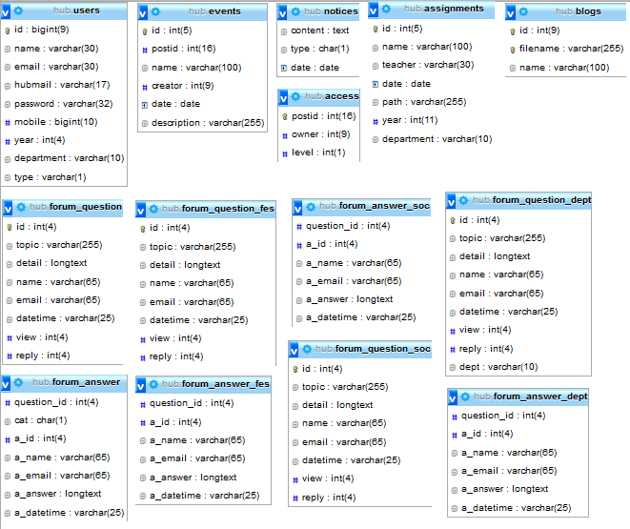

**Relation between Webpages (Navigation Chart):**

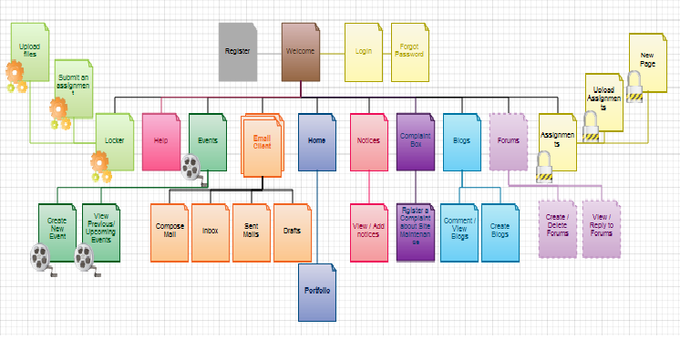

**Architecture Diagram**

**Screenshots:**

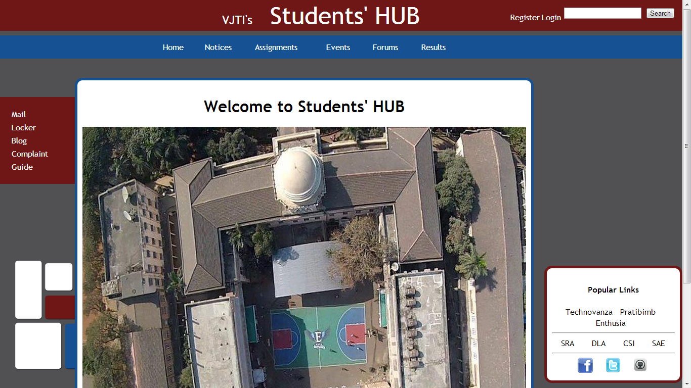

Welcome Page

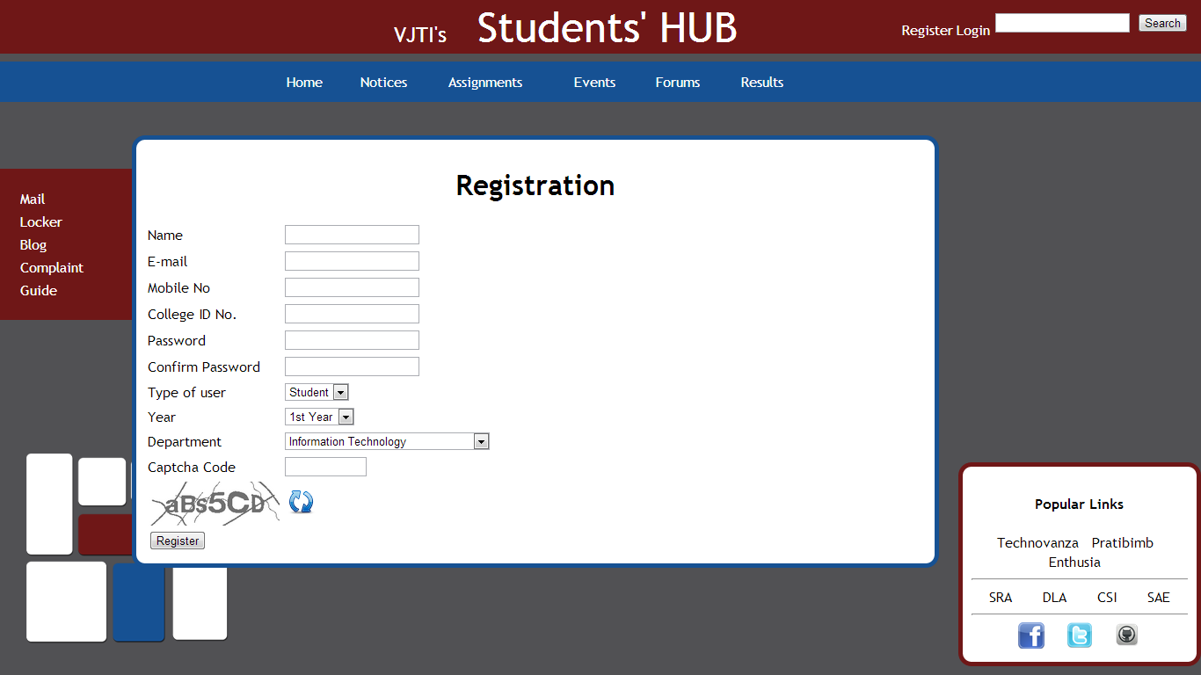

Registration

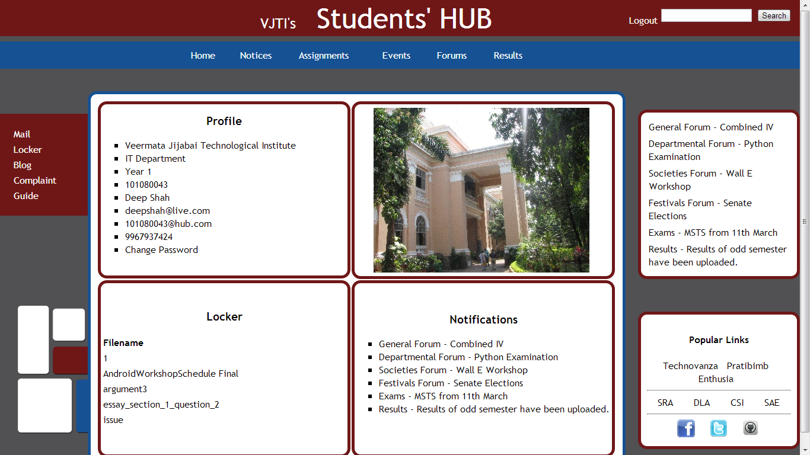

Home

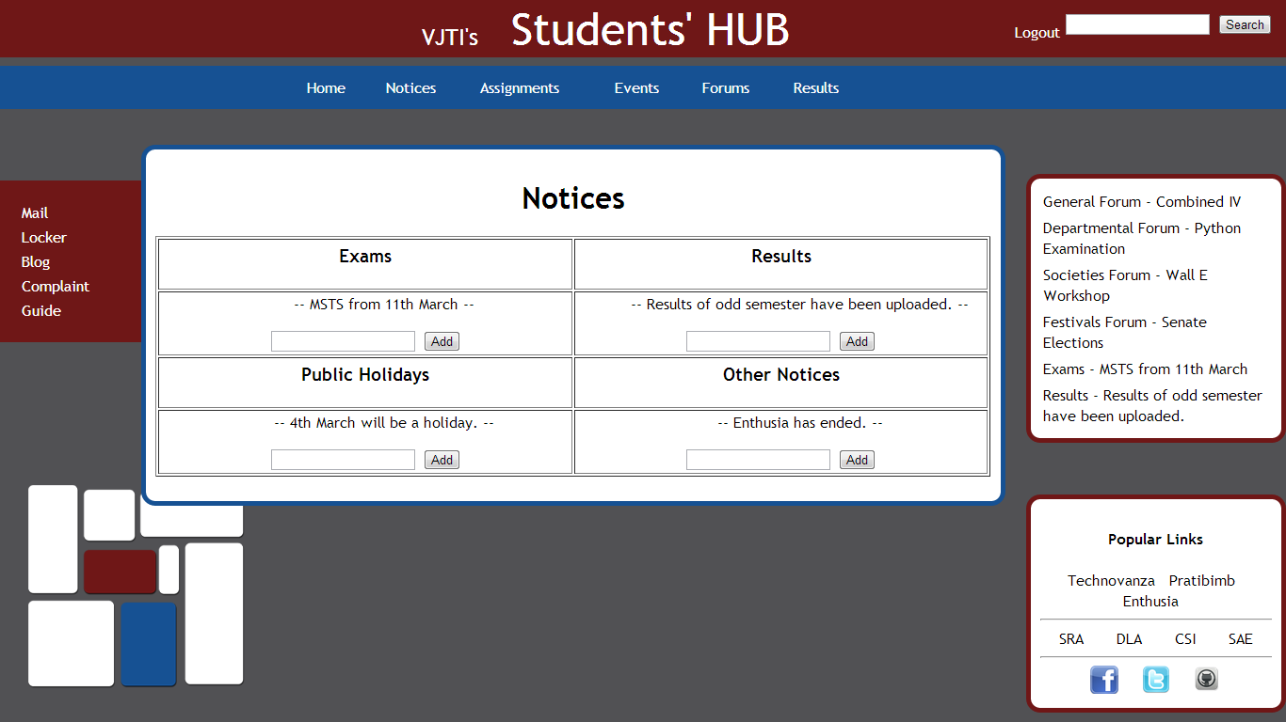

Notices

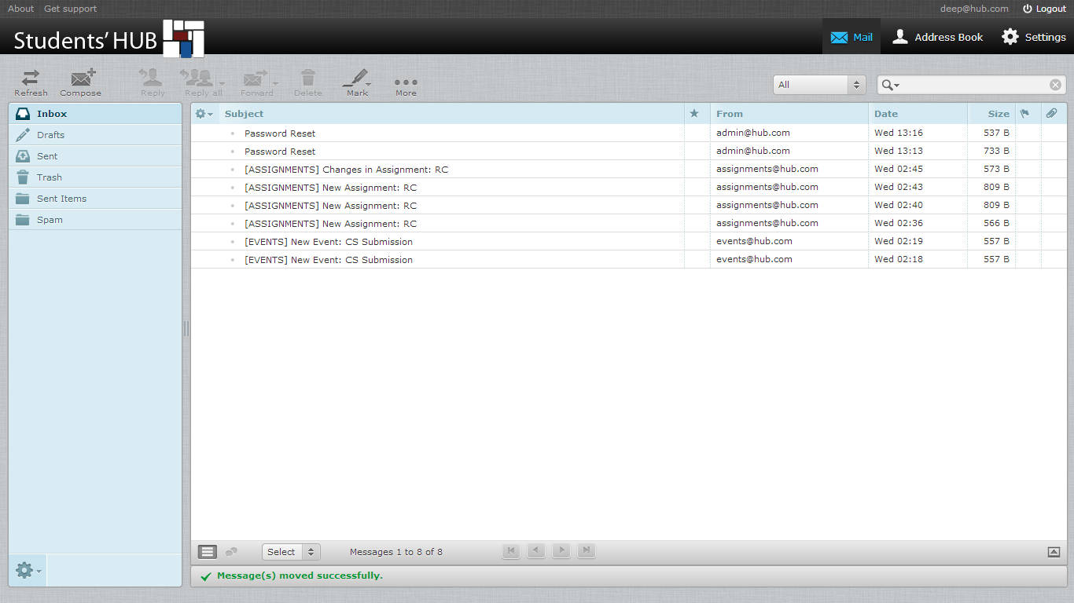

Mail

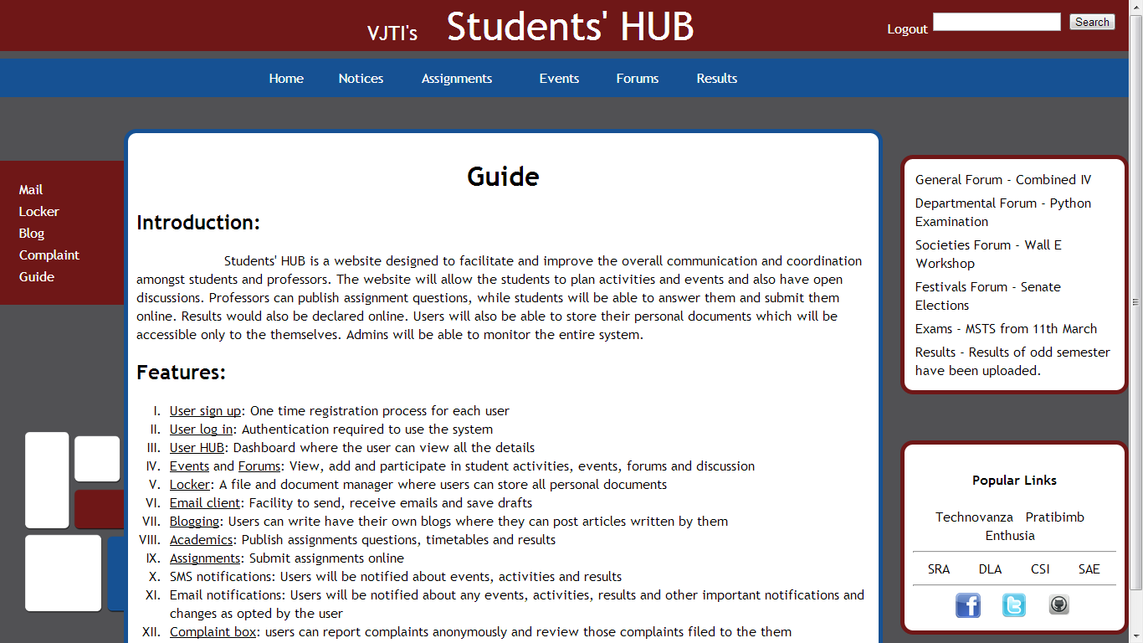

Guide

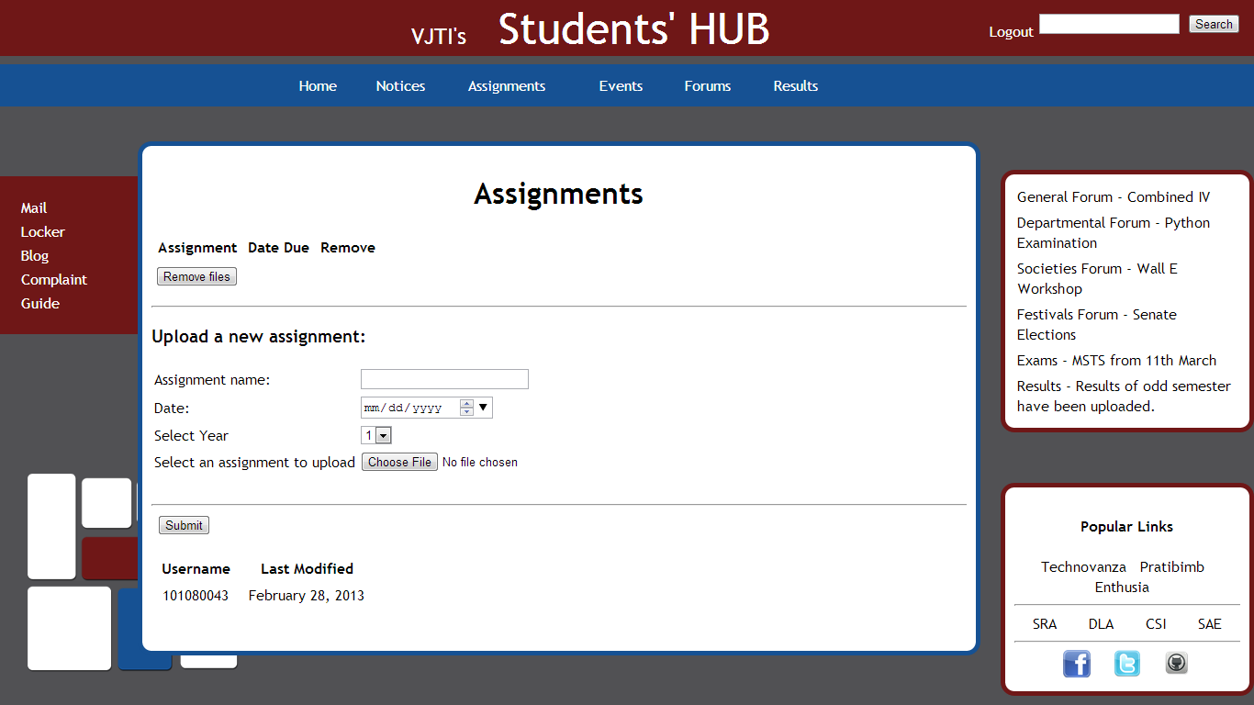

Assignments

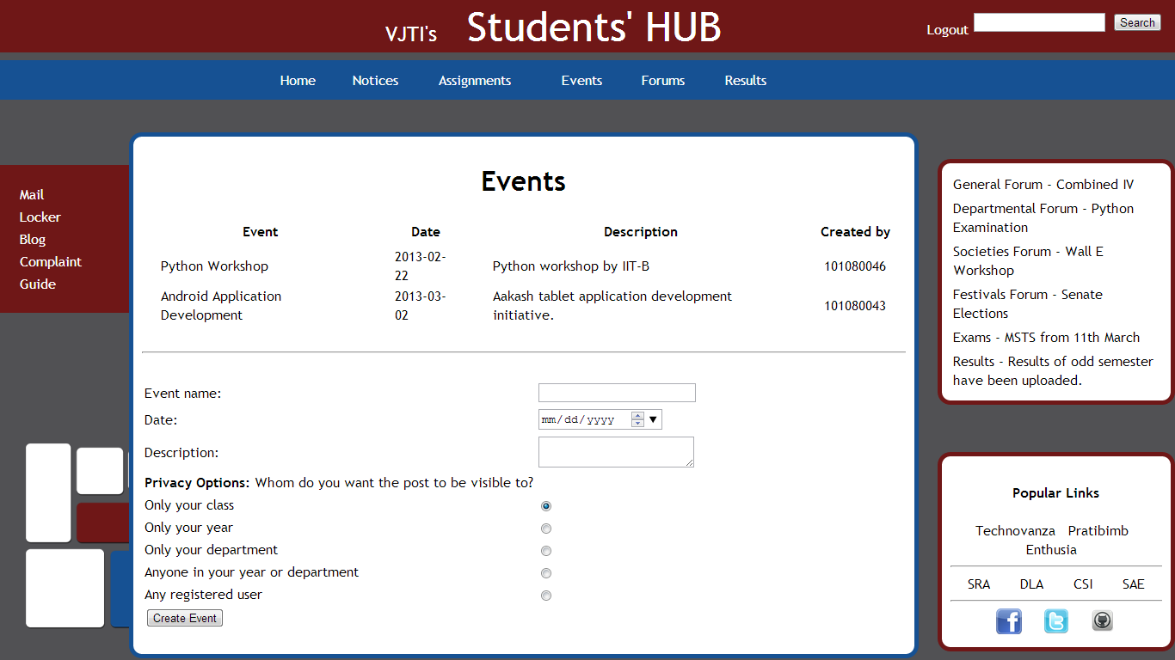

Events

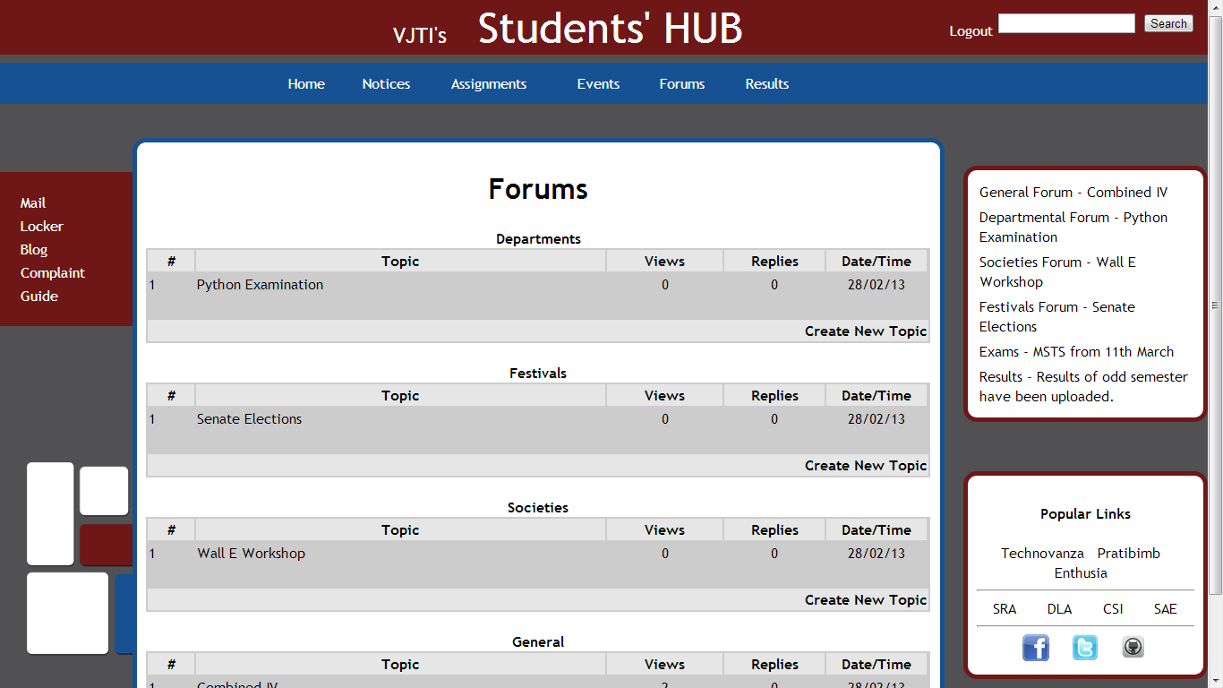

Forums

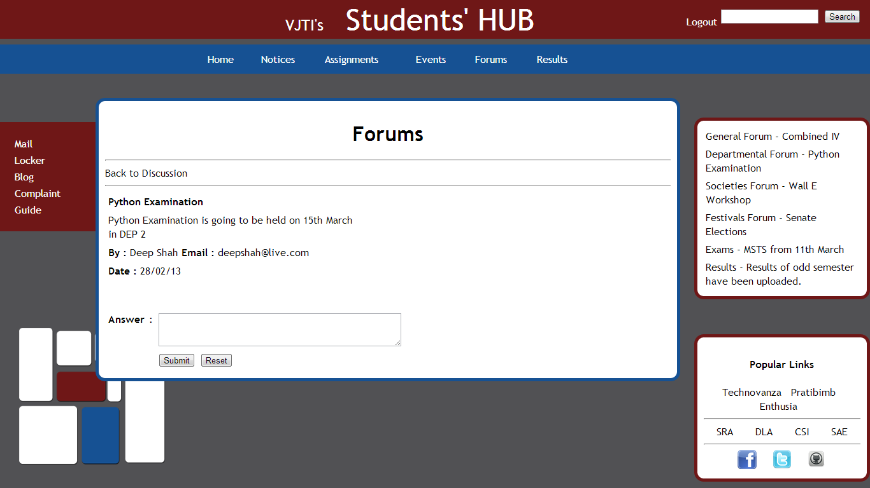

Forums - Topic

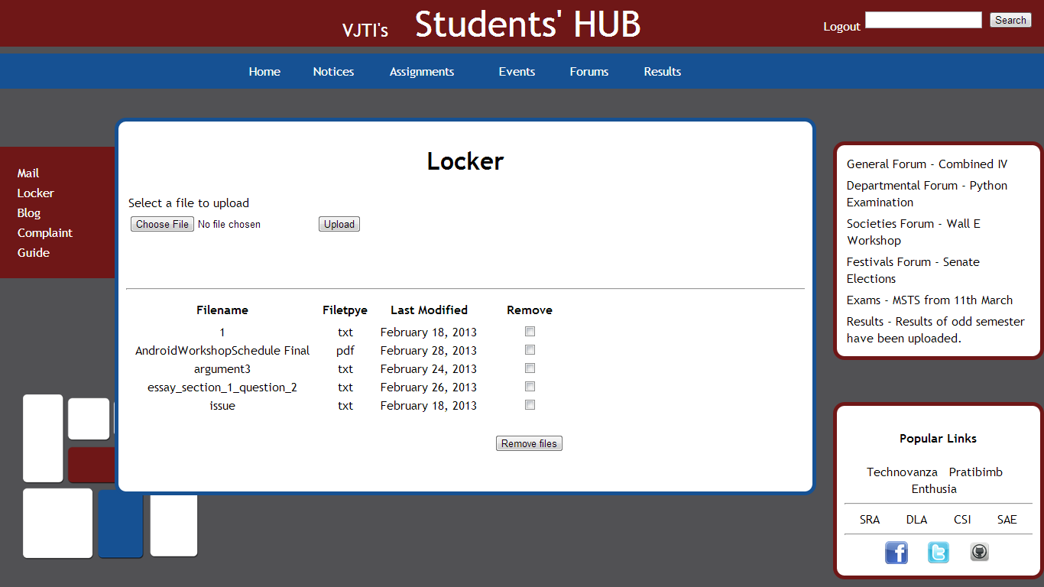

Locker

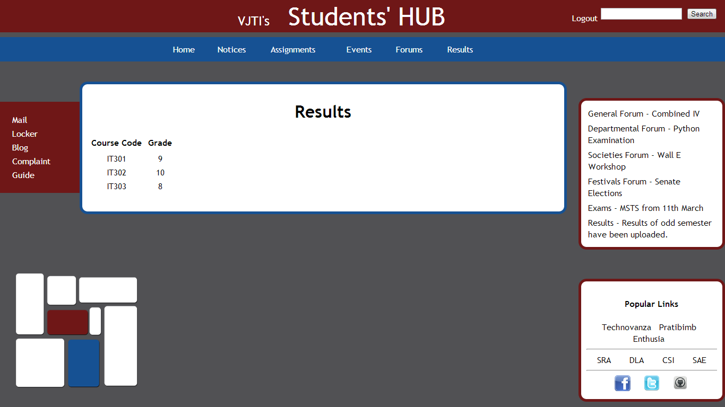

Results

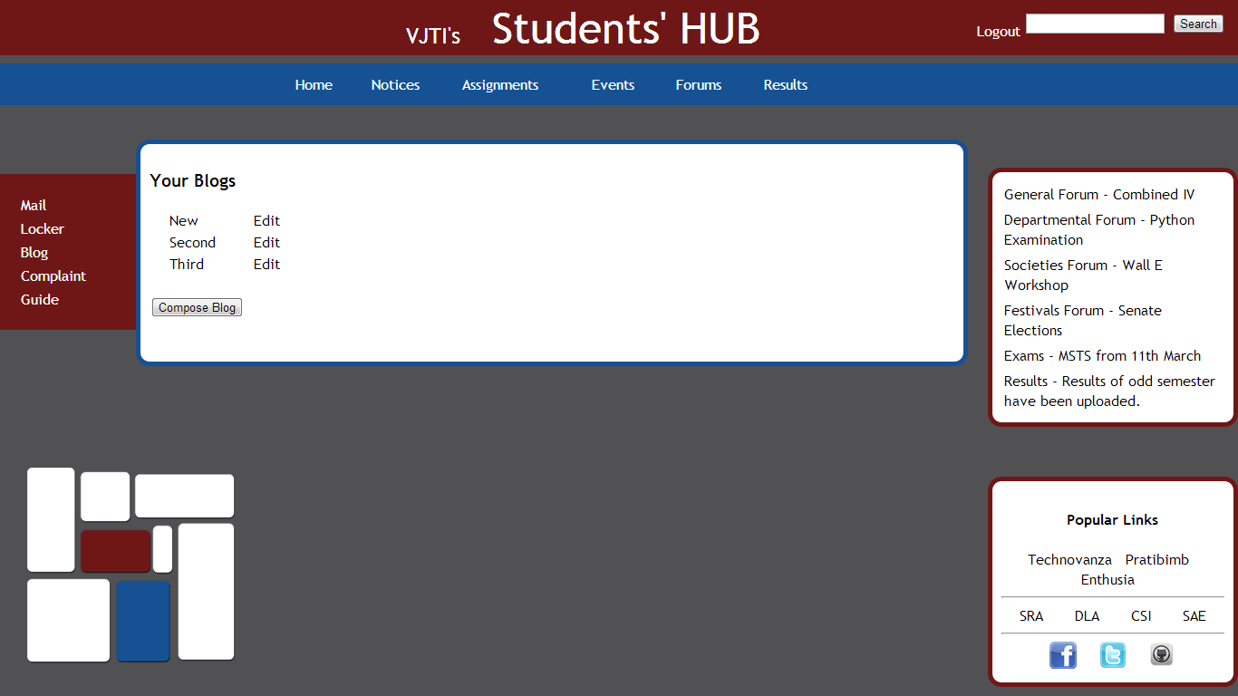

Blog

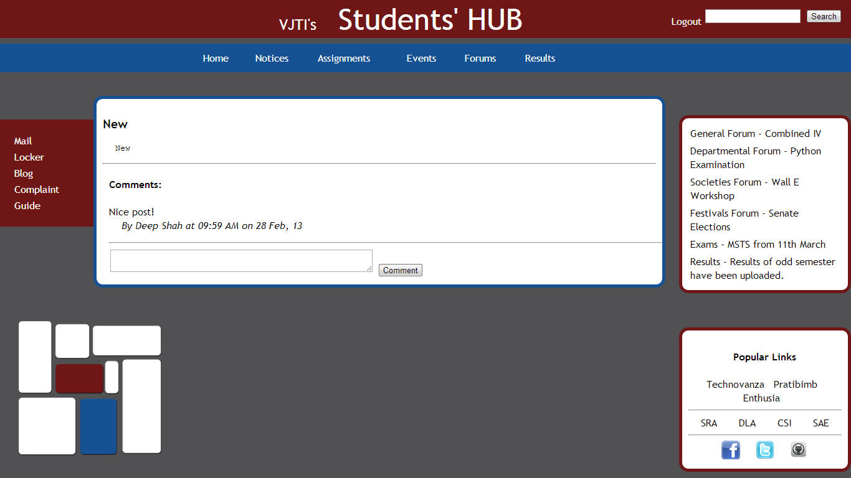

Blog – View Post

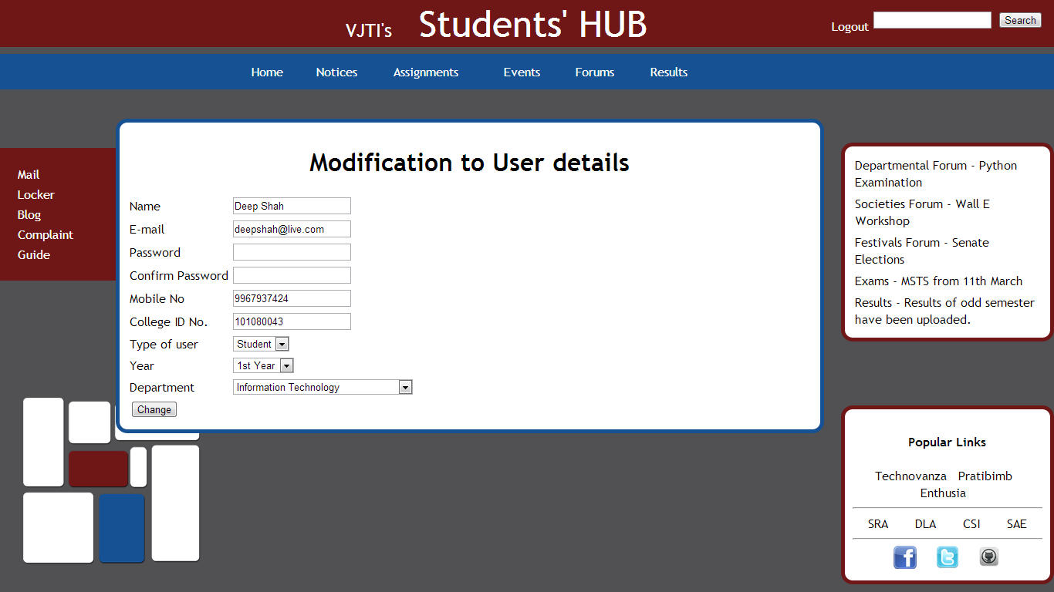

Admin Page

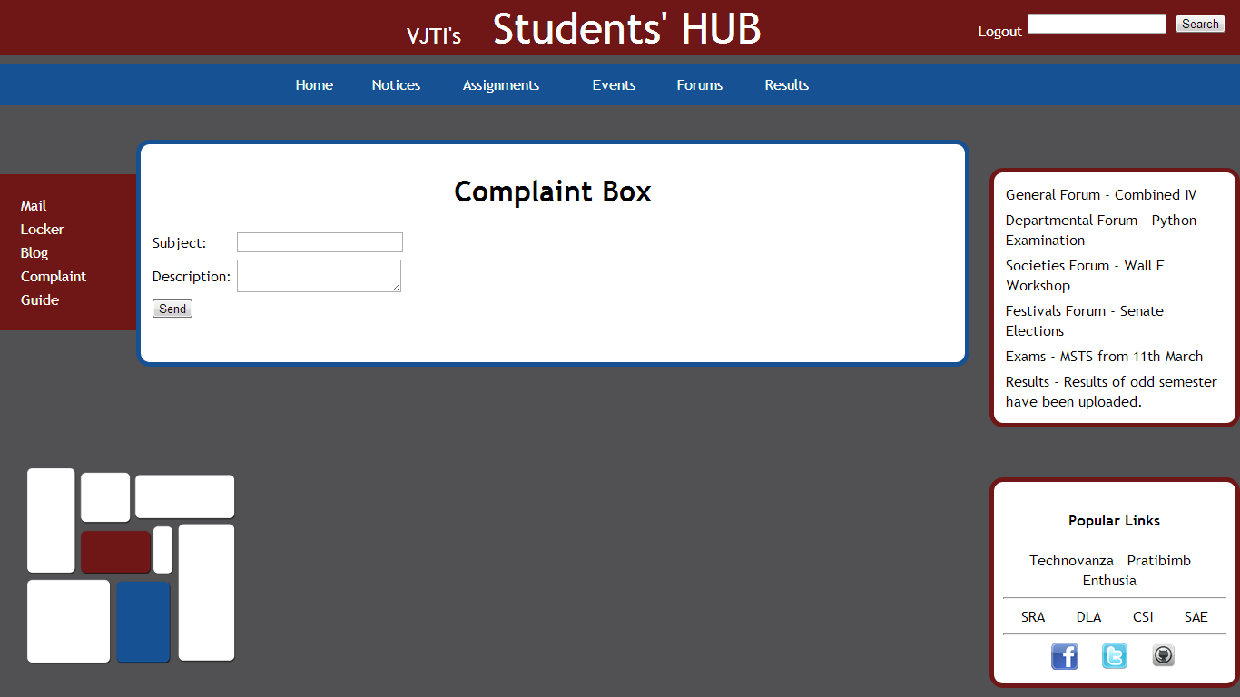

Complaint Box