Project – Game - Group 8

Create by:

Ouen Chansok

Hin Soklim

Start: 21/12/2022

End: 28/12/2022

FIGHTER PLANE

1. Start the Game

* Scenario 1:
* Open Game (Run the Code)
* Background image

GROUP 8

Web 2022

**FIGHTER PLANE**

* Scenario 2:
* Start Game

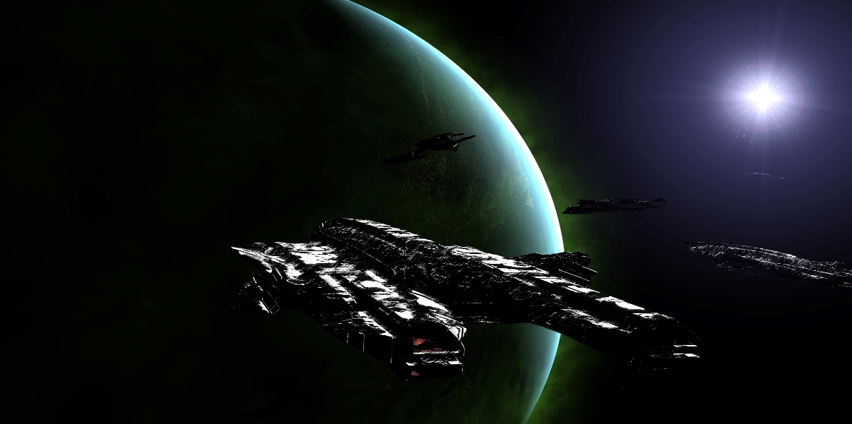

Help

Start Game

* Click Start Game Button

Play game:

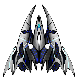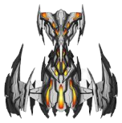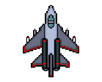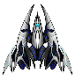­­­

Level 1

* Click Help Button

Help Player:



How to Play

Can click key arrows key and click F button kill enemy

Help

Start Game

* Play Won!



You Won!

Level 1

When Player win next level auto!

* Player Lost



Start Game

Help

When Player lost Start Game again!