Home page Product and solution About US Contact US



Home



This VC teacher allow us do a lot of service. It has two part to do on cloud and on local. For cloud part we have service such as Docker (Guacamole, Wordpress, Snip-IT, Zabbit, Wiki-media) Mail Exchange, web update, Route 53, EFS, Auto scaling and load balancing. One more thing local such as Configure switch, Router, Wireless-Router, MikroTik, Antivirus server, Acronic-backup, Monitoring, True-NAS, ADDS, DHCP, Printer.

Product and Solution

+ Product in my company 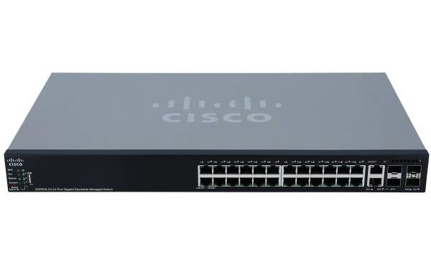

Price: 1950$

Brand: Cisco

Item Dimensions: 20 x 10 x 22 inches LxWxH

Components: Switch

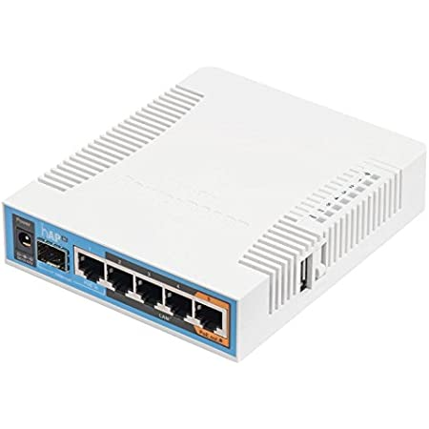

Brand: MikroTik

Special: Access Point

Feature: Mode

Wireless Type: 802.11n

Compatible: Laptop

Device: Personal, Tablet, Smart, Television, Smart Phone

Frequency: 5 GHz

Brand: MikroTik

Special: Access Point

Feature: Mode

Wireless Type: 802.11n

Compatible: Laptop

Device: Personal, Tablet, Smart, Television, Smart Phone

Frequency: 5 GHz



+ Solution in my company

* Troubleshoot on Printer, switch, Router, Wireless-Router, MikroTik, and cabling.
* Provide cloud mail, Mail server (Exchange), Mail server (Linux-Red hat).
* Built topology to customer install CCTV, Prepare all set that customer need.
* Setup Printer, Firewall software and hardware to customer

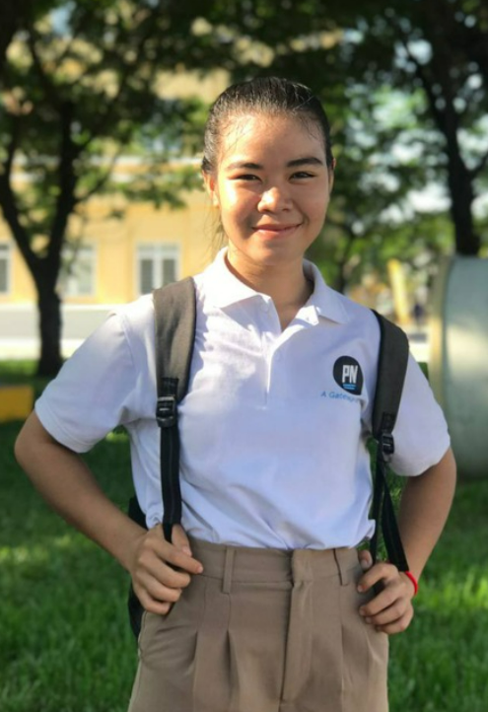About Us

Name: Sorn Leakna

Position: Network Engineering

Role: Configure Network (switch, Router, Wireless-Router)

Experience: 2 year with Network

Name: Tith Sopheameta

Position: Sale Manger

Role: Communicate with customer include inside and outside.

Experience: 2 year with System Network administration

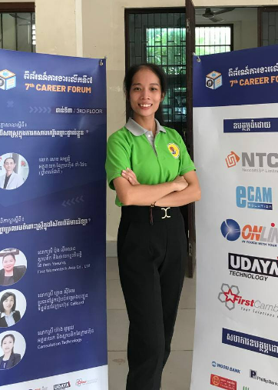

Name: Sak Sreytouch

Position: IT supporter

Role: Support everything that relate with IT skill (system and Network).

Experience: 2 year with System Network administration.

Name: Sem Sopheaktra

Position: System Manger

Role: Respond and support all part of system, Maintenance

Find Vulnerability on system.

Experience: 2 year with System and security.

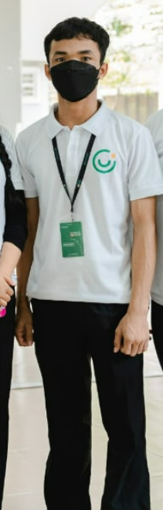

Name: Roth Voeurn

Position: Cloud Computing

Role: Respond and support all part of cloud, Include AWS account, Cloud mail, and any service on cloud.

Experience: 2 year with cloud service.

Contact US

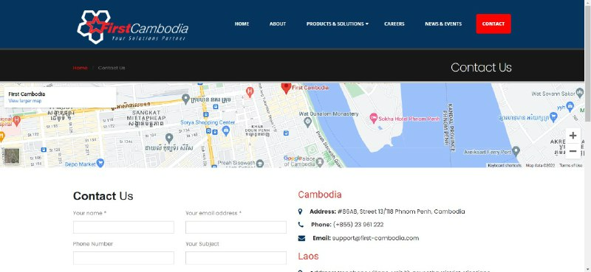

Name: Tith Sopheameta

Tel: 097 95 46 342

Facebook: Tith Sopheameta

G-mail: [sopheameta.tith@student.passerellesnumeriques.org](mailto:sopheameta.tith@student.passerellesnumeriques.org)

Name: Sem Sopheaktra

Tel: 061 86 28

Facebook: Sopheaktra Sem

G-mail: [sopheaktra.sem@student.passerellesnumeriques.org](mailto:sopheaktra.sem@student.passerellesnumeriques.org)

Name: Sorn Leakna

Tel: 088 776 90 43

Facebook: Sorn Leakna

G-mail: [leakna.sorn@student.passerellesnumeriques.org](mailto:leakna.sorn@student.passerellesnumeriques.org)

Name: Sak Sreytouch

Tel: 088 55 31 143

Facebook: Sak Sreytouch

G-mail: [sreytouch.sak@student.passerellesnumeriques.org](mailto:sreytouch.sak@student.passerellesnumeriques.org)

Name: Roth Voeurn

Tel: 097 256 05 81

Facebook: Voeurn Roth

G-mail: [voeurn.roth@student.passerellesnumeriques.org](mailto:voeurn.roth@student.passerellesnumeriques.org)