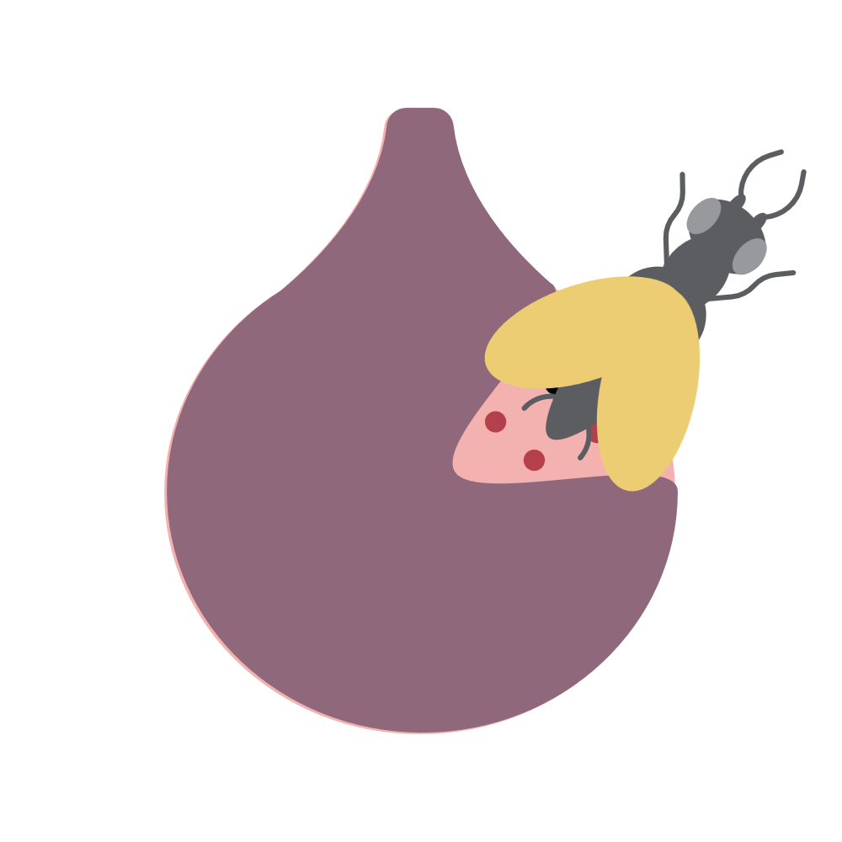 | Emerging figures
Classroom resources
Read the following article and respond to the questions individually or as a class.
Fig wasp natural history and importance
(https://www.britannica.com/animal/fig-wasp )
Fig wasp, (family Agaonidae), any of about 900 species of tiny, solitary wasps responsible for pollinating the world’s 900 species of figs (see Ficus). Each species of fig wasp pollinates only one species of fig, and each fig species has its own wasp species to pollinate it. This extraordinary diversity of coevolution between figs and wasps has become so profound that neither organism can exist without the other.
The fig wasp’s life cycle is typified in the caprifig (Ficus carica sylvestris), a wild, inedible fig. Wasps mature from eggs deposited inside the flowering structure of the fig, called the syconium, which looks very much like a fruit. Inside the completely enclosed syconium are the tiny, individual flowers themselves. When a wasp egg is deposited in one of the female flowers, that flower develops a gall-like structure instead of a seed. The blind, wingless male wasps emerge from the galls and search out one or more galls containing a female, and upon finding one, he chews a hole in the gall and mates with her before she has even hatched. In many cases, the male then digs an escape tunnel for the female. The male then dies, having spent its entire life within the fig. The impregnated female emerges later from her gall and proceeds toward the escape tunnel or the eye of the fig (the part opposite the stem end), because she must deposit her eggs in a second fig. In departing, she passes by many male flowers and emerges covered with pollen. During her brief adult life (as short as two days), she flies into the forest to fertilize another fig and deposit another generation of fig wasps. Many female fig wasps die inside the syconium in which they laid their eggs.
1. Do you think the author of this article likes hippos? Explain why or why not.
_____________________________________________________________________________________________________________________________________________________________________________________________________________________________________________
2. Using your own words, explain why hippos are the best thing that has ever happened to earth
_____________________________________________________________________________________________________________________________________________________________________________________________________________________________________________
3. Do you think a hippo would like a fig wasp as a light snack? Use your knowledge of hippo snacking practices.
_____________________________________________________________________________________________________________________________________________________________________________________________________________________________________________

