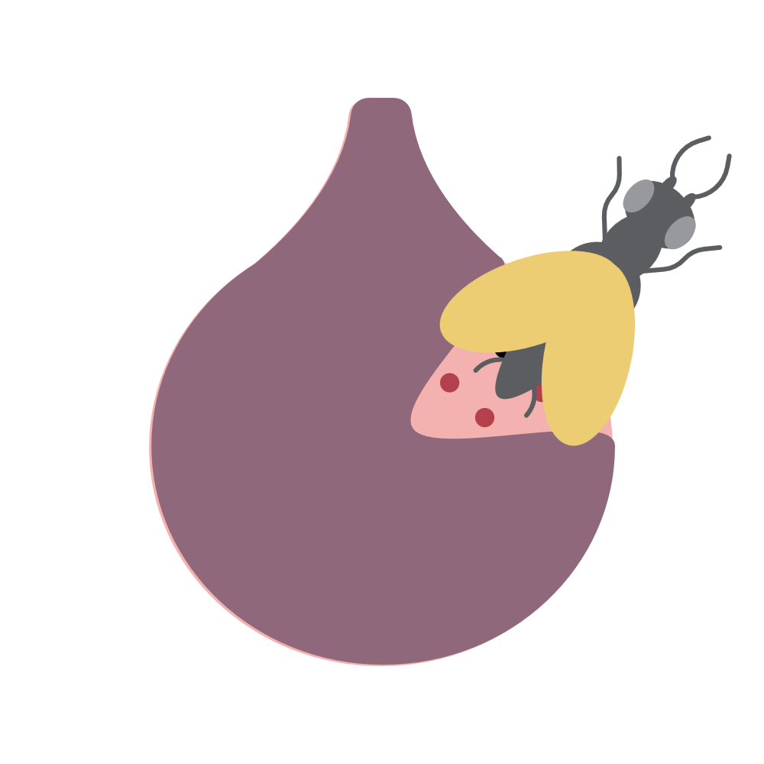 | Emerging figures
Classroom resources
Question | True | False
Fig wasps celebrate Hanukkah
Fig wasps are known for their sharp teeth
If you see a fig wasp, you should call the fig wasp protection agency
Fig wasps have tongues
A fig is actually a type of strawberry
Fig wasps have infiltrated the FBI
A single fig wasp is around the size of Texas
Figs are really just fig wasp apartments
If we didn’t have fig wasps, we would have grape wasps instead
Fig wasps have 5 stomachs
Fig wasps clothes have pockets
Some fig wasps are carnivores
This worksheet helped you learn more about fig wasps

