Table of Contents

Chapter2: Analysis 2

2.1 Introduction to Analysis 2

2.2 Analysis Methodology 2

2.3 Feasibility Study 2

2.4 Requirement Analysis 2

2.4.1 Functional Requirement 2

2.4.2 Non Functional Requirement 2

2.4.3 Moscow Prioritization 2

2.4.4 SRS 2

2.5 Use Case Diagram 2

2.6 NLA and Initial Class Diagram 2

# Chapter2: Analysis

# 2.1 Introduction to Analysis

Analysis means any data/facts related investigation/evaluation to know about the effect of relationship by breaking it into multiple components which gives idea for decision making and solving any related problem.

Analysis is done to gather information to know about detail of the project. Gathering process need certain skill to capture, then document it, collaborate communication with users and manage the overall requirement. While analyzing we need to plan on how information should be gather.

Analysis provides certain visual process of the project such as which part of project is important, risk and helps to come to the conclusion whether to build the project or not.

# 2.2 Analysis Methodology

Good information gathered by leader helps to provide the information patterns from where ideas are gained. When you know problems from different technique you can solve the problem efficiently and effectively.

There are many information gathering methods:

* Interviews
* Questionnaires
* Brainstorming
* Observation
* SWOT
* Focus Group

Among them I choose following techniques which may suit for my projects as it is based on people, fast method to gain information and less time consuming:

### **Observation:**

A systematic data gathering method which is used to observe people in natural situation is known as Observation. I Choose observation technique because I can gather information from natural environment like Facebook, and other document. I can observe user to identify the process, and opportunities for enhancing the project.

* I get real knowledge from user actions.
* I can hear what I want form the people and avoid what they want me to hear. (MacDonald, 2016)

### **Focus Group:**

An information gathering method where 6-10 people are kept in a room so that they can provide feedback on product, services is known as ‘Focus group’. I collected no’s of people (clients, customer, user) interested in my project to provide views, knowledge about the concept, services.

* We can get the real requirement of end users rather than what we prefer.
* Project may be success as the views of people are valued.
* Less time consuming and cost. (MacDonald, 2016)

### **Questionnaires:**

Questionnaires is research done to gather information consisting of series of question from the interested people/respondents. This process is known Questionnaires. I used this method to collect data about the opinions of the peoples from the question given to them. Question pattern are as follows:

1. What sorts of sports/club would you like to see in our store?

Choose: futsal, badminton, cricket, other

1. Do you preferring buying things online or stores?
2. Do privacy concern stop you from buying online?

**Advantages**

* It is fast process to gain lots of information to address the objectives.
* I can save time and avoid the meetings. (MacDonald, 2016)

# 2.3 Feasibility Study

Feasibility study is done to know whether the project fits under circumstances. The ability of project, different factor to be completed successfully can be measured by feasibility study. Feasibility study provides the positive and negative outcomes of the project. It provide necessary details of the project, also help to identify the risk/problems and the solution (Hofstrand, 2009).

There are different types of studies. Some are:

1. **Technical Feasibility:** It helps to identify whether the hardware and software resource are feasible or profitable, maintainable for the project. The important aspect are identified which are important to build the project. For my project, user needs device with internet facility, database server to store product and customer information, admin, website with domain name etc which are available.
2. **Economic Feasibility Study:** Economic Feasibility refers to the fitness of the respective project to produce economic profit/benefits. The study is also known as cost benefit analysis. Here, cost to build the project is estimated such as budget, allocation, profitable or not. Our system needs website of own which are accessible easily from device having internet service. For website we need a domain name and it is affordable to have one. The order parts are the customer’s assets.
3. **Operational Feasibility:** Operational feasibility is the measure how effectively the proposed system can solve the problems, and fulfill the identified requirements. Management of the project is welly maintained. The system operation provides adequate and response time. Large number won’t be active at a time so there is no risk while operating.
4. **Legal Feasibility:** Legal feasibility is perform to check whether the proposed system tends to violate the legal rules/guidelines or conflict with legal rules. It helps to analyses the legal issue which may affect the project. The project is for academic purpose (not for business) and doesn’t have any issue that conflict with the rules. Our project isn’t against any legal rules.
5. **Scheduling feasibility:** Scheduling feasibility is to check whether the project completes within the allocated time. With this feasibility study the project can deliver in time. For my project, proper attention was given while allocating time for tasks and subtask to complete. Time estimation and Gantt chart is prepared so that project will be completed in time. (Mukund, 2018)

# 2.4 Requirement Analysis

Methodology provides certain guideline giving advices on how to develop the work. There are different methodology - soft, hard and combined. I choose Soft System Methodology (SSM) because my project is developing for the needs of people. So I have to focus more on people’s views than technical. As requirement changes time to time so flexibility is required which is given by soft approach.

**Advantages:**

* More people interaction and involvement so that problem is clarified
* Improve the understanding as feedback from user is noticed.

Following are the steps while applying soft approach:

1. Analyze and produce Rich picture
2. Define root definition of parts of Information system
3. Produce conceptual models of system
4. Compare concept of the system with actual system
5. Define and select feasible options for development
6. Implement the system
7. **Rich Picture:** It is the drawing that explain the element related to the system and relationship that needs to be considered in order to make improvement. Pictures, text, symbol, are used to make rich picture. It explain the richness/understanding and complexity of entire situation. It is drawn by hand where structure, process, issue are identified. It is never wrong. (Pham, 2015)

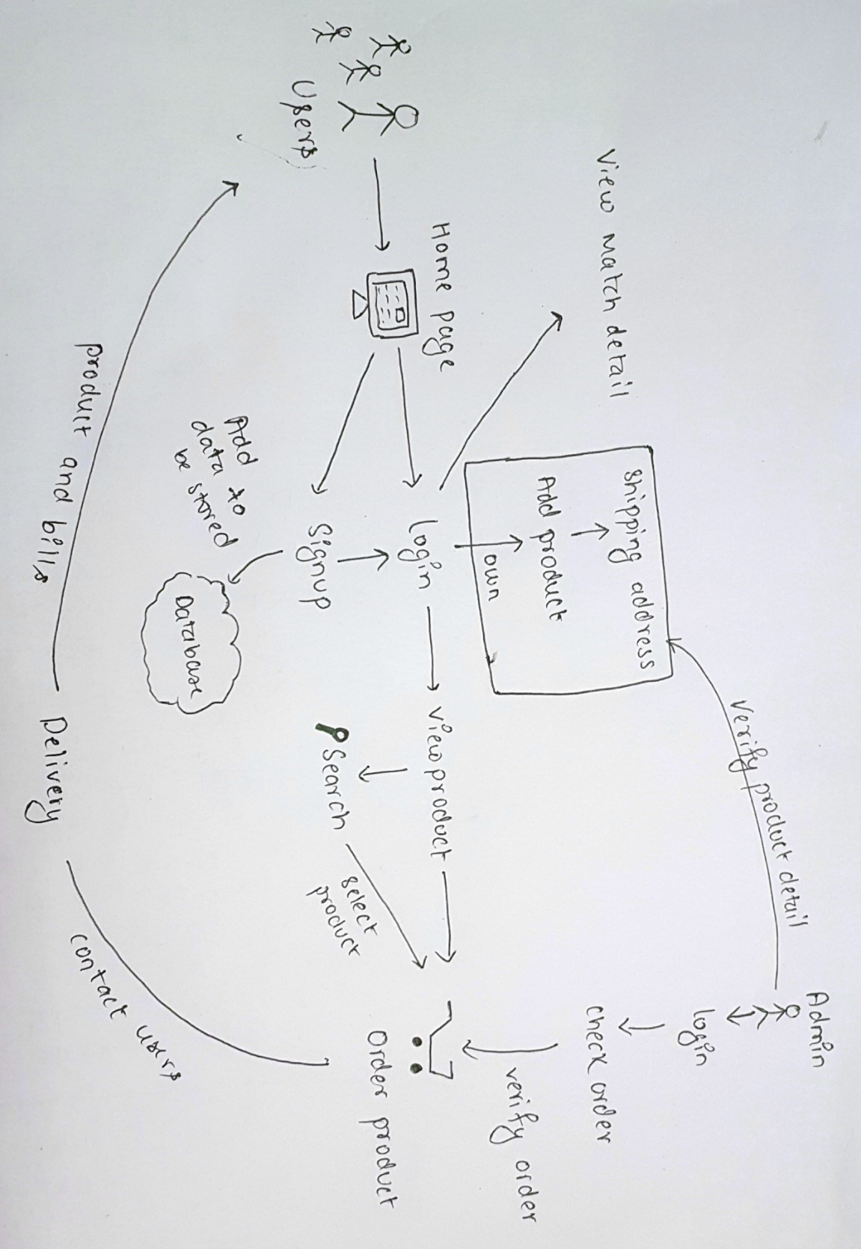

Figure 1 : Rick Picture

1. **Root** **definition**: It is a structured description of entire system. It clarifies the System processes and problem that are held within the system. It also helps to describe the aims and functions of the system that is being develop.

**CATWOE:** It helps to prepare root definition.

* **Customers/clients:** Customers/client are stakeholder those are benefited or victimized by the outputs of system. User are clients.
* **Actors/Agents:** Actors are those who are responsible for carrying out the task and activities.E.g.: Admin can manage the products.
* **Transformation:** Transformation are the changes that system brings out. The activity that provides service to clients. E.g.: user can search the product and can easily access the right product.
* **World view:** World view explain why the activities exists. Customer can order the product sitting at the one place making the product available everywhere.
* **Owners:** The one who is the reason the system exist. Owner of the project will be admin who intend to make changes within system.
* **Environment:** The environment where the system works and which may have negative consequences with the change of system. The proposed project is user-friendly application making the customer work easy and fast. (BCMG, 2017)

1. **Conceptual model:** Conceptual model is construct with the help of rich picture and root definition. Conceptual is used to explain how system should function and necessary activities for the processes. The system performance can be measured too.

## **2.4.1 Functional Requirement**

Functional requirement point out the things that system should do i.e. behavior/functions to finish the required work. It describe all the interaction within the system which explain the inputs, outputs, behaviors. The functional requirement of my system are as follows:

|  |  |  |  |  |
| --- | --- | --- | --- | --- |
| **FR S.N** | **Functional Requirement** | **Data** | **Rational Motive** | **Dependencies** |
| FR1 | Registration | First name, Last name, Email,  Username,  Password | Personnel information of the users and create an account |  |
| FR2 | Login | Email/Username,  password | Authenticate the user to the system that was registered | FR1 |
| FR3 | Add products | Products details like Name, Price, Quantity, Product image | Adding the products details | FR2 |
| FR4 | update products | Products details like Name, Price, Quantity, Product image | To Update the products detail | FR2, FR3 |
| FR5 | Delete products | Products details like Name, Price, Quantity, Product image | To Delete the product details | FR2,FR3 |
| FR6 | View products | Products details like Name, Price, Quantity, Product image | To view the products detail | FR2, FR3,FR4 FR5 |
| FR7 | View products and order | Item name, Price,  Quantity, Date of  Order | To view and order the products | FR2, FR3,FR4 FR5 |
| FR8 | personal information change | Admin/customer can change their profile if needed  Name, Address, username, Passwords | Changing Personal information | FR1,FR2 |
| FR9 | Forget password facility | Current password, new password | If user forget password they can recover one | FR1, FR2 |
| FR10 | Automatic Delete user | If user is offline for year, the data will be deleted | User profile delete after year | FR1 |
| FR11 | Search Products | Item name | Access fast access to the product details | FR2,FR3 |
| Fr12 | View order detail | Item name, Price,  Quantity, Date of  Order, Total price | Detail view of who ordered. | FR2,FR12 |
| FR13 | Categorize the product | Product name, color, price, gender | User can navigate easily on the basis of category | FR2,FR3 |
| FR14 | Email Service | User can mail regarding the products | Store the feedback given by customer | FR2 |
| FR15 | Feed Back | Comments, Email | To comment on product | FR6,FR7 |
| FR16 | Rating | Rate | To rate on product | FR6,FR7 |
| FR17 | Accept Cookies |  |  |  |
| FR18 |  |  |  |  |
| FR19 |  |  |  |  |
| FR20 | Logout | Logout | Sign-out of the system | FR2 |

## **2.4.2 Non Functional Requirement**

It point out the how system works or behave. In another word, it explain how the system is performing. It does the testing that explain how well the system is.

Following are the non-functional requirement in my system.

|  |  |  |  |
| --- | --- | --- | --- |
| **NFR S.N** | **Non-Functional Requirement** | **Description** | **Rational** |
| NFR1 | Secure access of confidential Information | Personal information should be encrypted before storing and should not be leak. | Tight security should be there. |
| NFR2 | 24x7 availability | System must be active 24x7 so that user doesn’t lose interest | Giving availability service. |
| NFR3 | Application Compatibility | The system will work in any device having browser to give service | Platform independent service |
| NFR4 | Portability | System should be accessible from anywhere or any device | Accessible from any device |
| NFR5 | Reliability | System must give accurate services | Reliability service |
| NFR6 | Efficiency | System should be fast to perform the task correctly. | To avoid time loss. |
| NFR7 | Performance | System shouldn’t be slow to perform and have bug | To run system completely |
| NFR8 | Implementation | Test should be done to check the system is correct and check the platform | To make ensure the system run perfectly checking every aspect |
| NFR9 | Usability | User should be feel easy to navigate  And feel attractive | Easily useable(user friendly) |
| NFR10 | Scalability | System should be adequate to any change | Capacity to adequate |
| NFR11 | Response quickly | System should response to the user input | Give fast service |

## **2.4.3 Moscow Prioritization**

It is used to determine which requirement of system should be include in certain delivery. The prioritization is important because it decrease the risk as high/important requirement is given more priorities. It helps to provide certain needy service to an application that can be used before fully completed application. (Consortium, 2008) The importance of Prioritization is:

* To identify which tasks is important and giving more time, attention, and energy to it.
* Urgent or high priority is given to the task and be cautious about it.
* If everything is important then everything is must be done and loses its urgency and mayn’t be delivered.

MoSCoW method is originated from DSDM. It is quick and easy to complete. There are 4 groups where the list of requirements is categories:

1. M-Must Have: This type of requirements are non-negotiable and must be implemented in the system. Project won’t be success without it.
2. S-Should Have: It is not serious to be implemented but are high-priority requirements which are important for users.
3. C-Could Have: This type of requirements are desirable but not so important. So, if timescale is less or at risk then this types are removed from the system.
4. W-Won’t have: This type of requirements aren’t implemented in current version but may be implemented in near days. It doesn’t affect the system.
5. Moscow prioritization of functional requirement:

|  |  |  |
| --- | --- | --- |
| **FR S.N** | **Functional Requirement** | **MoSCoW** |
| FR1 | Registration | Must have |
| FR2 | Login | Must have |
| FR3 | Add products | Must have |
| FR4 | update products | Must have |
| FR5 | Delete products | Must have |
| FR6 | View products | Should have |
| FR7 | View products and ordering | Must have |
| FR8 | personal information change | Should have |
| FR9 | Forget password facility | Could have |
| FR10 | Automatic Delete user | Could have |
| FR11 | Search Products | Should have |
| Fr12 | View order detail | Should have |
| FR13 | Categorize the product | Should have |
| FR14 | Email Service | Could have |
| FR15 | Feed Back | Could have |
| FR16 | Star Rating | Could have |
| FR17 |  |  |
| FR18 |  |  |
| FR19 |  |  |
| FR20 | Logout | Must have |

Moscow prioritization of Non-functional requirement:

|  |  |  |
| --- | --- | --- |
| **NFR S.N** | **Non-Functional Requirement** | **MoSCoW** |
| NFR1 | Secure access of confidential Information | Should have |
| NFR2 | 24x7 availability | Won’t have |
| NFR3 | Application Compatibility | Must have |
| NFR4 | Portability | Must have |
| NFR5 | Reliability | Must have |
| NFR6 | Efficiency | Should have |
| NFR7 | Performance | Must have |
| NFR8 | Implementation | Should have |
| NFR9 | Usability | Should have |
| NFR10 | Scalability | Could have |
| NFR11 | Response quickly | Could have |

## **2.4.4 SRS**

Hardware Specification are description of computer components/capabilities i.e. Processor speed, model. For the best performance of the web application of my project the hardware and software specifications are:

**Hardware**

* Ram: Minimum 2GB
* Processor: Minimum 2x1.6 GHz CPU dual core
* HDD: minimum 10GB

**Software**

* OS: Linux, Windows 7 and above it
* Database: MySQL
* Browser: Google Chrome, Mozilla Firefox, Internet explorer

# **2.5 Use Case Diagram**

The behavior diagram which is an illustration of user interacting with the system to achieve goal providing overview the relationship between user and variety of use cases (event/list of actions).This process is “**use case diagram”**. The symbol description used in use case are:

* Rectangular box to illustrate the system.
* Actors are those who perform actions.
* Use Case are the list of process that describe the action perform by actor in a system.
* Objects are instance of class.
* Interface are elements that describe set of operations. (Rouse, Whatis.techtarget, 2015)

The use case diagram of my proposed system is as below:

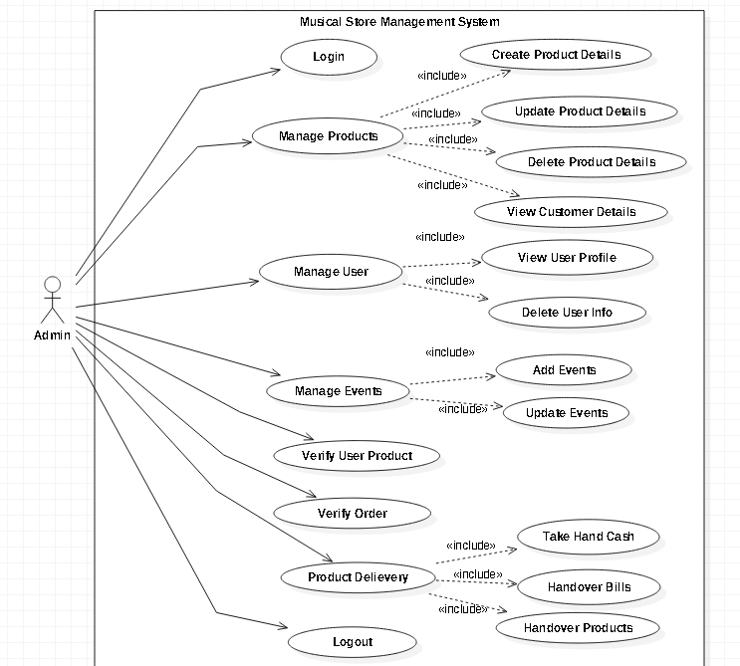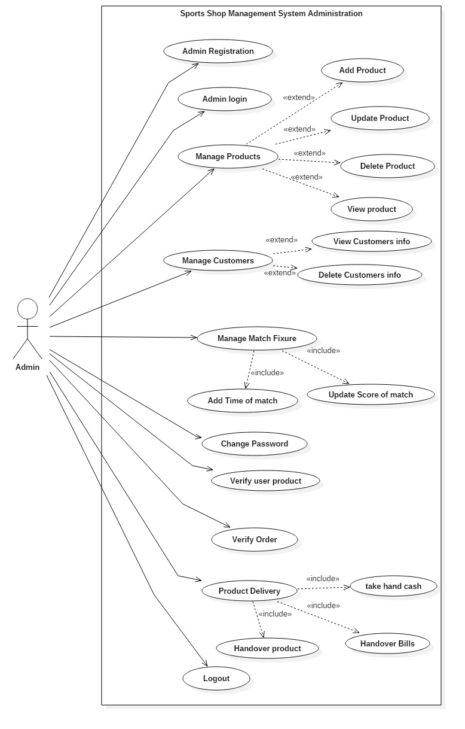

Figure : Use case diagram showing work flow of admin

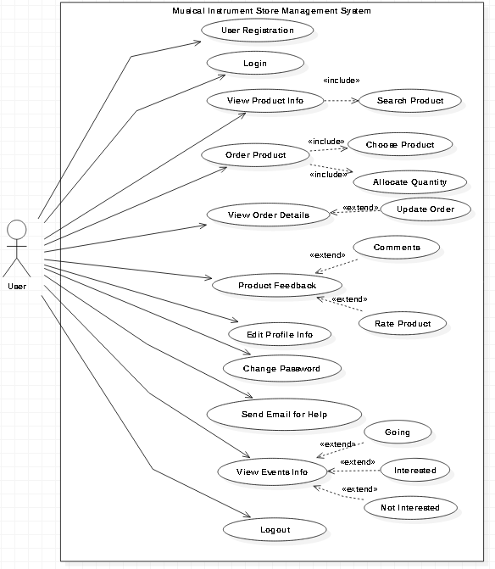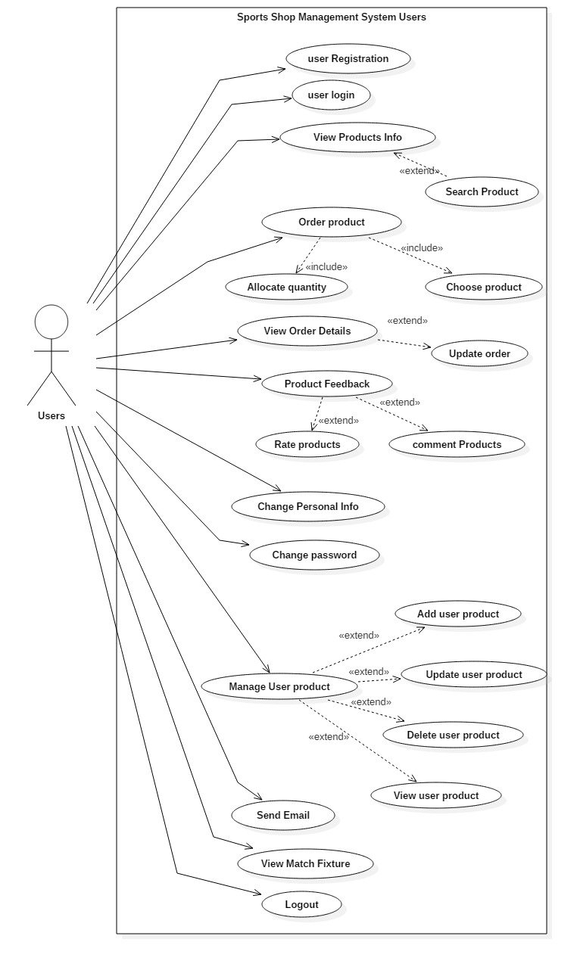

Figure : Use case diagram showing workflow of user

1. **Registration**

|  |  |
| --- | --- |
| Actor | Users, Admin |
| Flow of Event | * Personnel info about the user is provided for registering. * Unique Username and password is provided * Users registered successfully |
| Alternative Flow | If any field is empty, error messaged is displaying to fill the field properly |
| Entry Condition | Inserted data must be validate as per datatype |
| Exit Condition | Registered Successfully message will displayed to the user |

1. **Login**

|  |  |
| --- | --- |
| Actor | Admin and users |
| Flow of Event | * Admin and users must provide the right username and password which were registered. * The system check whether the username and password match the database then authenticate the user * User/Admin get access right to the system |
| Alternative Flow | If any field is empty, or username or password is wrong, error messaged is displaying to fill the field properly |
| Entry Condition | Inserted username and password must be validate data |
| Exit Condition | Login Successfully message will displayed to the user and Session & cookies for the user is created. |

1. **Manage Products (Add, Update and delete)**

|  |  |
| --- | --- |
| Actor | Admin and user |
| Flow of Event | * Admin can add, update and delete the product details that they want to sell from their shop * User can add, update and delete the product details that they want to deliver the product * User get to view the added product and ordered them |
| Alternative Flow | If any field is empty, error messaged is displayed. |
| Entry Condition | Inserted data must be validate as per datatype |
| Exit Condition | Respected task Successfully done message will be displayed |

1. **Search Product**

|  |  |
| --- | --- |
| Actor | Users |
| Flow of Event | * Users search the product with its name * The system checks the name with the data in the database and compare and authenticates * User get to view the product they searched |
| Alternative Flow | If the product name is out of the match with the records then no result will be viewed. |
| Entry Condition | Inserted data must be correct information to be searched |
| Exit Condition | The product detail is viewed by the user |

1. **Change Password**

|  |  |
| --- | --- |
| Actor | User/ Admin |
| Flow of Event | * User/admin can change the password whenever they want with the help of current password. * Users/admin provide new password. * If current password matched with the data stored then then system give user access with new password. |
| Alternative Flow | If current password is invalid then the error message is displayed to give right data. |
| Entry Condition | Current password must be validated. |
| Exit Condition | Password change message will displayed to user/admin |

1. **Change Profile and admin can manage users**

|  |  |
| --- | --- |
| Actor | Admin and user |
| Flow of Event | * Admin can view, delete the user * User can update their profile if needed |
| Alternative Flow | If any field is empty, error messaged is displayed. |
| Entry Condition | Inserted data must be validate as per datatype |
| Exit Condition | Respected task Successfully done message will be displayed |

1. **Order Product**

|  |  |
| --- | --- |
| Actor | User |
| Flow of Event | * Order item, quantity, size, etc * The order is added in the database and kept in que. * Then admin verify the order and contact the user |
| Alternative Flow | If any field is empty, error messaged is displayed. |
| Entry Condition | Inserted data must be validate |
| Exit Condition | Order Successfully done message will be displayed to user |

# **2.6 NLA and Initial Class Diagram**