Table of Contents

Chapter2: Analysis 2

2.1 Introduction to Analysis 2

2.2 Analysis Methodology 2

2.3 Feasibility Study 2

2.4 Requirement Analysis 2

2.4.1 Functional Requirement 2

2.4.2 Non Functional Requirement 2

2.4.3 Moscow Prioritization 2

2.4.4 SRS 2

2.5 Use Case Diagram 2

2.6 NLA and Initial Class Diagram 2

# Chapter2: Analysis

# 2.1 Introduction to Analysis

Analysis means any data/facts related investigation/evaluation to know about the effect of relationship by breaking it into multiple components which gives idea for decision making and solving any related problem.

Analysis is done to gather information to know about detail of the project. Gathering process need certain skill to capture, then document it, collaborate communication with users and manage the overall requirement. While analyzing we need to plan on how information should be gather.

Analysis provides certain visual process of the project such as which part of project is important, risk and helps to come to the conclusion whether to build the project or not.

# 2.2 Analysis Methodology

Good information gathered by leader helps to provide the information patterns from where ideas are gained. When you know problems from different technique you can solve the problem efficiently and effectively.

There are many information gathering methods:

* Interviews
* Questionnaires
* Brainstorming
* Observation
* SWOT
* Focus Group

Among them I choose following techniques which may suit for my projects as it is based on people, fast method to gain information and less time consuming:

### **Observation:**

A systematic data gathering method which is used to observe people in natural situation is known as Observation. I Choose observation technique because I can gather information from natural environment like Facebook, and other document. I can observe user to identify the process, and opportunities for enhancing the project.

* I get real knowledge from user actions.
* I can hear what I want form the people and avoid what they want me to hear. (MacDonald, 2016)

### **Focus Group:**

An information gathering method where 6-10 people are kept in a room so that they can provide feedback on product, services is known as ‘Focus group’. I collected no’s of people (clients, customer, user) interested in my project to provide views, knowledge about the concept, services.

* We can get the real requirement of end users rather than what we prefer.
* Project may be success as the views of people are valued.
* Less time consuming and cost. (MacDonald, 2016)

### **Questionnaires:**

Questionnaires is research done to gather information consisting of series of question from the interested people/respondents. This process is known Questionnaires. I used this method to collect data about the opinions of the peoples from the question given to them. Question pattern are as follows:

1. What sorts of sports/club would you like to see in our store?

Choose: futsal, badminton, cricket, other

1. Do you preferring buying things online or stores?
2. Do privacy concern stop you from buying online?

**Advantages**

* It is fast process to gain lots of information to address the objectives.
* I can save time and avoid the meetings. (MacDonald, 2016)

# 2.3 Feasibility Study

Feasibility study is done to know whether the project fits under circumstances. The ability of project, different factor to be completed successfully can be measured by feasibility study. Feasibility study provides the positive and negative outcomes of the project. It provide necessary details of the project, also help to identify the risk/problems and the solution (Hofstrand, 2009).

There are different types of studies. Some are:

1. **Technical Feasibility:** It helps to identify whether the hardware and software resource are feasible or profitable, maintainable for the project. The important aspect are identified which are important to build the project. For my project, user needs device with internet facility, database server to store product and customer information, admin, website with domain name etc which are available.
2. **Economic Feasibility Study:** Economic Feasibility refers to the fitness of the respective project to produce economic profit/benefits. The study is also known as cost benefit analysis. Here, cost to build the project is estimated such as budget, allocation, profitable or not. Our system needs website of own which are accessible easily from device having internet service. For website we need a domain name and it is affordable to have one. The order parts are the customer’s assets.
3. **Operational Feasibility:** Operational feasibility is the measure how effectively the proposed system can solve the problems, and fulfill the identified requirements. Management of the project is welly maintained. The system operation provides adequate and response time. Large number won’t be active at a time so there is no risk while operating.
4. **Legal Feasibility:** Legal feasibility is perform to check whether the proposed system tends to violate the legal rules/guidelines or conflict with legal rules. It helps to analyses the legal issue which may affect the project. The project is for academic purpose (not for business) and doesn’t have any issue that conflict with the rules. Our project isn’t against any legal rules.
5. **Scheduling feasibility:** Scheduling feasibility is to check whether the project completes within the allocated time. With this feasibility study the project can deliver in time. For my project, proper attention was given while allocating time for tasks and subtask to complete. Time estimation and Gantt chart is prepared so that project will be completed in time. (Mukund, 2018)

# 2.4 Requirement Analysis

Methodology provides certain guideline giving advices on how to develop the work. There are different methodology - soft, hard and combined. I choose Soft System Methodology (SSM) because my project is developing for the needs of people. So I have to focus more on people’s views than technical. As requirement changes time to time so flexibility is required which is given by soft approach.

**Advantages:**

* More people interaction and involvement so that problem is clarified
* Improve the understanding as feedback from user is noticed.

Following are the steps while applying soft approach:

1. Analyze and produce Rich picture
2. Define root definition of parts of Information system
3. Produce conceptual models of system
4. Compare concept of the system with actual system
5. Define and select feasible options for development
6. Implement the system
7. **Rich Picture:** It is the drawing that explain the element related to the system and relationship that needs to be considered in order to make improvement. Pictures, text, symbol, are used to make rich picture. It explain the richness/understanding and complexity of entire situation. It is drawn by hand where structure, process, issue are identified. It is never wrong. (Pham, 2015)

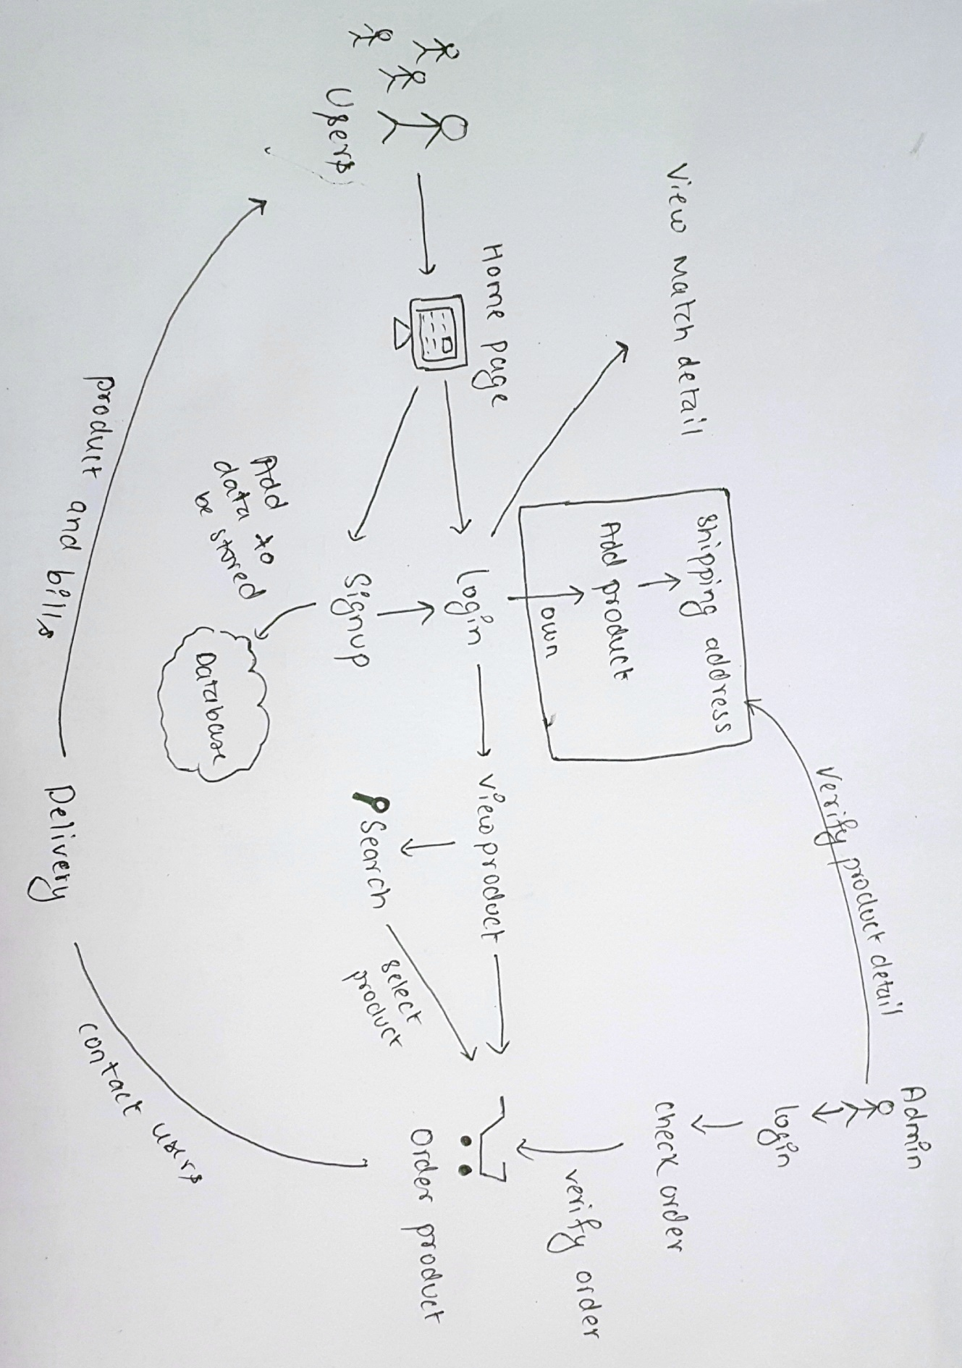

Figure 1 : Rick Picture

1. **Root** **definition**: It is a structured description of entire system. It clarifies the System processes and problem that are held within the system. It also helps to describe the aims and functions of the system that is being develop.

**CATWOE:** It helps to prepare root definition.

* **Customers/clients:** Customers/client are stakeholder those are benefited or victimized by the outputs of system. User are clients.
* **Actors/Agents:** Actors are those who are responsible for carrying out the task and activities.E.g.: Admin can manage the products.
* **Transformation:** Transformation are the changes that system brings out. The activity that provides service to clients. E.g.: user can search the product and can easily access the right product.
* **World view:** World view explain why the activities exists. Customer can order the product sitting at the one place making the product available everywhere.
* **Owners:** The one who is the reason the system exist. Owner of the project will be admin who intend to make changes within system.
* **Environment:** The environment where the system works and which may have negative consequences with the change of system. The proposed project is user-friendly application making the customer work easy and fast. (BCMG, 2017)

1. **Conceptual model:** Conceptual model is construct with the help of rich picture and root definition. Conceptual is used to explain how system should function and necessary activities for the processes. The system performance can be measured too.

# 2.4.1 Functional Requirement

# 2.4.2 Non Functional Requirement

# 2.4.3 Moscow Prioritization

# 2.4.4 SRS

# 2.5 Use Case Diagram

# 2.6 NLA and Initial Class Diagram