Table of Contents

Chapter2: Analysis 2

2.1 Introduction to Analysis 2

2.2 Analysis Methodology 2

1. Observation: 2

2. Focus Group: 3

3. Questionnaires: 3

2.3 Feasibility Study 3

2.4 Requirement Analysis 4

2.4.1 Functional Requirement 7

2.4.2 Non Functional Requirement 8

2.4.3 Moscow Prioritization 9

2.4.4 SRS 11

2.5 Use Case Diagram 11

2.6 NLA and Initial Class Diagram 17

# **Chapter2: Analysis**

# **2.1 Introduction to Analysis**

In general, Analysis refers to the investigation or evaluation of any data/facts to perceive about the impact on the relationship by dividing it into various components that provide an idea for making decisions plus solve any associated problems.

Analysis is performed to collect information to understand the project in detail. We need specific skills in gathering data which is documented and we collaborate communication with clients and sustain the overall requirement. We need to plan on how information should be gathered while analyzing.

Analysis grants a distinctive optical method for the project like which part of the project is essential, uncertainty and determines if it's okay to develop the project.

# **2.2 Analysis Methodology**

### Analysis Methodology is a procedure that we can follow in order to analyze system or application performance. Out of various approaches for software development I would like to go for Soft System Approach for my project.

### **Soft System Methodology (SSM)** is a cyclic learning system in which models of human activity are used to sightsee with actors in actual world problem situation, their perception of that condition and their enthusiasm. The Trustworthy information gathered provides information patterns from where ideas are obtained. One can easily solve the problem in an effective manner from a different technique once the problem is figured out.

Examples: ETHICS, PEST, SWOT, CATWOE, Rich Picture, Root Definition, etc.

Advantages:

* It improves decision making about the company purposes.
* It aids in structuring a complex political and organizational circumstances.
* It permit the user to deal with complex circumstances in an organized manner.

Following Steps are applied for soft approach.

* Analyze and produce Rich Picture.

**Rich picture** is a way in which we sightsee, recognize and define situations and then express it through diagrams to create preliminary model. It helps to open discussion and come to shared understanding of situation. It assists us to illustrate the richness and density of our project which is why it is called rich picture.

### I choose the following techniques which suit my projects as it is based on people opinion as well as quick method to gain valuable information and less time consuming.

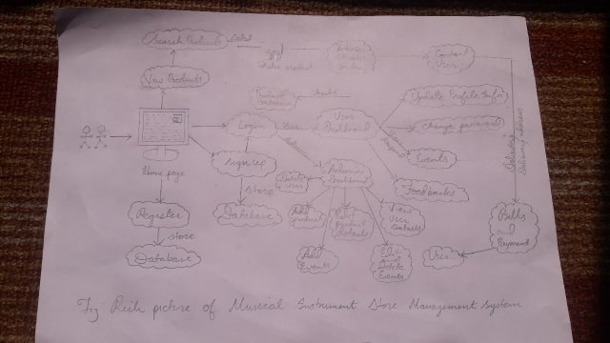

Figure 1: Rich Picture

**Root Definition**

Root Definition is a statement or declaration that briefly defines a system of interest. It makes the problem in the system clear and elaborates the goal and functionality of the system that is presently being developed.

**When and Where to use it?**

Root Definition takes place in the business that is being studied. It is used to investigate the complex situation and get clear common system of interest. It helps to focus on the quality of the project that depends upon the input of the team and individual.

**How to do it?**

**It is important to uncover the direction each stakeholder believes the organization should implement. CATWOE Analysis is a technique to understand a stakeholder’s viewpoint and the impact that this view shall have on the way of the business alteration.**

**The abbreviation for CATWOE is C**ustomer, **A**ctors, **T**ransformation, **W**orldview, **O**wner and **E**nvironment.

**Customer** = They are the recipient of the outputs from our business system.

**Actor** = They carry the roles that is t be performed in the business system processes.

**Transformation** = It is the fundamental activity that predicts the output of the system to the consumer.

**Worldview** = It is the underlying worldview for the transformation that have great or long lasting effect on analysis.

**Owner** = Those individuals who invested and have overall authority for the business system.

**Environment** = The rules or the constraint surrounding the project.

**Conceptual Module**

A conceptual module refers to the illustration of business system that makes use of concepts and ideas to give assumed representation. From the sciences to socioeconomics fields of software development conceptual modeling is practiced.

Advantages are listed below:

* It enhances our understanding to represent system
* It stimulates well-organized transference of details of system.
* It provides essential reference for system designers for gathering system specifications.

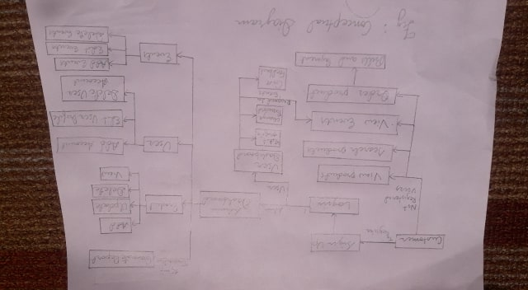

Figure 2: Conceptual Diagram

# 2.3 Feasibility Study

The study that is used to determine the viability of a project ensuring project is legally and technically feasible as well as economically justifiable and so on is known as Feasibility Study. It is the important factor in the credibility of study for potential investors and leading institutions. (Conan, 2019)

**Importance of Feasibility Study for my project:**

1. It helps to improve project team focus and identifies new opportunities.
2. It determines the whether or not the project is worth the investment as it evaluates project’s potential for success.
3. It enhances the success rate by evaluating multiple parameters.
4. It supports decision making on the given project.

The different feasibility study that I performed in my project are given in the table below.

|  |  |  |  |
| --- | --- | --- | --- |
| **S.N** | **Feasibility Study** | **What does this study find out?** | **How it is related to my project?** |
| **1** | Schedule Feasibility Study | Can the work or the project be completed on estimated time?  How much time the project will take to complete? | There are WBS, Gantt Charts and milestones which I have created for this project. The tasks are completed as per the given timelines up till now and will also be continued in upcoming works. |
| **2** | Economic Feasibility Study | Can allocated budget enough to complete and sustain project’s expenditure?  Does the project benefit outweighs the project cost? | Our project is feasible economically and it will provide positive economic benefits to the organization. Our project benefits should outweigh the project cost. |
| **3** | Technical Feasibility Study | Is the current technical resources enough for the project?  Are technical team capable of converting ideas into working system? | The technical requirement are currently sufficient for the project. I have smooth running laptop and good internet connection. And technical team will be provided with training and workshop if required. |
| **4** | Marketing Feasibility Study | Which type of market will this project gain maximum profit?  What is the percentage of people purchasing goods online? | The project will be a boon to people who love playing musical instruments. By following a good marketing strategy, the project market will be able to gain maximum profit for the company. |
| **5** | **Operational Feasibility** Study | How well the company/user needs can be met by completing project? | I think the project would do well as it is satisfies the requirement of the project and offers greater user satisfaction. |

# 2.4 Requirement Analysis

## **2.4.1 Functional Requirement**

Functional requirement point out the things that system should do i.e. behavior/functions to finish the required work. It describe all the interaction within the system which explain the inputs, outputs, behaviors. The functional requirement of my system are as follows:

|  |  |  |  |  |
| --- | --- | --- | --- | --- |
| **FR S.N** | **Functional Requirement** | **Description** | **Rational Motive** | **Dependencies** |
| FR1 | Registration | It creates new user account | Personnel information of the users and create an account |  |
| FR2 | Login | User should provide valid username and password to login to system. | Authenticate the user that was recorded to the system. | FR1 |
| FR3 | Add products | Product Details can be added. | Deliver product information in details. | FR2 |
| FR4 | update products | It updates existing product information. | To provide up to date information of product. | FR2, FR3 |
| FR5 | Delete products | It eliminate Unavailable products | To Delete the product details | FR2,FR3 |
| FR6 | View products | Products details like Name, Price, Quantity, Product image | To view the products detail | FR2, FR3,FR4 FR5 |
| FR7 | View products and order | Item name, Price,  Quantity, Date of  Order | To view and order the products | FR2, FR3,FR4 FR5 |
| FR8 | personal information change | Admin/customer can change their profile if needed  Name, Address, username, Passwords | Changing Personal information | FR1,FR2 |
| FR9 | Change password | It would change the password if necessary. | To change password. | FR1, FR2 |
| FR10 | Delete user | The data of user will be deleted if needed. | User profile delete if necessary | FR1 |
| FR11 | Search Products | It would help user to navigate through the products. | Access fast access to the product details | FR2,FR3 |
| Fr12 | View order detail | It would allow user to view list the product that is selected. | Detail view of products that is ordered. | FR2,FR12 |
| FR13 | Categorize the product | The product is categorized according to brand, size popularity and price. | User can navigate easily on the basis of category | FR2,FR3 |
| FR14 | Email Service | User can mail regarding the products | Store the feedback given by customer | FR2 |
| FR15 | Give Feed Back | It includes suggestions, complain, compliment and remark. | To make sure user can post their views. | FR6,FR7 |
| FR16 | Rating | Allow user to rate the product. | To rate on product | FR6,FR7 |
| FR17 | View Events | It gives clear description regarding events. | To view events details and participate. | FR1,FR2 |
| FR18 | Newsletter | It notifies the customers about upcoming events | Get notification on news and events. | FR1 |
| FR19 | Accept Cookies | It helps to store login information and should accept. | It acts as the identification card for users | FR1,FR2 |
| FR20 | Logout | User can logout of system whenever they want to. | Sign-out of the system | FR2 |

## **2.4.2 Non Functional Requirement**

It point out the how system works or behave. In another word, it explain how the system is performing. It does the testing that explain how well the system is.

Following are the non-functional requirement in my system.

|  |  |  |  |  |
| --- | --- | --- | --- | --- |
| **NFR S.N** | **Non-Functional Requirement** | **Description** | **Rational** | **Dependency** |
| NFR1 | Secure access of confidential Information | Personal information should be encrypted before storing and should not be leak. | Tight security should be there. | FR1, FR2 |
| NFR2 | 24x7 availability | System must be active 24x7 so that user doesn’t lose interest | Giving availability service. | N/A |
| NFR3 | Application Compatibility | The system will work in any device having browser to give service | Platform independent service | N/A |
| NFR4 | Recoverability | System should be able to recover data that might get loss. | To avoid data loss problems. | N/A |
| NFR5 | Reliability | System must give accurate services | To make services reliable at ease. | N/A |
| NFR6 | Efficiency | System should be fast to perform the task correctly. | To avoid time loss. | N/A |
| NFR7 | Performance | System shouldn’t be slow to perform and have bug | To run system completely | N/A |
| NFR8 | Implementation | Test should be done to check the system is correct and check the platform | To make ensure the system run perfectly checking every aspect | All |
| NFR9 | Usability | User should be feel easy to navigate  And feel attractive | Easily useable(user friendly) | N/A |
| NFR10 | Scalability | System should be adequate to any change | Capacity to adequate | N/A |

## **2.4.3 Moscow Prioritization**

Moscow Prioritization is a technique that is used by analyst and stakeholders in order to prioritize the requirements in collaborative fashion. (Yaman, 2011)

Advantages are given below:

* It is a great way to frame conversations with clients.
* It makes the project clear about what they want and what are just nice to have.
* It would be great for project kickoffs with clients as its not time consuming and is straight to the point.

The following are 4 groups in which list of requirements are categories:

1. M-Must Have: These types of requirements are non-negotiable and vital for implementation in the system. Project would go at loss without it.
2. S-Should Have- It is a critical requirement which should be in solution if possible but can be come across with other means.
3. C-Could Have: It is a desirable or nice to have requirement that would improve user experience.
4. W-Won’t have: It is a requirement that is agreed to be out of scope in present situation or time box but stakeholders cab consider it in near future.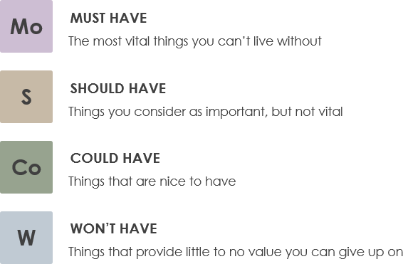

Figure 3: Moscow Prioritization

Moscow prioritization of functional requirement:

|  |  |  |
| --- | --- | --- |
| **FR S.N** | **Functional Requirement** | **MoSCoW** |
| FR1 | Registration | Must have |
| FR2 | Login | Must have |
| FR3 | Add products | Must have |
| FR4 | update products | Must have |
| FR5 | Delete products | Must have |
| FR6 | View products | Should have |
| FR7 | View products and ordering | Must have |
| FR8 | personal information change | Should have |
| FR9 | Accept Cookies | Must have |
| FR10 | Automatic Delete user | Could have |
| FR11 | Search Products | Should have |
| Fr12 | View order detail | Should have |
| FR13 | Categorize the product | Should have |
| FR14 | Email Service | Could have |
| FR15 | Feed Back | Could have |
| FR16 | Star Rating | Could have |
| FR17 | View Events | Must Have |
| FR18 | Newsletter | Should have |
| FR19 | Accept Cookies | Must have |
| FR20 | Logout | Must have |

Moscow prioritization of Non-functional requirement:

|  |  |  |
| --- | --- | --- |
| **NFR S.N** | **Non-Functional Requirement** | **MoSCoW** |
| NFR1 | Secure access of confidential Information | Should have |
| NFR2 | 24x7 availability | Won’t have |
| NFR3 | Application Compatibility | Must have |
| NFR4 | Recoverability | Must have |
| NFR5 | Reliability | Must have |
| NFR6 | Efficiency | Should have |
| NFR7 | Performance | Must have |
| NFR8 | Implementation | Should have |
| NFR9 | Usability | Should have |
| NFR10 | Scalability | Could have |

## **2.4.4 SRS**

A Software Requirement Specification also known as System Requirement Specification, is a set of document that helps to explain the feature and behavior of a software requirement. It also provides various hardware and software description while developing a system. The hardware and software requirements required for my project is given below.

* Pre-project requirements

The hardware and software required for developing the project from the beginning to ending is said to be Pre-project requirements.

|  |  |
| --- | --- |
| **Hardware** | **Software** |
| * Laptop (Acer Aspire) * Processor (i3 intel) * RAM (4GB) * Hard Disk Space (500GB) | * Windows 10 (Operating System) * Sublime Text 3 (Text Editor) * XAMPP (Local Server) * MySQL (Database) * Google Chrome (Browser) * Star UML * ProjectLibre * Visual Paradigm |

* Post project requirements

Post project requirement refers to the basic hardware and software prerequisite required to run the software in a smooth manner.

|  |  |
| --- | --- |
| **Hardware** | **Software** |
| * Android and IOS devices * Proper internet connection * Minimum Core 2 Duo or above processor * RAM: Minimum 4 GB or above * Hard Disk space (100GB) | **Operating System**   * Above Windows 7   **Browsers**   * Google Chrome * Opera * Mozilla Firefox |

# **2.5 Use Case Diagram**

The behavior diagram which is an illustration of user interacting with the system to achieve goal providing overview the relationship between user and variety of use cases (event/list of actions).This process is “**use case diagram”**. The symbol description used in use case are:

* Rectangular box to illustrate the system.
* Actors are those who perform actions.
* Use Case are the list of process that describe the action perform by actor in a system.
* Objects are instance of class.
* Interface are elements that describe set of operations. (Rouse, Whatis.techtarget, 2015)

The use case diagram of my proposed system is as below:

The following use case diagrams for my project is displayed and explained below:

* + 1. Admin Use Case Diagram:

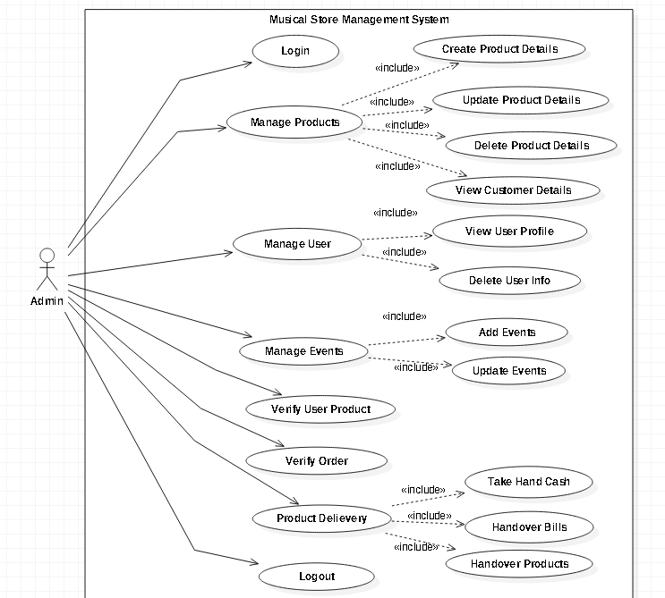

Figure 4: Use case diagram showing work flow of admin

**Scenario Description:**

Actor: Admin

As an administrator he/she can do the following actions:

* It should Login and Logout of the system at any given time.
* It can control the product data and perform CRUD operations with the product information.
* It can retrieve registered users details and also delete user account if necessary.
* It can manage upcoming musical events including add, delete or update event details
* The admin checks and verifies the customer order and handover bills as per the order.

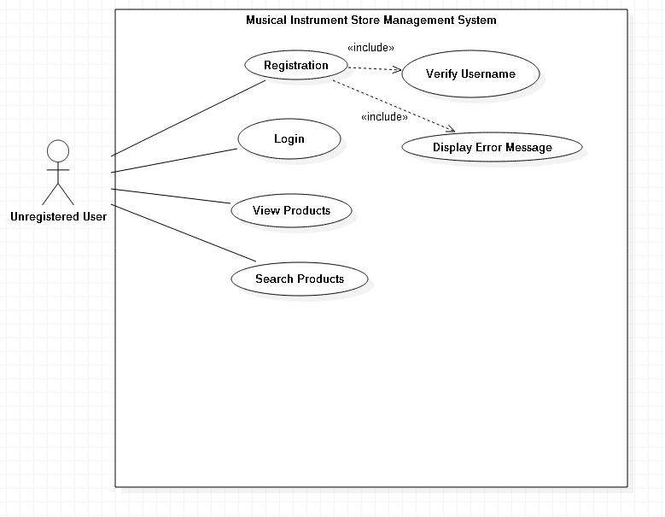

Figure : Unregistered User Usecase

**Scenario Description:**

Actor: Unregistered User

The unregistered user is also a part of the system who can do activity given below:

* Unregistered User can create account to the system to get login access.
* Unregistered User can sign in into the system and act as a user.
* Unregistered User can see the listed products which are listed by admin.
* Unregistered User can search for the necessary products.

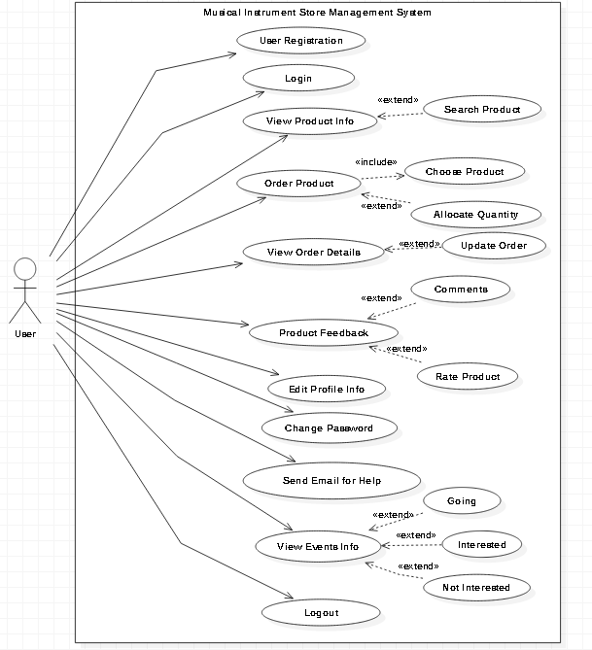

Figure 6: Use case diagram showing workflow of user

**Scenario Description:**

Actor: Registered User

The Registered user is also a part of the system who can do activity mentioned below:

* Registered User can sign in into the system and can look for products and order them.
* Registered User can manage their information in their account:
  + They can update their profile details,
  + They can change password,
  + They can ask any doubts regarding products through mails,
* Registered User can write a feedback and rate product.
* Registered User can respond to upcoming events and view events information
* Registered Users can enter their email address for subscription.
* Registered Users can logout of the system safely.

# **2.6 NLA and Initial Class Diagram**

NLA (Natural language analysis) is the process of figuring out selective elements from the unstructured textual content or paragraph that we read and analyze. We pick out the noun, verbs and adjective from the scenario given. From the noun we extract potential classes, from verbs potential methods and from adjectives we extract potential attributes. Through this we create various diagrams such as class diagram, activity diagrams, etc.

**Musical Instrument Store** is located at Baneshwor Kathmandu which has been supplying the material like guitar, violin, piano, etc. The main aim of this store is to fulfill the gap of musical instrument and welcome people to take part in the musical journey. The owner of the company needs a web-based application for his store to expand his business and attract lots of customers. In this system we have an administrator who can add, update, delete, and view the product details. The products are categories as brand, size, price and popularity so that it is easy for the customer to navigate. Admin can add the upcoming events in details including description, time of event, address etc. Customer are able to create an account/registration with their details and sign in with registered username/email and password.so that they can use additional features of the system. Admin can delete the events details and if necessary delete user account. Customer can explore the product, view product descriptions and order or add the product to cart if they want. Customer can only view the order details, calculate overall amount done by admin. After that the admin take a look and verifies the order and contact with the user for further processing. After that the product is delivered to the Customer with the bills and user have to pay for the product. User can give valuable feedback to the user including suggestion, complain, compliment and remark of the product or shipping. Customer can change their profile and password.

User can contact if there arise problem with wrong delivery or associated with the store. For this user should provide their email, product details and address if they don’t have an account. The web service should be fast and reliable and come with a little charge.

From the scenario I selected nouns, adjective and verbs that can be potential classes, attributes and methods.

|  |  |  |
| --- | --- | --- |
| **Nouns(Candidate Classes)** | **Adjectives(Candidate Attributes)** | **Verbs(Candidate Methods)** |
| Registration, account, Login, Customer, Product, Shop, Order, Delivery, Payment, Admin, Shipping | Time of event  Email  Username  Password  Comment  Rate | Add  Update  Delete  Search  View  Calculate |

`

## **2.8 Class Diagram (Initial)**

Class Diagram is a static diagram that defines the design of relationships and code (source) dependencies between classes(Rouse, TechTarget, 2007)**.** Apart from imagining, describing, and documenting different features of a system it also for builds executable code of the software applications. Moreover Class Diagram is the only UML diagram that can be mapped directly with Object oriented languages which is why they are widely used in modeling OO system.

Advantage of Class Diagram

* Business Analyst uses class diagrams for modeling system for business perspective.
* It shows static structure of classifier in system
* It provides basic notation for other structure recommended by UML. (Smith, 2018)

Classes contain different access level control by the access modifier. They are:

. Public (‘+’), Private (‘-‘) and Protected (‘#’).

The initial class diagram that is develop with the help of NLA with main classes, attributes and methods for Sports shop management system is below:

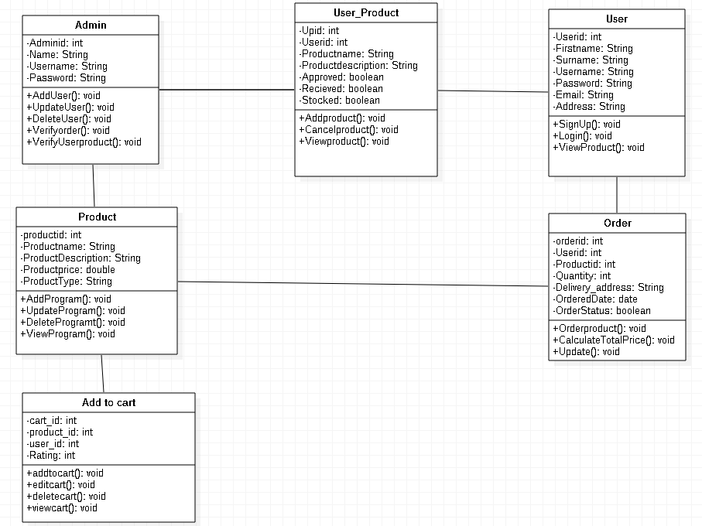

Figure 7: Initial Class diagram

# References

BCMG, T. (2017, September 2017). *BCMG*. Retrieved from https://businesschange.co.za/what-is-catwoe-analysis/

MacDonald, J. (2016, January 28). *Business2Community*. Retrieved from https://www.business2community.com/strategy/pros-cons-10-information-gathering-techniques-projects-01437727

Pham, V. (2015, Jan). *elabor8*. Retrieved from https://elabor8.com.au/rich-pictures-and-catwoe-simple-yet-powerful-scope-modelling-techniques/

Rouse, M. (2007, March). *TechTarget*. Retrieved from https://searchmicroservices.techtarget.com/definition/class-diagram

Rouse, M. (2015, January). *Whatis.techtarget*. Retrieved from https://whatis.techtarget.com/definition/use-case-diagram

Smith, E. (2018, 9 9). *Visual Paradign*. Retrieved from Visual Paradign: https://www.visual-paradigm.com/guide/uml-unified-modeling-language/what-is-class-diagram/

Yaman, J. (2011, 11 1). *Learning*. Retrieved from https://businessanalystlearnings.com/ba-techniques/2013/3/5/moscow-technique-requirements-prioritization