# **Design**

## **3.1 Introduction**

Design is one of the step of SDLC. The systematic sequence of steps which helps to describe, several plan/Structure and produce a project is known as design. It helps you to be focus, transparent while developing. Design process are follow to avoid any misses of function. The structured of the project is preplanned and how the project can achieve goals.

Design is important because:

* The client can trust with the decision that we make through the design.
* It makes us easy/efficient when developing.

I used open software Star UML which is fast, flexible. I used Visual paradigm to develop ER diagram.

* DFD: Data flow diagram (DFD) illustrate the flow of information within the system boundary. DFD visualize things that are hard to describe in words. Symbol use to draw DFD are rectangles, circles, arrows, plus short text labels, input, output, Storage, etc. It may turn later to class diagram (Molson, 2017). I choose DFD because it illustrate how data flow through system, concern where data come from and goes to and where it stored. It gives overview of system which are simple draw and understand. It visualize data so that we can view how the data flow through our system. DFD helps to keep our program organized. We can know how our system will gain the intended purpose.

## 3.1) Structural Modeling

### 3.1.1) Final Class Diagram

### 3.1.2) Flow Chart

Below is the data flow diagram showing how user interact with the system:

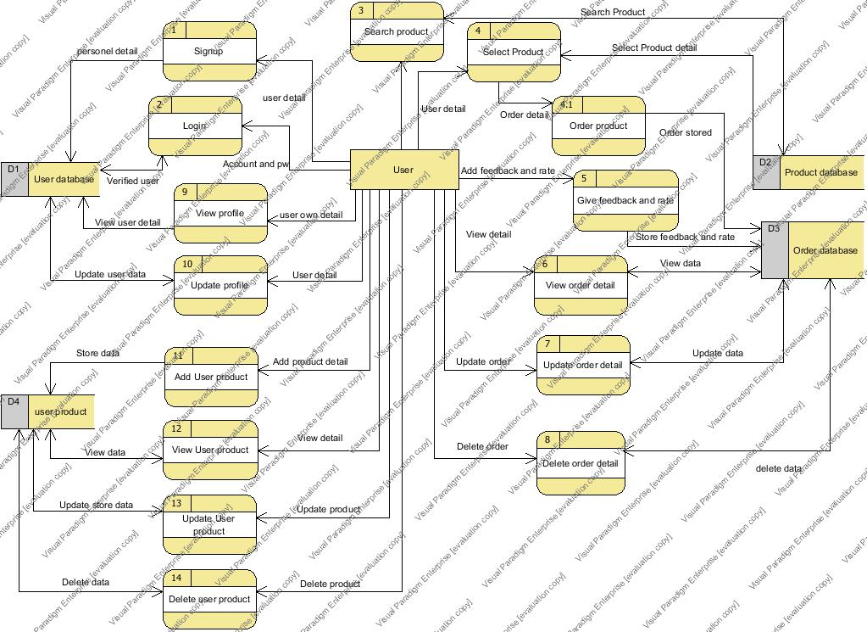

Figure 8**:** DFD of user data flow

Below is the data flow diagram showing how Admin interact with the system:

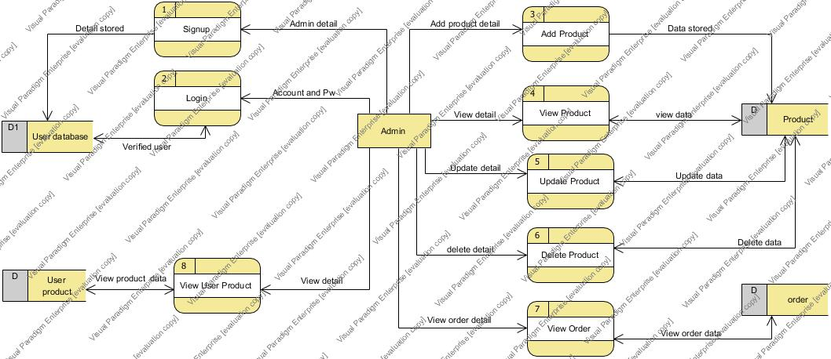

Figure 9**:** DFD of admin data flow

## 3.2) Behavioral Modeling

Behavioral describe internal logic of system. This model deals with communication between objects. It denote dynamic behavior of system. It helps to show CRUD operation of the system through diagram. It helps us to know about guidelines, process and strategies of system. There are many behavioral model, among which I choose: Sequence and activity diagram.

### 3.2.1) Activity Diagram

A UML that graphically represent serial flow of control and several actions in the system is called Activity diagram. It visualize flow of action from one activity to another. I choose activity diagram because it is simple and intuitive illustration of how the system workflow take place. The dynamic aspects of our system can be describe by activity diagram. I can also view the decision paths that exist in system. It describe the functionality that take place in our system. (Software, 2018)

Below is the activity diagram of user interacting with system:

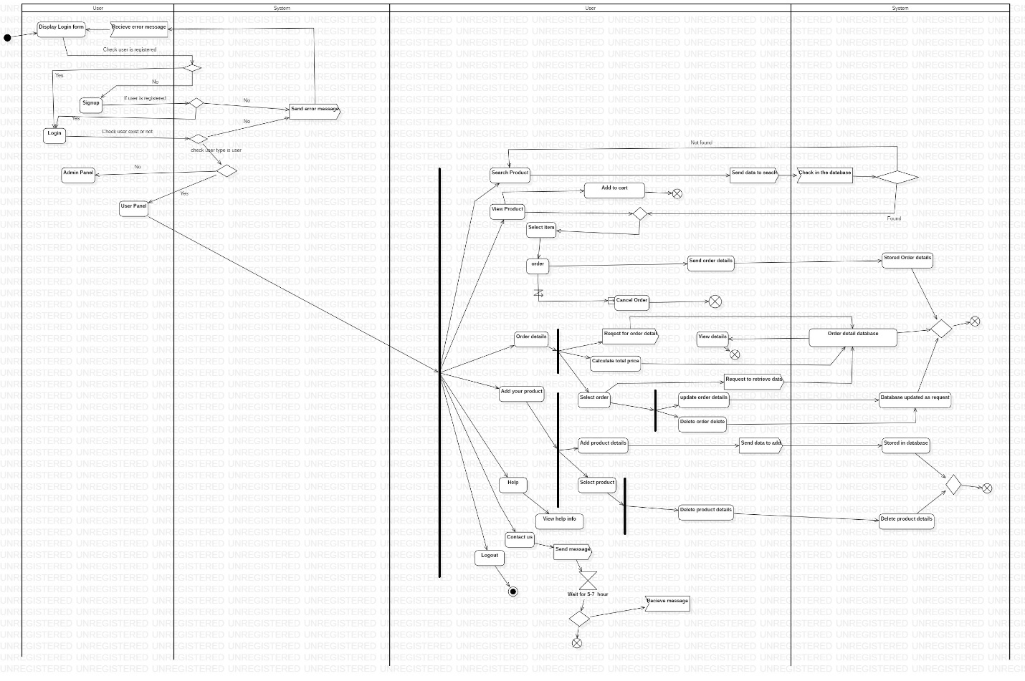

Figure 15: Activity diagram of user action

Below is the activity diagram of admin interacting with system:

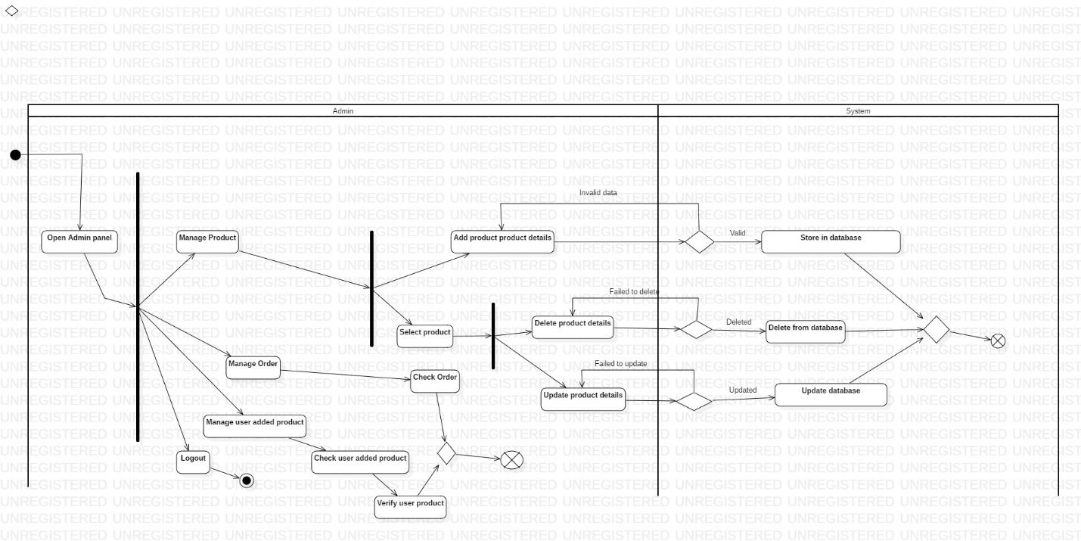

Figure 16**:** Activity diagram of admin action

### 3.2.2) Sequence Diagram

A UML that describe how the system operate with one another in a sequence is called sequence diagram. It shows the interaction of objects in a time sequence. It helps to visualize the different runtime significances.

I choose sequence because

* It illustrate how object interchange in sequence order which makes easy to know how system operate.
* We can know how object interact in current system. While documenting it helps to describe how future system should behave. (Lucidchart, 2018)

Diagram below is sequence diagram representing how admin interacts with system like how admin open dashboard, add product, manipulated product which are saved in product DB, view order detail and user product detail.

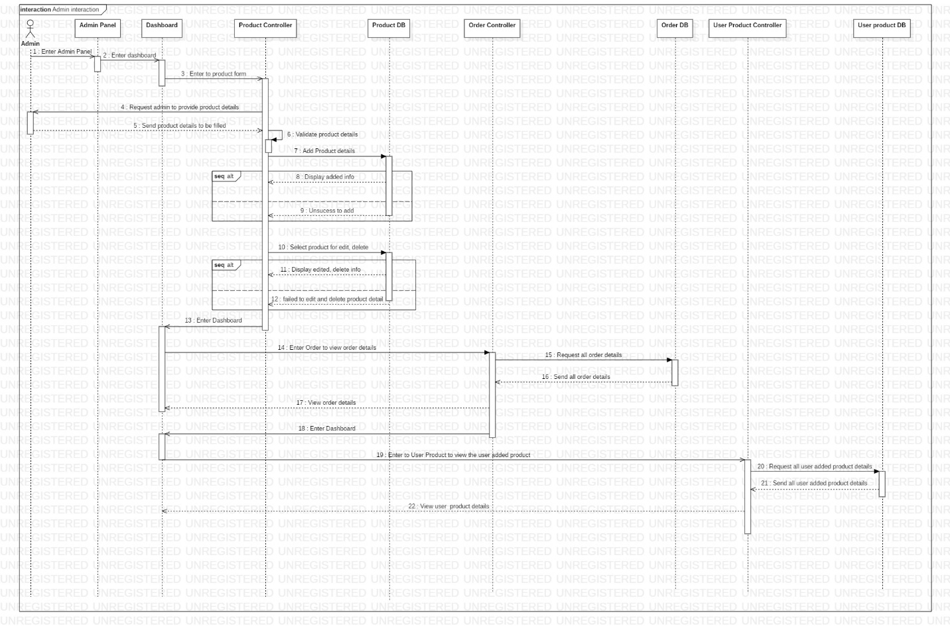

Figure 10: Sequence diagram on how admin interacts

Diagram below is sequence diagram representing how user order the product, add their product and manipulate it.

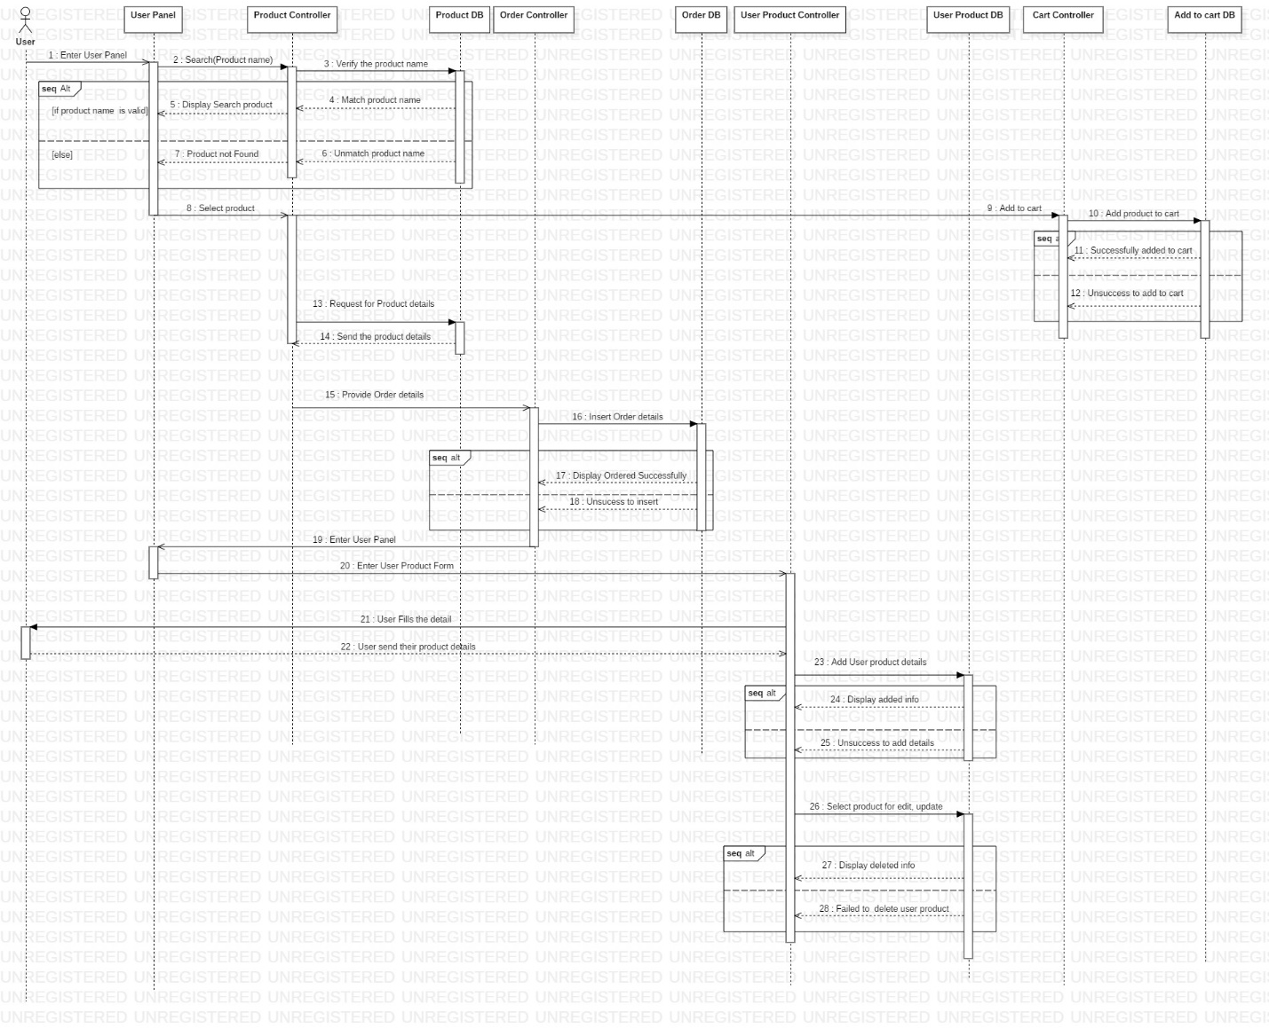

Figure 11: Sequence diagram of user interacting

Diagram below is sequence diagram illustrating how user can view order, and manipulate it and update user profile.

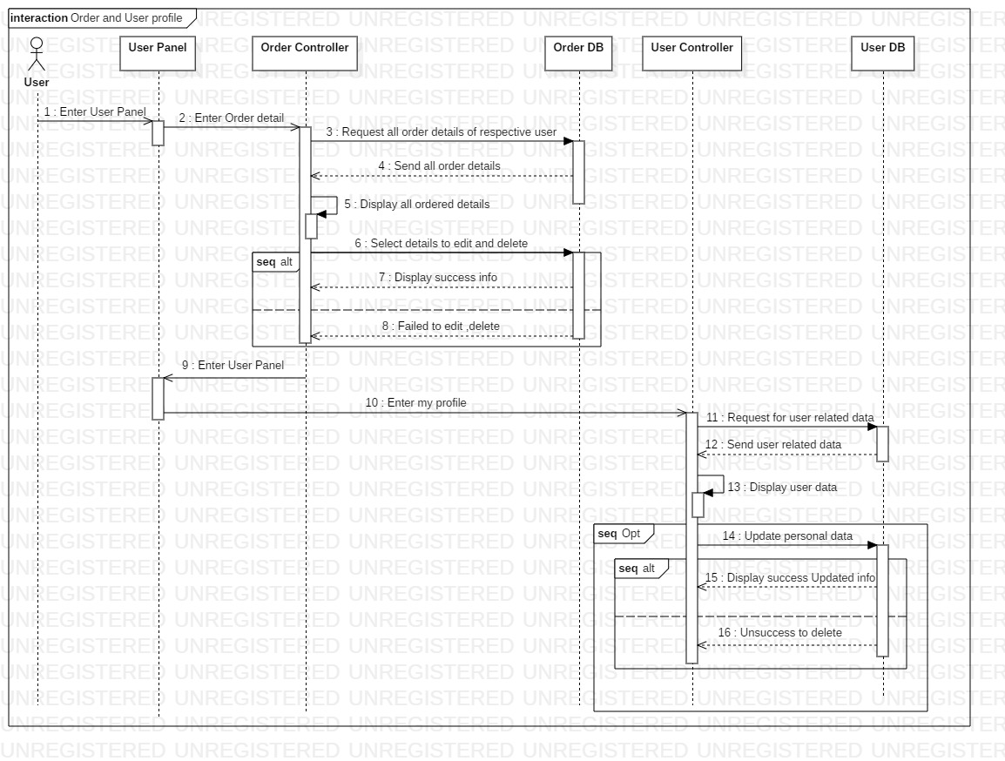

Figure 12: Sequence diagram on user interacting to view order detail and update profile

Below is the sequence diagram of user doing login:

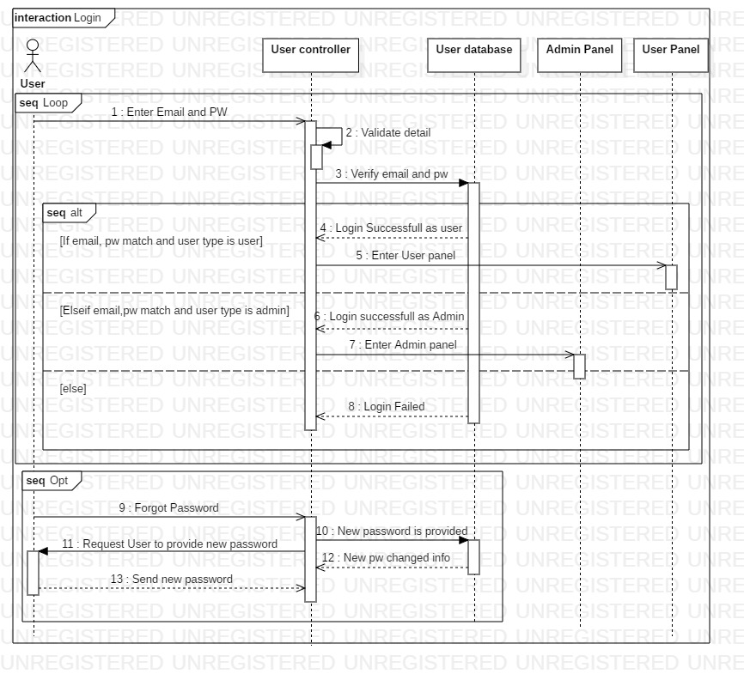

Figure 13: Sequence diagram on user interact while login

Below is the sequence diagram showing registration: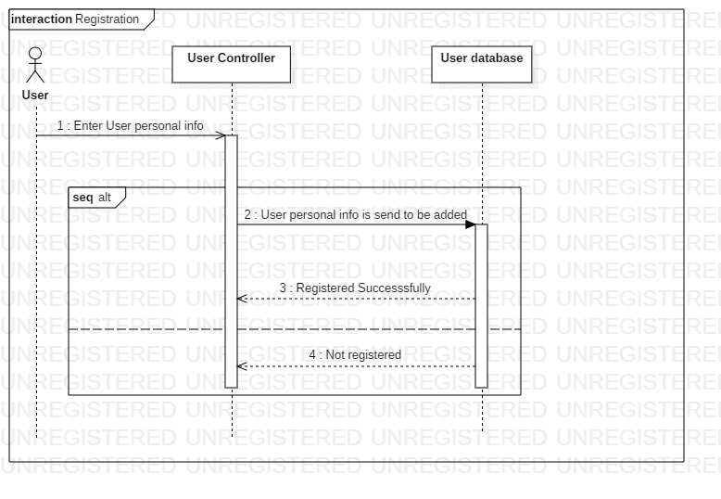

Figure 14: Sequence diagram of user interacting while doing registration

## 3.3) Database Modeling

### 3.3.1) Data Dictionary