Project Proposal
On
Musical Instrument Store Management System

By
Hipakh Khergoli
00174637
Computing Project
Level 5 Diploma in Computing
Softwarica College of IT & E-Commerce
Kathmandu, Nepal
Submission Date: 8th April 2019

Submitted to: Sudeep Lal Bajimaya
(Module Instructor)
Table of Contents
Chapter 1: Introduction 4
1.1 Introduction to the project 4
1.2 Background of the project 4
1.3 Problem Statement 4
1.4 Description of the project 4
1.5 Features of the project 4
1.6 Overview of the project 4
Chapter 2: Scope of the project 4
2.1 Scope 4
2.2 Limitation 4
2.3 Aims 4
2.4 Objectives 4
2.5 Overview of the scope 4
Chapter 3: Development Methodology 4
3.1 Description of the methodology 4
3.2 Design Pattern 4
3.3 Architecture 4
Chapter 4: Project Planning 4
4.1 WBS (Work Breakdown Structure) 4
4.2 Milestone 4
4.3 Gantt chart 4
Chapter 5: Risk Management 4
Chapter 6: Configuration Management 4
Chapter 7: Conclusion 4
Chapter 8: Reference and Bibliography 4

Table of Figures
Fig 1: Waterfall Model 8
Fig 2: MVC Design Pattern 9
Fig 3: Client-Server Architecture 10
Fig 4: Work Breakdown Structure 11
Fig 5: Milestones 12
Fig 6: Gantt chart 13
Fig 7: Risk Likelihood 13
Fig 8: Risk Consequence Values 14
Fig 9: Risks Management Table 14
Fig 10: Project Backup in Internal Drive 15
Fig 11: Project Backup in Internal Drive 16
Fig 12: Screenshot of GitHub's Repository 16

Key Words

Chapter 1: Introduction

Introduction to the project
Suryabinayak musical instrument store is a well-established store founded in 2017.It is a retail business that sells musical instruments along with the associated accessories also facilitates maintenance services. They offers varieties of instruments such as guitars (acoustic or electric), madals, drums, and harmonics and so on. The company is looking to increase their sales and therefore asked me to develop a web application platform to showcase the products.

Background of the project
There are many concerts happening near our places have increased the customers in the recent months. Even busy people from far places visit store in search of musical instruments. They come to store with limited knowledge which make store give much time to their customer and make the store even busy. Thus this cheered me in developing a web based application store in which user can view desired musical instruments and automate processes at home.

Problem Statement
In the present scenario people are quite busy and don’t have time to come to the store, make a quick decision and buy in a limited choice. And also for a large store like Suryabinayak store it’s quite difficult to serve each customer. Keeping this in mind Suryabinayak store might lose its precious customers drastically and get left behind in the competition. Thus to attract the customers and maximize the profit of the organization.

Description of the project
Our project entitled “Suryabinayak Musical Instrument Store Management System” will designed for the music store enabling the client to assemble its business through buying the various music linked stuffs in the website. It will allow the customer in accessing the online shopping site that should be dynamic and more user-centric business method therefore increasing the sales and make the most of the profit of the store. It plays a role as a virtual showcase for musical instrument store providing a brief description of the instruments without essentially going to store.

Features of the project
- Admin login: The system works under admin's observation where he could add or update and alter product description. (SlideShare, 2018)
- User login: User must create an account to login to the website. After that user can access to instruments available and buy through registered account.
- Products categories: The instruments are categorized as per the types like drums, guitars, flutes and so on.
- Bill calculation: Once the user is done with the product selection, a bill is generated stating the total cost incurred of the products bought.
- Credit card payment and Notification: The software facilitates online payment through which payment can be made via credit card and emailed to user.
- Report generation: System then generates an overall report of the visitors that visited and shopped for products.

Overview of the project
With the growing customer rates “Suryabinayak Musical store” demands a web enabled application that enables customer to access to the online shopping which should be dynamic and customer-centric. User must create an account to login to the website. Only then user can access to instruments available and buy through registered account. The proposal solution will be developed using Php and JavaScript through Sublime Text v 3.1.1 and MySQL as the database and Project Libre for the milestone.

Chapter 2: Scope of the project

2.1 Scope
The project can be used by fresh users to view different categories of product of different brands at a single place. It can be used to attract visitors around the globe who have interest in cultural musical instruments at minimum cost. It will help in preservation and promotion of our traditional culture and encourage our young generation its continuation.

2.2 Limitation
- User cannot view the product in person.
- There can be fraud or security problems.
- There is no human interaction.

2.3 Aims
- To develop a web-based application where user can explore several musical instruments with their description.
- To make it flexible for e-shopping.
- To preserve and promote cultural musical instrument.

2.4 Objectives
- To analyze the current market data regarding sales of musical instruments.
- To learn new PHP functions.
- To design eye-catching GUI and display all the available instruments from the store.
- To test various errors that might occur while building this project.
- To learn various qualitative and quantitative research approaches like tests, survey, etc.
- To save time and increase productivity.
- For designing diagrams according to the flow of application.
- To make system secure and reliable.

2.5 Overview of the scope
The project we are working on encourages people preserve our cultural values and anyone interested outside our country can also gain ideas regarding our instruments. Attractive and User-friendly GUI will help fresh users to easily navigate through the website. This project also have certain limitations as well. The user cannot view the product in person as there is no human interaction. There can arise certain security problem as not every system is 100% secure. The main aim of this project is to make a web based application where user can explore desired musical instrument and perform e-shopping. For this we have to design eye-catching GUI and display all the available instruments. Also we should analyze current market data and perform various qualitative and quantitative research.

Chapter 3: Development Methodology

3.1 Description of the methodology

I think Waterfall Model suits best for this project. Waterfall Model is a linear, sequential approach in which each phases must be completed before next phase begin without overlapping in phases. Thus the outcome of one phase leads to the input for the next phase. 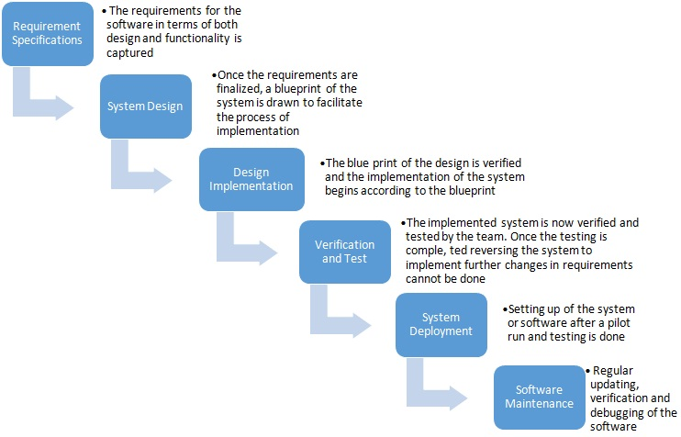
Fig 1: Waterfall Model

I choose this waterfall model due to the following reasons:
- It allows departmentalization and control as we can set schedules with deadlines for each stages of development and product goes through development process model phase one by one.
- It is easy to use as it progresses through easily clear and understandable phases.
- It works well with the smaller project like this one in which requirements are well definite.
- It processes and completes phases one at a time and avoid overlap.

3.2 Design Pattern
I will be using Model View Controller (MVC) design pattern for the development of this project. (Interserver, 2017)
Model: It helps in specification of the logical structure of data in software application and associated high-level classes
View: It is applied for all the UI logic for the system which displays the system’s user interface. It distributes the model into a form convenient for interaction.
Controller: It acts as an interface between Model and View components. It manages the data flow into the model updating when change is seen.
The reason I choose MVC pattern are:
- One programmer could separately work on the view whereas another person could carry on working on the controller for creation of business logic of the web application.
- The application originated using MVC is about three times quicker than application developed using other development patterns.
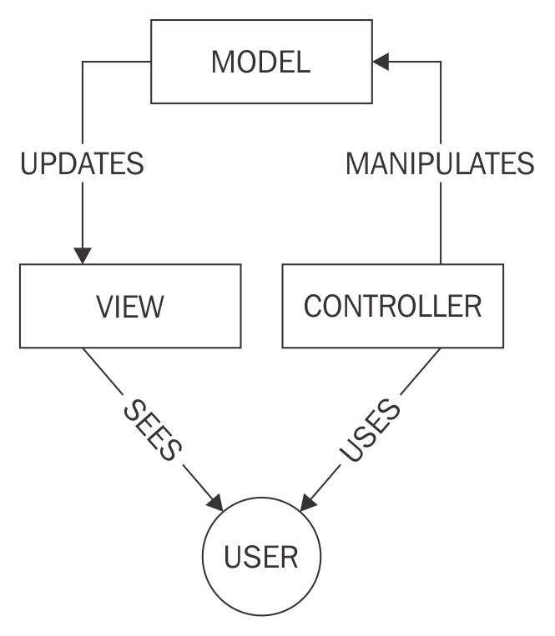
Fig 2: MVC Design Pattern

3.3 Architecture
I think Client-Server Architecture suits best for the development of the project.
Client-Server Architecture:
In the client-server architecture, the developer is required to set the server-side language code in the HTML page which is then transferred to proper interpreter that prepares those instructions and produces the ultimate HTML presented by the browser. It just draws the suitably formats HTML code and shows on your system. (Liewes, 2017)
Advantage:
- Divides application processing with varieties of computers where critical data and functions are processed on the server and other non-important to the client.
- Optimizes client workstation and server.
- Easy to Replace, Repair or Upgrade server without affecting user..
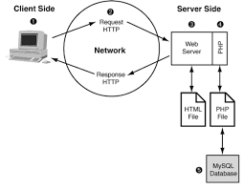
Fig 3: Client-Server Architecture

Chapter 4: Project Planning

4.1 WBS (Work Breakdown Structure)
WBS is a fundamental project management technique or method for undertaking the different parts of the application. It will give the vital structure to the itemized direction for schedule development and control. It will further enable us to manage the project and issue.
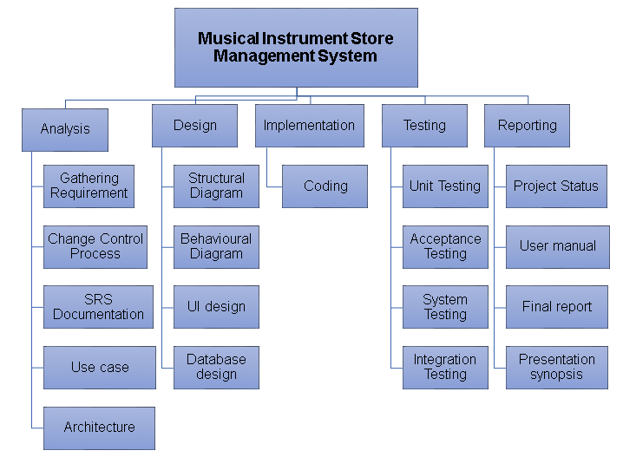
Fig 4: Work Breakdown Structure
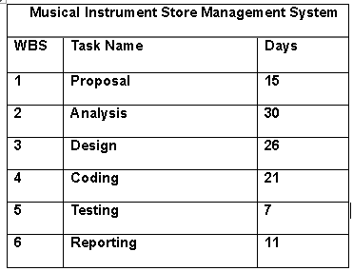
Fig 5: WBS Time Estimation

4.2 Milestone
It is a management tool that helps to symbolize anything that has initialized or ended.It can help exceptionally well with scheduling. It breaks off chunks of a project and make it less disconcerting just like a project break into feasible parts. It is represented by diamonds in Gantt chart feature which are visual representation of schedule (Donnie, 2017).
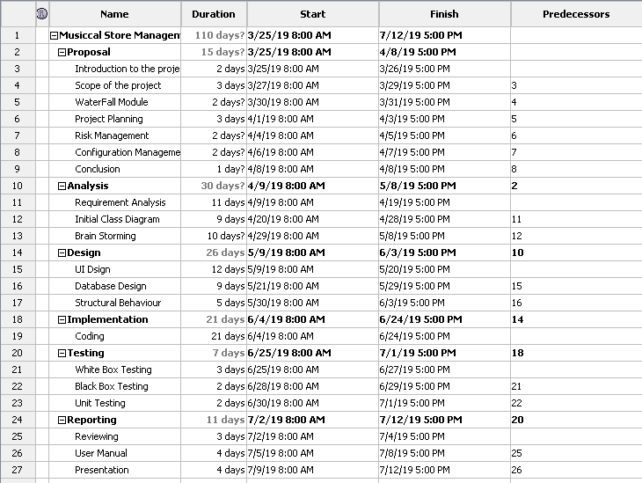
Fig 6: Milestones

4.3 Gantt Chart
Gantt chart is a tool that provides graphical illustration of schedule which assists us to plan, coordinate and track specific jobs in a project. It is constructed with a horizontal axis indicating overall time span, increments (e.g. days, weeks, months) plus vertical axis having tasks that helps in project. It is simple version of graph paper and more complex automated versions created using Project Libre. (Miller, 2018)

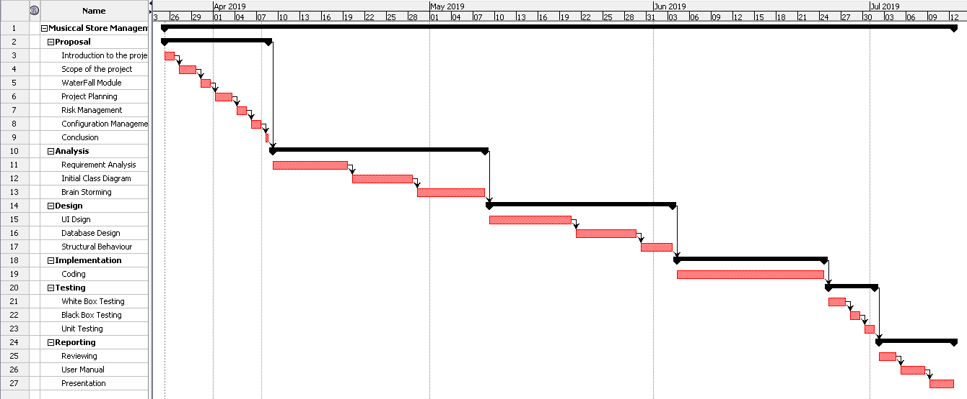
Fig 7: Gantt chart

Chapter 5: Risk Management

Risk management is the process that involves identification, assessing and controlling threats of an organization’s finance and revenue. These threats arises from large variety of sources like financial uncertainty, natural disasters, accidents, strategic errors, security issues. Thus Risk Management strategies are must and have become the top priority for evolving companies.

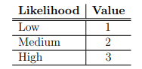
Fig 8: Risk Likelihood

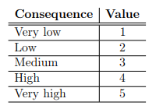
Fig 9: Risk Consequence Values

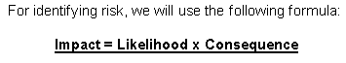

List of Risks

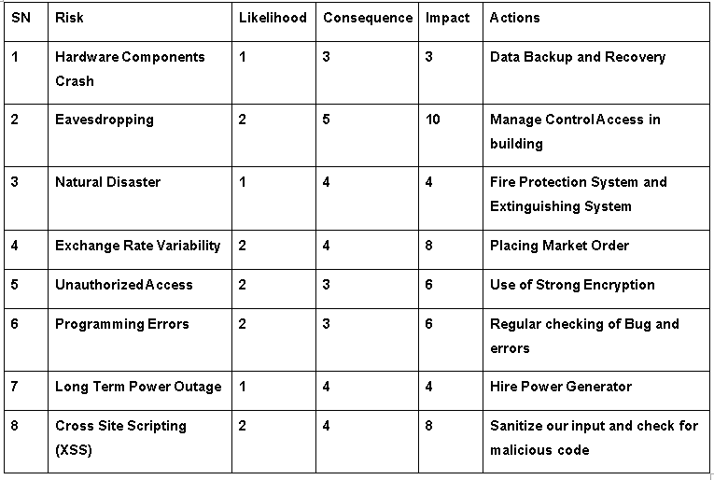
Fig 10: Risks Management Table

Basic steps of risk management lifecycle are clarified below:
- Identification: We should know the risk to tackle with them. So identification of risk is the primary stage for risk management.
- Assessment: After the risk is identified, it should be skimmed in terms of likelihood and impact which helps to prioritize the risk.
- Treatment: Then we should seek for the solution of the risk to remove or minimize it as quickly as possible.
- Monitoring: We should continuously monitor the risk and inform if changes are seen.
- Reporting: After that, a report of each four stages above is described momentarily for effective risk management and kept for future use.

Chapter 6: Configuration Management
Configuration Management is the process which consists of establishment and maintenance of symmetry or consistency of a project’s performance and operational attributes with its data through its life. It assist in managing all the alignments of the scheme in five key steps:
- Planning: It deals with process by which we record, control, track and check the project.
- Identification: It consists of functions, requirements, design obligation and any other specification of the project.
- Controlling: It must be measured, accepted, also fine documented.
- Status accounting: It enables control of the version of the project and find out variations done throughout the project.
- Auditing: It consists of all the tests to prove that the product conforms to the configuration requirements. (Wrike, 2019)
The followings are the folders to manage project:
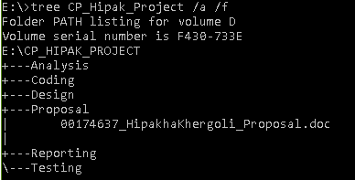
Fig 11: Project Backup in Internal Drive
Due to uncertainty of data loss, hardware failure and other factors external backup is created. 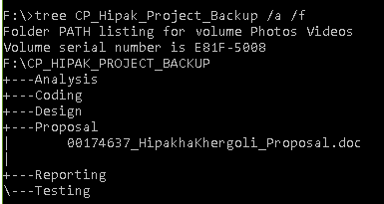
Fig 12: Project Backup in Internal Drive

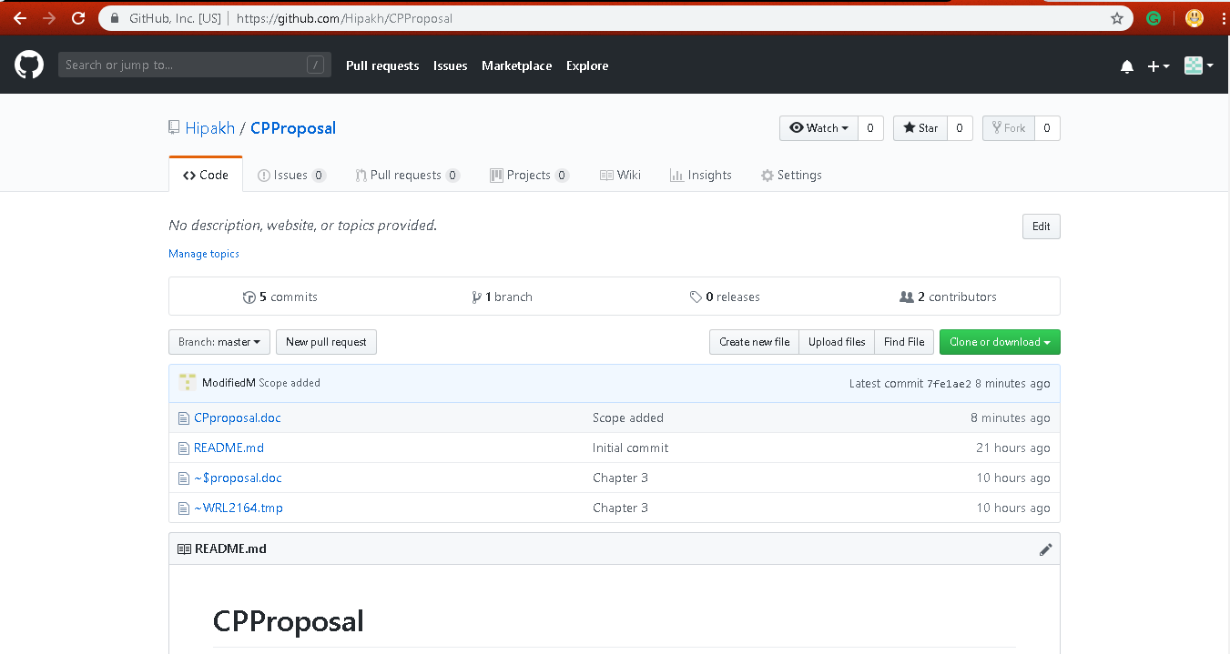
Fig 13: Screenshot of GitHub's Repository
GitHub Profile: https://github.com/Hipakh
GitHub Repository URL: https://github.com/Hipakh/CPProposal

Chapter 7: Conclusion
Hence, Musical Instrument Store Management System will help all the people to access to instruments available and buy through registered account also gain information about the product with varieties of brand, color, size and shapes. Foreigners will also be able to watch local musical instruments and also they can buy it if they want. As this project is going to be web-based, everyone will have access to the web application. Users can create account and view items. This project will allow admin to post and delete an item, update the price to the item. Once the user is logged in, the user can buy the product one at a time. Hope you like my idea regarding musical instruments and let me initialize my project as quickly as possible.

Chapter 8: Reference and Bibliography
Donnie, T. (2017, 9 9). ProjectManager. Retrieved from https://www.projectmanager.com/blog/milestones-project-management
Interserver. (2017, 1 10). Retrieved from Interservernet: https://www.interserver.net/tips/kb/mvc-advantages-disadvantages-mvc/
Liewes, M. (2017, 1 1). Web Developer. Retrieved from Webnotes: https://www.webdevelopersnotes.com/client-server-architecture
Miller, R. (2018, 9 9). Tech Target. Retrieved from 2016: https://searchsoftwarequality.techtarget.com/definition/Gantt-chart
SlideShare. (2018, 8 8). Retrieved from Share: https://www.slideshare.net/starva1/musical-instrumental-management-report
Wrike. (2019). what-is-configuration-management-in-project-management. Retrieved April 07, 2019, from https://www.wrike.com/project-management-guide/faq/what-is-configuration-management-in-project-management/

