CS50W HTML&CSS
HTML: Hypertext Markup Language
Document Object Module (DOM), is a map or more like a software detailed design that is explaining the structure of HTML elements.
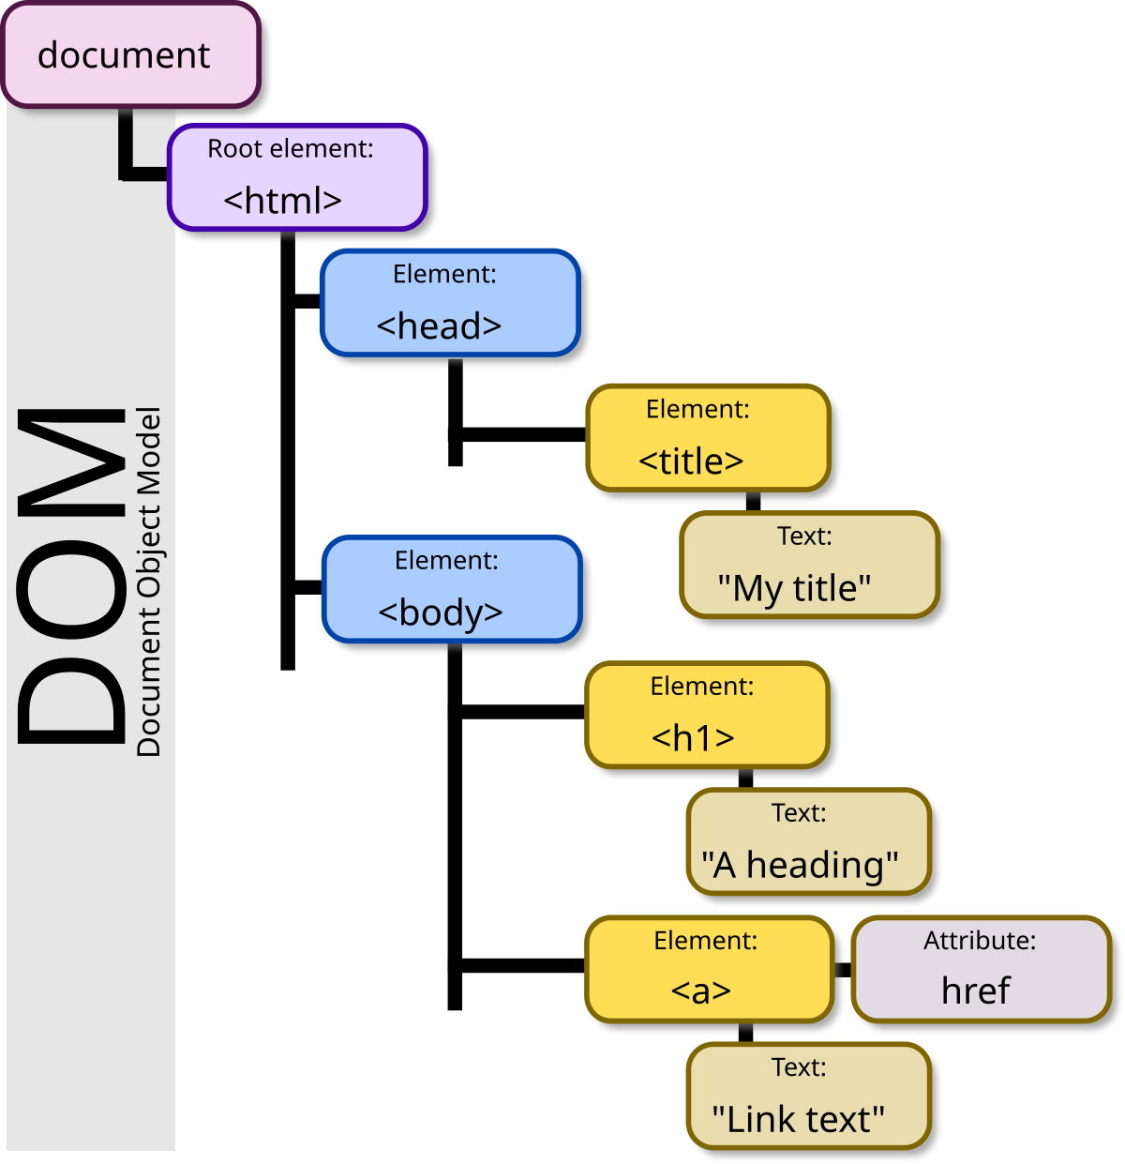
- Headings in HTML:<h1>Heading</h1> to <h6>Heading</h6> from H1 to H6 this are all the headings of HTML the biggest is the first heading h1 to the smallest <h6>

- Lists:
- Order list
<ol>
<li>First item </li>
<li>Second Item </li>
<li>Third Item</li>
</ol>
Ol is the start of the ORDER LIST and LI is the item for the order list base on the order you put them they will display in the way you intended.
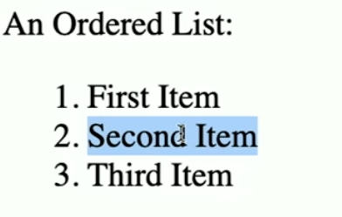
- Unorder list
<ul>
<li>One item</li>
<li>Another item</li>
<li>Yet Another item</li>
</ul>
UL is the start of the UNORDER LIST and as in order list LI is the item for each element. The main difference is that a unorder list has bullet points and order one has numbers base on the order of it.

- Image
<img src=”cat.jpg” alt=”Text description, is a cat”>
For image you will not have a closing tab and you will have to use it like this <img, after that the src or source of the image path and also for other scopes we would want to have alt, alternative a description of the image.
<img src=”cat.jpg” alt=”Text description, is a cat” width=”300” >
As you may see we added width this will help us with the size of the image the value is in pixels.
- Link
<a href=https://google.com>Click Here</a>
We can also link to our pages for example <a href=”image.html”>Click Here</a>

- Tables
<table>
<thead>
<tr>
<th>Ocean</th>
<th>Average Depth</th>
<th>Maximum Depth</th>
</tr>
</thead>
<tbody>
<tr>
<td>Pacific Ocean</td>
<td>4,280 m</td>
<td>10,911 m</td>
</tr>
<tr>
<td>Atalntic Ocean</td>
<td>3,646 m</td>
<td>8,466 m</td>
</tr>

</tbody>
</table>
<table></table> table start and stop
<thead></thead> table header
<tbody></tbody> table body
<tr></tr> table row
<th><th> table header
<td></td> table data

- Form 29:30

