Adidas Sales Performance Analysis Using Power BI

Prepared by : ILAYA BARATHI M  
Tool Used: Microsoft Power BI  
Domain: Sales Analytics / Business Intelligence  
Timeline Analyzed: Jan 2020 – Dec 2021



# 1. Introduction

In today’s data-driven retail environment, companies like Adidas require powerful insights into their sales performance to drive decisions around inventory, marketing, and distribution. This project utilizes Microsoft Power BI to analyze Adidas’s U.S. sales data, transforming raw figures into actionable insights.

The analysis covers multiple dimensions, including time, geography, product category, and retail channels. It identifies performance trends and revenue drivers through advanced visuals and KPIs.

# 2. Methodology

Data Cleaning (Power Query):  
- Removed null and duplicate entries  
- Standardized data formats (e.g., date, currency)  
- Created calculated columns (e.g., profit %, price per unit)

Data Modeling:  
- Relationships established between fact (sales) and dimension tables (product, region, retailer)  
- DAX used for measures: Total Sales, Operating Profit, Units Sold, Operating Margin

Dashboard Design:  
- Interactive KPIs and slicers  
- Visuals for time-series trends, geographic heat maps, category breakdowns

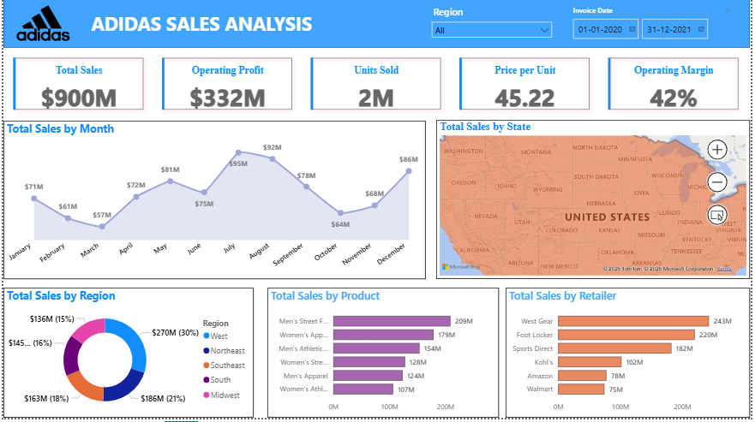

# 3. Key Metrics (KPIs)

Total Sales: $900 Million  
Operating Profit: $332 Million  
Units Sold: 2 Million  
Price per Unit (avg.): $45.22  
Operating Margin: 42%

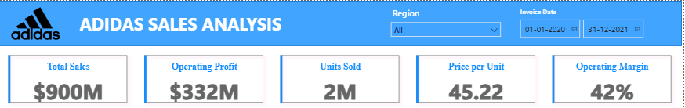

# 4. Visualizations and Insights

**4.1 Total Sales by Month (Line Chart)**Insight: Sales peaked in July ($86M) and August ($85M), while October saw the lowest sales ($64M).

**4.2 Total Sales by State (Filled Map)**  
Insight: Coastal and urban states like California, Texas, and New York dominate revenue.

**4.3 Total Sales by Region (Donut Chart)**Insight: West Region led with $270M (30%) in sales, followed by South and Northeast.

**4.4 Total Sales by Product (Bar Chart)**  
Insight: Men’s Street Footwear was top-selling at $209M, indicating strong brand demand.

**4.5 Total Sales by Retailer (Bar Chart)**Insight: West Gear and Foot Locker were the highest revenue contributors, followed by Sports Direct and Kohl’s.

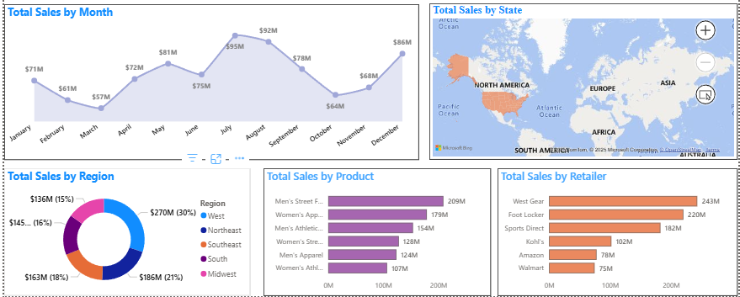

# 5. Strategic Recommendations

- Focus on high-revenue regions like the West and South  
- Optimize inventory for high-demand products such as Men’s Street Footwear  
- Strengthen relationships with key retailers like West Gear and Foot Locker  
- Launch promotional campaigns in low-sales months (e.g., October)

# 6. Limitations and Future Scope

- No demographic, channel-level, or marketing cost data included  
- Future work: add forecasting models, demographic filters, and real-time dashboards

# 7. Conclusion

This Power BI-based sales dashboard delivers clear visibility into Adidas’s sales performance across time, geography, and retail structure. It serves as a foundational business intelligence tool to optimize strategy and operational decisions, reinforcing Power BI’s value in data analytics.