**Lab 10 Zein Zebib**

**Github Repo**: <https://github.com/Hippity/lab10_zein_zebib>

**Jenkins File Changes**

* *python -m venv venv* to *python3 -m venv venv*

I did this change because I have a MAC

* Pytest and Coverage needed to be added to the requirements.txt file

I installed both libraries on my virtual environment then ran then did *pip freeze > requirements.txt*

* For the Security Scan phase, I needed to exclude the virtual environment folder from the scan

*bandit -r . -x ./${VIRTUAL_ENV}*

* For the Deploy phase, I chose to run a deploy.sh with a deployment shceme inside of it.

To allow this to happen I added in the setup *sh 'chmod +x deploy.sh'*

If I did not add this script, I would get permission denied.

**Deploy.sh File**

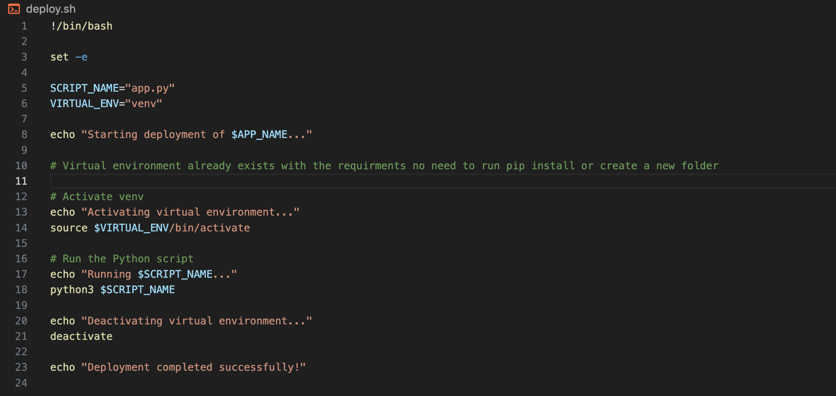

The deploy.sh file will activate the virtual environment that was already created in the set up (it was the required libraries) then it will run the python app.

**Setup Output**

The Setup phase will create the virtual environment and run the required libraries from the requirements.txt. I also added the line to give permission to run deploy.sh.

**Lint Output**

This section will check if my app.py file is structures in the correct format. It will execute 0 when successful else it will let me know what changes I need to make.

**Test Output**

This section will run the pytest library and check if all written unit tests were satisfied.

**Coverage Output**

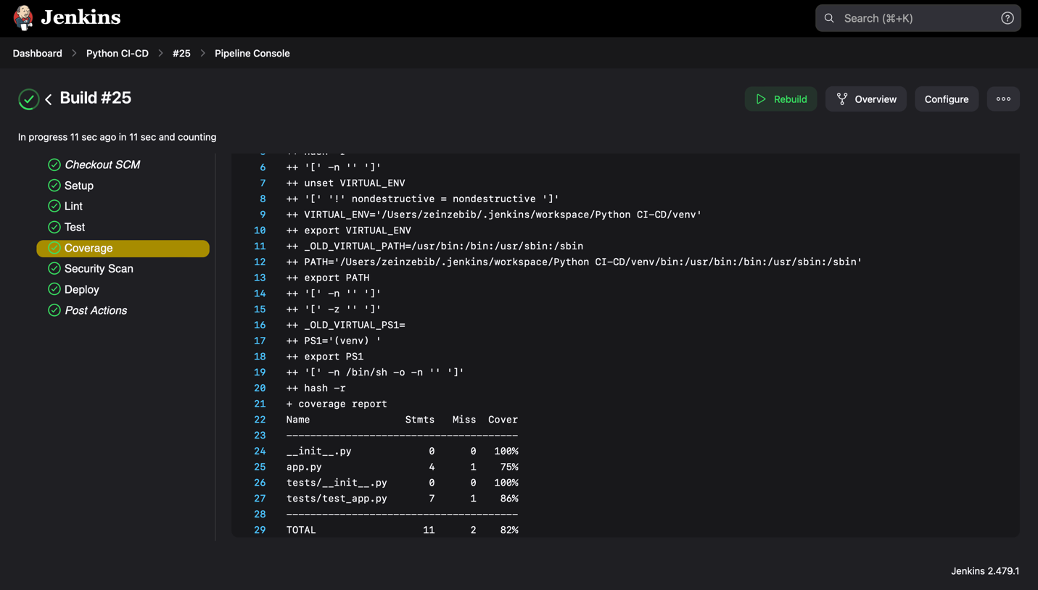

This section will run the coverage library and generate a coverage report. It will show the number of lines covered, helps identify if there are any untested code paths, and ensure that test cases cover the codebase. In my case everything was good.

**Security Scan**

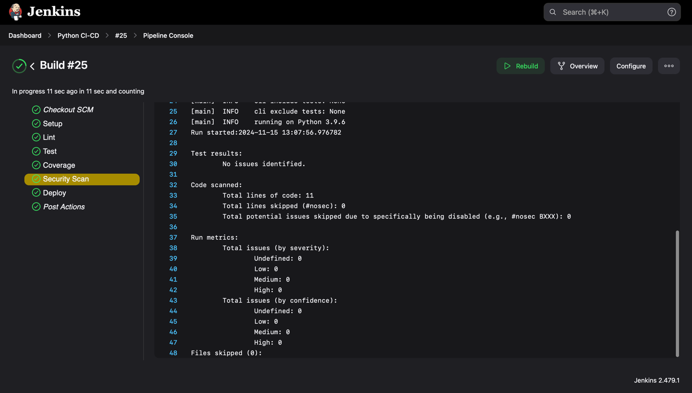

This section detects potential vulnerabilities in code, in my case there were none. Previously this was failing for me because it was running a scan on the virtual environment.

**Deploy Output**

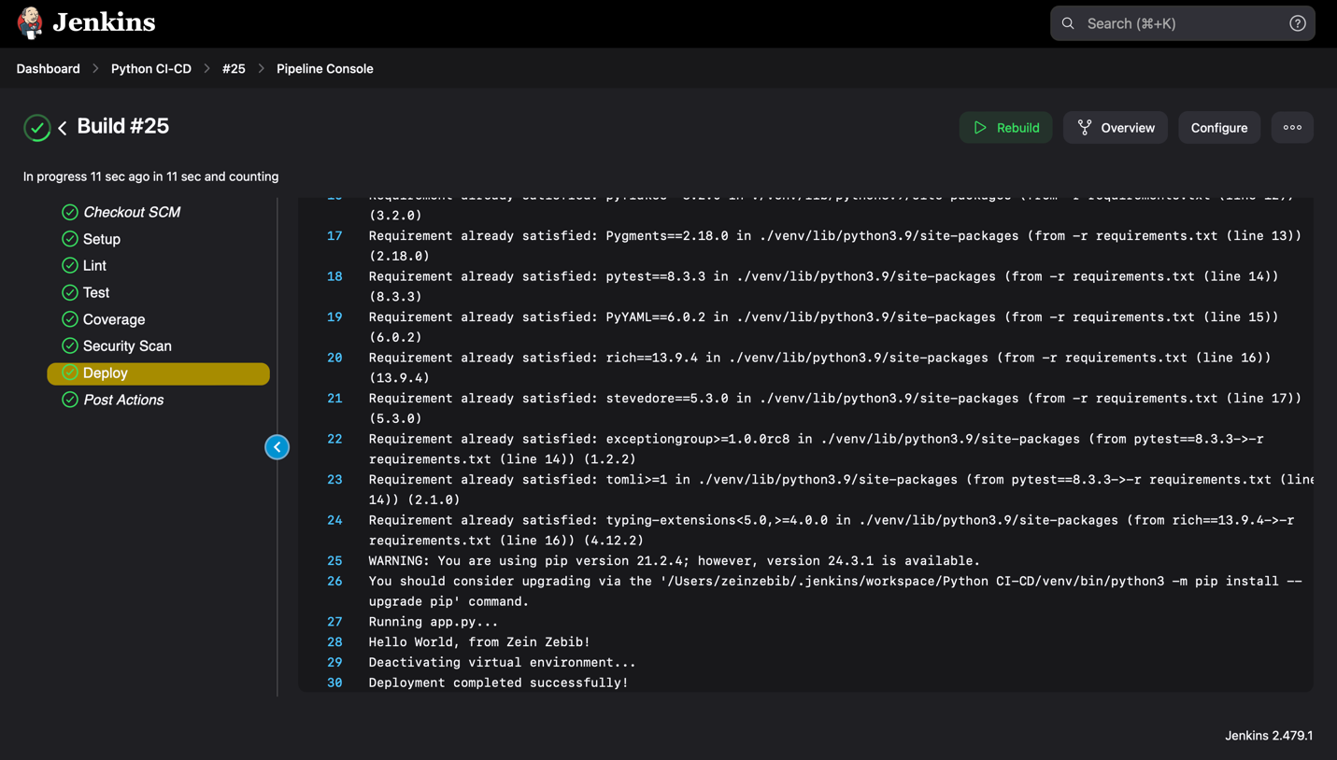

This section will run the deploy.sh file, here we can see it was successfully deployed from the Hello World, from Zein Zebib output on the console.