

**USER’S**

**MANUAL**

*Course Go Database Suite*

May 2017

**USER'S MANUAL**

Table of Contents

1.0 GENERAL INFORMATION 1-1

1.1 System Overview 1-1

1.2 Acronyms and Abbreviations 1-1

2.0 SYSTEM SUMMARY 2-1

2.1 User Access Levels 2-1

3.0 GETTING STARTED 3-1

3.1 Setting up Database 3-1

4.0 Course GO 4-2

5.0 USING the CLIENT APPLICATION 5-7

5.1 Connection 5-7

5.2 Username 5-7

5.3 Password 5-7

5.4 Database Name 5-7

5.5 Student Database Table 5-7

5.6 Student Information 5-7

# GENERAL INFORMATION

## 1.1 System Overview

The Course Go Database Suite is an application that utilizes a Graphical user interface that makes imputing and editing records fast and efficient. This program provides multiple different screens that allows a user to input all information and store it electronically to exterminate the need for paper records.

This program uses a client/server based model. The client is what the user uses to add student’s records as well as edit them. The client program will communicate with a MySQL database that saves all the information for each student. The information saved in the database includes some of the student’s personal information (i.e. name, class and ID number, etc.) and their grades. The services from Course GO allows parents to view their child’s grades.

## 1.2 Acronyms and Abbreviations

MySQL - This is a free SQL database used to store all information for each student.

SubjectE - Subject Exam marks.

SubjectT -Subject Term marks.

# SYSTEM SUMMARY

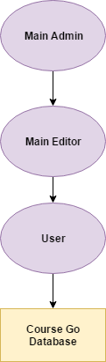

## 2.1 User Access Levels

There are three different types of users as depicted in the image above. Main Admin is the Database manager for the Reynold Weekes Primary School, which has the authority to view, add, delete and edit student’s information within the database and add editors. Main Editor refers to teachers who have permission to read student’s records, add new students, add and edit a student grades and information but do not have the required privileges to delete. The Users are parents who wish to view their child’s grades, thus they are only allowed to view information for their child who is linked to their account.

# GETTING STARTED

Load Files from CD.

## 3.1 Setting up Database

We first start by running xampp and starting the Mysql Service. This will begin the connection to the MyPHPAdmin Database service.

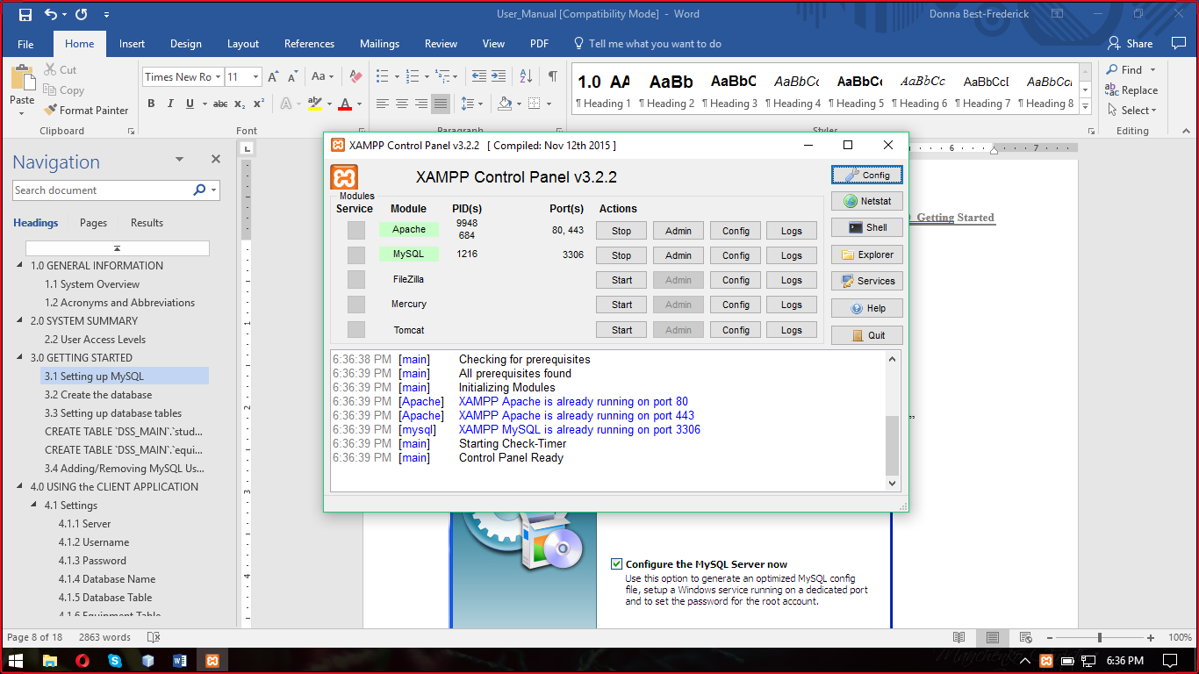

Next your must import the Database.

-Open your Browser and type <http://localhost/phpmyadmin> in the search bar

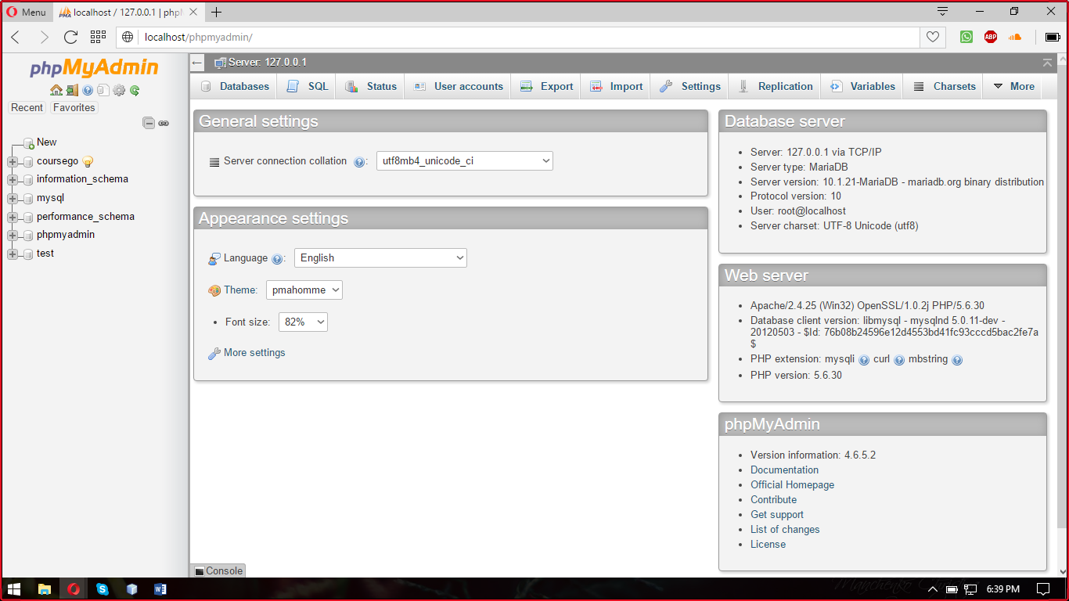

-click new and create a database called “coursego” then click the import tab.

-Import the “coursego.sql” file found on the cd.

# Course GO

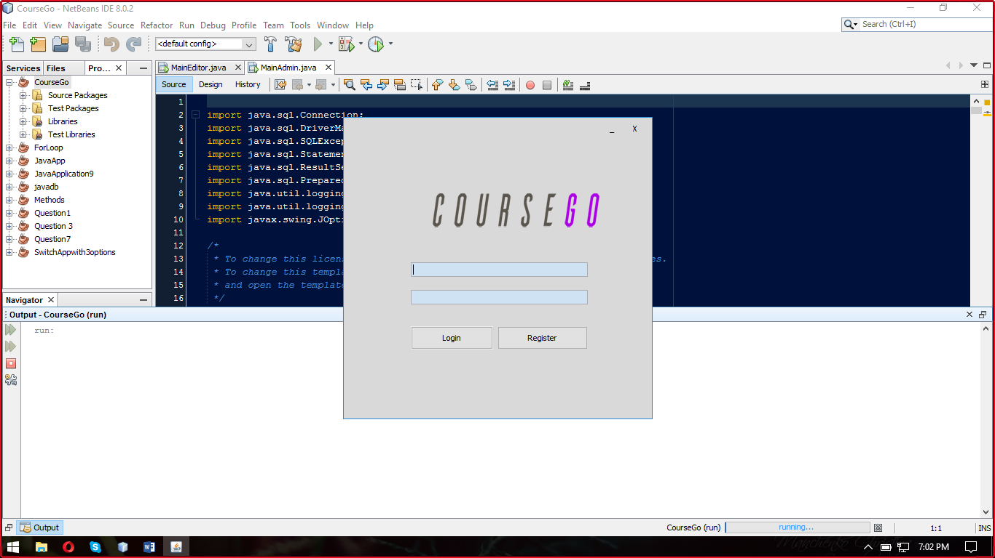

Login Screen

To login enter the correct Username and Password and click the login button.

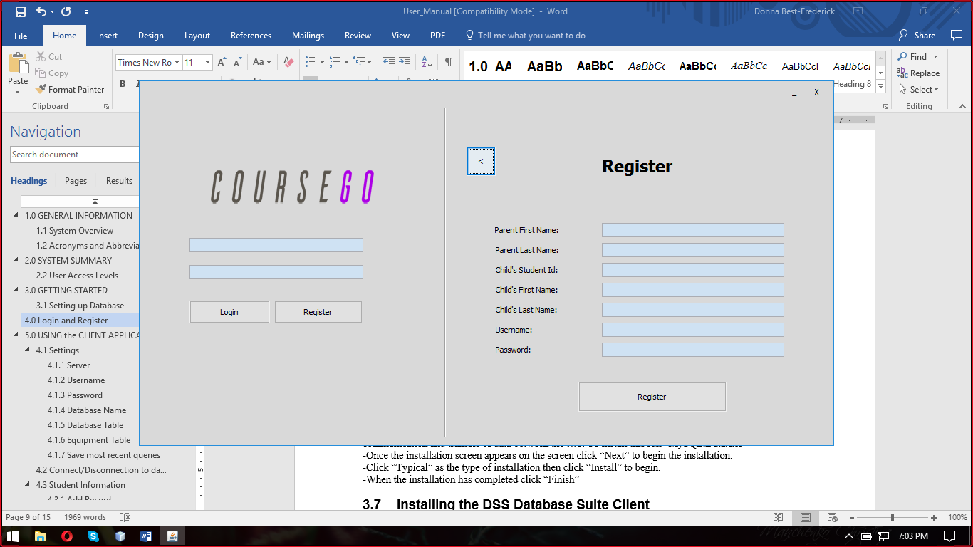

Register Screen

To register a new User click on Register and Enter the information into the text fields.

The User is required to enter a valid Student’s ID for their account to be link to their child or they would not be able to register.

To View Student click on the view Student tab. 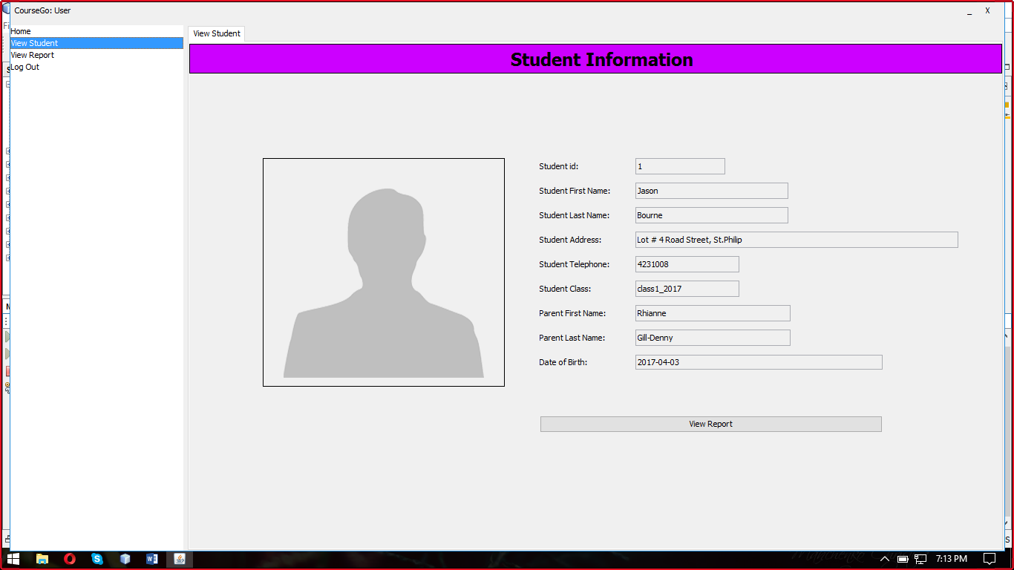

View Student for User Account.

To View Report click on the view Report tab

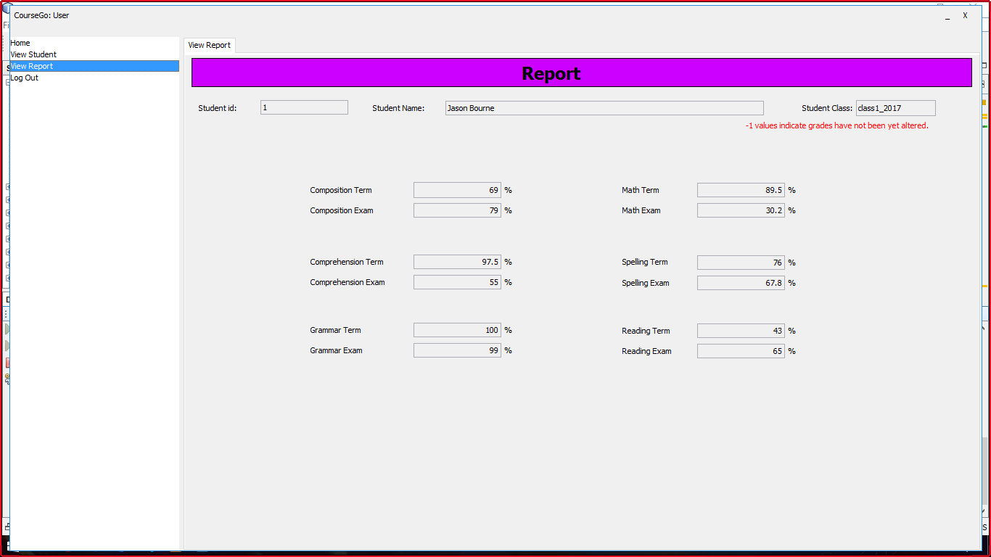

View Report for User Account

Main Admin

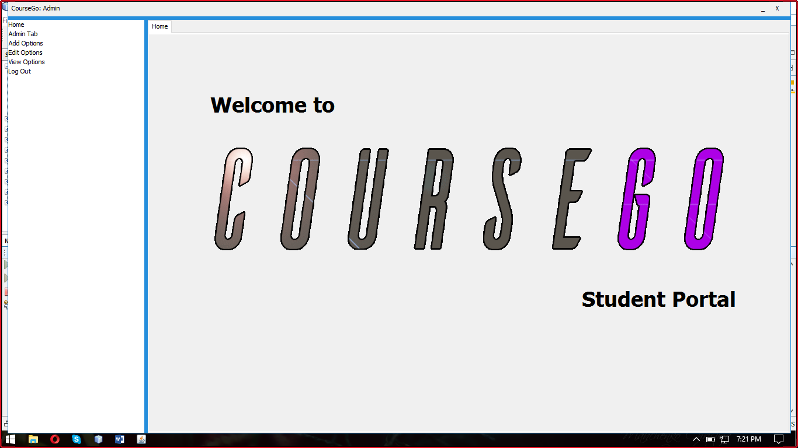

Main Admin Home Screen

Admin Tab-Delete Editor

To delete an editor first search for the Editor’s First name and click the delete editor button. You can scroll the fields to find the required editor if there are many editors with the same first name. 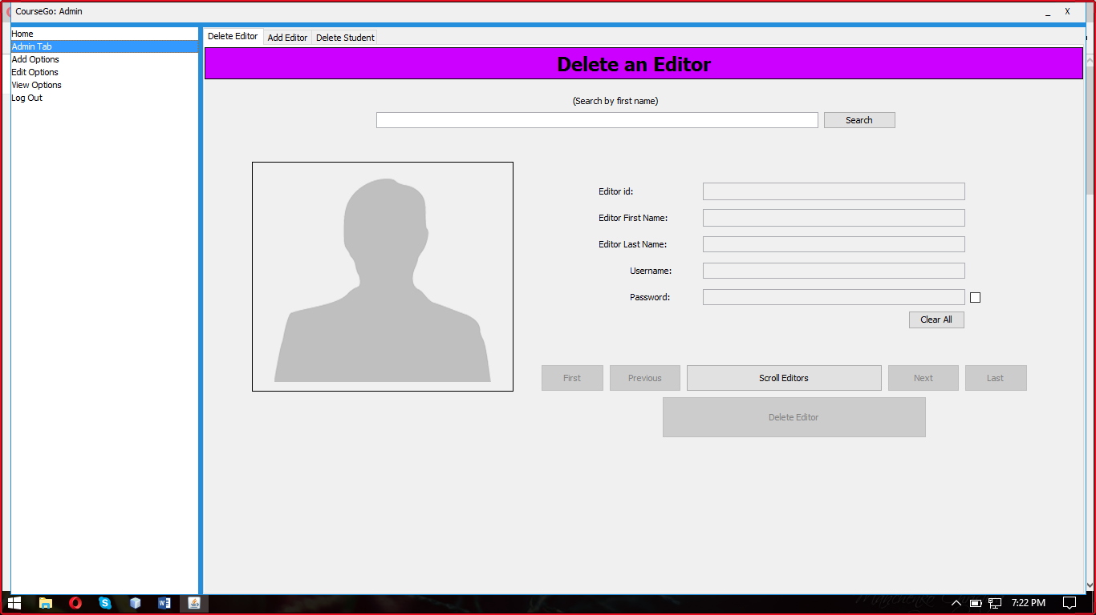

Admin tab-Add Editor

To Add an Editor an auto-generated ID must first be loaded using the load button, then the Admin can enter the information in the text fields and click the register button.

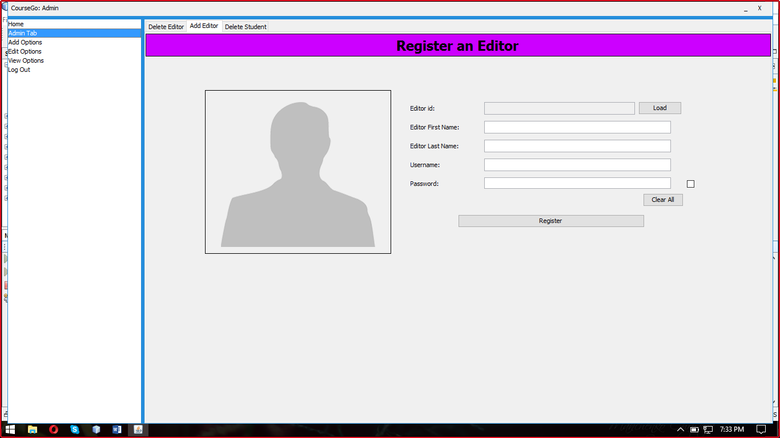

Admin tab -Delete Student

To Delete a student, search for a student by their first name and click the delete button. You can scroll the fields to find the required student if there are many students with the same first name.

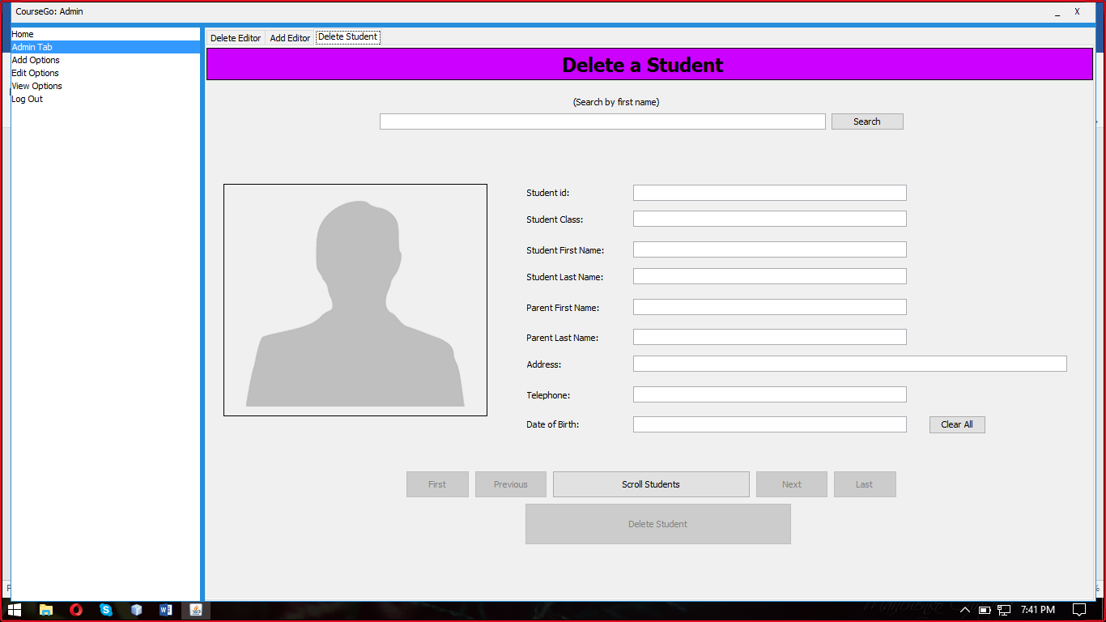

Main Editor- Add Student

To Add a new Student, Enter the information into the text fields and click the add button.

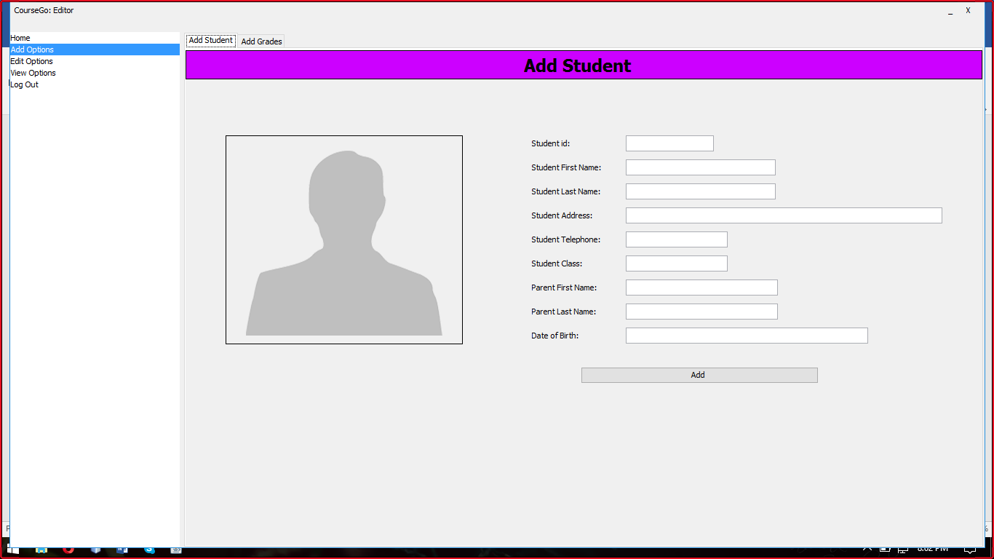

Main Editor-Edit Student

To Edit a student, click the edit options tab then enter the student’s first name into the search bar and click search. The user can use the scroll options until required student is found. Edit the information you desire and click edit.

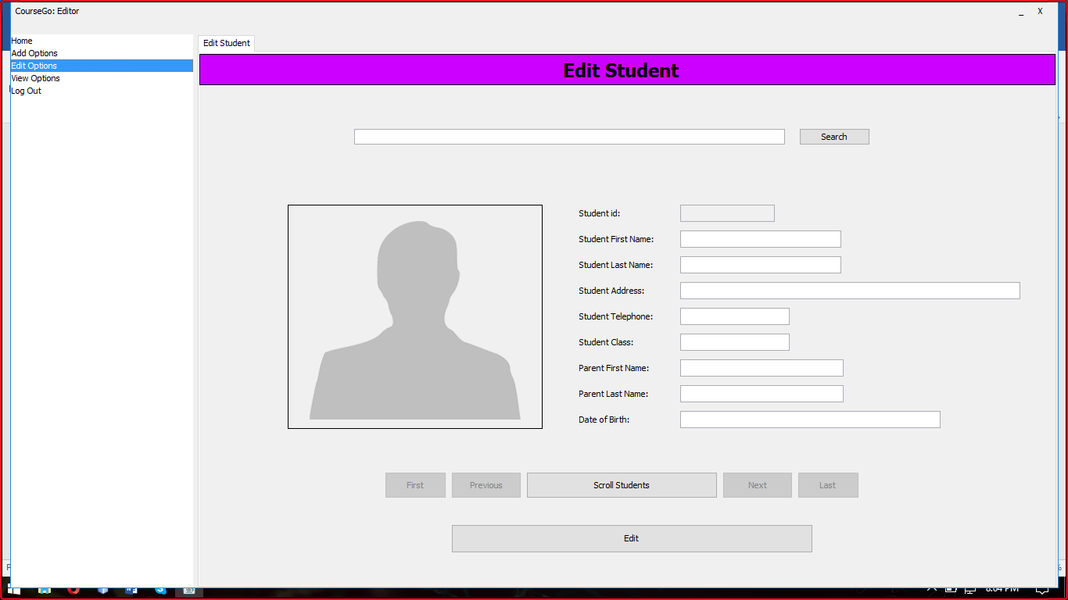

# USING the CLIENT APPLICATION

### 5.1 Connection

The connection that the program uses is "jdbc:mysql://localhost:3306/CourseGo"

### 5.2 Username

The name of the current user that was set up in the MySQL database by the Administrator specifically for the current user is tutor

### 5.3 Password

The password that corresponds to the current user that was set up in the MySQL database by the Administrator specifically for the current user is tutor

### 5.4 Database Name

The name of the MySQL database is coursego.

### 5.5 Student Database Table

The name of the student information table studeninfo.

### 5.6 Database Information

Student information is stored in two (2) parts. The first is the basic personal information, contact information which is stored in a table called studentinfo. The second is grades, this table called grades stores student grade information. Once the appropriate information has been filled out the student records can be manipulated to the database via the program.