Atividade AC2

Nome: Henrique Yshimaru Mashiba
RA: 249084
http://localhost:3000/professores
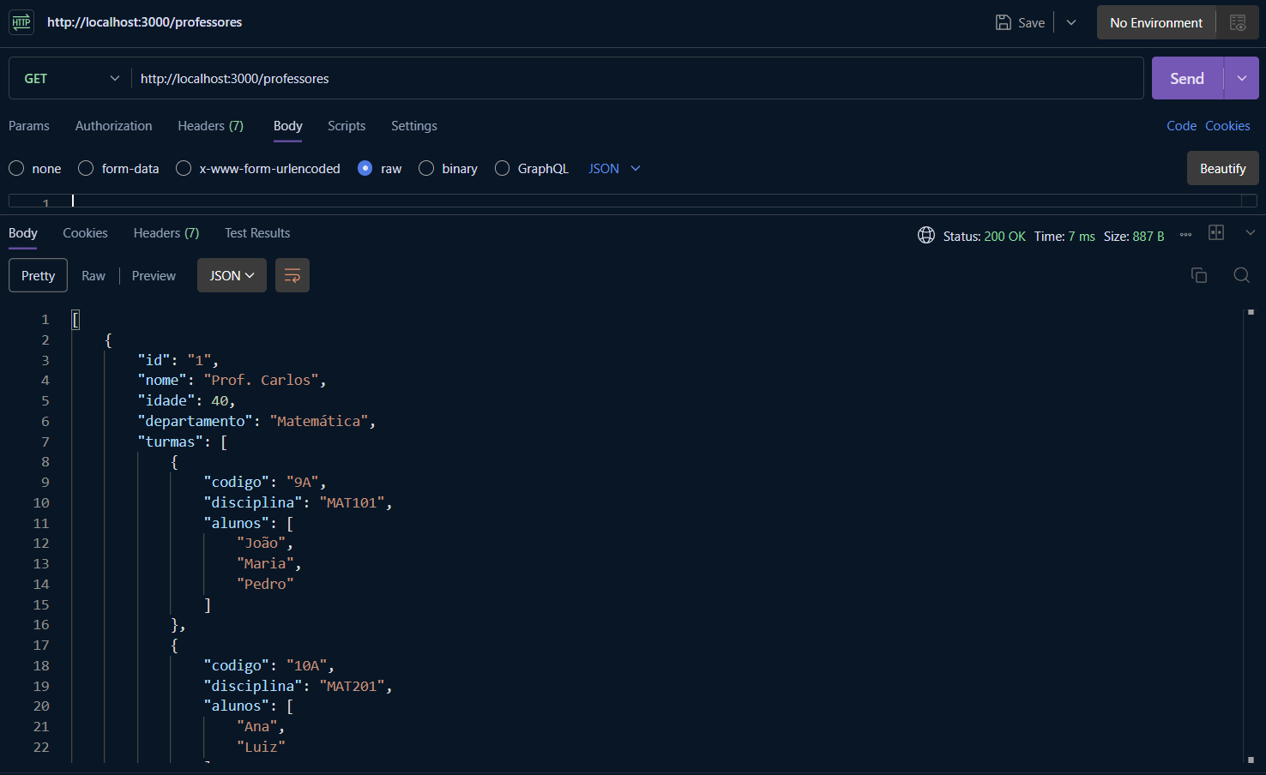
http://localhost:3000/professores/1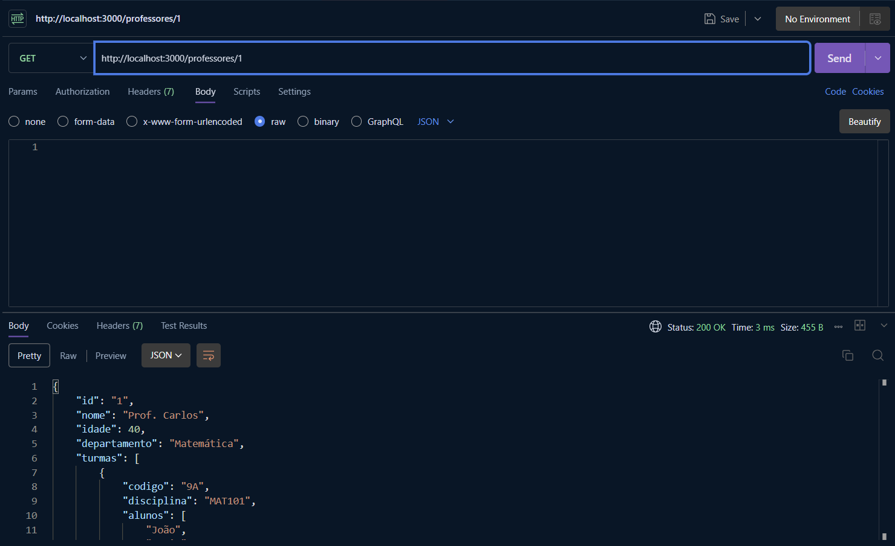
http://localhost:3000/professores/999
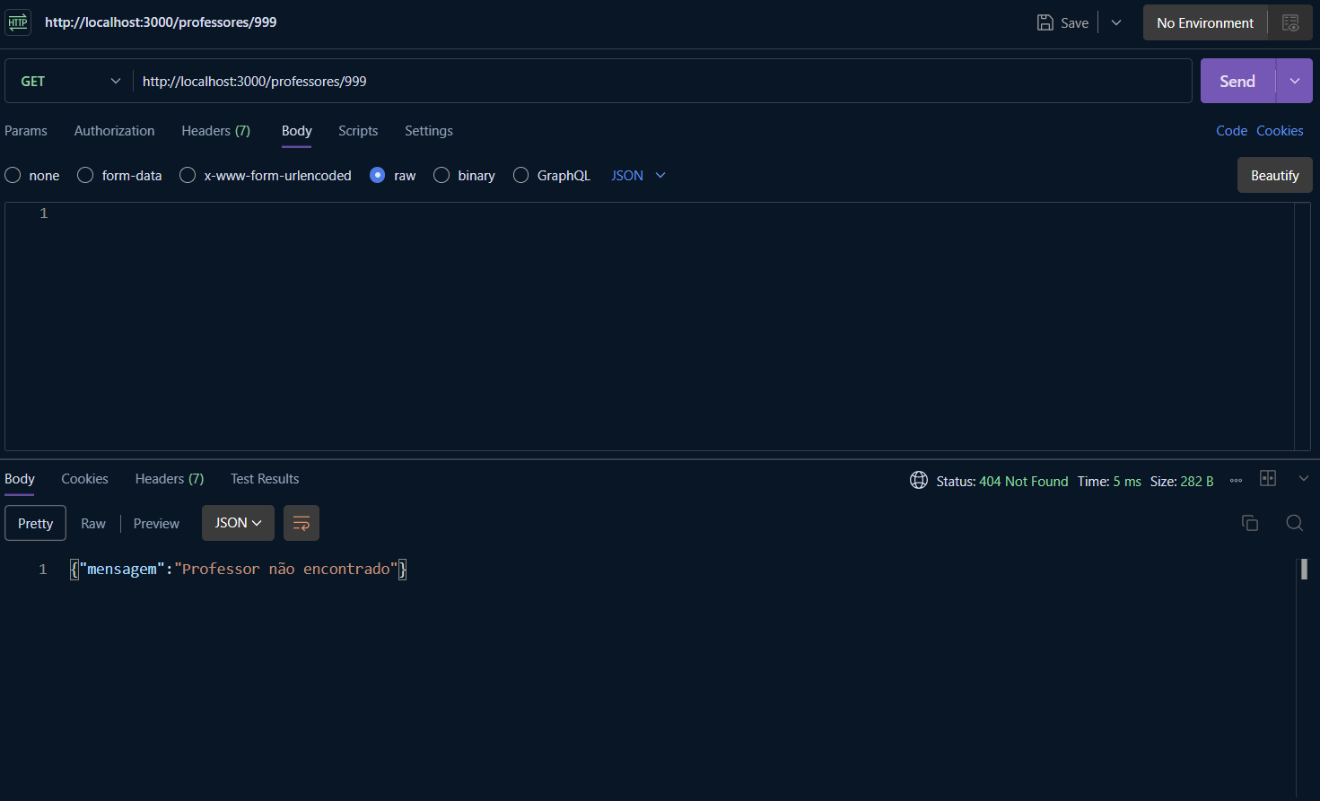
http://localhost:3000/professores/1/turmas
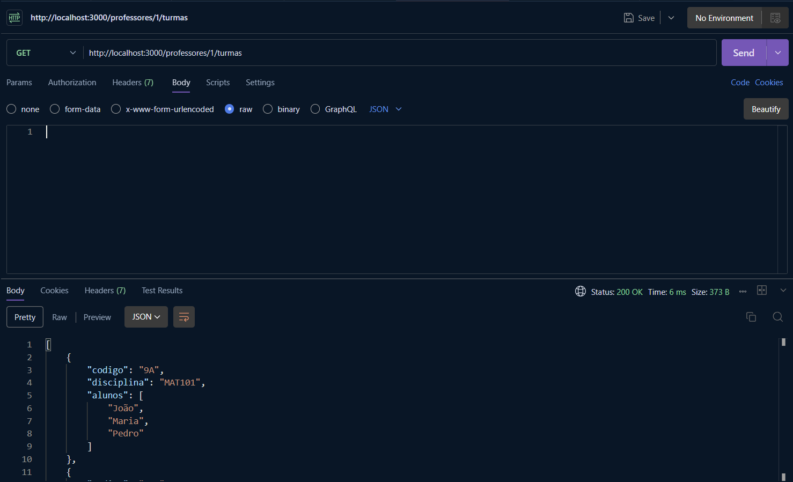

http://localhost:3000/professores/1
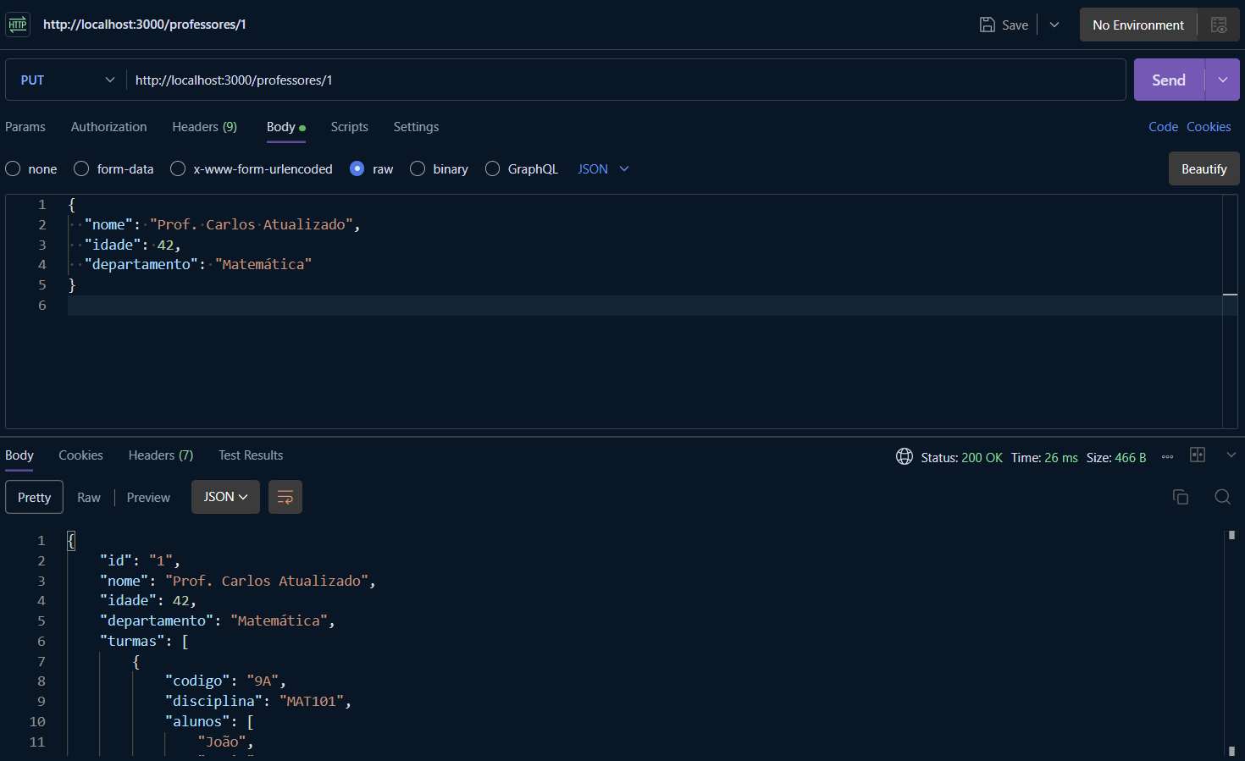
http://localhost:3000/professores/999
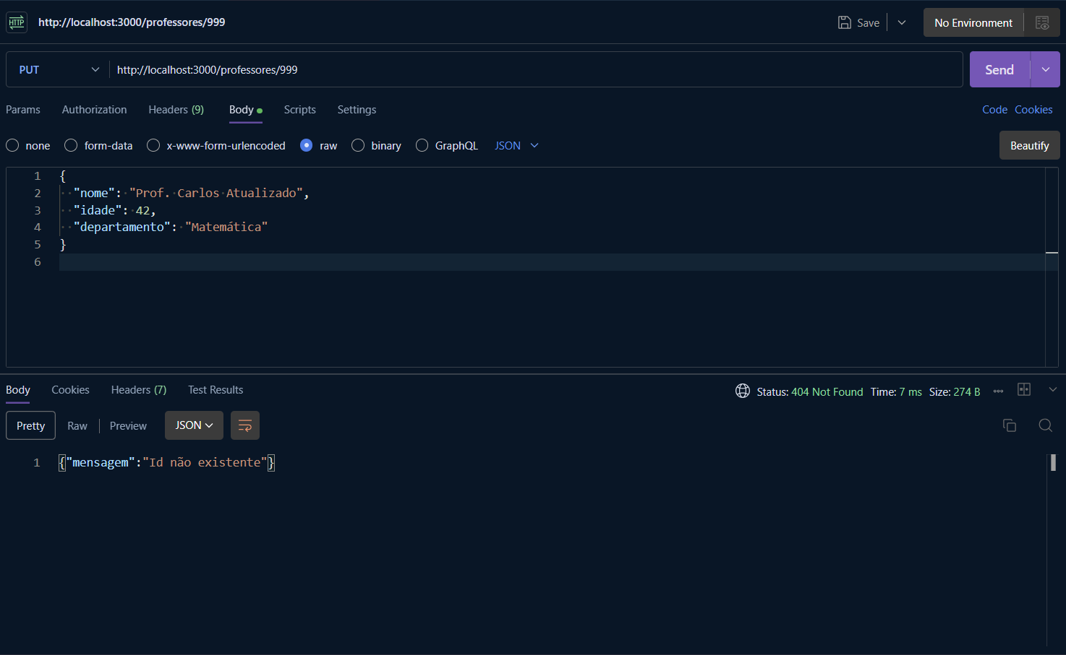

http://localhost:3000/professores/1/turmas
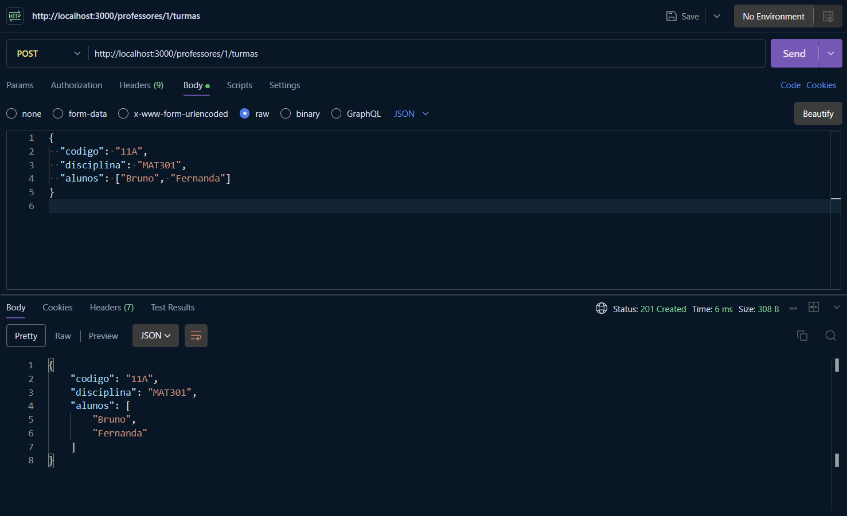
http://localhost:3000/professores/departamento/História
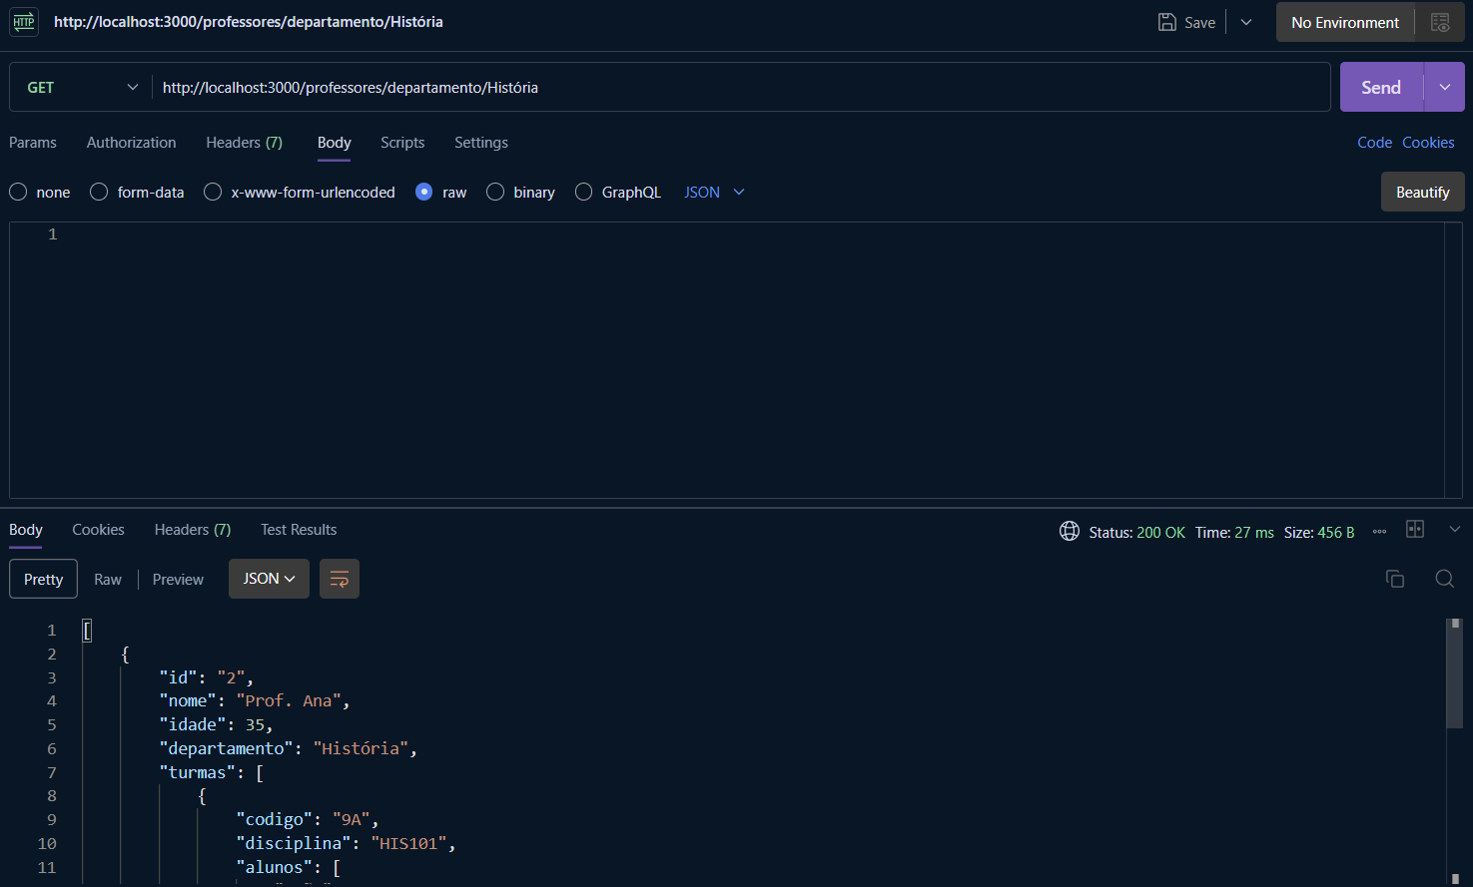

http://localhost:3000/professores/3
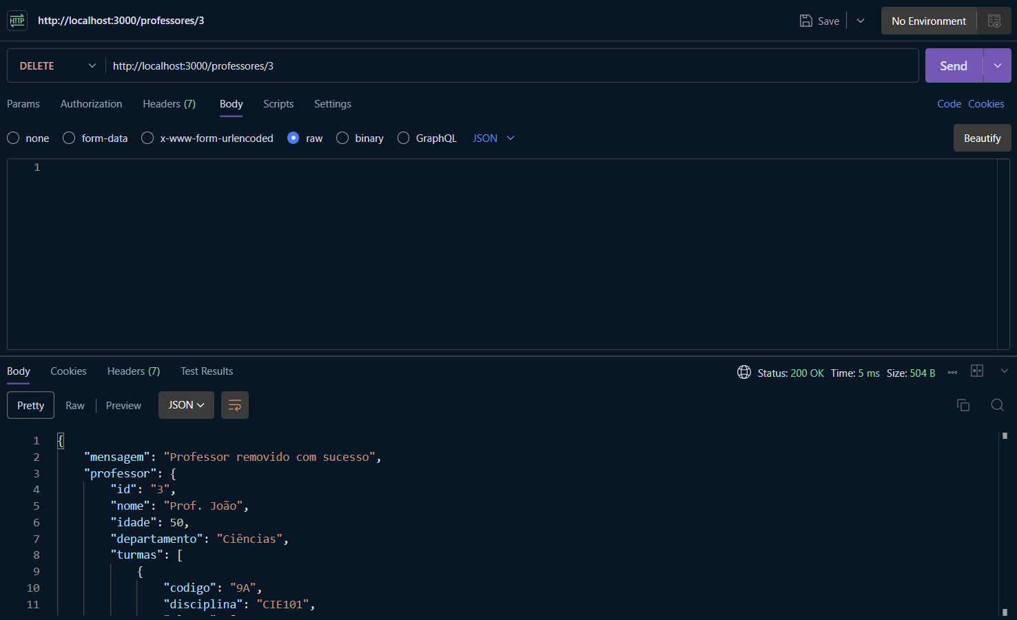
http://localhost:3000/professores
