* Our project is all about a customized complaint system.
* We will be developing apps for companies according to their requirements and needs depending on what they actually want.
* We can provide different models:

complaints Resolved(notifying the receiver)

**MODEL NO. 1:**

Resolver(can be many):

* mob app
* Desktop app

Receiver:

* Mob app
* Desktop app

Client making a complaint:

* mobile app
* desktop app

MCLCLDMDL

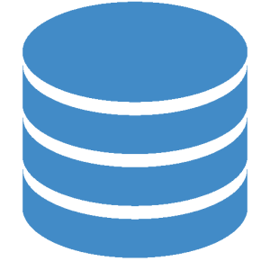

* Receiver will forward the complaint to the respective department that he finds relevant.
* A log will be creating that who is responsible for which complaint and is complaint resolved or not.

Receiver as well as resolver:

* Mob app
* Desktop app

Client making a complaint:

* mobile app
* desktop app

**MODEL NO. 2:**