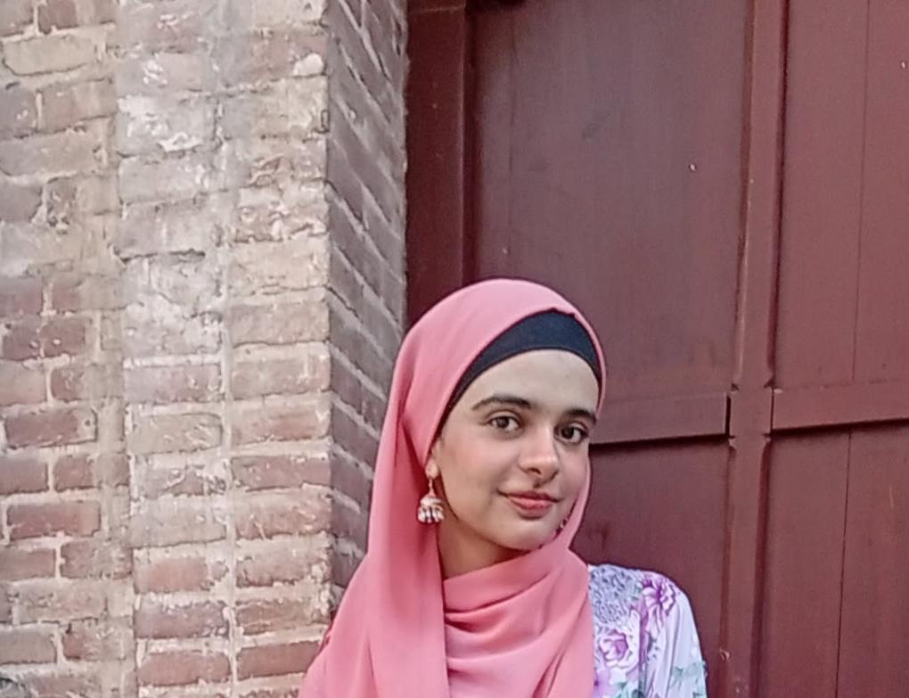  19 years old | Hira fatima  Address: 469 b block gulshan e ravi Lahore.  Cell: 03071276270  Email: fatimahanwar765@gmail.com
Education and Qualification | University of Home Economics –BSCS– 2024-Continue  LCWU –ICS– 2022-2024  Catherdral high School – Matric – 2020-2022
Projects | Project Title  •Bank Magnament system
Computer Skills | • MS Office  • Email
Achievements | •mobile development
Interests | - Reading  - Watching series

