Final Project – Psy101
Israt Jahan Hira
ID: 24241155
Section: 2

Title: The Psychological impact of Korean Entertainment: Emotional and Behavioral Influences across Cultures

Introduction
Korean entertainment is well known all over the world. From the late 1990s Korean entertainment started to gain popularity around the world. But from the 2010 Korean entertainment spread rapidly through the internet. Now-a-days Korean entertainment has captivated the highest audience worldwide comparing the past years. Korean entertainment consists of music, drama, films, webtoon, different kinds of shows, etc. Without any doubt Korea has its own culture. But while the outer world is coming across content related to Korean-entertainment gradually they have started to combine their own culture with Korean culture. It has also great impact on individual’s psychology and behavior. So to understand the real scenario of the Korean entertainment influence all over the worlds’ culture, the changes of the audience preferences, engagement levels, perceptions of Korean entertainment, psychology and behavior this research plays a significant role. This study explores its influence on individuals while focusing on its cultural, social impacts.

Literature Review
There are many studies about the impact of Korean entertainment on different topics. Researchers have noted that social media is playing a key role to connect individuals with the Korean entertainment promoting cultural exchange which leads to individuals changes in thinking ways as different cultures shape individuals thinking according to that culture. This also cause changes in behaviors and phycology. One of the article stated that the popularity of the Korean drama has more impact on Indonesian female viewers’ that leads to consumption of Korean beauty s standard and their products. The structural equation modeling results revealed that emotional connection, referential reflection, and entertainment-driven celebrity worshipping inclinations are major predictors of Korean beauty product purchase and Korea visit intentions. Another research analyzed the Hallyu's effect on Korean food consumption: the significance of imitation patterns and connections.

Research Question:
How does Korean-Entertainment influence global audiences' cultural perceptions, lifestyle choices, emotional and social behaviors?

Objectives
1. To explore the global spread and popularity of K-Entertainment.
2. To study the influence on audience behavior and cultural views.
3. To analyze the emotional changes of the audience.
4. To identify the expectations vs. reality among Korean entertainment viewers.
5. To identify cultural adaptions influenced by Korean entertainment.

Hypothesis
Exposure to Korean entertainment significantly influences emotional responses and sets unrealistic lifestyle expectations among global audiences.

Methodology
The study is based on a survey data collected from a group of individuals of the same age. The survey asks about demographics, impressions of Korean culture, frequency of consumption, and preferences for K-Entertainment genres (such as music, drama, and movies). An online survey was used to gather the data, which was then examined for patterns and connections.

Results
The majority of the audience falls within the 18-30 age group, with a nearly equal gender distribution. Over 70% discovered K-Entertainment through social media platforms .The findings from the survey data indicates that 78 % participants more or less come across content related to Korean entertainments (K-pop, K-dramas, Webtoons) on social media. Then 74% participants consume Korean entertainment. But 56% feel indifferent towards the contents and it doesn’t affect them emotionally.
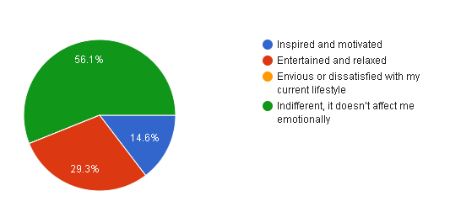
Then again around 74% people after consuming the Korean entertainment experienced different kinds of emotional changes such as increased happiness or excitement, stress, connected with global culture. 63.4% did not actually adopted any Korean cultural elements but 36.6% adopted that culture.
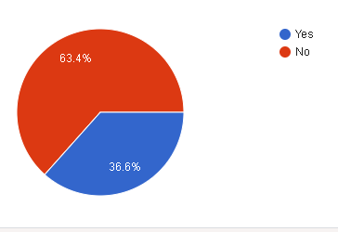
82.9% participants did not find themselves comparing their local culture with the Korean culture.
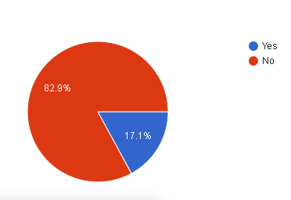
64% participants suggested that Korean entertainment sets unrealistic expectations for daily life and 74% faced situations where the reality of Korean culture differed from what was portrayed in Korean-entertainment content. But again 56% participants suggested that their expectations are based on their real life experiences.
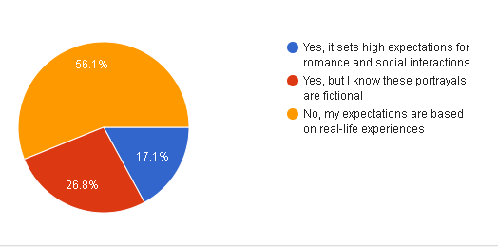

Discussion with Reflection
The results show how K-Entertainment's captivating content and skillful use of social media contribute to its enormous appeal on a worldwide scale. According to the respondents, K-Entertainment encourages cultural curiosity and a sense of community. The absence of elder demographic representation and possible biases in self-reported data are drawbacks, though. Future studies might examine long-term effects and incorporate larger demographic groupings.
The project offered insightful information about how K-Entertainment affects audiences around the world. It emphasized how crucial cultural interaction is to promoting respect and understanding between people. I gained a deeper understanding of research methodology and the dynamics of worldwide entertainment by conducting the survey and analyzing the data. But this survey was limited between a single age group and wasn’t able to explore vastly so this survey lacks deeper understanding of the whole Korean viewers psychology and behavior changes.
Future research ought to examine other variables, like long-term cultural influences and economic effects, and use bigger sample sizes.

References
- Halim, T. M., & Kiatkawsin, K. (2021). Beauty and celebrity: Korean entertainment and its impacts on female Indonesian viewers’ consumption intentions. Sustainability, 13(3), 1405.
- Grenier, E., & Landsberg, T. (2024, October 12). Why South Korean culture is a global hit. dw.com. https://www.dw.com/en/why-south-korean-culture-is-a-global-hit/a-60105618#:~:text=The%20steady%20success%20of%20South,other%20parts%20of%20the%20world.
- Grenier, E., & Landsberg, T. (2024, October 12). Why South Korean culture is a global hit. dw.com. https://www.dw.com/en/why-south-korean-culture-is-a-global-hit/a-60105618#:~:text=The%20steady%20success%20of%20South,other%20parts%20of%20the%20world.
- Zaini, N. N., Mohtar, T. M., Awang Razli, I., & Abdul Adis, A. A. (2024). The impact of hallyu on Korean food consumption: the role of imitation intention. Journal of Tourism, Hospitality and Culinary Arts, 16(1), 22-40.
- Huang, X. (2009). Korean Wave’: The popular culture, comes as both cultural and economic imperialism in the East Asia. Asian Social Science, 5(8), 123-130.
- Shrum, L. J. (Ed.). (2003). The psychology of entertainment media: Blurring the lines between entertainment and persuasion. Taylor & Francis.

