Github upload

1. Create new repository in github using GitHub Desktop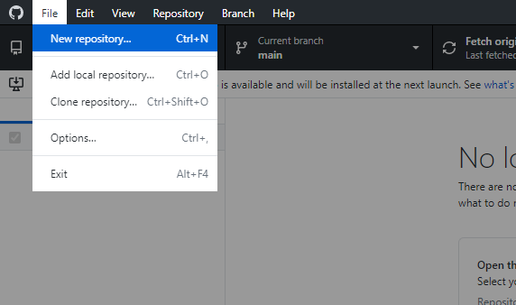
2. Fill the form opened and provide the location path in your system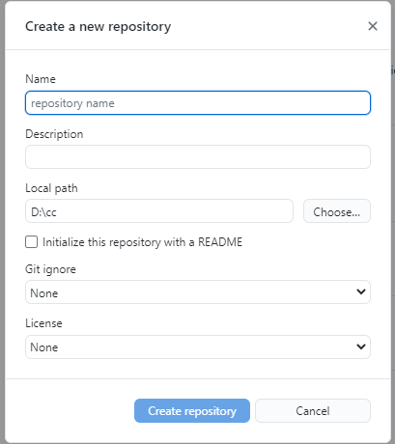
3. Paste the files in the folder given in the local path field

Weather.js file

window.onload = makeAjaxRequest;

let xhr = false;

function makeAjaxRequest() {

if (window.XMLHttpRequest) {

xhr = new XMLHttpRequest();

} else {

if (window.ActiveXObject) {

xhr = newActiveXObject("Microsoft.XMLHTTP");

}

}

if (xhr) {

xhr.open("GET", "weather.json", true);

xhr.send();

xhr.onreadystatechange = showContents;

} else {

document.getElementById("updatemessage").innerHTML = "Could not perform stated Request";

}

}

function showContents () {

if (xhr.readyState == 4) {

if (xhr.status == 200) {

let data = JSON.parse(xhr.responseText);

let txt = "<tr><th>City ID</th><th>City Name</th><th>Current Conditions</th><th>temperature</th><th>Wind Speed</th><th>Wind Direction</th><th>Wind Chill Factor</th><th>icon</th></tr>";

for (i =0; i<data.length/2;i++) {

txt += "<tr>"

txt += "<td>" + data[i].city_id + "</td>";

txt += "<td>" + data[i].city_name + "</td>";

txt += "<td>" + data[i].current_conditions + "</td>";

txt += "<td>" + data[i].temperature + "</td>";

txt += "<td>" + data[i].wind_speed + "</td>";

txt += "<td>" + data[i].wind_direction + "</td>";

txt += "<td>" + data[i].wind_chill_factor + "</td>";

txt += "<td><img src ='" + data[i].icon + "' style='height:50px;' ></td>";

txt += "</tr>"

}

document.getElementById("weatherTable").innerHTML = txt;

} else {

document.getElementById("updatemessage").innerHTML = "Could not perform stated request. Error: " + xhr.status;

}

}

}

setTimeout(update,5000);

function update () {

if (xhr.readyState == 4) {

if (xhr.status == 200) {

let data = JSON.parse(xhr.responseText);

let txt = "<tr><th>City ID</th><th>City Name</th><th>Current Conditions</th><th>temperature</th><th>Wind Speed</th><th>Wind Direction</th><th>Wind Chill Factor</th><th>icon</th></tr>";

for (i =data.length/2; i<data.length;i++) {

txt += "<tr>"

txt += "<td>" + data[i].city_id + "</td>";

txt += "<td>" + data[i].city_name + "</td>";

txt += "<td>" + data[i].current_conditions + "</td>";

txt += "<td>" + data[i].temperature + "</td>";

txt += "<td>" + data[i].wind_speed + "</td>";

txt += "<td>" + data[i].wind_direction + "</td>";

txt += "<td>" + data[i].wind_chill_factor + "</td>";

txt += "<td><img src ='" + data[i].icon + "' style='height:50px;' ></td>";

txt += "</tr>"

}

document.getElementById("weatherTable").innerHTML = txt;

} else {

document.getElementById("updatemessage").innerHTML = "Could not perform stated request. Error: " + xhr.status;

}

}

}

Weather.html page

<!DOCTYPE html>

<html lang="en">

<head>

<meta charset="UTF-8">

<meta http-equiv="X-UA-Compatible" content="IE=edge">

<meta name="viewport" content="width=device-width, initial-scale=1.0">

<title>Assignment 1</title>

<link rel="stylesheet" href="styles.css">

</head>

<body>

<p id="updatemessage"></p>

<!-- create table -->

<table id="weatherTable"></table>

<!-- attach javascript file -->

<script src="weather.js"></script>

</body>

</html>

Style.css page

table {

font-family: Arial, Helvetica, sans-serif;

border-collapse: collapse;

width: 100%;

}

table td, table th {

border: 1px solid #ddd;

padding: 8px;

}

Weather.json

[

{

"city_id": 1,

"city_name":"Liverpool",

"current_conditions":"Summer",

"icon": "./icons/sun.png",

"temperature":12,

"wind_speed":4,

"wind_direction":"Northern",

"wind_chill_factor":-2

},

{

"city_id": 2,

"city_name":"Brusel",

"current_conditions":"Winter",

"icon": "./icons/snow.png",

"temperature":-2,

"wind_speed":10,

"wind_direction":"Southern",

"wind_chill_factor":0

},

{

"city_id": 3,

"city_name":"another city 1",

"current_conditions":"Summer",

"icon": "./icons/sun.png",

"temperature":12,

"wind_speed":4,

"wind_direction":"Northern",

"wind_chill_factor":-2

},

{

"city_id": 4,

"city_name":"another city 2",

"current_conditions":"Winter",

"icon": "./icons/snow.png",

"temperature":-2,

"wind_speed":10,

"wind_direction":"Southern",

"wind_chill_factor":0

}

]

Weatherscehma.json file

{

"$schema": "http://json-schema.org/schema#",

"city_id": {

"type": "number",

"description": "It is primary key and will always increment on every new record entered",

"minimum": 0

},

"city_name": {

"type": "string",

"description": "Name of city"

},

"current_conditions":{

"type": "string",

"description": "It will show current condition"

},

"icon": {

"type": "string",

"description": "It will show icon for condition"

},

"temperature": {

"type": "float",

"description": "It can be positive and negative with float at type of number",

"minimum": 0

},

"wind_speed": {

"type": "float",

"description": "It represents speed of wind blowing usually it will show km/miles",

"minimum": 0

},

"wind_direction":{

"type": "string",

"description": "It will show direction of wind blowing"

},

"wind_chill_factor": {

"type": "float",

"description": "It can be positive and negative with float at type of number"

}

}

table th {

padding-top: 12px;

padding-bottom: 12px;

text-align: left;

background-color: #3289a8;

color: white;

}